­­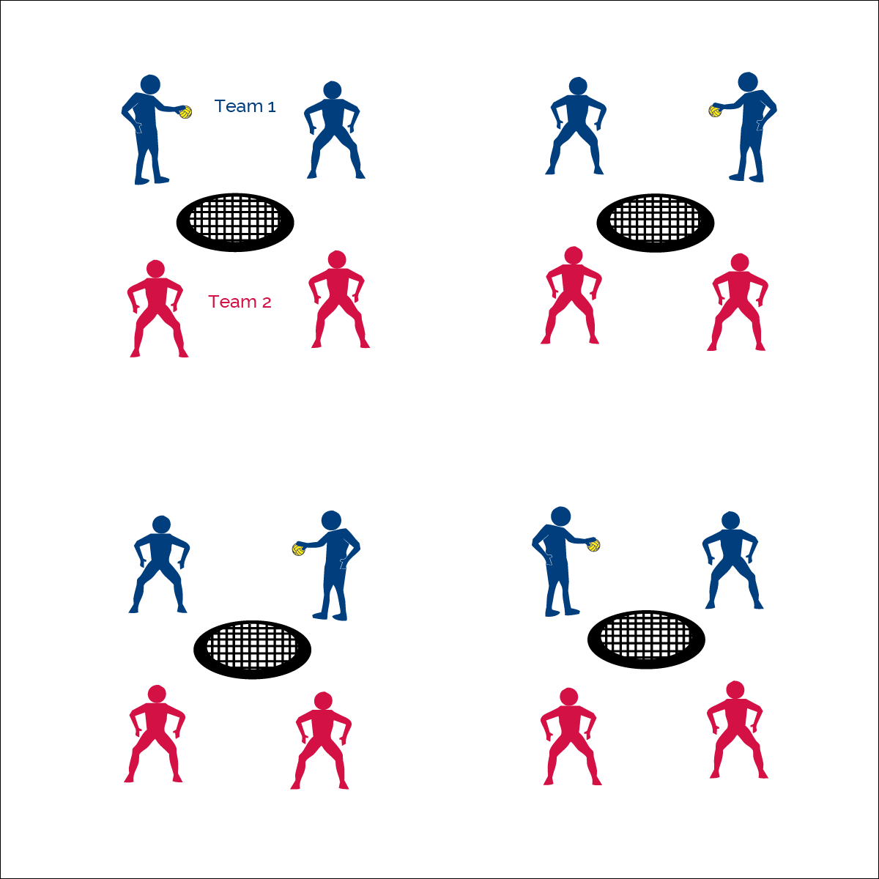

**Make ‘em Move**



* **Skill:** I will select spike placement in order to make the defender move to make a catch.
* **Cognitive:** I will be able to discuss how force and timing impact spike placement.
* **Fitness:** I will remain actively engaged throughout all activities.
* **Personal & Social Responsibility:** I will act appropriately and with proper Roundnet etiquette.



* Toss Serve, 1 Pass, Spike
* Hit to Space (Not to Defense)



**Equipment:**

* 1 Spikeball® net & 1 ball per group of 4 students

**Set-Up:**

1. Set Spikeball® nets up in the activity area, allowing space for vigorous activity.
2. Place 1 Spikeball® at each net.
3. Pair students and send 2 pairs (4 players) to each net.

**Activity Procedures:**

1. Today’s activity is a 2v2 game called Make ‘em Move. The object of the game is to spike the ball into open space and make the defenders move to catch it.
2. Play starts off a tossed served from the defense. The offense gets 1 pass and then must spike the ball to the defenders.
3. If the defense has to move their feet in order to make a catch, the offense scores a point. If the defense catches the ball without moving their feet, the defense scores a point.
4. Offensive players change roles each serve (i.e., passer to spiker). Change offense and defense after every 5 serves.

**Grade Level Progression:**

**6th:** Spikes are made to right or left of defender.

**7th:** Spikes are made to open space, which could include the area closest to the net, right, or left of defender.

**8th:** Spikes are made to open space with varying degrees of force.

**Make ‘em Move**



Placement, Offense, Defense, Force, Timing, Etiquette, Opponent



* **Standard 1 [M13.6-8]:** Strikes with a mature overarm pattern in a non-dynamic environment for net/wall games such as volleyball, handball, badminton, or tennis (6); Strikes with a mature overarm pattern in a dynamic environment for net/wall games such as volleyball, handball, badminton, or tennis (7); Strikes with a mature overarm pattern in a modified game for net/wall games such as volleyball, handball, badminton, or tennis (8).
* **Standard 2 [M8.7-8]:** Selects offensive shot based on opponent’s location (hit where opponent is not) (7); Varies placement, force and timing of return to prevent anticipation by opponent (8).
* **Standard 4 [M6.6-8]:** Identifies the rules and etiquette for physical activities/games and dance activities (6); Demonstrates knowledge of rules and etiquette by self-officiating modified physical activities/games or following parameters to create or modify a dance (7); Applies rules and etiquette by acting as an official for modified physical activities/games and creating dance routines within a given set of parameters (8).



* **DOK 1:** What is the definition of force? What is the definition of timing?
* **DOK 2:** How do force and timing affect spiking accuracy? Placement?
* **DOK 3:** How is accuracy related to placement?
* **DOK 4:** Let’s design and conduct an experiment that can be used to help explain the relationship between force, timing, and accuracy.



**Review content:** As fundamental skill practice evolves into small-sided tactical practice, it’s important to introduce strategic concepts while also taking time to review and reinforce the critical skill elements covered in previous lessons. This highlights the cumulative nature of the module content, the relationship between skill development and tactical gameplay, as well as the need for ongoing skill practice.

* **Adaptation:** Use a balloon or lightweight ball. Remove the net from the activity.
* **Extension:** Add a second defender to the activity.

