­­  
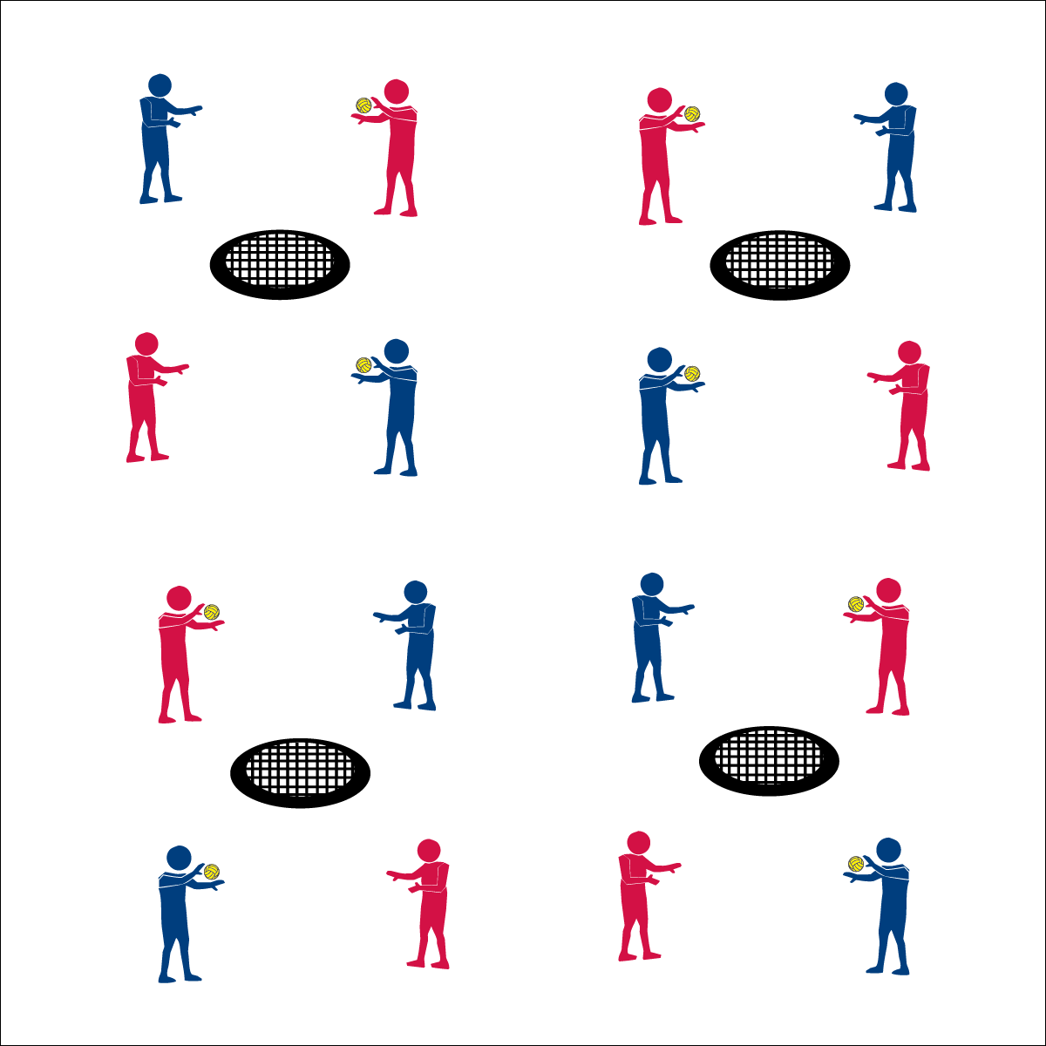

**Anticipate & Position**



* **Skill:** I will position myself to reduce offensive options during defensive challenges.
* **Cognitive:** I will define the terms anticipation and positioning as they relate to Roundnet.
* **Fitness:** I will remain actively engaged in all challenges.
* **Personal & Social Responsibility:** I will contribute to a positive activity environment.



* Anticipate (Analyze, Predict)
* Position (Stay Alert, Move to Position, Athletic Stance)



**Equipment:**

* 1 Spikeball® net per group of 4 students
* 2 balls per group of 4 students
* 1 Task Tent per group of 4 students
* 1 large cone
* 1 Defensive Challenge Card per group of 4 students
* 1 Defensive Cue Chart per group of 4 students

**Set-Up:**

1. Set Spikeball® nets up in the activity area, allowing space for vigorous activity.
2. Place 2 Spikeball® at each net.
3. Display 1 Defensive Cue Chart at each net using a large cone and Task Tent.
4. Pair students and send 2 pairs (4 players) to each net.

**Activity Procedures:**

1. Today we’re going complete a series of defensive challenges to help us learn how to anticipate a spike and position ourselves to best defend against that spike.
2. Anticipating a spike means that you’re reading and predicting where a spike will go before it’s made by your opponent. Positioning is your response to that anticipation. You move to the spot where the spike can go and you’re ready in athletic stance (demonstrate and practice critical elements).
3. On the start signal, you and your partner are going to work to complete the first set challenges on the Challenge Card. On the stop signal, you’ll reset and work with the other team at your net to complete the second set of challenges on the Challenge Card.
4. Focus your effort on anticipation and positioning.

**Grade Level Progression:**

**6th:** Complete partner challenges.

**7th:** Complete partner and team challenges.

**8th:** Complete all challenges and then play Roundnet for Rookies.

**Anticipate & Position**



Analyze, Anticipation, Athletic Stance, Positioning, Predict, Offense, Defense, Return



* **Standard 1 [M13.6-8]:** Strikes with a mature overarm pattern in a non-dynamic environment for net/wall games such as volleyball, handball, badminton, or tennis (6); Strikes with a mature overarm pattern in a dynamic environment for net/wall games such as volleyball, handball, badminton, or tennis (7); Strikes with a mature overarm pattern in a modified game for net/wall games such as volleyball, handball, badminton, or tennis (8).
* **Standard 2 [M8.6]:** Reduces offensive options for opponents by returning to mid-court position (6).
* **Standard 5 [M3.6-8]:** Recognizes individual challenges and copes in a positive way, such as extending effort, asking for help/feedback, and/or modifying the tasks (6); Generates positive strategies such as offering suggestions/assistance, leading/following others, and/or providing possible solutions when faced with a group challenge (7); Develops a plan of action and makes appropriate decisions based on that plan when faced with an individual challenge (8).



* **DOK 1:** What is the definition of anticipation? What is the definition of positioning?
* **DOK 2:** How does anticipation affect positioning?
* **DOK 3:** How are anticipation and positioning related to Roundnet defense?
* **DOK 4:** Work with your partner to identify areas of defensive weakness, then design a plan to improve those areas.

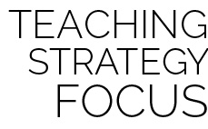

**Help students examine their reasoning:** Middle school students often find it difficult to self-identify areas of weakness. They associate weakness with failure rather than opportunities for growth. Asking students to examine their weaknesses and provide logical explanations for those deficiencies can help them develop a growth mindset focused on improvement rather than self-doubt/blame. This dialog must be done with patience and care, guiding students to critique the logic surrounding an outcome or challenge rather then focusing on an emotional response to a personal weakness.

* **Adaptation:** Use a balloon and provide a raised surface. Students focus on positioning their hands based on the trajectory of the spiked balloon.
* **Extension:** Add a “Professional” level requiring 30 successes for each challenge.

