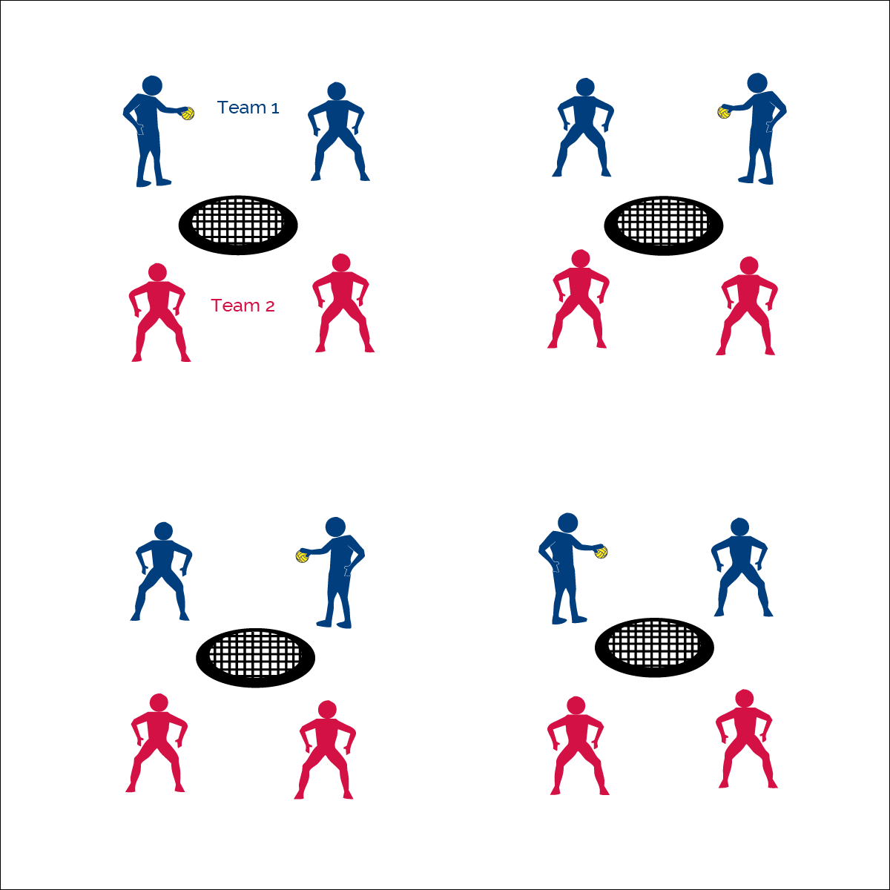­­

**ROUNDNET 4 ROOKIES**



* **Skill:** I will combine Roundnet striking and positioning skills with offensive and defensive tactics.
* **Cognitive:** I will discuss the importance of social interaction.
* **Fitness:** I will remain actively engaged in Roundnet games.
* **Personal & Social Responsibility:** I will demonstrate the importance of social interaction as it applies to Spirit of the Game.



* Spirit of the Game: Responsibility, Fair Play, Respect, and Joy of Play



**Equipment:**

* 1 Spikeball® net & 1 ball per group of 4 students

**Set-Up:**

1. Set Spikeball® nets up in the activity area, allowing space for vigorous activity.
2. Place 1 Spikeball® at each net.
3. Pair students and send 2 pairs (4 players) to each net.

**Activity Procedures:**

1. It’s time to play Roundnet for Rookies.
2. This is a full game of Roundnet, using a toss serve to begin the game.
3. Let’s take a look at this quick video from Spikeball® to review how to play: <https://youtu.be/J8T5TIrHtzs>
4. Each game today will be timed for 5 minutes, and then we’ll find new teams to play against.
5. Use rally scoring (points can be won by the serving or receiving team).
6. To serve, begin with a simple toss serve.
7. Each team has up to 3 hits to send the ball to the net for a change of possession. If the ball can’t be returned with a clean bounce on the net, then a point is awarded to the opposing team. The team that wins the point gets the next serve. Alternate servers each time your team becomes the serving team.
8. If there are any questions about infractions or faults, it’s an automatic redo.

**Grade Level Progression:**

**6th:** Play 5 minute games, matching teams with similar abilities.

**7th:** Play 3 minute games in King of the Court tournament format.

**8th:** Allow students to choose opponents. Play games to 21, win by 2. Switch sides when a team scores 11.

* **Adaptation:** Play the game using a balloon and small desk as the spiking surface. Spiker must hit the ball in the direction of 1 of the 2 opponents.
* **Extension:** Progress to Roundnet 4 Pros.



**Help students engage in cognitively complex tasks:** Roundnet 4 Rookies maybe students’ first experience playing a game of Roundnet. It’s a dynamic but slightly modified activity using the combined skill and tactical elements introduced throughout all previous activities. It’s important to supervise and assess short bursts of student gameplay, looking for areas needing improvement while avoiding excessive frustration. Then allow students to revisit practice tasks and continue building capacity for extended and more competitive game play.



* **DOK 1:** How can you recognize a positive social interaction?
* **DOK 2:** How can different social interactions affect a game of Roundnet?
* **DOK 3:** Can you predict your emotional reaction to a game of Roundnet that involves a positive social interaction? A negative social interaction?
* **DOK 4:** Let’s develop a plan for keeping class social interactions positive.



* **Standard 1 [M15.6]:** Transfers weight with correct timing for the striking pattern (6).
* **Standard 2 [M8.6-8]:** Reduces offensive options for opponents by returning to mid-court position (6); Selects offensive shot based on opponent’s location (hit where opponent is not) (7); Varies placement, force, and timing of return to prevent anticipation by opponent (8).
* **Standard 5 [M6.6-8]:** Demonstrates respect for self and others in activities and games by following the rules, encouraging others, and playing within the spirit of the game or activity (6); Demonstrates the importance of social interaction by helping and encouraging others, avoiding trash talk, and providing support to classmates (7); Demonstrates respect for self by asking for help and helping others in various physical activities. (8).



Combine, Positioning, Tactic, Self-Officiating, Serve, Social Interaction, Spirit of the Game, Strategy

**ROUNDNET 4 ROOKIES**