­­

**TEAM TACTICS**

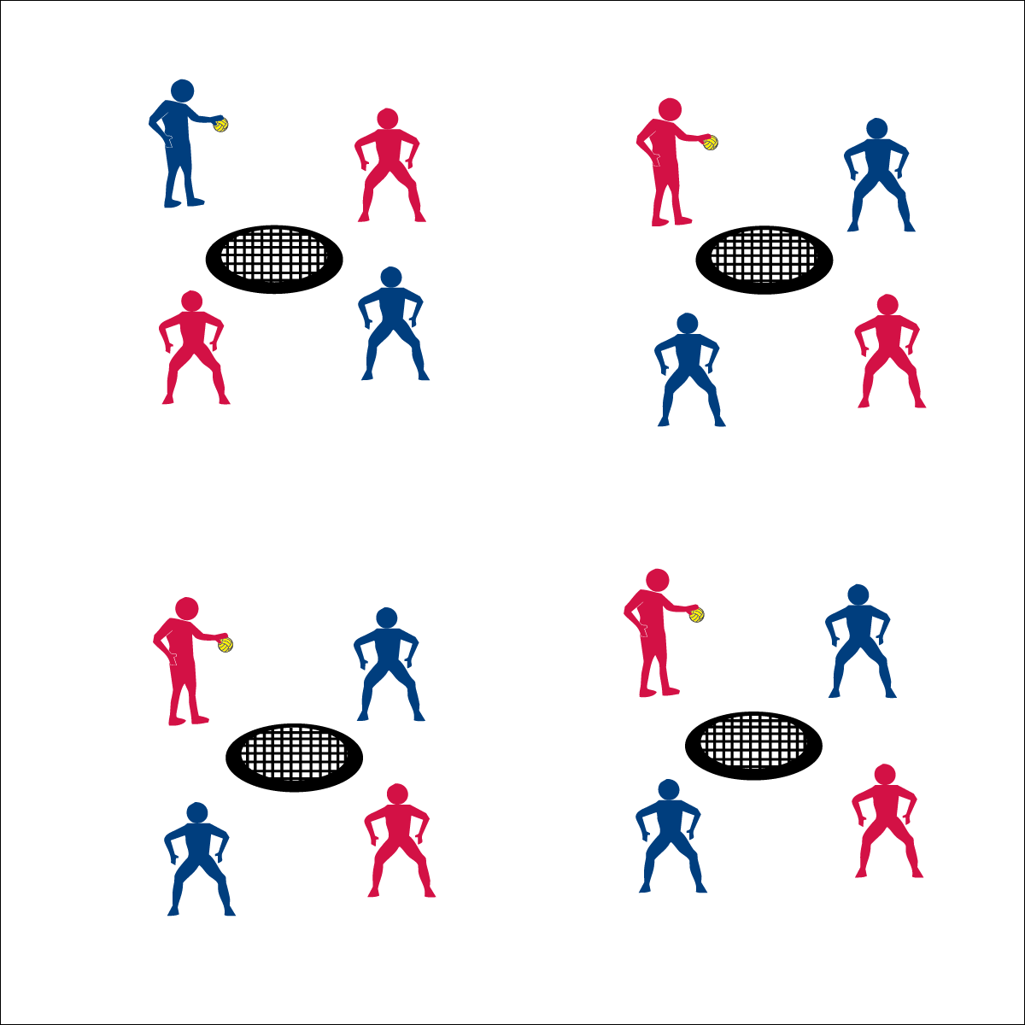

* **Skill:** I will select spike type and placement based on the location of the defense.
* **Cognitive:** I will discuss how placement, force, and timing impact the effectiveness of spikes.
* **Fitness:** I will review the components of fitness impacted by participation in Roundnet.
* **Personal & Social Responsibility:** I will respond appropriately to various social situations that arise  
  in cooperative activity settings.



* Stay Alert
* Cooperate with Clear Communication
* Finish the Play



**Equipment:**

* 1 Spikeball® net & 1 ball per group of 4 students
* 1 large cone
* 1 Task Tent per group of 4 students
* 1 Tactical Team Challenge Card per group of 4 students

**Set-Up:**

1. Set Spikeball® nets up in a large activity area with plenty of room for vigorous activity.
2. Place 1 Spikeball® at each net.
3. Display the Tactical Team Challenge Cards with a Task Tent and a large cone.
4. Pair students and send 2 pairs (4 players) to each net.

**Activity Procedures:**

1. Today is a Team Tactics practice day. You and your partner will work with another team to master a series of tactical team challenges.
2. The focus of the practice will be passing accuracy, spiking accuracy, and shot selection.
3. On the start signal, your group will work to complete the tasks on the Challenge Card.
4. On the stop signal, switch partners to mix up your group and work to complete the challenges again.

**Grade Level Progression:**

**6th:** Focus on refining skills at challenge levels 1-3.

**7th:** Extend the activity with levels 4-6.

**8th:** Allow students to create their own Team Challenge Cards.

* **Adaptation:** Focus this activity on challenge level 1 using a balloon or lightweight ball.
* **Extension:** Add a “Professional” level requiring 30 successes for each challenge.



**Help students revise knowledge:** Students revise knowledge and refine skills by correcting performance errors and cognitive misconceptions. Team Tactics performance challenges are designed provide purposeful practice opportunities in between authentic game play experiences. This helps students to see themselves as active learners who can improve though practice.



* **DOK 1:** What would you include on a list that would describe an accurate spike?
* **DOK 2:** How does placement, force, and timing impact the effectiveness of a spike?
* **DOK 3:** How would you describe the sequence of performing a perfect spike?
* **DOK 4:** Create a spiking performance that demonstrates the successful use of placement, force, and timing. Be prepared to replicate that performance.



* **Standard 2 [M8.7-8]:** Selects offensive shot based on opponent’s location (hit where opponent is not) (7); Varies placement, force, and timing of return to prevent anticipation by opponent (8).
* **Standard 4 [M4.6-8]:** Accepts differences among classmates in physical development, maturation, and varying skill levels by providing encouragement and positive feedback (6); Demonstrates cooperation skills by establishing rules and guidelines for resolving conflicts (7); Responds appropriately to participants’ ethical and unethical behavior during physical activity by using rules and guidelines for resolving conflicts (8).



Tactic, Positioning, Placement, Force, Timing, Effective, Cooperation

**TEAM TACTICS**