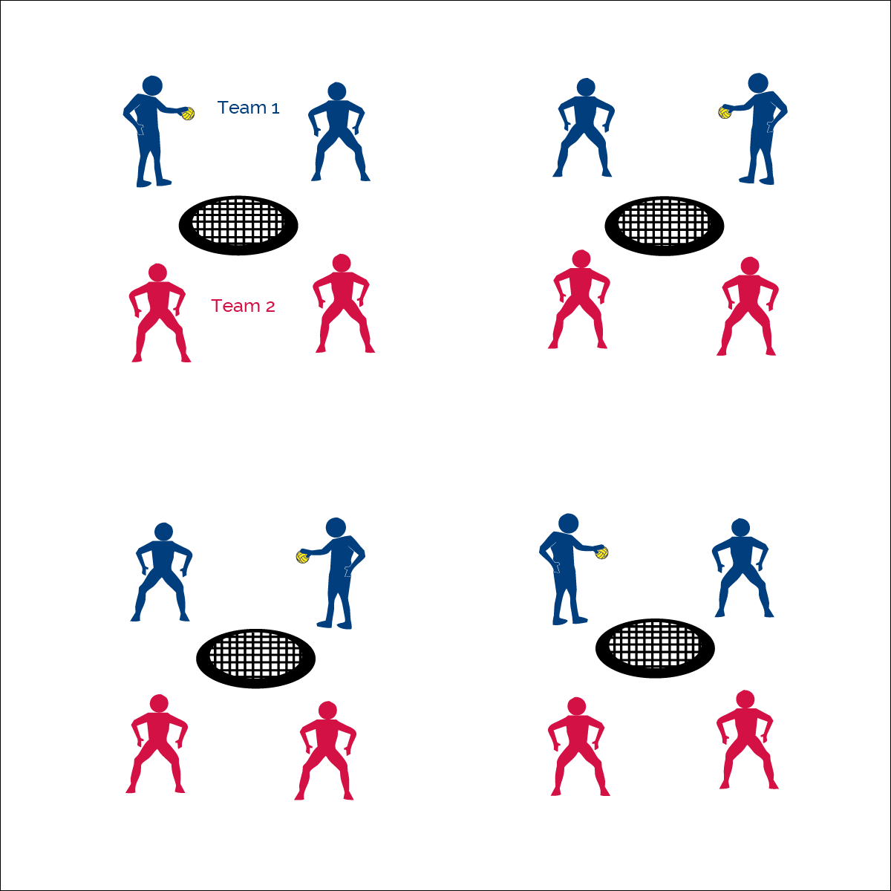­­

**ROUNDNET 4 PROS**



* **Skill:** I will perform a strike serve to begin each rally.
* **Cognitive:** I will discuss the importance of applying the rules and etiquette of game play.
* **Fitness:** I will remain actively engaged in Roundnet games.
* **Personal & Social Responsibility:** I will demonstrate the importance of applying rules and etiquette of game play.



* Spirit of the Game: Responsibility, Fair Play, Respect, and Joy of Play



**Equipment:**

* 1 Spikeball® net & 1 ball per group of 4 students

**Set-Up:**

1. Set Spikeball® nets up in the activity area, allowing space for vigorous activity.
2. Place 1 Spikeball® at each net.
3. Pair students and send 2 pairs (4 players) to each net.

**Activity Procedures:**

1. It’s time to play Roundnet for Pros. We’ll play Roundnet with a full spike serve to begin the game.
2. Each game today will be timed for 5 minutes, then we’ll find new teams to play against. Use rally scoring (points can be won by the serving or receiving team). To serve, begin with full spike serve.
3. Each team has up to 3 hits to send the ball to the net for a change of possession. If the ball can’t be returned with a clean bounce on net, then a point is awarded to the opposing team. The team that wins the point, gets the next serve. Alternate servers each time your team becomes the new serving team.
4. If there are any questions about infractions or faults, it’s an automatic redo.
5. Work during the game to focus on teamwork and communication.
   1. Call “mine” when moving to play a spiked ball.
   2. Use verbal cues to help your teammate know where you are on the court.
   3. Congratulate ALL players after a good play or rally.

**Grade Level Progression:**

**6th:** Play 5 minute games, matching teams with similar abilities.

**7th:** Play 3 minute games in King of the Court tournament format.

**8th:** Allow students to choose opponent. Play games to 21, win by 2. Switch sides when a team scores 11.

* **Adaptation:** Play the game using a balloon and small desk as the spiking surface. Spiker must hit the ball in the direction of 1 of the 2 opponents.
* **Extension:** Students must make at least 1 pass per rally using a body part other than the hand



**Help students process content:** Roundnet 4 Pros provides an authentic game experience with an emphasis on competent skill application. This format also allows students an opportunity to see why, when, and how the skills and concepts they’ve learned apply to and impact a performance. This step in the progression requires teachers to be fully engaged in observing performances for teachable moments in which meaningful dialog can enhance and experience and therefore promote learning.



* **DOK 1:** What does etiquette mean?
* **DOK 2:** What do you know about the etiquette of Roundnet?
* **DOK 3:** Why are rules and etiquette important for successful Roundnet game play?
* **DOK 4:** Develop a class plan for upholding both rules and etiquette.
* **DOK 1:** What is the Spirit of the Game?
* **DOK 2:** How is the Spirit of the Game applied in Roundnet?



* **Standard 1 [M13.6-8]:** Strikes, with a mature overarm pattern, in a non-dynamic environment for net/wall games such as volleyball, handball, badminton or tennis (6); Strikes, with a mature overarm pattern, in a dynamic environment for net/wall games such as volleyball, handball, badminton or tennis (7); Strikes, with a mature overarm pattern, in a modified game for net/wall games such as volleyball, handball, badminton or tennis (8).
* **Standard 2 [M8.6-8]:** Reduces offensive options for opponents by returning to mid-court position (6); Selects offensive shot based on opponent’s location (hit where opponent is not) (7); Varies placement, force and timing of return to prevent anticipation by opponent (8).
* **Standard 4 [M6.6-8]:** Identifies the rules and etiquette for physical activities/games and dance activities (6); Demonstrates knowledge of rules and etiquette by self-officiating modified physical activities/games or following parameters to create or modify a dance (7); Applies rules and etiquette by acting as an official for modified physical activities/games and creating dance routines within a given set of parameters (8).



Rally, Serve, Etiquette, Spirit of the Game

**ROUNDNET 4 PROS**