­­

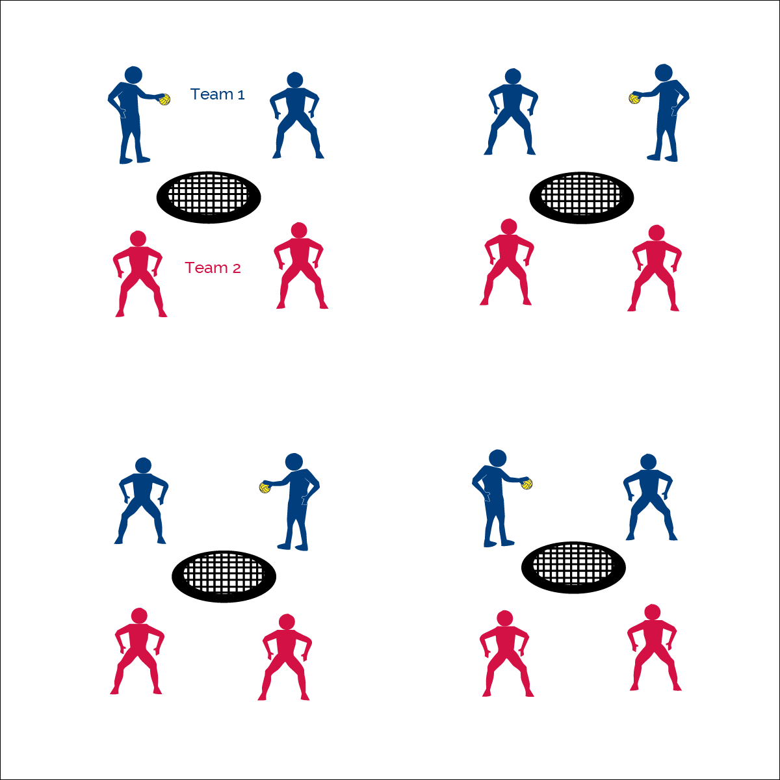



**Equipment:**

* 1 Spikeball® net and ball per group of 4

**Set-Up:**

1. Set Spikeball® nets up in the activity area, allowing space for vigorous activity.
2. Place 1 Spikeball® at each net.
3. Pair students and 2 pairs (4 players) to each net.
4. Create a tournament format and schedule for teams to follow for a set number of lessons.

**Activity Procedures:**

1. Now that we have Roundnet skills and strategy, it’s time to play in our Annual Roundnet Tournament!
2. Teachers, we recommend 3 different approaches to setting up a Roundnet tournament in your class. *(Download our Tournament Tool Kit for more information and helpful resources.)*
   1. **All-In Round Robin Format:** This format gives all students a chance to play an equal number of games with final rankings based on overall records. It’s okay to have a tie for first place.
   2. **A Varsity & JV Round Robin Format:** Teams are set and ranked based on skill level. The class is then divided in half with the highest skilled playing in the Varsity Tournament and the lowest skilled playing in the JV Tournament. Again, all students play an equal number of games and each tournament is given its own final ranking.
   3. **King of the Court Format:** This format can be used for 1-day tournaments as well as for ranking teams for a more formal Round Robin Tournament. Set up a King of the Court Tournament by numbering off all Spikeball® nets—1, 2, 3, 4…. Games are played for a set amount of time. Winners move one court closer to the #1 court, while non-winners move one court closer to the last # court. All teams should move, except the winners of the #1 court and the non-winners of last court.
      1. To use this format for ranking teams, record where teams finished at the end of class. This will be used to divide the class into two groups for the tournament. The top half of class will be in the Varsity Tournament, and the bottom half of class will be in the JV Tournament.

**TOURNAMENT OPTIONS**



* **Skill:** I will combine Roundnet striking and athletic positioning skills with offensive and defensive tactics.
* **Cognitive:** I will demonstrate the importance of applying rules and etiquette of game play.
* **Fitness:** I will remain actively engaged in Roundnet games.
* **Personal & Social Responsibility:** I will accept and respect differences among my classmates of varying skill levels.



* Self-Officiating (Play by the Rules, Score Honestly, Respect All Players)
* Redo ALL Questionable Calls

* **Adaptation:** Provide an experienced player or adult at each game to assist with rules, etiquette, skills, and strategy. Modify the game as needed based on successful modifications used in previous activities.
* **Extension:** Explore additional tournament formats such as elimination style formats for advanced players with mature sportsmanship.



**Organize students to interact with content:** The nature of physical education requires kinesthetic experiences for skill building and conceptual understanding. Balancing the competitive nature of authentic gameplay with the need for positive and successful experience can be difficult for teachers. It’s important to organize students within tournament formats that match their skill levels and personal preferences. Allowing students to select from competitive and non-competitive formats can help provide the positive movement experience students need in order to develop an appreciation for and a desire to seek out physical activity for a lifetime.



* **DOK 1:** How can you recognize proper etiquette?
* **DOK 2:** With respect to etiquette, what have you noticed about the Roundnet games that we’ve played in class?
* **DOK 3:** What is your interpretation of Spirt of the Game? Can you support your interpretation with specific examples from previous game play?



* **Standard** **Standard 1 [M13.6-8]:** Strikes with a mature overarm pattern in a non-dynamic environment for net/wall games such as volleyball, handball, badminton, or tennis (6); Strikes with a mature overarm pattern in a dynamic environment for net/wall games such as volleyball, handball, badminton, or tennis (7); Strikes with a mature overarm pattern in a modified game for net/wall games such as volleyball, handball, badminton, or tennis (8).
* **Standard 2 [M8.6-8]:** Reduces offensive options for opponents by returning to mid-court position (6); Selects offensive shot based on opponent’s location (hit where opponent is not) (7); Varies placement, force, and timing of return to prevent anticipation by opponent (8).
* **Standard 4 [M6.6-8]:** Identifies the rules and etiquette for physical activities/games and dance activities (6); Demonstrates knowledge of rules and etiquette by self-officiating modified physical activities/games or following parameters to create or modify a dance (7); Applies rules and etiquette by acting as an official for modified physical activities/games and creating dance routines within a given set of parameters (8).
* **Standard 4 [M4.6-8]:** Accepts differences among classmates in physical development, maturation, and varying skill levels by providing encouragement and positive feedback (6); Demonstrates cooperation skills by establishing rules and guidelines for resolving conflicts (7); Responds appropriately to participants’ ethical and unethical behavior during physical activity by using rules and guidelines for resolving conflicts (8).



Combine, Tactics, Etiquette, Spirit of the Game, Tournament

**TOURNAMENT OPTIONS**