­­­

* Above-Chest Pass
* Below-Chest Pass
* Control
* Accuracy

­

* **Skill:** I will demonstrate below-chest & above-chest passes.
* **Cognitive:** I will identify the components of skill-related fitness required for successful participation in Roundnet.
* **Fitness:** I will actively engage in all practice tasks in order to improve my skill-related fitness.
* **Personal & Social Responsibility:** I will listen to feedback and use suggestions to improve my Roundnet skills.
* **Standard 3 [M7.6-8]:** Identifies the components of skill-related fitness (6); Distinguishes between health-related and skill-related fitness (7); Compares and contrasts health-related fitness components (8).
* **Standard 5 [M3.6-8]:** Recognizes individual challenges and copes in a positive way, such as extending effort, asking for help/feedback, and/or modifying the tasks (6); Generates positive strategies such as offering suggestions/assistance, leading/following others, and/or providing possible solutions when faced with a group challenge (7); Develops a plan of action and makes appropriate decisions based on that plan when faced with an individual challenge (8).
* Depth of Knowledge Exit Slip created with activity debrief questions

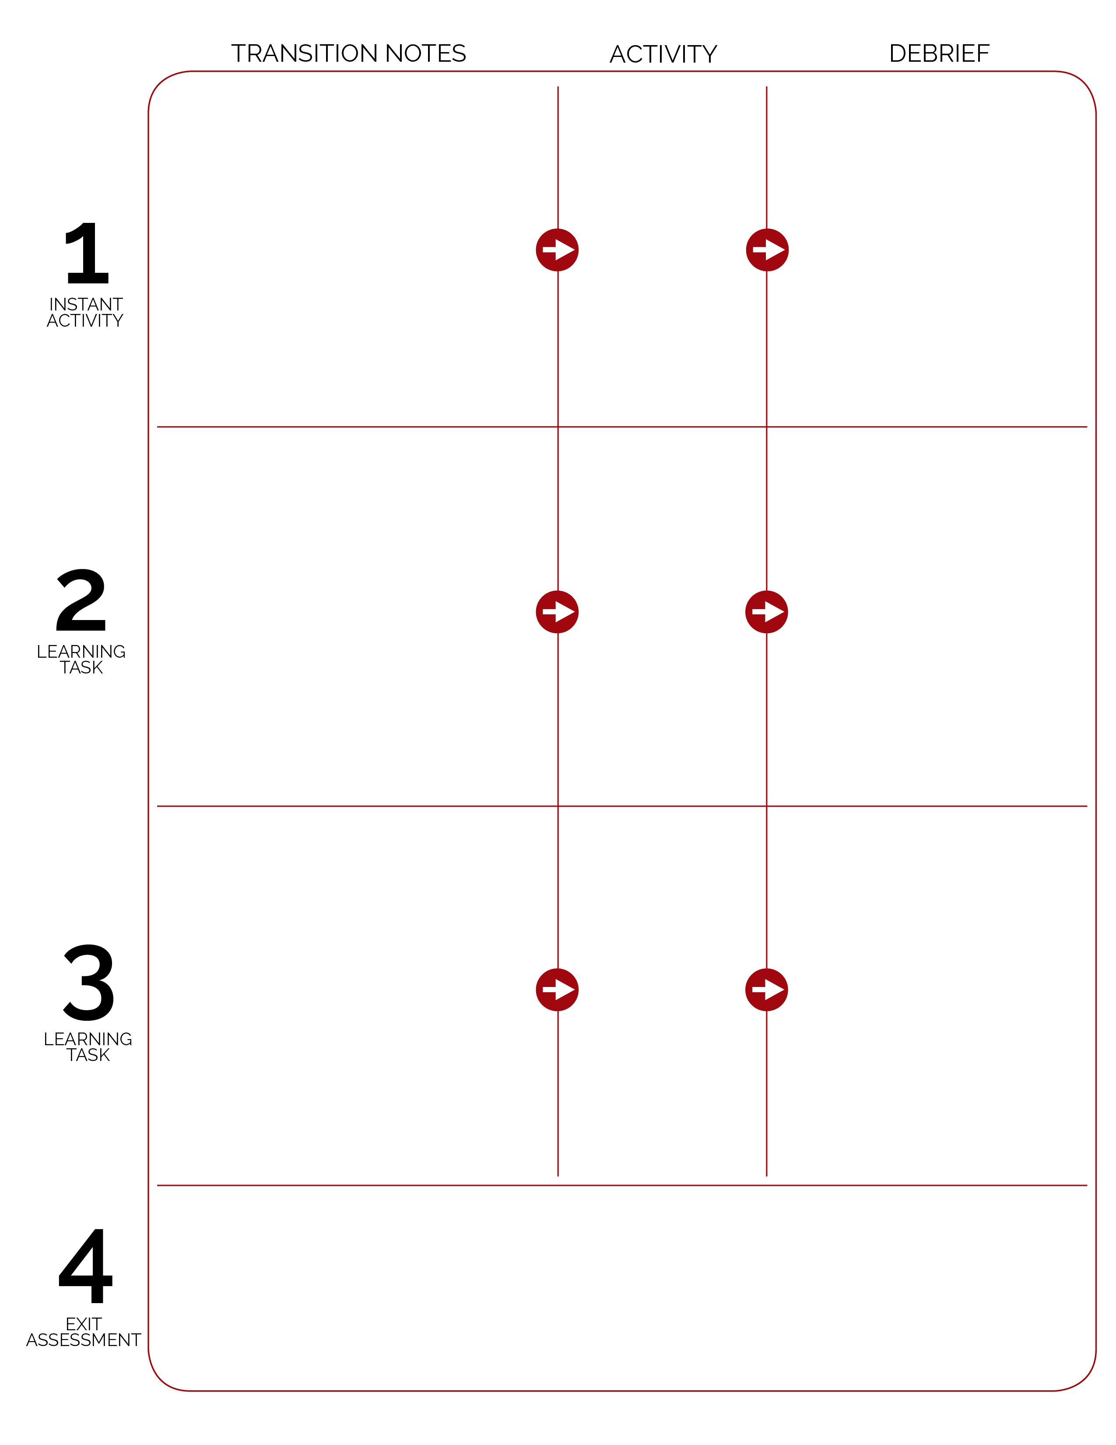

Students help to reset the activity area for the next class and then complete the lesson exit slip prior to getting ready to leave class.

*Exit slip question:* Can you develop a self-passing practice plan to do outside of class in order to improve 1 or more component of skill-related fitness? List at least 2 activities/drills along with the component of fitness targeted.

Using a projector, screen, and device with internet, show class Spikeball® Introduction Videos:

* <https://youtu.be/J8T5TIrHtzs>
* <https://youtu.be/UXPjH3uk0Bs>

Demonstrate below- and above-chest passes. Highlight cues on cue charts.

Prompts students to complete Self-Passing Challenges.

Cones are set up for self-passing challenges. Spikeball® sets are to the side of the activity area. Students grouped in 4s and set up for self-passing challenges with enough personal space to complete Pick a Card warm-up activities. Pass Challenge Cards and Cue Charts are displayed in Task Tent for each group.

Spikeball Bounce & Catch

Self-Passing Challenges

Each group of 4 now picks up cones and replaces them with Spikeball® nets and balls. Nets are spaced with enough room for safe participation. Demonstrate basic bounce and catch. Prompt students to complete all Bounce & Catch Challenges.

**DOK 1:** Can you name & describe each bounce used in this activity?

**DOK 2:** How does the angle at which the ball is thrown affect the way it bounces off off the net?

**DOK 3:** How is a person’s knowledge of each of these bounces related to their Roundnet performance?

**DOK 1:** What are the components of skill-related fitness?

**DOK 2:** Which components affect Roundnet performance? Why? (provide evidence)

Pick A Card

(OPEN Instant Activities)

Who will tell the class their favorite healthy food, along with what food group that food belongs to?