­­­

* Academic language
* Academic language

­

* **Skill:** Skill focus
* **Cognitive:** Cognitive focus
* **Fitness:** Fitness focus
* **Personal & Social Responsibility:** PSR focus
* **Standard #** [Outcome.Code] Outcome description
* **Standard #** [Outcome.Code] Outcome description
* Selected Assessment

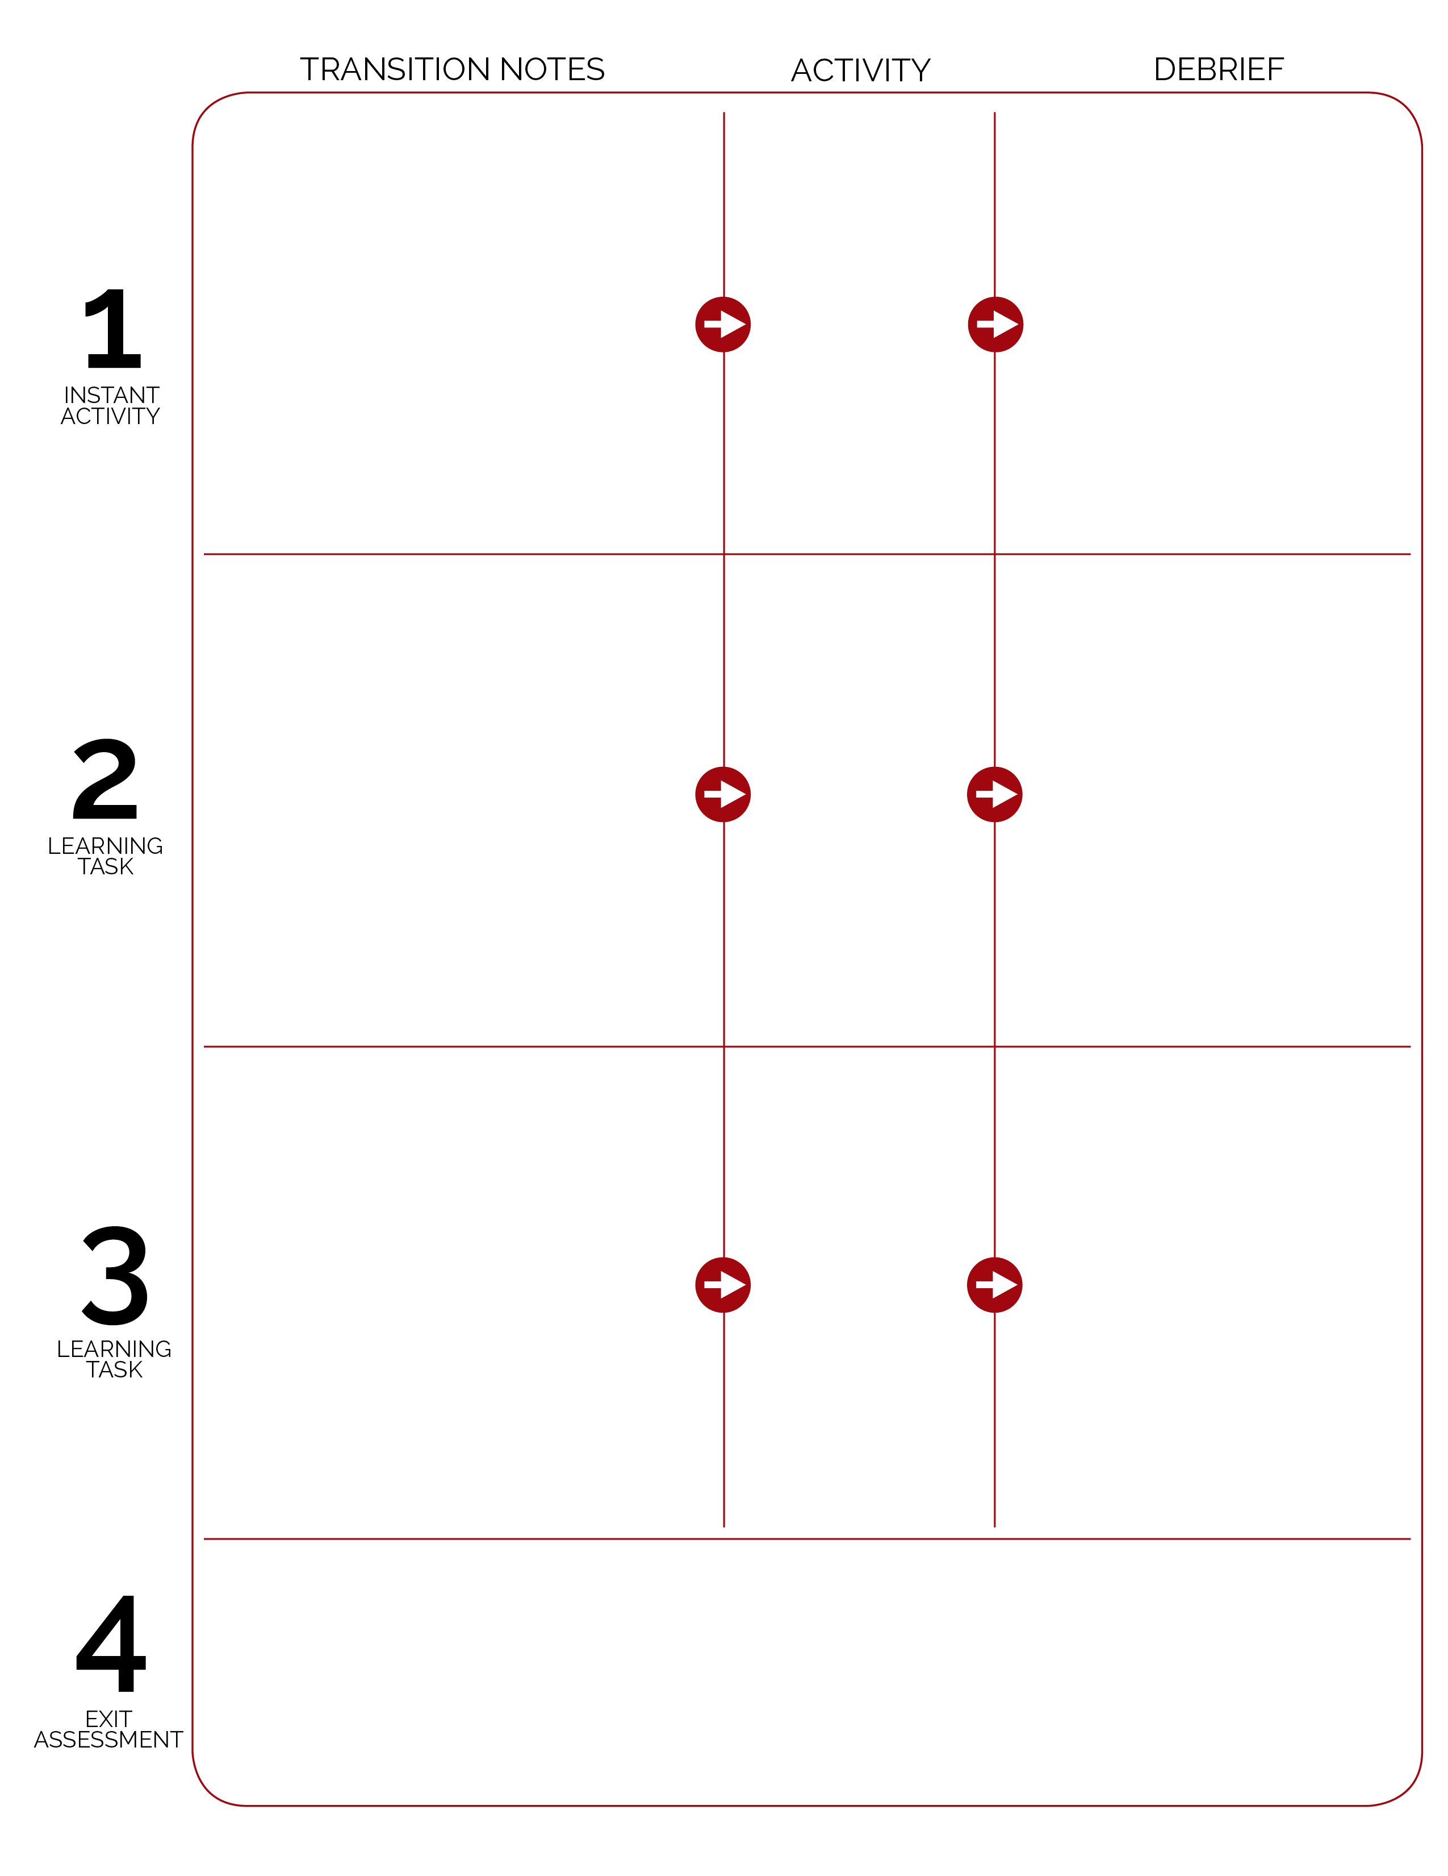

Exit assessment

Debrief questions

Activity name

Transition notes for next activity

Transition notes for next activity

Activity name

Debrief questions

Debrief questions

First activity

Transition Notes for first activity