­_­­

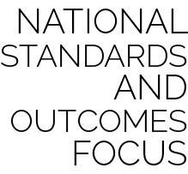

* **Standard 1.** Demonstrates competency in a variety of motor skills and movement patterns.
* **Outcome E22.K-2.** Volleys a lightweight object (balloon), sending it upward (K); Volleys an object with an open palm, sending it upward (1); Volleys an object upward with consecutive hits (2).
* **Outcome E24.K-2.** Strikes a lightweight object with a paddle/short-handled racket (K);Strikes a ball with a short-handled implement, sending it upward (1);Strikes an object upward with a short-handled implement, using consecutive hits (2).
* **Standard 2.** Applies knowledge of concepts, principles, strategies, and tactics related to movement and performance.
* **Outcome E3.1b-2.** Differentiates between strong and light force (1b); Varies time and force with gradual increases and decreases (2).

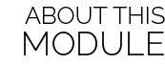

This module introduces students to the basics of volleying and striking through developmental play. Striking with the hand is followed by striking with a short-handled paddle, preparing students to progress toward paddle and racquet activities at the intermediate level.

|  |  |  |
| --- | --- | --- |
| **RESOURCES** | **FOCUS OUTCOMES & STANDARDS** | **PAGE** |
| Module Overview |  | **1** |
| Required Materials List |  | **5** |
| **Activity Plans** |  |  |
| Keep It Up | Standard 1 [E22.K-2] | **6** |
| Musical Balloon Bop | Standard 1 [E22.K-2] | **8** |
| Bull’s Eye | Standard 1 [E22.K-2] | **10** |
| Air Ball | Standard 1 [E22.K-2] | **12** |
| Net Ball | Standard 1 [E22.K-2] | **14** |
| Paddle It Up | Standard 1 [E24.K-2] | **16** |
| Musical Paddle Bop | Standard 1 [E24.K-2] | **18** |
| Net Ball (w/paddle) | Standard 1 [E24.K-2] | **20** |
| Station Day | Standard 1 [E22 & E24] | **22** |
| Sample First Lesson Plan |  | **24** |
| Academic Language Posters |  | **29 pages** |
| Station Cards |  | **6 pages** |
| **Student Assessment Tools** |  |  |
| Self-Assessment Worksheet |  |  |
| Holistic Performance Rubric |  |  |
| Teacher Self-Evaluation & Reflection Guide |  |  |

*NOTE:* *Additional standards and outcomes addressed are specified on each activity plan.*

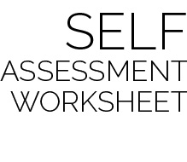

This simple self-assessment provides each student with a structure for reflecting on current skill level, setting a goal for growth and development, and then reassessing progress toward that goal.

The authors recommend that students complete this form as a pre-assessment on the day that skills are first introduced. For example, during the module’s first lesson, students participate in the activity Keep It Up. At the end of this activity, students would complete the Pre and Goal columns for Volleying (Hand) (and possibly Striking - Hand). Underhand Serve and those that involve work with a paddle would not be completed until a future lesson introduces those skills. A post-assessment for all skills would then be completed during the Module’s Station Day lesson.

Introduce the self-assessment tool and process to K-1 students by completing the worksheet as a class, rating the entire group’s performance. Next, set a group goal for improvement and complete the post-assessment together. Young students will most likely need too much guidance to complete this type of assessment independently. We recommend attempting an independent self-assessment at the end of grade 1 and then throughout grade 2.



Two types of assessment are provided as a part of this module. However, there are many different ways for teachers and students to assess and evaluate student learning and skill development.

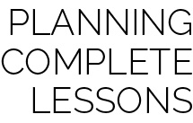

Each skill-building activity in this module is meant to be one part of a complete lesson. The authors recommend the following formula for creating a 30 to 45 minute lesson:

Instant Activity (not on block plan) *5-10 minutes*

+ Skill Activity with Debrief *10-15 minutes*

+ Skill Activity with Debrief *10-15 minutes*

+ Check for Understanding *5 minutes*

**Important:** Suggestions are what they say they are – *suggestions*. All OPEN materials are offered in MS Word format so that you can easily modify our suggestions to meet the needs of your students.

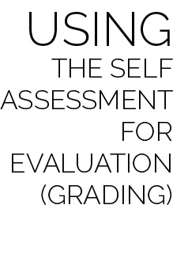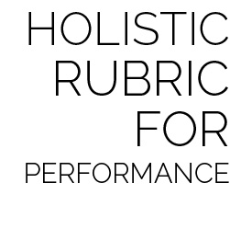

The Holistic Rubric can be used as both a formative and summative assessment within the module. Providing students with the rubric’s criteria early in the module will allow for discussion and formative evaluation throughout activities and lessons.

Two rubrics are given for teachers to choose from based completely on preference. The Single Holistic Rubric provides one set of criteria including both skill and personal and social responsibility (PSR) characteristics. The Dual Holistic Rubric separates skill and PSR characteristics, providing two sets of criteria to be evaluated separately. Either rubric can be completed in full on the Module’s Station Day, providing a final holistic evaluation of each student’s performance.

When evaluating a student’s performance in using the Self-Assessment Worksheet, the student’s score should be based on the process and quality of self-reflection, not the student’s ability to score a full column of smiles or stars. Here is a sample rating scale for self-assessment evaluation:

* Well Below Competence (1): Was present, but refused to complete self-assessment.
* Lacks Competence (2): Completed each assessment with little effort. Student pre- and post-assessments do not match teacher-observed skill performance.
* Competent (3): Most skill assessments match the student’s skill level with a goal for improvement and an accurate post-assessment. Evidence of reflection is present.
* Proficient (4): All skill assessments match the student’s skill level with a goal for improvement and an accurate post-assessment. Evidence of reflection and a regard for quality of work is present.

*NOTE: The evaluation scale suggested for the self-assessment is consistent with the scale used for the Holistic Rubrics discussed below. This consistency allows teachers to average several scores for the sake of a final evaluation or grade.*



|  |  |  |
| --- | --- | --- |
| **Lesson** | **Skill Activity** | **Suggested Academic Language** |
| 1 | Keep It Up + Musical Balloon Bop (Pre Assessment – Striking) | Strike, Volley, Up, Consecutive, Self-Space, Actively Engage, Improve, Safety**,** General Space, Share |
| 2 | Keep It Up + Bull’s Eye (Pre Assessment –Underhand Serve) | Accuracy, Strike, Palm, Underhand Serve, Force, Strong, Light, Practice, Skill, Confidence |
| 3 | Musical Balloon Bop + Air Ball (Pre Assessment –Volleying) | Strike, Volley, Palm, Appropriate, Feedback, Response, Improve, Practice, Skill |
| 4 | Air Ball + Net Ball | Position, Strike, Independent, Improve, Strike, Volley, Accurate |
| 5 | Keep It Up + Paddle It Up + Musical Paddle Bop (Pre Assessment –Striking Paddle) | Paddle, Strike, Safe, Participation, Actively Engage, Improve, Equipment**,** Up, Self-Space, Shared Space, Respect, Safety |
| 6 | Paddle It Up + Musical Paddle Bop + Net Ball (w/paddle) (Pre Assessment –Volleying & Underhand Serve Paddle) | Strike, Underhand Serve, Paddle, Challenge, Improve, Skill, Accurate |
| 7 | Paddle It Up + Musical Paddle Bop + Net Ball | Strike, Underhand Serve, Paddle, Challenge, Improve, Skill, Accurate |
| 8 | Keep It Up + Net Ball (w/hands) + Net Ball (w/paddle) | Strike, Underhand Serve, Paddle, Challenge, Improve, Skill, Accurate |
| 9 | Station Day  (Exit Assessment) | Academic Language Review |