­­

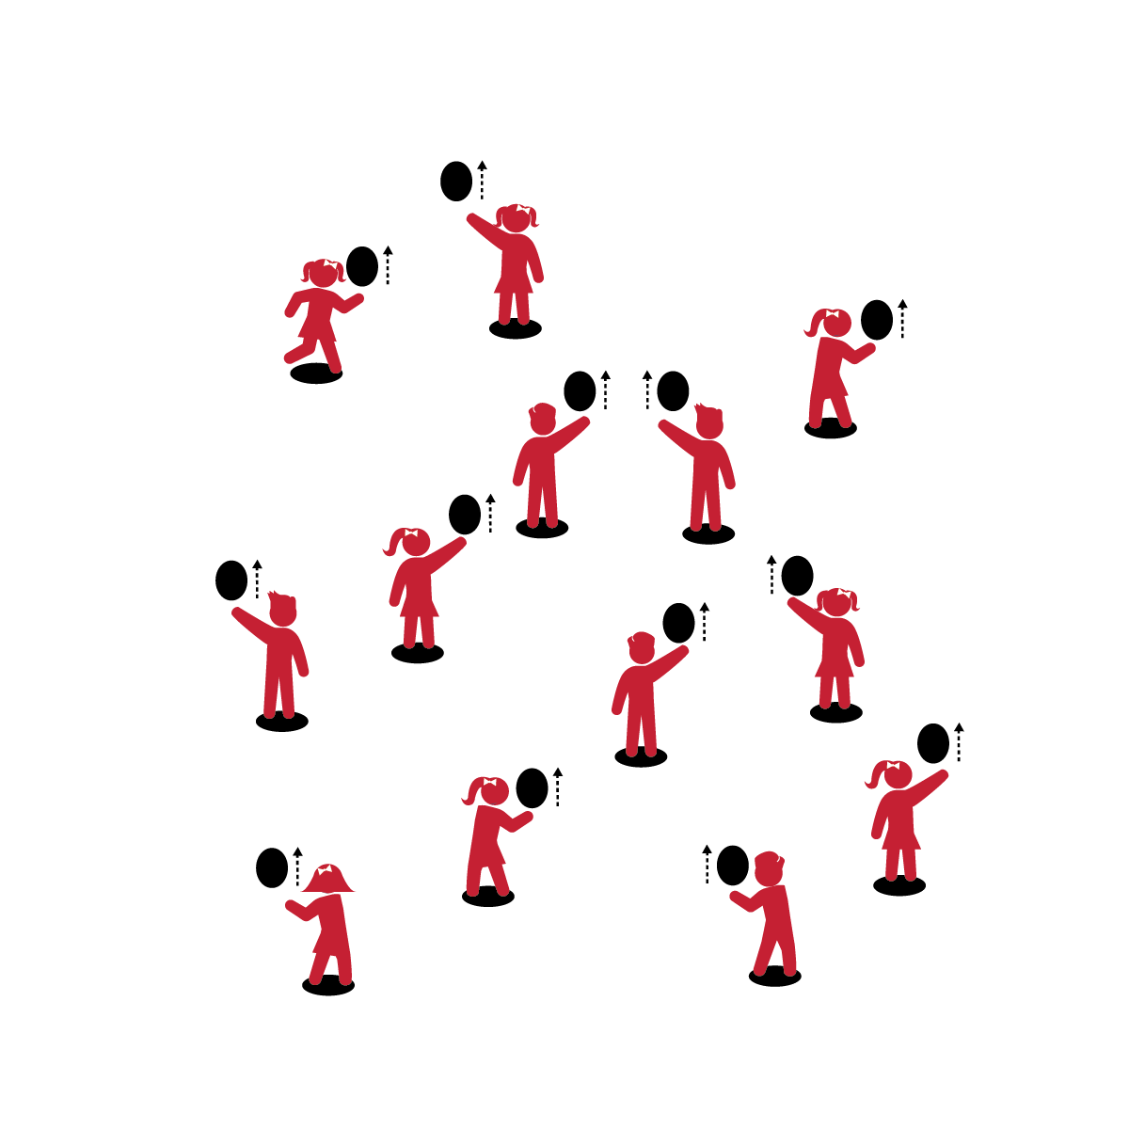

**KEEP IT UP**

* **Skill:** I will volley the balloon up into their air as many times as I can before it hits the floor.
* **Cognitive:** I will work with a balloon in my self-space.
* **Fitness:** I will actively engage and work to improve my volleying skills.
* **Personal & Social Responsibility:** I will work safely and follow all rules.
* Body in Position
* Swing to Strike Low with Palm
* Push Up to Strike High with Finger Pads
* Follow Through Straight Up

**Equipment:**

* 1 balloon/foam ball per student
* 1 spot marker per student

**Set-Up:**

1. Scatter spots throughout the activity area.
2. Each student with a balloon or foam ball at a spot.

**Activity Procedures:**

1. Let’s play Keep It Up with the balloon!
2. On the start signal, practice striking the balloon or ball straight up with your palm.
3. How many strikes can you make without dropping the balloon/ball?

**Grade Level Progression:**

**K:** Students strike and then catch the balloon before striking it again.

**1st:** Introduce foam balls to students who are ready to progress.

**2nd:** Emphasize continuous hits.

**KEEP IT UP**



* Challenge students to keep the balloon or foam ball up with both their dominant and non-dominant hands.



* Toss the balloon to the student, allowing her/him to track the tossed object and then strike it upward.



Volley, Up, Consecutive, Self-Space, Actively Engage, Improve, Safety



* **Standard 1 [E22.K-2]** Volleys a lightweight object (balloon), sending it upward (K); Volleys an object with an open palm, sending it upward (1); Volleys an object upward with consecutive hits (2).
* **Standard 2 [E1.Ka]** Differentiates between movement in personal (self-space) and general space (Ka).
* **Standard 3 [E2.K-2]** Actively participates in physical education class (K); Actively engages in physical education class (1); Actively engages in physical education class in response to instruction and practice (2).
* **Standard 4 [E1.K-2]** Follows directions in group settings (e.g., safe behaviors, following rules, taking turns) (K); Accepts personal responsibility by using equipment and space appropriately (1); Practices skills with minimal teacher prompting (2).



* **DOK 1:** What is self-space?
* **DOK 2:** Why is it important to stay in self-space with your balloon?
* **DOK 3:** What might happen if someone moved out of their self-space during the activity?

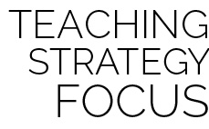

**Manage response rate with tiered questioning techniques:** Inquiry-based instruction helps students process, internalize, and learn the content presented. By asking questions that are increasingly complex, you’re helping students deepen their thinking and understanding of class content. It’s also important to allow all students to respond and interact in class discussion. One way to do this is for students to discuss their thoughts in pairs or small groups.

**MUSICAL BALLOON BOP**

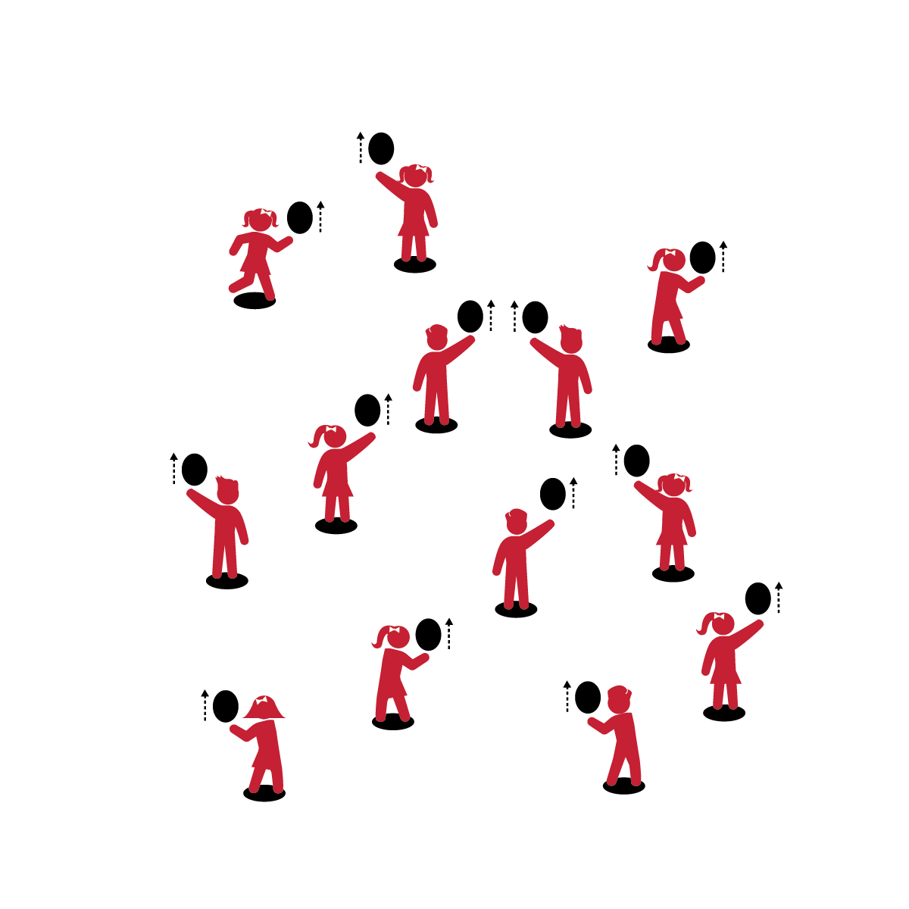

* **Skill:** I will work in personal space to volley balloons upward, and then move safely in general space to find a new balloon.
* **Cognitive:** I will describe what it looks like to be actively engaged.
* **Fitness:** I will actively engage and work to improve my volleying skills.
* **Personal & Social Responsibility:** I will share space and equipment with my classmates.
* Body in Position
* Swing to Strike Low with Palm
* Push Up to Strike High with Finger Pads
* Follow Through Straight Up

**Equipment:**

* 1 balloon per student
* 1 spot marker per student
* Music

**Set-Up:**

1. Scatter spots throughout the activity area.
2. Each student with a balloon standing at a spot.

**Activity Procedures:**

1. This activity is called Musical Balloon Bop.
2. When the music begins, strike the balloon straight up (with your dominant hand) so that it goes over your head. Strike it straight up as many times as you can before the music stops.
3. When the music stops, put the balloon on the spot and then quickly walk to a new spot to find a new balloon.
4. When the music starts again, start hitting your new balloon.

**Grade Level Progression:**

**K:** Students strike and then catch the balloon before striking it again.

**1st:** Practice with dominant and non-dominant hands. Introduce foam balls to students who are ready to progress.

**2nd:** Emphasize continuous hits with both dominant and non-dominant hands.

**MUSICAL BALLOON BOP**



* Use the music as a simple start and stop cue. Students freeze and stay on their spots when the music stops, and then continue at the same spots when the music restarts.



* When the music stops, challenge students to continuously strike the ball while they travel to a new spot. After each pause, they will be at new spots with the same balloons.



General Space, Share, Volley, Up, Consecutive, Self-Space, Actively Engage, Improve, Safety



* **Standard 1 [E22.K-2]** Volleys a lightweight object (balloon), sending it upward (K); Volleys an object with an open palm, sending it upward (1); Volleys an object upward with consecutive hits (2).
* **Standard 2 [S2.E1.Ka]** Differentiates between movement in personal (self-space) and general space (Ka).
* **Standard 3 [S3.E2.K-2]** Actively participates in physical education class (K); Actively engages in physical education class (1); Actively engages in physical education class in response to instruction and practice (2).
* **Standard 4 [E4.K-2]** Shares equipment and space with others (K); Works independently with others in a variety of class environments (e.g., small & large groups) (1); Works independently with others in partner environments (2).



* **DOK 1:** What does actively engaged look like? Sound like? Feel like?
* **DOK 2:** How would you summarize what actively engaged looks, sounds, and feels like?
* **DOK 3:** How is being actively engaged in physical education related to improving your skill?



**Help students practice skills:** Active engagement requires physical and cognitive engagement. As students perform the psychomotor task of striking the balloon, engage them cognitively with verbal skill cues and purposeful feedback.

**BULL’S EYE**

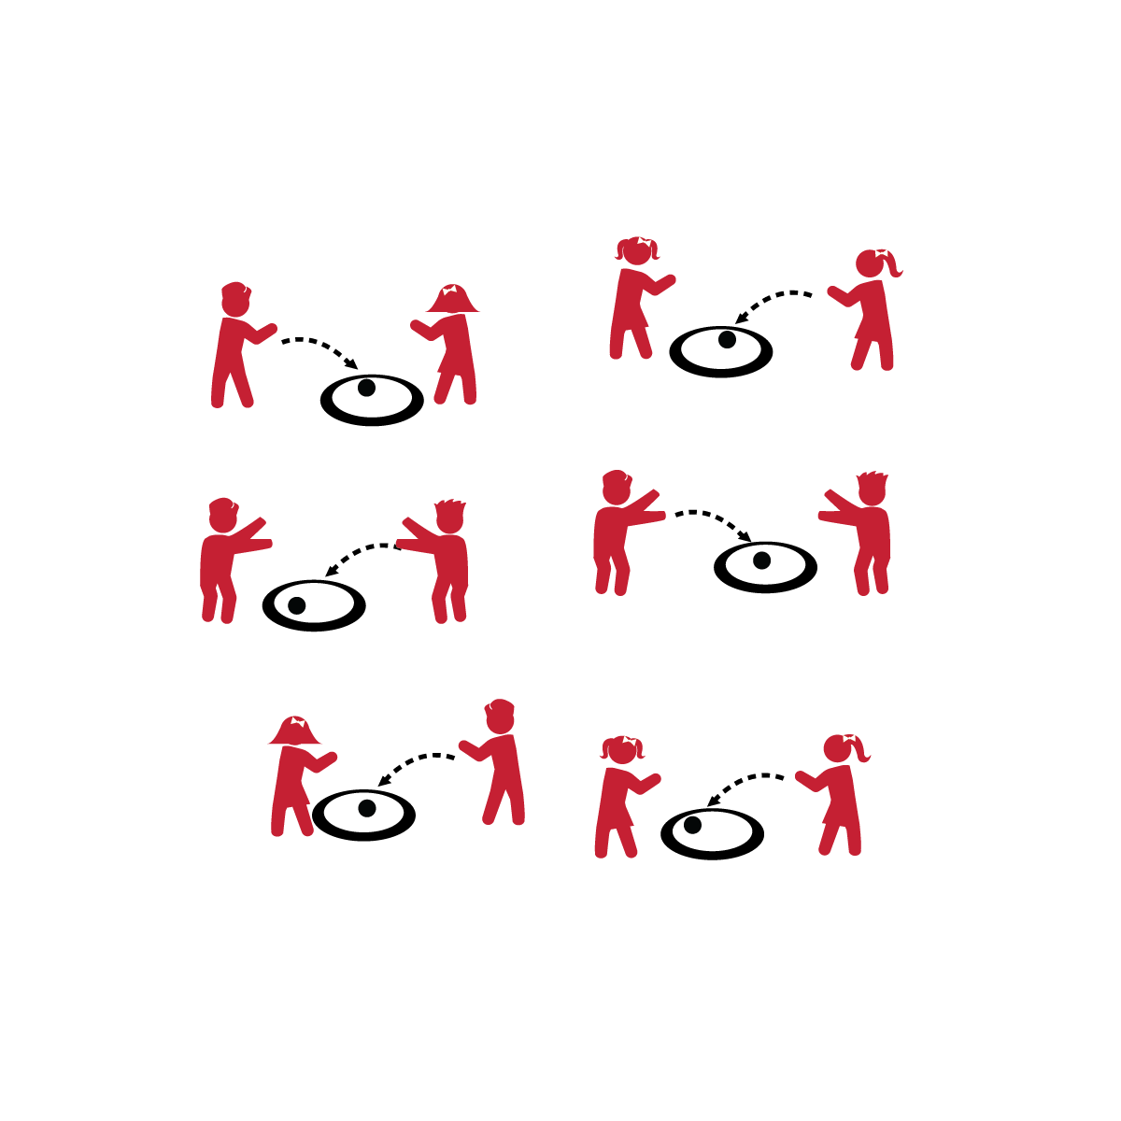

* **Skill:** I will use the correct amount of force when striking the foam ball.
* **Cognitive:** I will explain the difference between strong and light force.
* **Fitness:** I will actively engage and work to improve my striking skills.
* **Personal & Social Responsibility:** I will continue practicing my striking skills in order to build my confidence.
* Square to Target
* Opposite Foot Forward
* Tick Tock Swing
* Contact Balloon with Palm Waist High
* Follow Through Up Toward Target

**Equipment:**

* 1 hoop per pair
* 1 foam ball per pair

**Set-Up:**

1. Scatter hoops throughout the activity area.
2. Pair students, each pair with 1 foam ball, standing in front of a hoop.

**Activity Procedures:**

1. It’s time to play Bull’s Eye! You’re going to try to underhand serve your ball so that it lands in your hoop.
2. On the start signal, take turns serving the ball so that it lands in your hoop.
3. Attempt 3 serves and then switch roles with your partner.

**Grade Level Progression:**

**K:** Introduce the activity with students tossing the ball into the hoop. This establishes the activity management and demonstrates the task objective to the students. Then progress to the underhand serve.

**1st:** Implement the activity as written above.

**2nd:** Challenge students to take a step back from the hoop after 3 successful serves in a row.

**BULL’S EYE**



* Allow students to select an object to serve that promotes greater success and/or enjoyment (e.g., a balloon).



* **Standard 1 [E22.K-2]** Volleys a lightweight object (balloon), sending it upward (K); Volleys an object with an open palm, sending it upward (1).
* **Standard 2 [S2.E3.1b-2]** Differentiates between strong and light force (1b); Varies time and force with gradual increases and decreases (2).
* **Standard 3 [S3.E2.K-2]** Actively participates in physical education class (K); Actively engages in physical education class (1); Actively engages in physical education class in response to instruction and practice (2).
* **Standard 4 [E3.K-2]** Follows instruction/directions when prompted (K); Responds appropriately to general feedback from the teacher (1); Accepts specific corrective feedback from the teacher (2).
* **Standard 5 [E2.K-2]** Acknowledges that some physical activities are challenging/difficult (K); Recognizes that challenge in physical activities can lead to success (1); Compares physical activities that bring confidence and challenge (2).



* Play *Match Me If You Can*. Give each pair a spot marker. Partner A attempts a serve from the spot. If the serve lands in the hoop, Partner B must attempt a serve from the same spot. If not, Partner B can move the spot and attempt a serve.



Accuracy, Strike, Palm, Force, Strong, Light, Practice, Skill, Confidence



* **DOK 1:** What is force?
* **DOK 2:** What’s the difference between strong and light force?
* **DOK 3:** How is how is force related to being accurate?



**Help students process content:** Allow students to interact and experiment with different degrees of strong and light force. It is important for them to be able to verbally define what force is. However, physically interacting with different forces, as force relates to striking and accuracy, will allow students to deepen their understanding of the concept.

**AIR BALL**

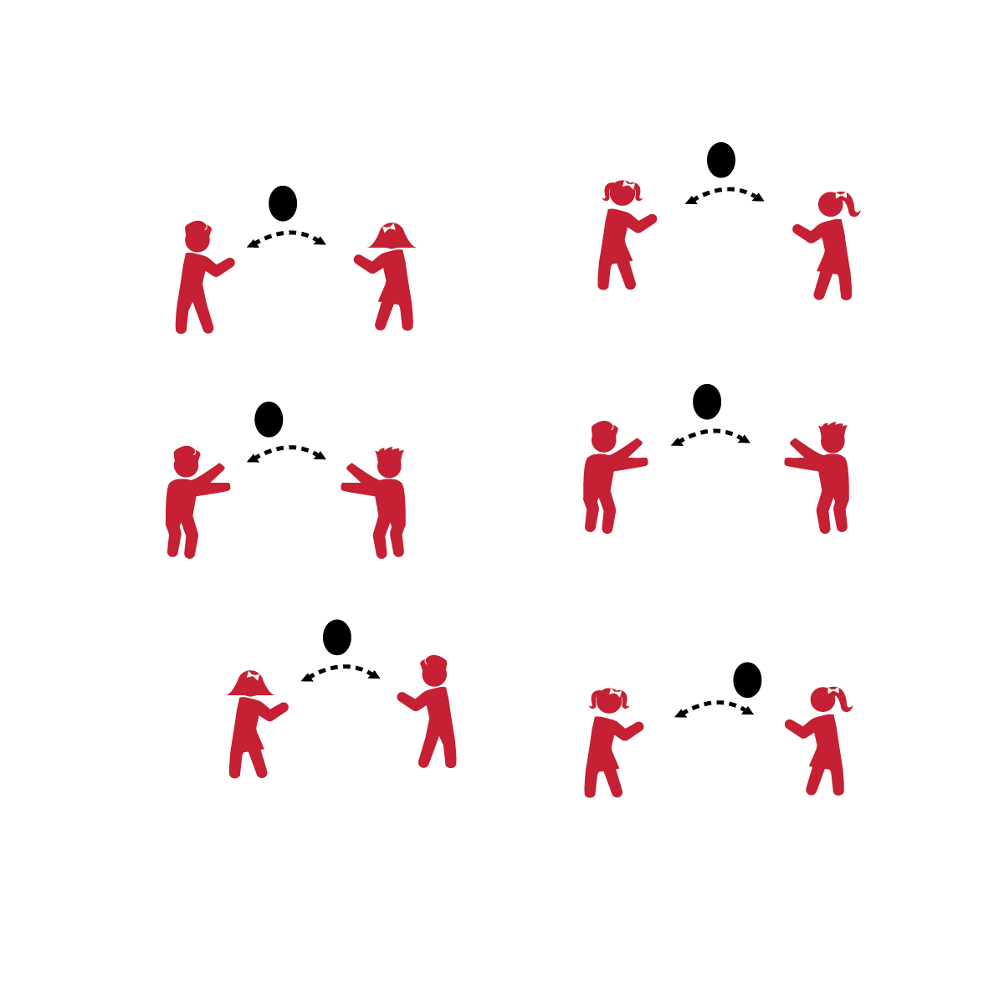

* **Skill:** I will strike the balloon upward with an open palm so that my partner can strike it before it hits the ground.
* **Cognitive:** I will describe what it means to show appropriate responses to feedback from the teacher.
* **Fitness:** I will actively engage and work to improve my striking and volleying skills.
* **Personal & Social Responsibility:** I will accept teacher feedback and use it to improve.
* Body in Position
* Swing to Strike Low with Palm
* Push Up to Strike High with Finger Pads
* Follow Through Straight Up

**Equipment:**

* 1 balloon per pair

**Set-Up:**

1. Pair students and send them into open space with 1 balloon per pair.

**Activity Procedures:**

1. This game is called Air Ball. The object of the game is to work with your partner to keep the balloon in the air as long as you can.
2. As you play, I will give you and your partner feedback that will help you improve your striking and volleying skills.
3. Start when I say, “GO.” Stop on the stop signal.

**Grade Level Progression:**

**K:** Allow students to strike the balloon as many times in row as needed before passing it to their partners.

**1st:** Limit each student to 2 strikes before the balloon is passed to her/his partner.

**2nd:** Players must volley the balloon back and forth with a partner with only 1 strike.

**AIR BALL**



* Allow students to catch and then serve the balloons to their partners.



* Add players to groups for an added challenge. Volleys can be made in a pattern, after a certain number of self-volleys, or with no restrictions.



Strike, Volley, Palm, Appropriate, Feedback, Response, Improve, Practice, Skill



* **Standard 1 [E22.K-2]** Volleys a lightweight object (balloon), sending it upward (K); Volleys an object with an open palm, sending it upward (1); Volleys an object upward with consecutive hits (2).
* **Standard 3 [S3.E2.K-2]** Actively participates in physical education class (K); Actively engages in physical education class (1); Actively engages in physical education class in response to instruction and practice (2).
* **Standard 4 [E3.K-2]** Follows instruction/directions when prompted (K); Responds appropriately to general feedback from the teacher (1); Accepts specific corrective feedback from the teacher (2).



* **DOK 1:** What does feedback mean?
* **DOK 2:** What did you notice about the feedback I (your teacher) gave you about your striking skills?
* **DOK 3:** What is the best response to teacher feedback?
* **DOK 3:** How is feedback related to improving?



**Help students practice processes:** Responding appropriately to constructive feedback is an essential part of the learning process that must be practiced. Isolating, discussing, and processing this concept will help students both understand and appreciate its importance.

**NET BALL**

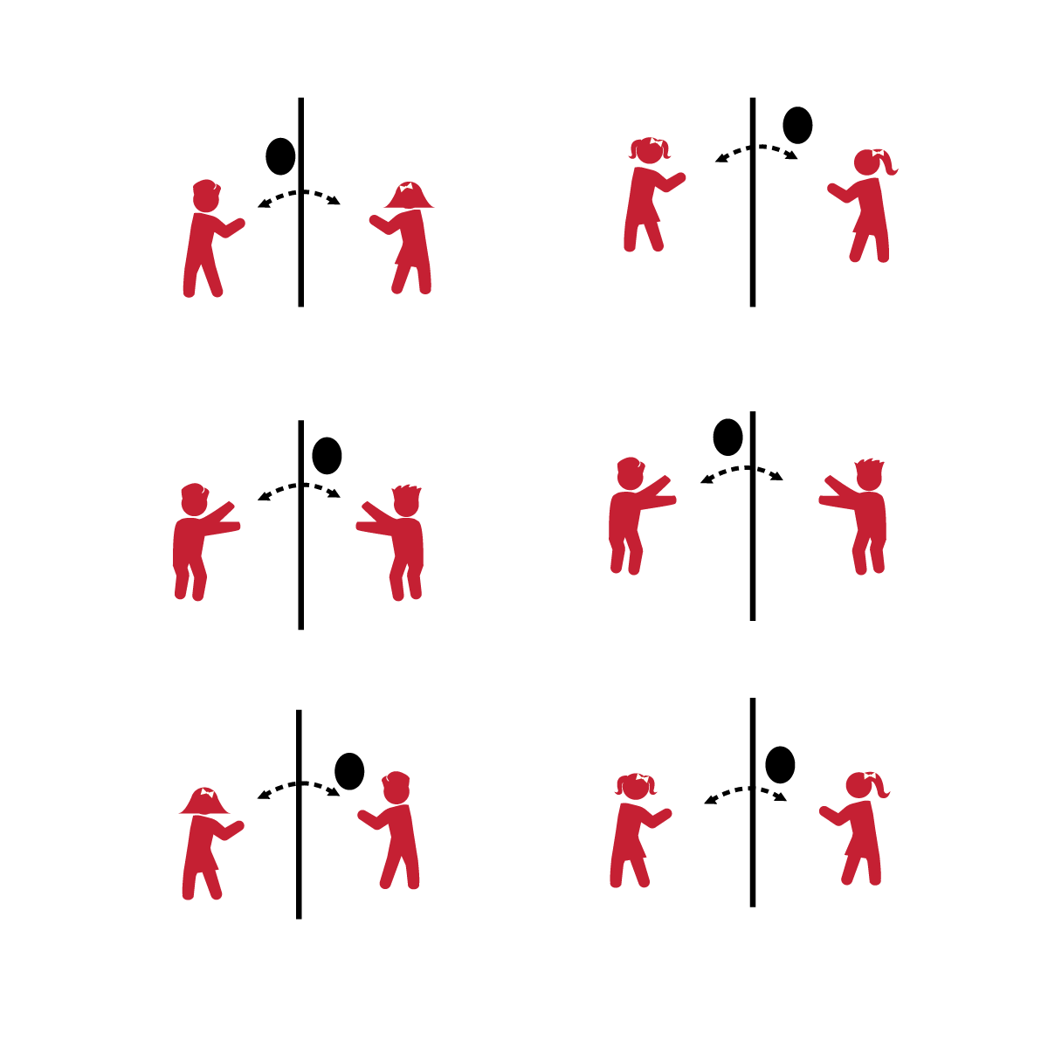

* **Skill:** I will move into position in order to strike (or catch) the balloon.
* **Cognitive:** I will describe what it looks like when partners work independently.
* **Fitness:** I will actively engage and work to improve my striking and volleying skills.
* **Personal & Social Responsibility:** I will make accurate passes so that my partner can improve her/his striking and volleying skills.
* Square to Target
* Opposite Foot Forward
* Tick Tock Swing
* Contact Balloon with Palm Waist High
* Follow Through Up Toward Target

**Equipment:**

* 1 balloon per pair
* 1 jump rope per pair
* 4 low profile cones per pair

**Set-Up:**

1. Create 1 grid per 2 students using half cones.
2. Divide grids in half using jump ropes.
3. Pair students and send each pair into a grid with 1 balloon.
4. Set Player 1 on one side of the rope and Player 2 on the other side.

**Activity Procedures:**

1. This game is called Net Ball. You’ll work with a partner to send the balloon over the net (jump rope) so that your partner can catch (or strike) the balloon.
2. It will be important to toss (or serve) the balloon accurately to your partner.

**Grade Level Progression:**

**K:** Player 1 tosses the balloon over the net; Player 2 must catch it before it hits the ground. Player 2 then tosses the balloon over the net; Player 1 must catch it before it hits the ground. Advance to striking after students display the ability to move to the tossed balloon in order to make a catch.

**1st:** Player 1 tosses the balloon over the net; Player 2 must strike the balloon up into the air and then catch it before it hits the ground. Player 2 will then toss the balloon for Player 1 to strike and catch.

**2nd:** Player 1 serves the balloon over the net; Player 2 volleys the balloon back over the net before it hits the ground. Allow up to 3 hits per side as students work to make it over the net. How many times can you and your partner volley the balloon back and forth before it hits the ground?

**NET BALL**



* Allow the object to be caught off a bounce and then served.



* Progress to a light weight foam ball or inflatable.



Position, Strike, Independent, Improve, Volley, Accurate



* **Standard 1 [E22.K-2]** Volleys a lightweight object (balloon), sending it upward (K); Volleys an object with an open palm, sending it upward (1); Volleys an object upward with consecutive hits (2).
* **Standard 3 [S3.E2.K-2]** Actively participates in physical education class (K); Actively engages in physical education class (1); Actively engages in physical education class in response to instruction and practice (2).
* **Standard 4 [E4.K-2]** Shares equipment and space with others (K); Works independently with others in a variety of class environments (e.g., small & large groups) (1); Works independently with others in partner environments (2).
* **Standard 5 [E2.K-2]** Acknowledges that some physical activities are challenging/difficult (K); Recognizes that challenge in physical activities can lead to success (1); Compares physical activities that bring confidence and challenge (2).



* **DOK 1:** What does it look like when partners work independently? Sound like? Feel like?
* **DOK 2:** How does working independently affect others in the class?
* **DOK 3:** How are accurate passes and hits related to working independently?



**Organize students to interact with content:** Striking and volleying are essential skills needed for developing physical literacy. The ability to work independently with a partner is also an essential social skill for ongoing skill development. This activity provides many opportunities for students to interact with class content through shared experience and cooperative learning.

**PADDLE IT UP**

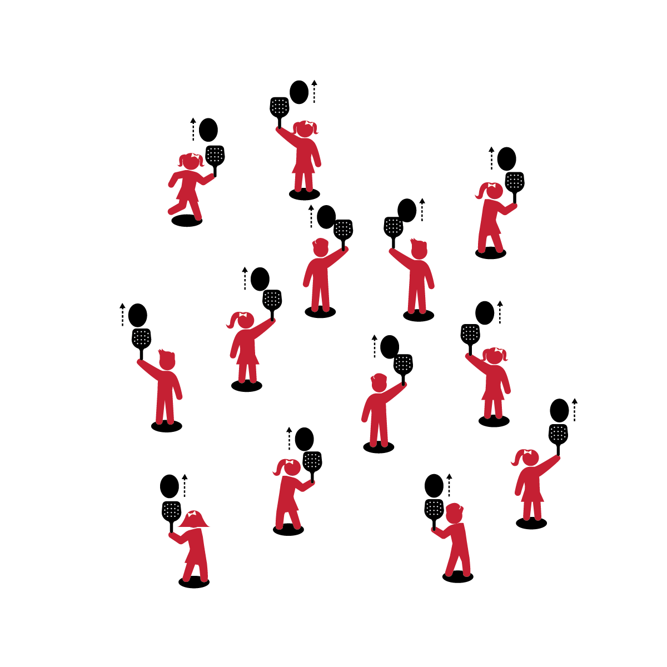

* **Skill:** I will strike the balloon upward using a paddle.
* **Cognitive:** I will describe what safe participation with a paddle or racket looks like.
* **Fitness:** I will actively engage and work to improve my skill with a paddle.
* **Personal & Social Responsibility:** I will work safely with physical education equipment.
* Hold Paddle with a Hand-Shake Grip
* Keep Wrist Firm
* Paddle Flat (Parallel with Ground)
* Strike Balloon Up in Front of Body

**Equipment:**

* 1 paddle per person
* 1 balloon / fleece ball per student
* 1 spot marker per person

**Set-Up:**

1. Scatter spots throughout the activity area.
2. Each student with a paddle and a balloon or cotton ball at a spot.

**Activity Procedures:**

1. Let’s play Paddle It Up using a paddle to keep the balloon in the air!
2. On the start signal, practice striking the balloon or ball straight up with the paddle.
3. How many strikes can you make without letting the balloon hit the ground?

**Grade Level Progression:**

**K:** Start with students balancing the balloon on the paddle. Introduce striking after students demonstrate the ability to hold the paddle parallel to the ground and keep the balloon from falling.

**1st:** Introduce fluffy cotton balls to students who are ready to progress.

**2nd:** Emphasize continuous hits.

**PADDLE IT UP**



* **DOK 1:** What does safe participation with a paddle look like?
* **DOK 2:** How is safe participation different from unsafe participation?
* **DOK 3:** How is safe participation related to improving your skills?



* **Standard 1 [E24.K-2]** Strikes a lightweight object with a paddle/short-handled racket (K);Strikes a ball with a short-handled implement, sending it upward (1);Strikes an object upward with a short-handled implement, using consecutive hits (2).
* **Standard 2 [S2.E1.Ka]** Differentiates between movement in personal (self-space) and general space (Ka).
* **Standard 3 [S3.E2.K-2]** Actively participates in physical education class (K); Actively engages in physical education class (1); Actively engages in physical education class in response to instruction and practice (2).
* **Standard 4 [E6.K-2b]** Follows teacher directions for safe participation and proper use of equipment with minimal reminders (K); Follows teacher directions for safe participation and proper use of equipment without teacher reminders (1); Works independently and safely in physical education (2a); Works safely with physical education equipment (2b).



* Toss the balloon to the student, allowing her/him to track the tossed object and then strike it with the paddle.



* Challenge students to travel in general space while continuously hitting the object.



Paddle, Strike, Safe, Participation, Actively Engage, Improve, Equipment



**Review content:** Quickly review students’ past experience with the activity Keep It Up, and emphasize the cumulative nature of their skill development and practice. Introducing the paddle to an activity that students know and have mastered allows them to connect prior learning and success to a new and more difficult task.

**MUSICAL PADDLE BOP**

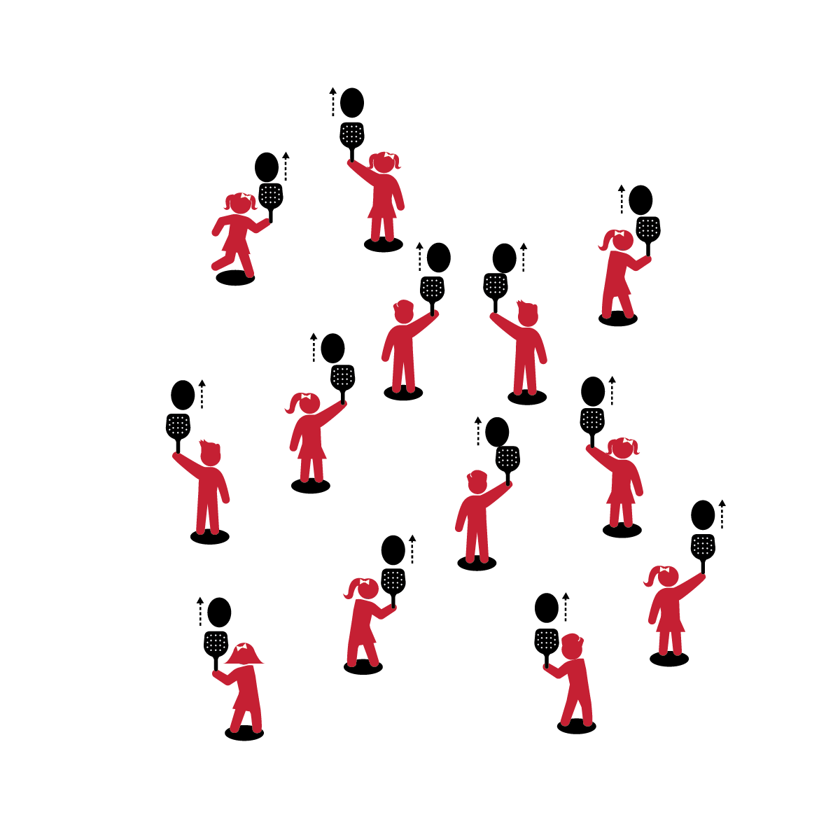

* **Skill:** I will strike the balloon upward using a paddle.
* **Cognitive:** I will talk about differences between self and shared space.
* **Fitness:** I will actively engage and work to improve my skill with a paddle.
* **Personal & Social Responsibility:** I will safely move throughout shared space, respecting the personal safety of my classmates.
* Hold Paddle with a Hand-Shake Grip
* Keep Wrist Firm
* Paddle Flat (Parallel with Ground)
* Strike Balloon Up in Front of Body

**Equipment:**

* 1 paddle per person
* 1 balloon/fleece ball per student
* 1 spot marker per person

**Set-Up:**

1. Scatter spots throughout the activity area.
2. Each student with a paddle and balloon standing at a spot.

**Activity Procedures:**

1. It’s time for Musical Paddle Bop.
2. When music begins, strike the balloon straight up with the paddle so that it goes over your head. Strike it straight up as many times as you can before the music stops.
3. When music stops, put the paddle and balloon on the spot and then quickly walk to a new spot to find a new paddle and balloon.
4. When the music starts again, start striking your new balloon.

**Grade Level Progression:**

**K:** Students balance the balloon on the paddle while the music plays. Introduce striking when students show signs of readiness.

**1st:** Introduce cotton balls to students who are ready to progress.

**2nd:** Emphasize continuous hits.

**MUSICAL PADDLE BOP**



* Use the music as a simple start and stop cue. Students freeze on their spots when the music stops, and then continue at the same spots when the music restarts.



* When the music stops, challenge students to continuously strike the balloons/balls with the paddles while they travel to a new spot. After each pause they will be at new spots with the same balloons/balls.



Strike, Up, Self-Space, Shared Space, Respect, Safety



* **Standard 1 [E24.K-2]** Strikes a lightweight object with a paddle/short-handled racket (K);Strikes a ball with a short-handled implement, sending it upward (1);Strikes an object upward with a short-handled implement, using consecutive hits (2).
* **Standard 2 [S2.E1.Ka]** Differentiates between movement in personal (self-space) and general space (Ka).
* **Standard 3 [S3.E2.K-2]** Actively participates in physical education class (K); Actively engages in physical education class (1); Actively engages in physical education class in response to instruction and practice (2).
* **Standard 4 [E4.K-2]** Shares equipment and space with others (K); Works independently with others in a variety of class environments (e.g., small & large groups) (1); Works independently with others in partner environments (2).



* **DOK 1:** What is shared space?
* **DOK 2:** What is the difference between self-space and shared space? What are the similarities?
* **DOK 3:** What might happen if someone didn’t respect the personal space of her or his classmates?



**Help students examine similarities and differences:** A personal bubble is often used as a metaphor for personal/self-space. Challenge students to identify a metaphor for shared space (e.g., a highway, a parking lot, etc.). This strategy prompts students to think about and analyze an important concept at a complex but developmentally appropriate level.

**NET BALL (W/PADDLE)**

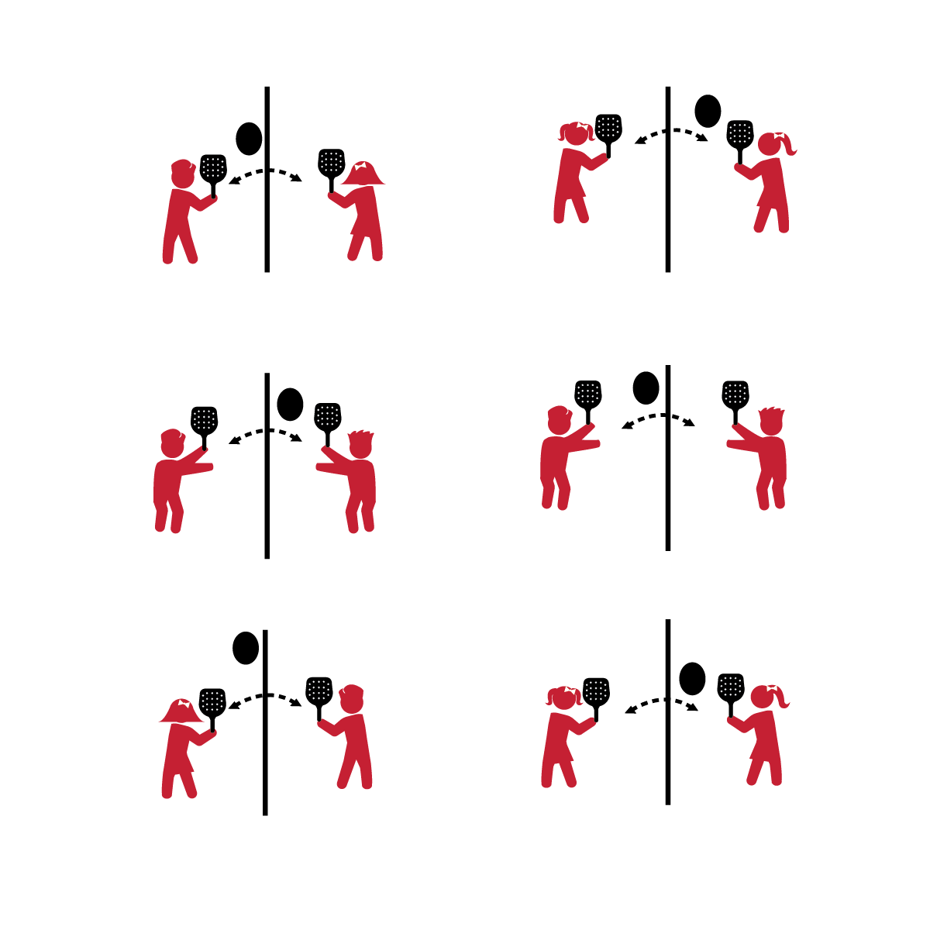

* **Skill:** I will strike the balloon (ball) over the net line using a paddle.
* **Cognitive:** I will talk about activities that are a challenge for me.
* **Fitness:** I will actively engage and work to improve my skill with a paddle.
* **Personal & Social Responsibility:** I will try to make accurate hits so that my partner can improve her/his striking skills.

**Equipment:**

* 1 paddle per student
* 1 balloon per pair
* 1 jump rope per pair
* 4 low profile cones per pair

**Set-Up:**

1. Create 1 grid per 2 students with low profile cones.
2. Divide grids in half using jump ropes.
3. Pair students and send them into a grid, each with a paddle and 1 balloon per pair.
4. Set Player 1 on one side of the rope, and Player 2 on the other side.

* Square to Target
* Opposite Foot Step Forward
* Paddle Back to Front with a Tick Tock Swing
* Trunk Coil Back to Front
* Follow Through up Toward Target

**Activity Procedures:**

1. Today we’re going to play Net Ball with a paddle. You’ll work with a partner to send the balloon over the net (jump rope) so that your partner can strike it with a paddle.
2. It will be important to toss (or serve) the balloon accurately to your partner.

**Grade Level Progression:**

**K:** Player 1 tosses the balloon over the net; Player 2 must touch it with the paddle before it hits the ground. Player 2 then tosses the balloon over the net; Player 1 must touch it with the paddle before it hits the ground.

**1st:** Player 1 tosses the balloon over the net; Player 2 must strike the balloon up into the air before it hits the ground. Player 2 will then toss the balloon for Player 1 to strike and catch.

**2nd:** Player 1 serves the balloon over the net; Player 2 volleys the balloon back over the net before it hits the ground. Allow up to 3 hits per side as students work to make it over the net. How many times can you and your partner volley the balloon back and forth before it hits the ground?

**NET BALL (W/PADDLE)**



* Remove the jump rope (net), allowing students to volley and move freely throughout the area.



* Use cones to raise the jump rope (net) 12 to 18 inches off of the ground. Students must volley the object over the net.



Strike, Paddle, Challenge, Improve, Skill, Accurate



* **Standard 1 [E24.K-2]** Strikes a lightweight object with a paddle/short-handled racket (K);Strikes a ball with a short-handled implement, sending it upward (1);Strikes an object upward with a short-handled implement, using consecutive hits (2).
* **Standard 3 [S3.E2.K-2]** Actively participates in physical education class (K); Actively engages in physical education class (1); Actively engages in physical education class in response to instruction and practice (2).
* **Standard 4 [E4.K-2]** Shares equipment and space with others (K); Works independently with others in a variety of class environments (e.g., small & large groups) (1); Works independently with others in partner environments (2).
* **Standard 5 [E2.K-2]** Acknowledges that some physical activities are challenging/difficult (K); Recognizes that challenge in physical activities can lead to success (1); Compares physical activities that bring confidence and challenge (2).



* **DOK 1:** How does it feel when something you are trying to learn is challenging?
* **DOK 2:** What steps could you follow to overcome a challenge?
* **DOK 3:** What would happen if you quit as soon as something was challenging? What would happen if you kept trying?



**Help students engage in complex tasks:** Volleying an object over a line or net is a complex task for most young children. However, it also represents a challenging application to the skills they’ve been working to develop. Allowing students to both fail and succeed in complex tasks that utilize developed skills allows them to develop meaning for prior (and future) skill practice. Encouraging perseverance and examining student grit is an essential for helping students embrace and grow from challenging tasks.

**STATION DAY**

## 

**Activity Procedures:**

1. Today is a Station Day. We’ll complete each station for 2 (or 3) minutes. One station is an assessment station where you’ll be given feedback based on your skill performance.
2. *Teacher: Talk through and/or demonstrate each station. Emphasize expectations at the assessment station.*
3. When the music starts, begin working at your station. When it stops, you’ll have 1 minute to clean up the station equipment and rotate to the next station. Wait until the music begins again before you start the activity at the new station.
4. While we’re learning this station format, I’ll pause the music for a longer period of time so that every team is able to clean up their area and rotate.

**Equipment:**

* 24 low profile cones
* Station music and music player
* See station cards for equipment needs

**Set-Up:**

1. Using low profile cones, create 6-10 grids (depending on size of class and activity area).
2. Set station cards up on tall cones in each grid.
3. Set up each station according to its station card.
4. Designate one station as an assessment station.
5. Create groups of 2-4 students, each group at a different station.

* **Skill:** I will perform skill assessments to the best of my ability, following as many skills cues as I can.
* **Cognitive:** I will follow the instructions on each station card in order to stay actively engaged with my team.
* **Fitness:** I will find my pulse/heart rate after each station in order to see if it is beating faster than when I’m sitting or resting.
* **Personal & Social Responsibility:** I will follow the rules and parameters of the Station Day learning environment.
* Start Activity with Music
* When Music Stops: Clean the Area and Rotate

**STATION DAY**



* Some students may need step-by-step assistance during clean-up and rotation. Pause the music and don’t restart until every group has safely transitioned.



* Challenge older students (stronger readers) to complete the task written on each card without an explanation or demonstration.



*Select words from the module that you’re teaching.*



* **Standard** **1, 2, 3, 5** [*Select outcomes from the module that you’re teaching.*]
* **Standard 4 [E4.K-2]** Shares equipment and space with others (K); Works independently with others in a variety of class environments (e.g., small groups, stations) (1); Works independently with others in partner environments (2).



* *Select questions from the module that you’re teaching or the assessment that you’re using.*



**Organizing students to interact with content:** The use of grids to organize students into learning stations is an effective way to manage activity, assessment, and cooperative learning opportunities. Practice using this format several times, especially with young children, before attempting to facilitate an assessment experience. Students need time to master the management aspects of station work. However, once this routine is learned, it often becomes an essential management tool in physical education.