­­

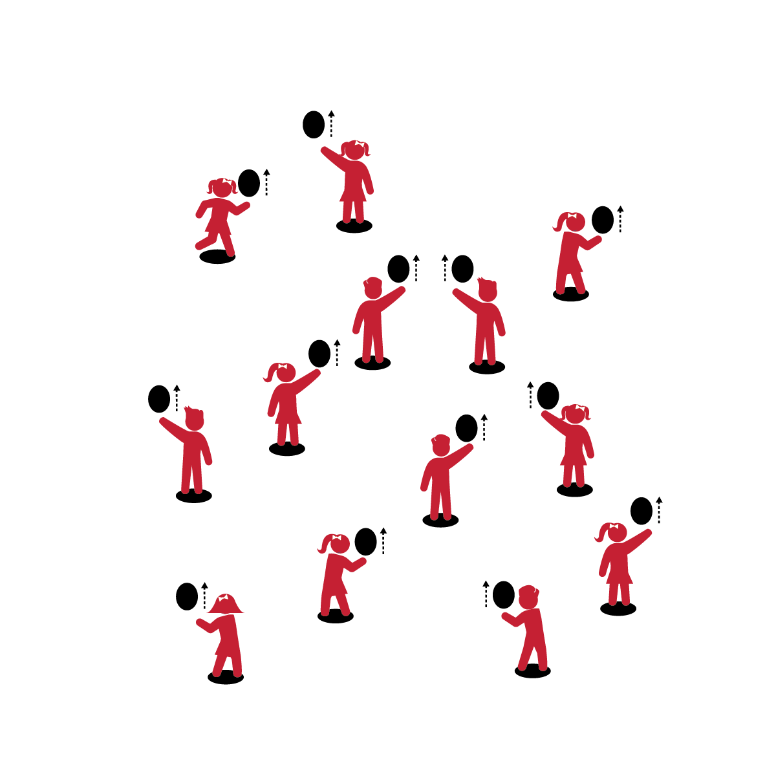

**Activity Procedures:**

1. Let’s play Keep It Up with the balloon!
2. On the start signal, practice striking the balloon or ball straight up with your palm.
3. How many strikes can you make without dropping the balloon/ball?

**Grade Level Progression:**

**K:** Students strike and then catch the balloon before striking it again.

**1st:** Introduce foam balls to students who are ready to progress.

**2nd:** Emphasize continuous hits.



**Equipment:**

* 1 balloon/foam ball per student
* 1 spot marker per student

**Set-Up:**

1. Scatter spots throughout the activity area.
2. Each student with a balloon or foam ball at a spot.



* Body in Position
* Swing to Strike Low with Palm
* Push Up to Strike High with Finger Pads
* Follow Through Straight Up



* **Skill:** I will volley the balloon up into their air as many times as I can before it hits the floor.
* **Cognitive:** I will work with a balloon in my self-space.
* **Fitness:** I will actively engage and work to improve my volleying skills.
* **Personal & Social Responsibility:** I will work safely and follow all rules.

**KEEP IT UP**

**KEEP IT UP**



* Challenge students to keep the balloon or foam ball up with both their dominant and non-dominant hands.



* Toss the balloon to the student, allowing her/him to track the tossed object and then strike it upward.



Volley, Up, Consecutive, Self-Space, Actively Engage, Improve, Safety



* **Standard 1 [E22.K-2]** Volleys a lightweight object (balloon), sending it upward (K); Volleys an object with an open palm, sending it upward (1); Volleys an object upward with consecutive hits (2).
* **Standard 2 [E1.Ka]** Differentiates between movement in personal (self-space) and general space (Ka).
* **Standard 3 [E2.K-2]** Actively participates in physical education class (K); Actively engages in physical education class (1); Actively engages in physical education class in response to instruction and practice (2).
* **Standard 4 [E1.K-2]** Follows directions in group settings (e.g., safe behaviors, following rules, taking turns) (K); Accepts personal responsibility by using equipment and space appropriately (1); Practices skills with minimal teacher prompting (2).



* **DOK 1:** What is self-space?
* **DOK 2:** Why is it important to stay in self-space with your balloon?
* **DOK 3:** What might happen if someone moved out of their self-space during the activity?



**Manage response rate with tiered questioning techniques:** Inquiry-based instruction helps students process, internalize, and learn the content presented. By asking questions that are increasingly complex, you’re helping students deepen their thinking and understanding of class content. It’s also important to allow all students to respond and interact in class discussion. One way to do this is for students to discuss their thoughts in pairs or small groups.