­­

**MUSICAL BALLOON BOP**



* **Skill:** I will work in personal space to volley balloons upward, and then move safely in general space to find a new balloon.
* **Cognitive:** I will describe what it looks like to be actively engaged.
* **Fitness:** I will actively engage and work to improve my volleying skills.
* **Personal & Social Responsibility:** I will share space and equipment with my classmates.



* Body in Position
* Swing to Strike Low with Palm
* Push Up to Strike High with Finger Pads
* Follow Through Straight Up



**Equipment:**

* 1 balloon per student
* 1 spot marker per student
* Music

**Set-Up:**

1. Scatter spots throughout the activity area.
2. Each student with a balloon standing at a spot.

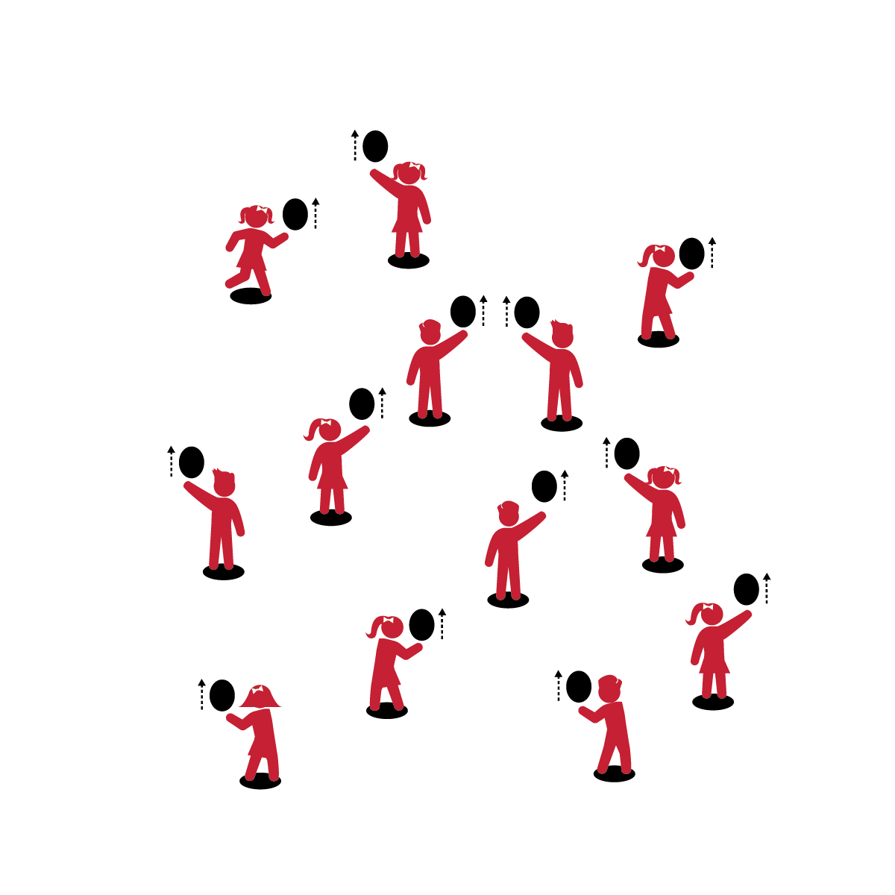

**Activity Procedures:**

1. This activity is called Musical Balloon Bop.
2. When the music begins, strike the balloon straight up (with your dominant hand) so that it goes over your head. Strike it straight up as many times as you can before the music stops.
3. When the music stops, put the balloon on the spot and then quickly walk to a new spot to find a new balloon.
4. When the music starts again, start hitting your new balloon.

**Grade Level Progression:**

**K:** Students strike and then catch the balloon before striking it again.

**1st:** Practice with dominant and non-dominant hands. Introduce foam balls to students who are ready to progress.

**2nd:** Emphasize continuous hits with both dominant and non-dominant hands.

**MUSICAL BALLOON BOP**



General Space, Share, Volley, Up, Consecutive, Self-Space, Actively Engage, Improve, Safety



* **Standard 1 [E22.K-2]** Volleys a lightweight object (balloon), sending it upward (K); Volleys an object with an open palm, sending it upward (1); Volleys an object upward with consecutive hits (2).
* **Standard 2 [S2.E1.Ka]** Differentiates between movement in personal (self-space) and general space (Ka).
* **Standard 3 [S3.E2.K-2]** Actively participates in physical education class (K); Actively engages in physical education class (1); Actively engages in physical education class in response to instruction and practice (2).
* **Standard 4 [E4.K-2]** Shares equipment and space with others (K); Works independently with others in a variety of class environments (e.g., small & large groups) (1); Works independently with others in partner environments (2).



* **DOK 1:** What does actively engaged look like? Sound like? Feel like?
* **DOK 2:** How would you summarize what actively engaged looks, sounds, and feels like?
* **DOK 3:** How is being actively engaged in physical education related to improving your skill?

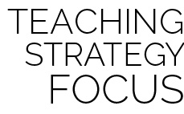

**Help students practice skills:** Active engagement requires physical and cognitive engagement. As students perform the psychomotor task of striking the balloon, engage them cognitively with verbal skill cues and purposeful feedback.



* Use the music as a simple start and stop cue. Students freeze and stay on their spots when the music stops, and then continue at the same spots when the music restarts.



* When the music stops, challenge students to continuously strike the ball while they travel to a new spot. After each pause, they will be at new spots with the same balloons.