­­

**BULL’S EYE**



* **Skill:** I will use the correct amount of force when striking the foam ball.
* **Cognitive:** I will explain the difference between strong and light force.
* **Fitness:** I will actively engage and work to improve my striking skills.
* **Personal & Social Responsibility:** I will continue practicing my striking skills in order to build my confidence.



* Square to Target
* Opposite Foot Forward
* Tick Tock Swing
* Contact Balloon with Palm Waist High
* Follow Through Up Toward Target



**Equipment:**

* 1 hoop per pair
* 1 foam ball per pair

**Set-Up:**

1. Scatter hoops throughout the activity area.
2. Pair students, each pair with 1 foam ball, standing in front of a hoop.

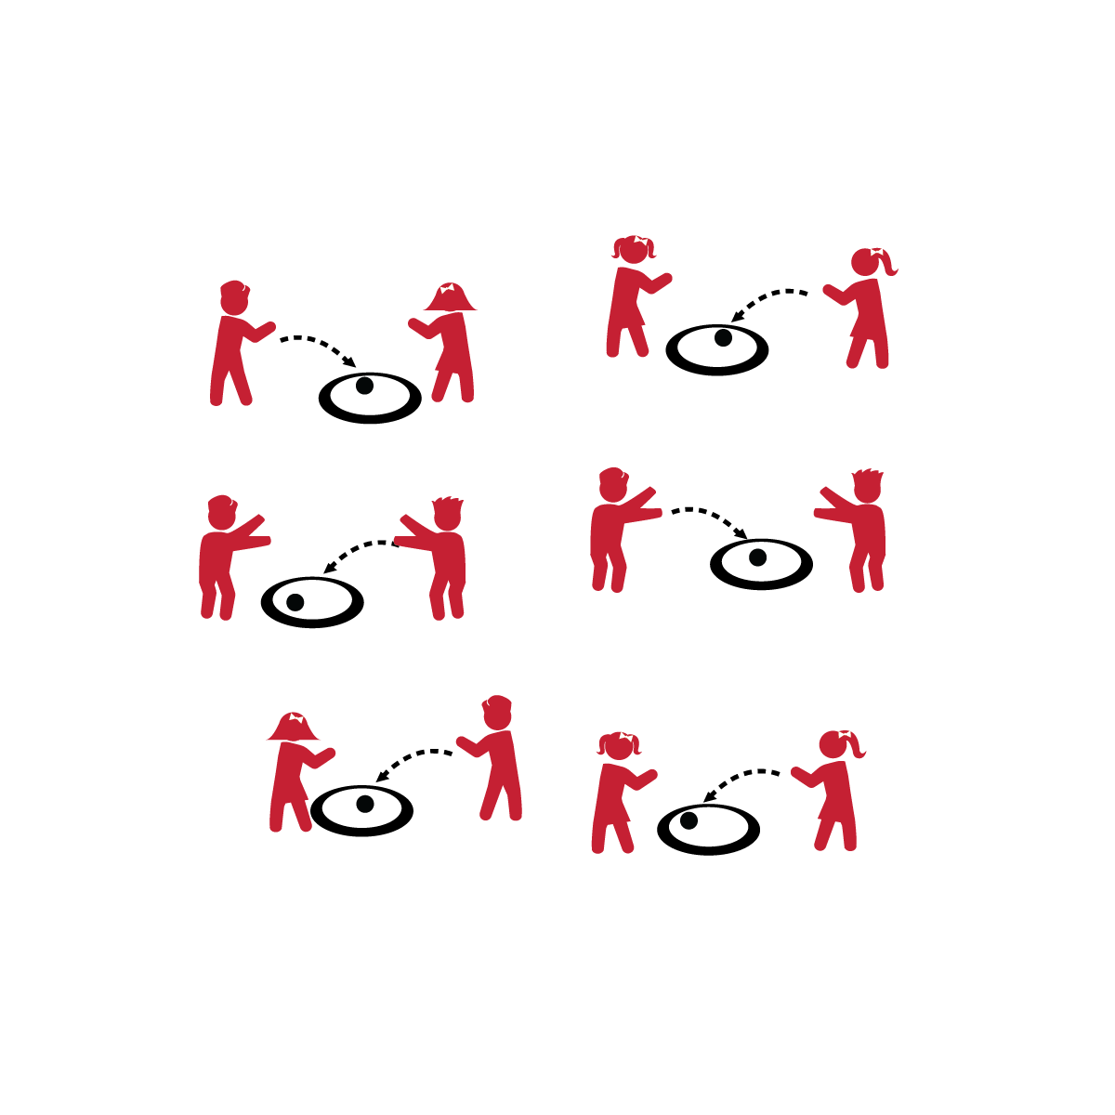

**Activity Procedures:**

1. It’s time to play Bull’s Eye! You’re going to try to underhand serve your ball so that it lands in your hoop.
2. On the start signal, take turns serving the ball so that it lands in your hoop.
3. Attempt 3 serves and then switch roles with your partner.

**Grade Level Progression:**

**K:** Introduce the activity with students tossing the ball into the hoop. This establishes the activity management and demonstrates the task objective to the students. Then progress to the underhand serve.

**1st:** Implement the activity as written above.

**2nd:** Challenge students to take a step back from the hoop after 3 successful serves in a row.



* Play *Match Me If You Can*. Give each pair a spot marker. Partner A attempts a serve from the spot. If the serve lands in the hoop, Partner B must attempt a serve from the same spot. If not, Partner B can move the spot and attempt a serve.



* Allow students to select an object to serve that promotes greater success and/or enjoyment (e.g., a balloon).

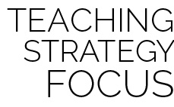

**Help students process content:** Allow students to interact and experiment with different degrees of strong and light force. It is important for them to be able to verbally define what force is. However, physically interacting with different forces, as force relates to striking and accuracy, will allow students to deepen their understanding of the concept.



* **DOK 1:** What is force?
* **DOK 2:** What’s the difference between strong and light force?
* **DOK 3:** How is how is force related to being accurate?



* **Standard 1 [E22.K-2]** Volleys a lightweight object (balloon), sending it upward (K); Volleys an object with an open palm, sending it upward (1).
* **Standard 2 [S2.E3.1b-2]** Differentiates between strong and light force (1b); Varies time and force with gradual increases and decreases (2).
* **Standard 3 [S3.E2.K-2]** Actively participates in physical education class (K); Actively engages in physical education class (1); Actively engages in physical education class in response to instruction and practice (2).
* **Standard 4 [E3.K-2]** Follows instruction/directions when prompted (K); Responds appropriately to general feedback from the teacher (1); Accepts specific corrective feedback from the teacher (2).
* **Standard 5 [E2.K-2]** Acknowledges that some physical activities are challenging/difficult (K); Recognizes that challenge in physical activities can lead to success (1); Compares physical activities that bring confidence and challenge (2).



Accuracy, Strike, Palm, Force, Strong, Light, Practice, Skill, Confidence

**BULL’S EYE**