­­

**AIR BALL**



* **Skill:** I will strike the balloon upward with an open palm so that my partner can strike it before it hits the ground.
* **Cognitive:** I will describe what it means to show appropriate responses to feedback from the teacher.
* **Fitness:** I will actively engage and work to improve my striking and volleying skills.
* **Personal & Social Responsibility:** I will accept teacher feedback and use it to improve.



* Body in Position
* Swing to Strike Low with Palm
* Push Up to Strike High with Finger Pads
* Follow Through Straight Up



**Equipment:**

* 1 balloon per pair

**Set-Up:**

1. Pair students and send them into open space with 1 balloon per pair.

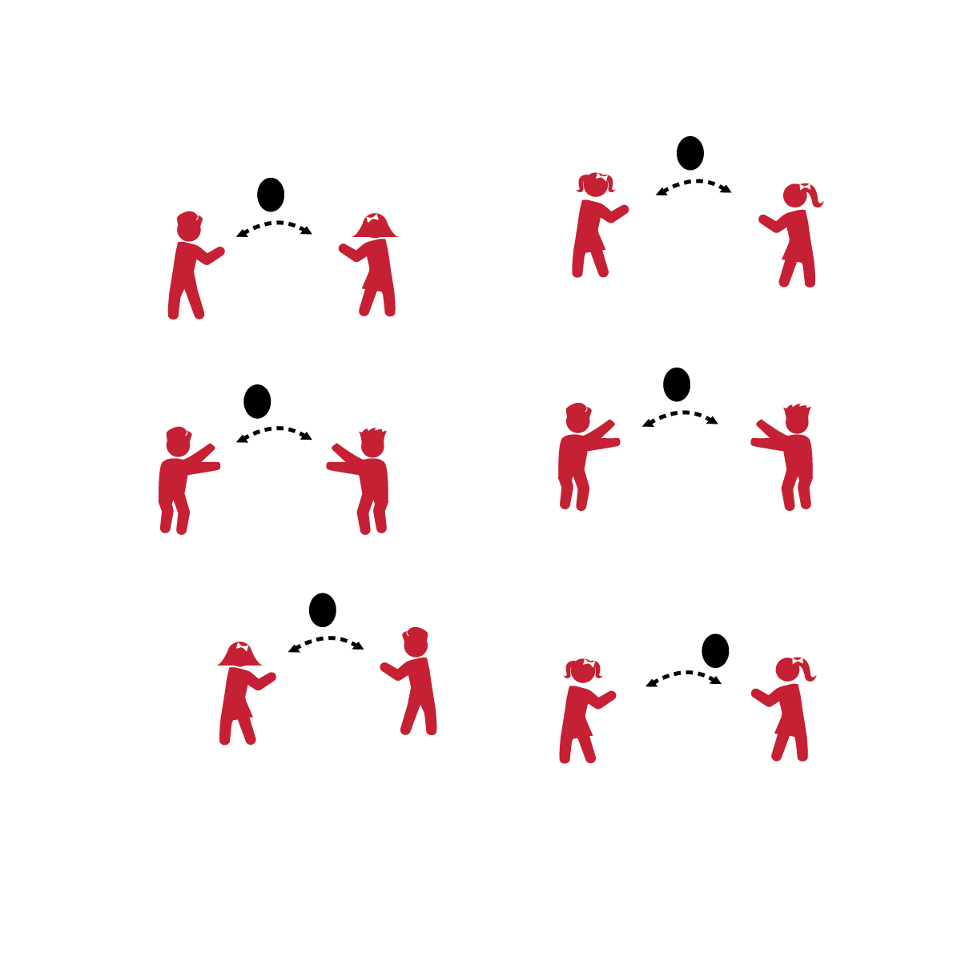

**Activity Procedures:**

1. This game is called Air Ball. The object of the game is to work with your partner to keep the balloon in the air as long as you can.
2. As you play, I will give you and your partner feedback that will help you improve your striking and volleying skills.
3. Start when I say, “GO.” Stop on the stop signal.

**Grade Level Progression:**

**K:** Allow students to strike the balloon as many times in row as needed before passing it to their partners.

**1st:** Limit each student to 2 strikes before the balloon is passed to her/his partner.

**2nd:** Players must volley the balloon back and forth with a partner with only 1 strike.

**AIR BALL**



Strike, Volley, Palm, Appropriate, Feedback, Response, Improve, Practice, Skill

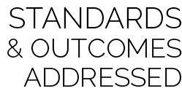

* **Standard 1 [E22.K-2]** Volleys a lightweight object (balloon), sending it upward (K); Volleys an object with an open palm, sending it upward (1); Volleys an object upward with consecutive hits (2).
* **Standard 3 [S3.E2.K-2]** Actively participates in physical education class (K); Actively engages in physical education class (1); Actively engages in physical education class in response to instruction and practice (2).
* **Standard 4 [E3.K-2]** Follows instruction/directions when prompted (K); Responds appropriately to general feedback from the teacher (1); Accepts specific corrective feedback from the teacher (2).



* **DOK 1:** What does feedback mean?
* **DOK 2:** What did you notice about the feedback I (your teacher) gave you about your striking skills?
* **DOK 3:** What is the best response to teacher feedback?
* **DOK 3:** How is feedback related to improving?



**Help students practice processes:** Responding appropriately to constructive feedback is an essential part of the learning process that must be practiced. Isolating, discussing, and processing this concept will help students both understand and appreciate its importance.



* Allow students to catch and then serve the balloons to their partners.



* Add players to groups for an added challenge. Volleys can be made in a pattern, after a certain number of self-volleys, or with no restrictions.