­­

**NET BALL**



* **Skill:** I will move into position in order to strike (or catch) the balloon.
* **Cognitive:** I will describe what it looks like when partners work independently.
* **Fitness:** I will actively engage and work to improve my striking and volleying skills.
* **Personal & Social Responsibility:** I will make accurate passes so that my partner can improve her/his striking and volleying skills.



* Square to Target
* Opposite Foot Forward
* Tick Tock Swing
* Contact Balloon with Palm Waist High
* Follow Through Up Toward Target



**Equipment:**

* 1 balloon per pair
* 1 jump rope per pair
* 4 low profile cones per pair

**Set-Up:**

1. Create 1 grid per 2 students using half cones.
2. Divide grids in half using jump ropes.
3. Pair students and send each pair into a grid with 1 balloon.
4. Set Player 1 on one side of the rope and Player 2 on the other side.

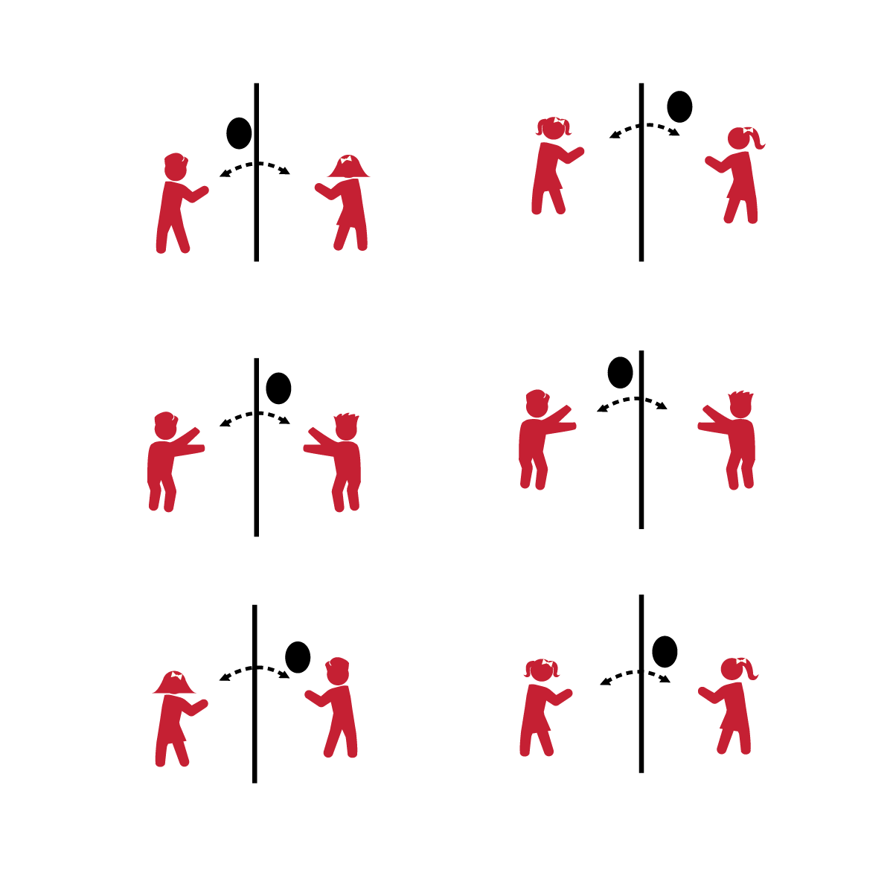

**Activity Procedures:**

1. This game is called Net Ball. You’ll work with a partner to send the balloon over the net (jump rope) so that your partner can catch (or strike) the balloon.
2. It will be important to toss (or serve) the balloon accurately to your partner.

**Grade Level Progression:**

**K:** Player 1 tosses the balloon over the net; Player 2 must catch it before it hits the ground. Player 2 then tosses the balloon over the net; Player 1 must catch it before it hits the ground. Advance to striking after students display the ability to move to the tossed balloon in order to make a catch.

**1st:** Player 1 tosses the balloon over the net; Player 2 must strike the balloon up into the air and then catch it before it hits the ground. Player 2 will then toss the balloon for Player 1 to strike and catch.

**2nd:** Player 1 serves the balloon over the net; Player 2 volleys the balloon back over the net before it hits the ground. Allow up to 3 hits per side as students work to make it over the net. How many times can you and your partner volley the balloon back and forth before it hits the ground?

**NET BALL**



Position, Strike, Independent, Improve, Volley, Accurate

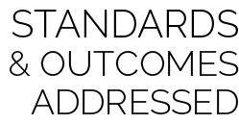

* **Standard 1 [E22.K-2]** Volleys a lightweight object (balloon), sending it upward (K); Volleys an object with an open palm, sending it upward (1); Volleys an object upward with consecutive hits (2).
* **Standard 3 [S3.E2.K-2]** Actively participates in physical education class (K); Actively engages in physical education class (1); Actively engages in physical education class in response to instruction and practice (2).
* **Standard 4 [E4.K-2]** Shares equipment and space with others (K); Works independently with others in a variety of class environments (e.g., small & large groups) (1); Works independently with others in partner environments (2).
* **Standard 5 [E2.K-2]** Acknowledges that some physical activities are challenging/difficult (K); Recognizes that challenge in physical activities can lead to success (1); Compares physical activities that bring confidence and challenge (2).



* **DOK 1:** What does it look like when partners work independently? Sound like? Feel like?
* **DOK 2:** How does working independently affect others in the class?
* **DOK 3:** How are accurate passes and hits related to working independently?



**Organize students to interact with content:** Striking and volleying are essential skills needed for developing physical literacy. The ability to work independently with a partner is also an essential social skill for ongoing skill development. This activity provides many opportunities for students to interact with class content through shared experience and cooperative learning.



* Allow the object to be caught off a bounce and then served.



* Progress to a light weight foam ball or inflatable.