­­

**PADDLE IT UP**



* **Skill:** I will strike the balloon upward using a paddle.
* **Cognitive:** I will describe what safe participation with a paddle or racket looks like.
* **Fitness:** I will actively engage and work to improve my skill with a paddle.
* **Personal & Social Responsibility:** I will work safely with physical education equipment.



* Hold Paddle with a Hand-Shake Grip
* Keep Wrist Firm
* Paddle Flat (Parallel with Ground)
* Strike Balloon Up in Front of Body



**Equipment:**

* 1 paddle per person
* 1 balloon / fleece ball per student
* 1 spot marker per person

**Set-Up:**

1. Scatter spots throughout the activity area.
2. Each student with a paddle and a balloon or cotton ball at a spot.

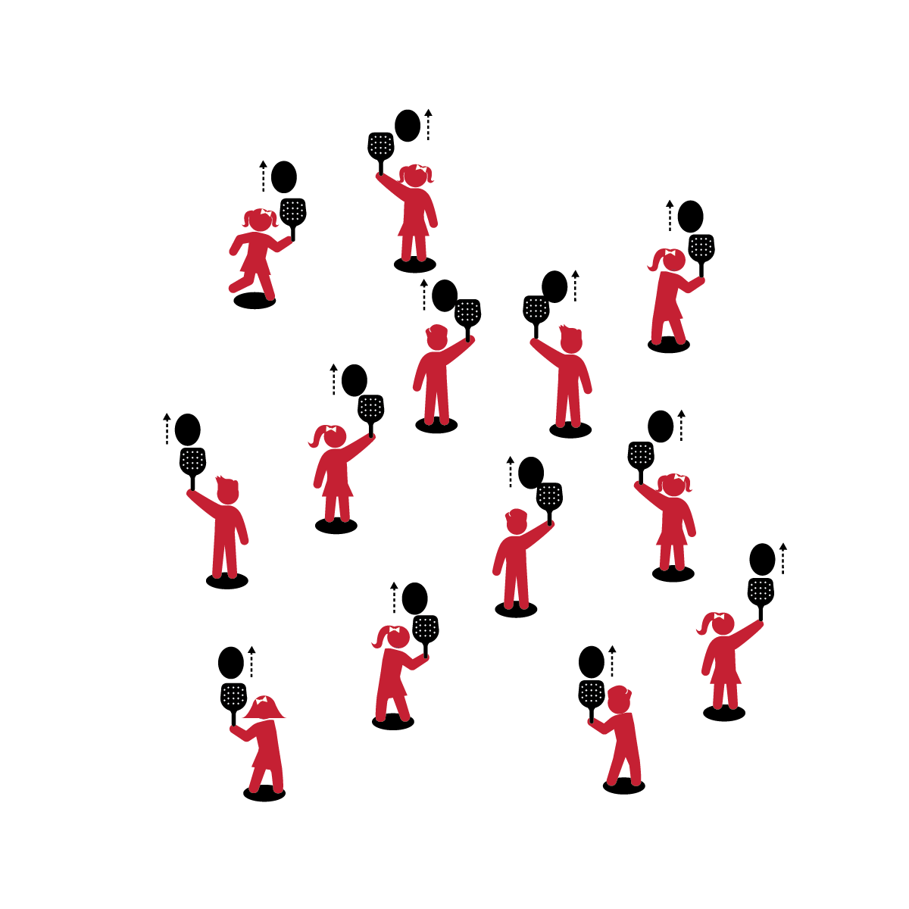

**Activity Procedures:**

1. Let’s play Paddle It Up using a paddle to keep the balloon in the air!
2. On the start signal, practice striking the balloon or ball straight up with the paddle.
3. How many strikes can you make without letting the balloon hit the ground?

**Grade Level Progression:**

**K:** Start with students balancing the balloon on the paddle. Introduce striking after students demonstrate the ability to hold the paddle parallel to the ground and keep the balloon from falling.

**1st:** Introduce fluffy cotton balls to students who are ready to progress.

**2nd:** Emphasize continuous hits.

**PADDLE IT UP**



Paddle, Strike, Safe, Participation, Actively Engage, Improve, Equipment



* **Standard 1 [E24.K-2]** Strikes a lightweight object with a paddle/short-handled racket (K);Strikes a ball with a short-handled implement, sending it upward (1);Strikes an object upward with a short-handled implement, using consecutive hits (2).
* **Standard 2 [S2.E1.Ka]** Differentiates between movement in personal (self-space) and general space (Ka).
* **Standard 3 [S3.E2.K-2]** Actively participates in physical education class (K); Actively engages in physical education class (1); Actively engages in physical education class in response to instruction and practice (2).
* **Standard 4 [E6.K-2b]** Follows teacher directions for safe participation and proper use of equipment with minimal reminders (K); Follows teacher directions for safe participation and proper use of equipment without teacher reminders (1); Works independently and safely in physical education (2a); Works safely with physical education equipment (2b).



* **DOK 1:** What does safe participation with a paddle look like?
* **DOK 2:** How is safe participation different from unsafe participation?
* **DOK 3:** How is safe participation related to improving your skills?

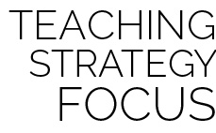

**Review content:** Quickly review students’ past experience with the activity Keep It Up, and emphasize the cumulative nature of their skill development and practice. Introducing the paddle to an activity that students know and have mastered allows them to connect prior learning and success to a new and more difficult task.



* Toss the balloon to the student, allowing her/him to track the tossed object and then strike it with the paddle.



* Challenge students to travel in general space while continuously hitting the object.