­­

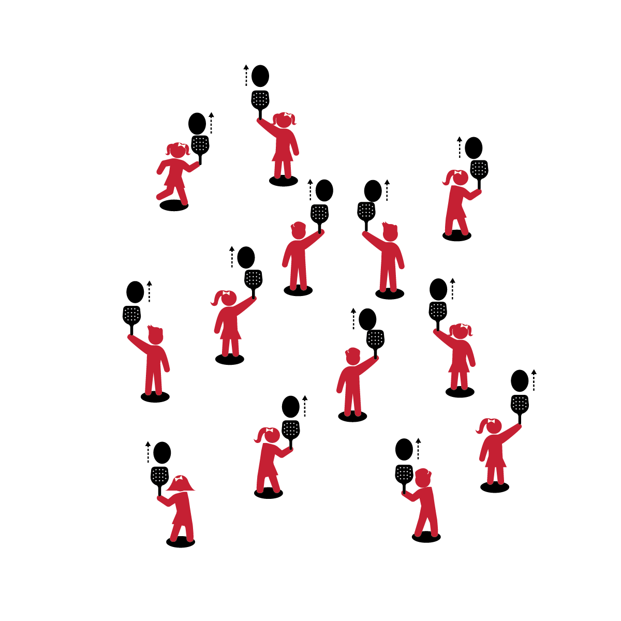

**Activity Procedures:**

1. It’s time for Musical Paddle Bop.
2. When music begins, strike the balloon straight up with the paddle so that it goes over your head. Strike it straight up as many times as you can before the music stops.
3. When music stops, put the paddle and balloon on the spot and then quickly walk to a new spot to find a new paddle and balloon.
4. When the music starts again, start striking your new balloon.

**Grade Level Progression:**

**K:** Students balance the balloon on the paddle while the music plays. Introduce striking when students show signs of readiness.

**1st:** Introduce cotton balls to students who are ready to progress.

**2nd:** Emphasize continuous hits.



**Equipment:**

* 1 paddle per person
* 1 balloon/fleece ball per student
* 1 spot marker per person

**Set-Up:**

1. Scatter spots throughout the activity area.
2. Each student with a paddle and balloon standing at a spot.



* Hold Paddle with a Hand-Shake Grip
* Keep Wrist Firm
* Paddle Flat (Parallel with Ground)
* Strike Balloon Up in Front of Body



* **Skill:** I will strike the balloon upward using a paddle.
* **Cognitive:** I will talk about differences between self and shared space.
* **Fitness:** I will actively engage and work to improve my skill with a paddle.
* **Personal & Social Responsibility:** I will safely move throughout shared space, respecting the personal safety of my classmates.

**MUSICAL PADDLE BOP**

**MUSICAL PADDLE BOP**



Strike, Up, Self-Space, Shared Space, Respect, Safety



* **Standard 1 [E24.K-2]** Strikes a lightweight object with a paddle/short-handled racket (K);Strikes a ball with a short-handled implement, sending it upward (1);Strikes an object upward with a short-handled implement, using consecutive hits (2).
* **Standard 2 [S2.E1.Ka]** Differentiates between movement in personal (self-space) and general space (Ka).
* **Standard 3 [S3.E2.K-2]** Actively participates in physical education class (K); Actively engages in physical education class (1); Actively engages in physical education class in response to instruction and practice (2).
* **Standard 4 [E4.K-2]** Shares equipment and space with others (K); Works independently with others in a variety of class environments (e.g., small & large groups) (1); Works independently with others in partner environments (2).



* **DOK 1:** What is shared space?
* **DOK 2:** What is the difference between self-space and shared space? What are the similarities?
* **DOK 3:** What might happen if someone didn’t respect the personal space of her or his classmates?

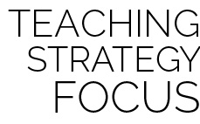

**Help students examine similarities and differences:** A personal bubble is often used as a metaphor for personal/self-space. Challenge students to identify a metaphor for shared space (e.g., a highway, a parking lot, etc.). This strategy prompts students to think about and analyze an important concept at a complex but developmentally appropriate level.



* Use the music as a simple start and stop cue. Students freeze on their spots when the music stops, and then continue at the same spots when the music restarts.



* When the music stops, challenge students to continuously strike the balloons/balls with the paddles while they travel to a new spot. After each pause they will be at new spots with the same balloons/balls.