­­­

* Strike
* Self-Space
* Actively Engage
* Safe

­

* **Skill:** I will volley the balloon up into their air as many times as I can before it hits the floor.
* **Cognitive:** I will work with a balloon in my self-space.
* **Fitness:** I will actively engage and work to improve my volleying skills.
* **Personal & Social Responsibility:** I will work safely and follow all rules.
* **Standard 1 [E22.K-2]** Volleys a lightweight object (balloon), sending it upward (K); Volleys an object with an open palm, sending it upward (1); Volleys an object upward with consecutive hits (2).
* **Standard 2 [S2.E1.Ka]** Differentiates between movement in personal (self-space) and general space (Ka).
* Striking (Pre-Assessment)

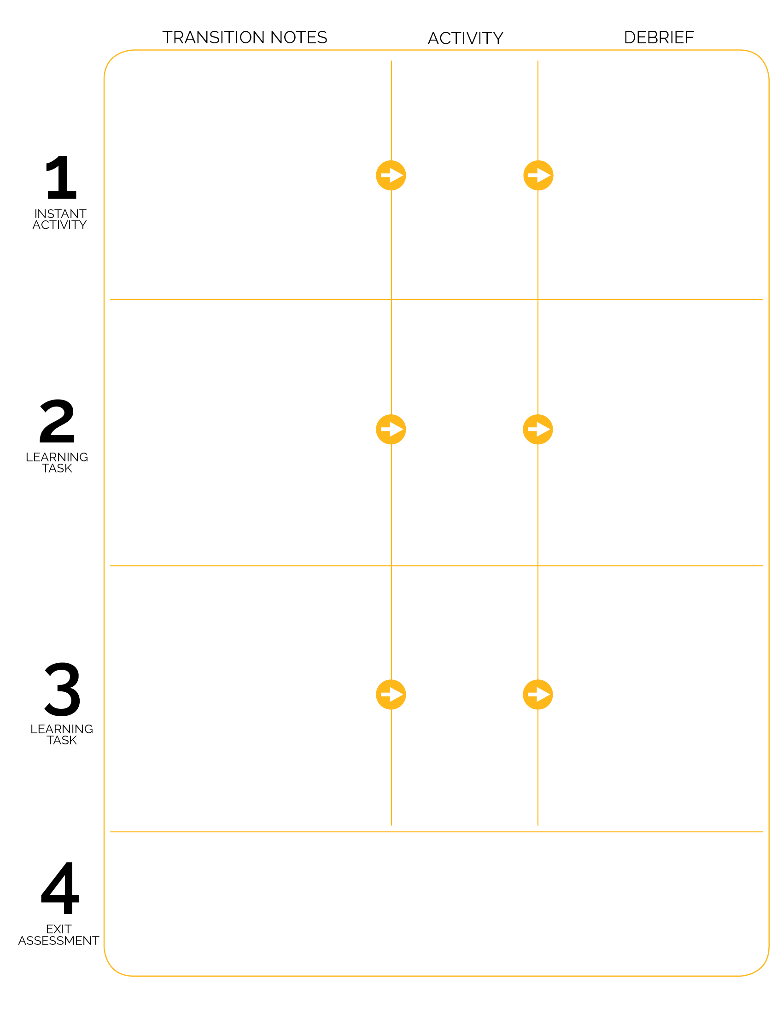

Volleying and Striking Self-Assessment (Striking)

Grades K-1: Discuss and complete the Self-Assessment as a large group with all students.

Grade 2: Assessment stations are set up on the sidelines. When I say “GO,” return your equipment to the equipment station, then move to an assessment station to complete the assessment.

**DOK 1:** What is self-space?

**DOK 2:** Why is it important to stay in self-space with your balloon?

**DOK 3:** What might happen if someone moved out of their self-space during the activity?

**DOK 1:** What is an example of a Green Light Food? A Red Light Food?

**DOK 2:** What are different ways that we can tell Green Light Foods and Red Light Foods apart?

**DOK 1:** What does actively engaged look like? Sound like? Feel like?

**DOK 2:** How would you summarize what actively engaged looks, sounds, and feels like?

**DOK 3:** How is being actively engaged in Phys Ed related to improving your skill?

Musical Balloon Bop

Yum Yum Yum

Keep It Up

Spot markers are scattered in activity area. 1 spot per student. As students enter the class, they find a spot and face the teacher.

Balloons are on the sideline, away from where students enter.

Send students to get a balloon by color (all blue, then all red, etc.). Students return to their spot with a balloon and listen for instruction.

Students hold balloons between their knees while the teacher is giving instruction.

Demonstrate Balloon Bop movement with 1 student while giving activity instruction.