**KEEP IT UP**

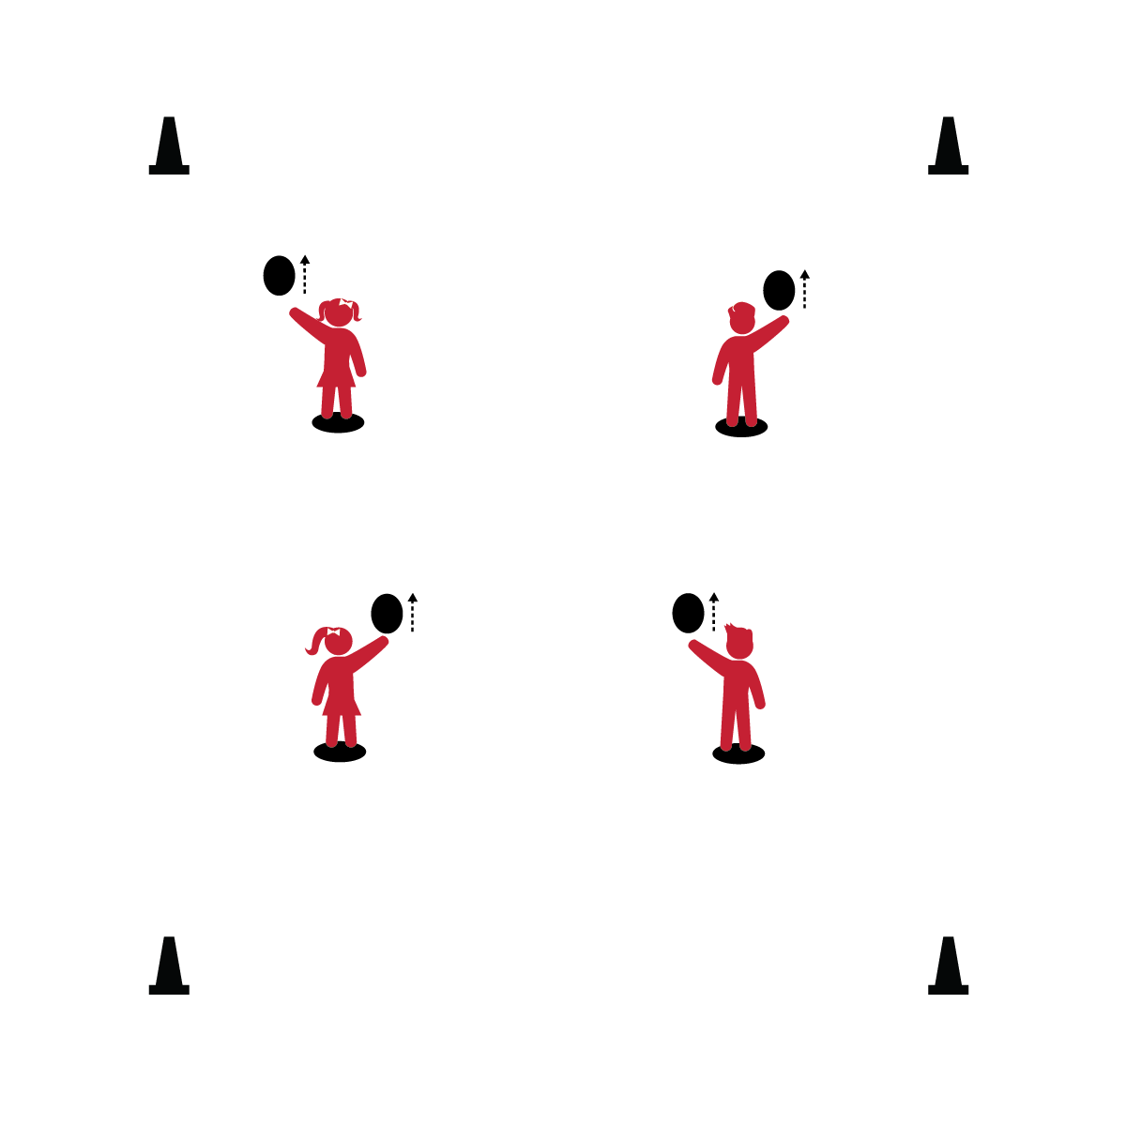

1. Strike the balloon straight up with your palm.
2. How many strikes can you make without the balloon hitting the floor?

**BULL’S EYE**

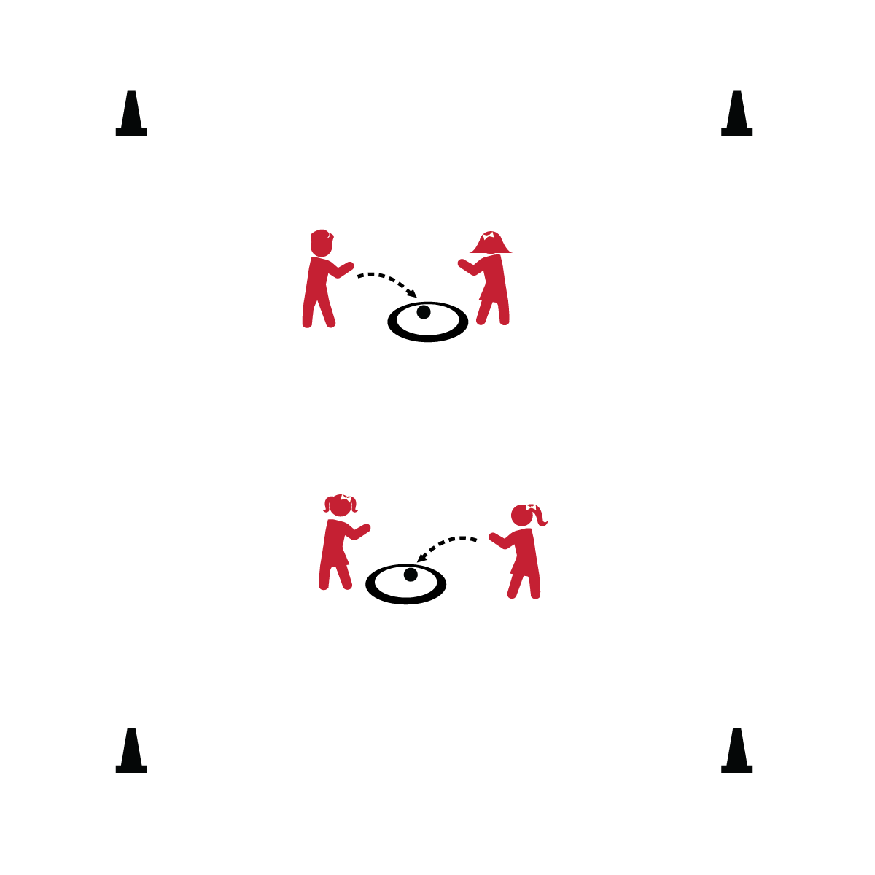

1. Underhand serve the ball so that it lands in your hoop.
2. Attempt 3 serves, then switch with your partner.

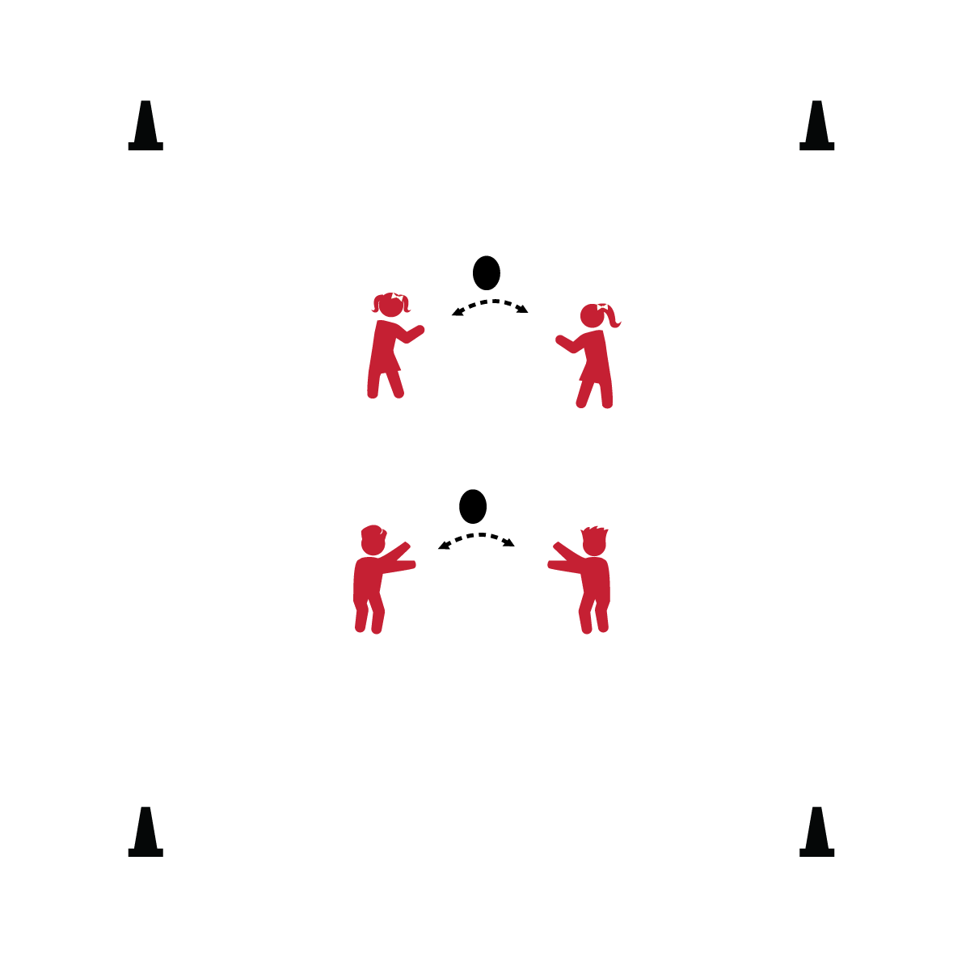

**AIR BALL**

1. Work with your partner to keep the balloon in the air as long as you can.
2. If the ball hits the floor, pick it up and start again.

**PADDLE IT UP**

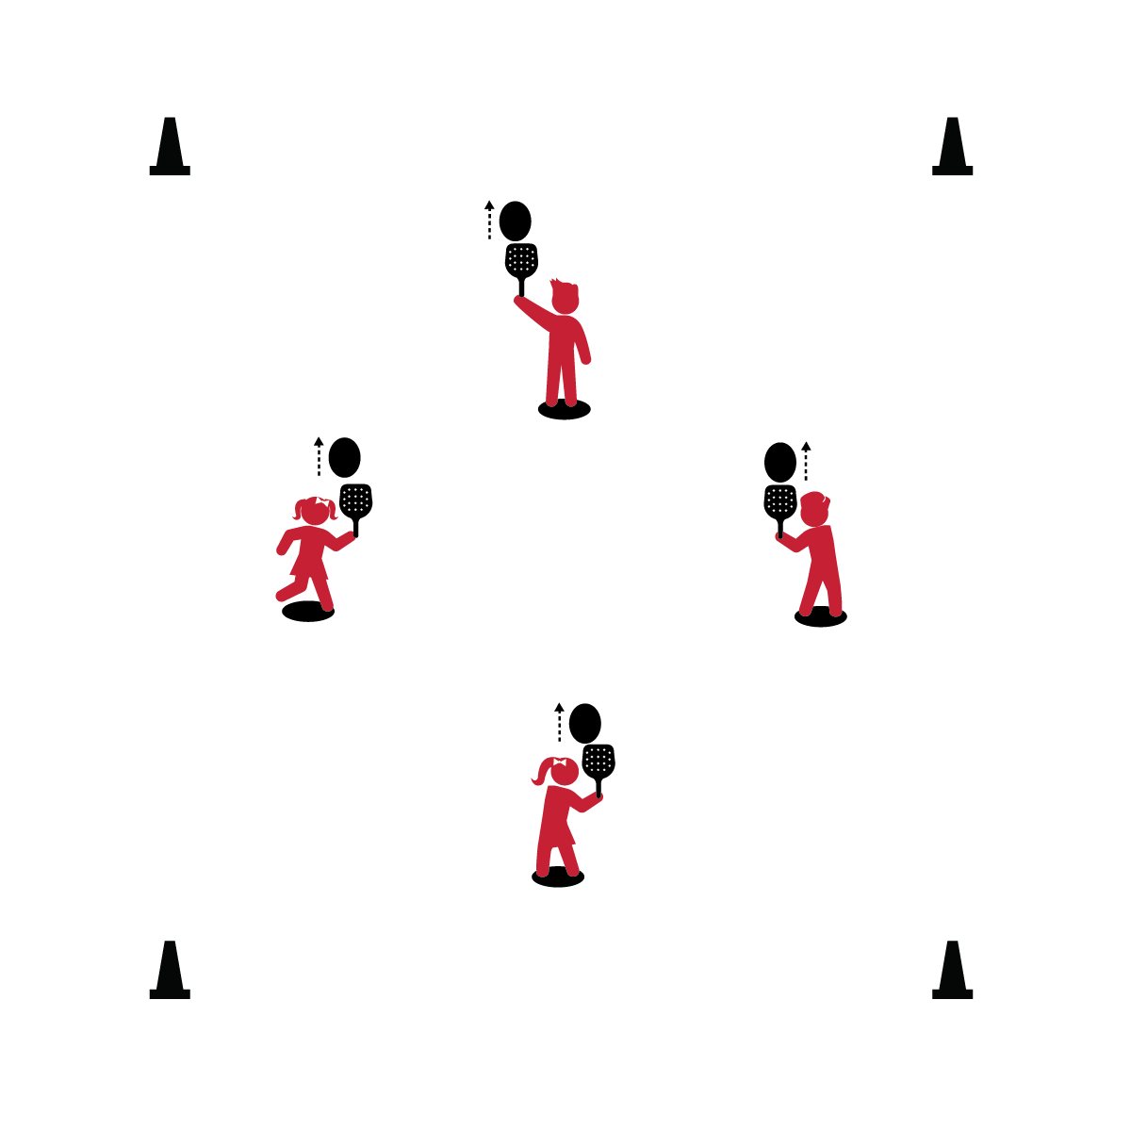

1. Use a paddle to keep the balloon in the air.
2. How many hits can you make without letting the balloon hit the ground?

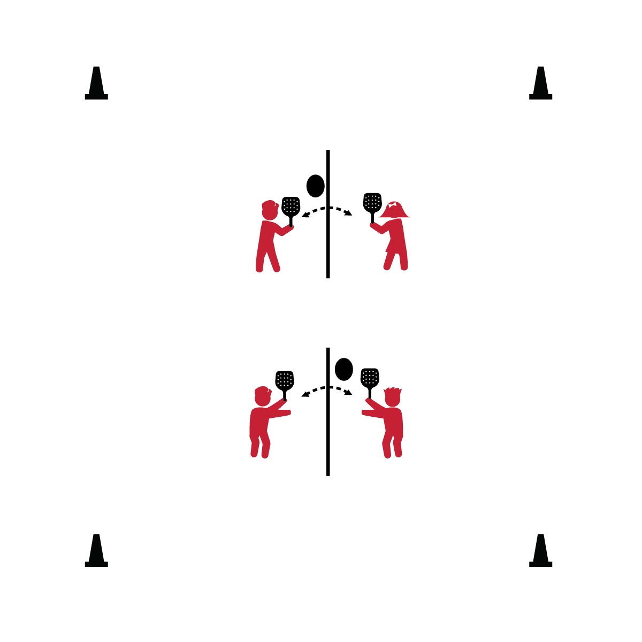

1. Work with your partner to send the balloon back and forth over the jump rope.
2. Take turns starting play with an underhand serve.

**NET BALL (W/ PADDLE)**

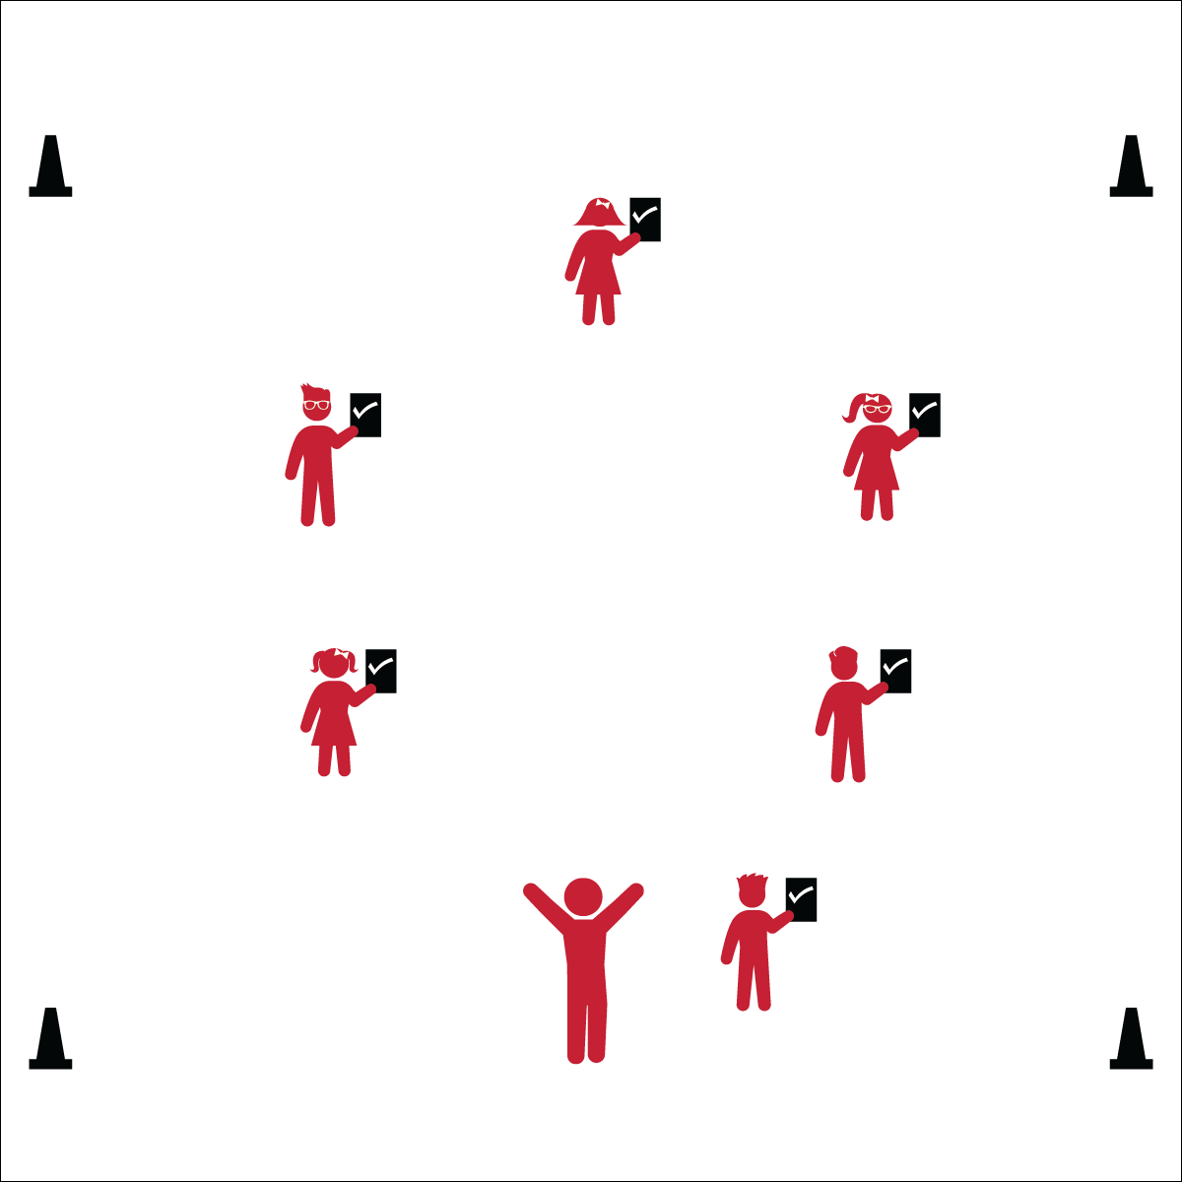

1. Complete the Assessment for Volleying & Striking.
2. When you’re finished, see how many times you can keep the balloon in the air using a paddle.

**SELF-ASSESSMENT**