­­

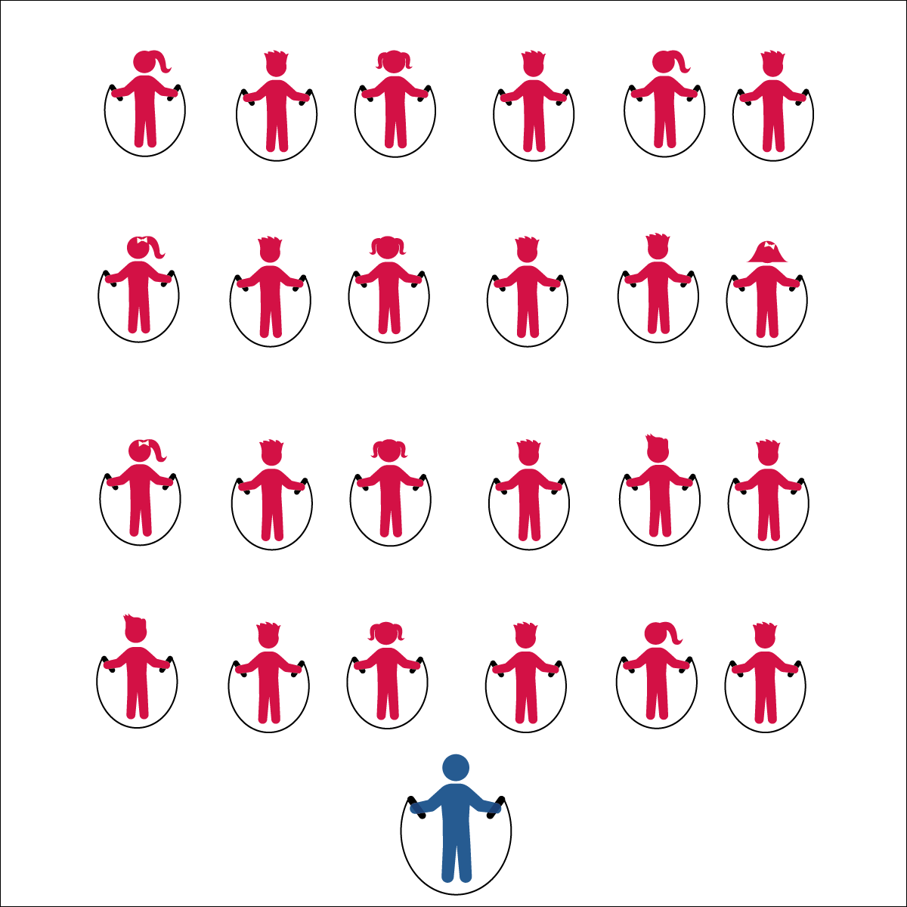

* **Skill:** I will practice a variety of jump rope skills using the cues my teacher gives me in class.
* **Cognitive:** I will give examples of physical activities that enhance fitness.
* **Fitness:** I will work to stay actively engaged during all of the jump rope activities.
* **Personal & Social Responsibility**: I will demonstrate safe behaviors without being reminded by a teacher.

**BACK TO BASICS**

* Work Safely by Respecting Self-Space
* See *Jump Rope Progression Card* for Basic Jump Rope Skill Cues

**Equipment:**

* 1 jump rope per student
* Rope Selection Rule Poster
* Jump Rope Progression Cards

**Set-Up:**

* Students spread out in general space facing the teacher, each with a jump rope.
* Jump Rope Progression Cards ready on clipboard or tablet.

**Activity Procedures:**

1. Today, we are going to review the progression for jumping rope.
2. It’s important that everyone has a jump rope that is the proper length. The Rope Selection Rule posted near the jump ropes will help you make the correct choice.
3. Now that everyone has a jump rope, follow along and repeat the skills that I demonstrate. For safety, remember to stay within your own personal space.
4. *Teachers, follow the Jump Rope Progression Cards and lead the class through the progressions for jumping rope.*

**Grade Level Progression:**

**3rd:** Complete the activity as described above.

**4th:** Students work in small groups, each with a progression card, to review basic jump rope technique.

**5th:** Combine this activity with Creative Mode Station Cards. Work through the progression card with students who need assistance. Allow more advanced students to complete Creative Mode Stations.

**BACK TO BASICS**



Jump, Land, Two-Foot Take Off, Vertical, Turn, Enhance, Fitness, Safe, Health-Related Fitness, Skill-Related Fitness



* **DOK 1:** How can you recognize activities that enhance fitness?
* **DOK 1:** What are some examples of activities that enhance fitness?
* **DOK 2:** How does jumping rope enhance health-related fitness?
* **DOK 3:** Which components of fitness would be most impacted if you jumped rope every day? Why?



* Allow students to use ropes in a variety of styles and lengths.
* Jump an invisible rope to music with a slow and steady beat. Increase the tempo of the music selection to increase the intensity of the activity.
* Provide ongoing verbal cues with individualized instruction and/or peer tutoring.



* **Standard 1 [S1.E4.3]** Jumps and lands in the vertical plane using a mature pattern (3).
* **Standard 3 [E3.3-5]** Describes the concept of fitness and provides examples of physical activity to enhance fitness (3); Identifies the components of health-related fitness (4); Differentiates between skill-related and health-related fitness (5).
* **Standard 4 [E6.3-5]** Works independently and safely in physical activity settings (3); Works safely with peers and equipment in physical activity settings (4); Applies safety principles with age-appropriate physical activities (5).



**Identify Critical Content:** Jump rope success depends on students’ ability to understand and perform the basic jump. At each grade level, students will benefit from a review of jump rope cues and content. Likewise, there will most likely be students at each grade level who haven’t mastered the basic jump and will require remediation. Take time to assess where students are starting and then identify the critical content needed for progression.

**CREATIVE MODE STATIONS**

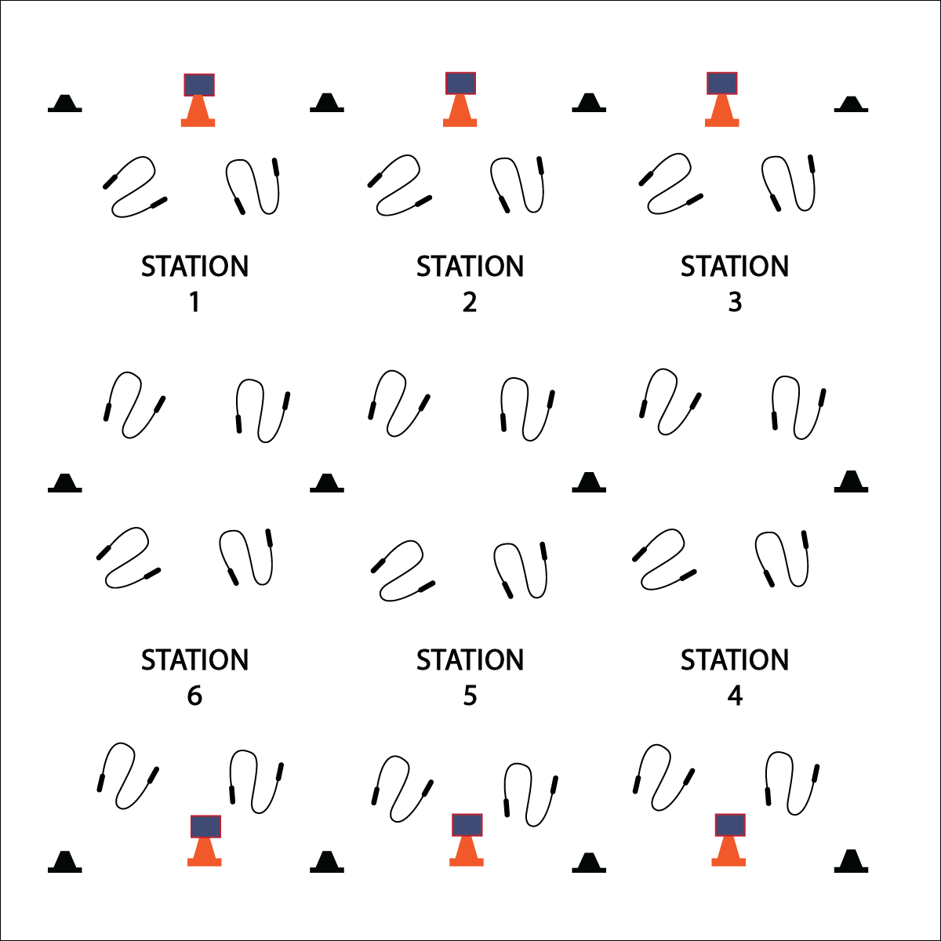

* **Skill:** I will perform a variety of jump rope tricks.
* **Cognitive:** I will discuss the health benefits of jumping rope.
* **Fitness:** I will actively participate at all jump rope stations in order to increase my heart rate.
* **Personal & Social Responsibility:** I will work independently and safely at each station.
* Work Safely by Respecting Self-Space
* Work Responsibly and Independently at Each Station
* Clean Station Equipment Before Rotating

**Equipment:**

* 1 jump rope per student
* 12 low profile cones
* 6 large cones
* 6 Task Tents
* Creative Mode Station Cards
* Music

**Set-Up:**

1. Create 6 stations, each with a cone and station card.
2. Evenly distribute jump ropes at each station (e.g., 4 ropes per station).

**Activity Procedures:**

1. Today’s station activity is called Creative Mode! This is the day when you’ll work at stations to learn basic jump rope tricks that will eventually make up a jump rope routine.
2. At each station, there will be a Creative Mode Station Card that will give you instructions on what to do. You’ll complete that station task for 2 (or 3) minutes.
3. *Teachers: if necessary, demonstrate and explain all station tasks.*
4. When the music starts, begin working at your station. When it stops, you’ll have 1 minute to clean up the station equipment and rotate to the next station. Wait until the music begins again before starting the next activity.

**Grade Level Progression:**

**3rd:** Complete this activity with basic skills at each station.

**4th & 5th:** Provide basic and intermediate skills at each station.

**CREATIVE MODE STATIONS**



Skill, Trick, Benefit, Heart Rate, Short Rope, Long Rope, Quick, Slow, Pace, Health Benefits



* **DOK 1:** What are the health benefits of jumping rope?
* **DOK 2:** How do the benefits of jumping rope compare to the benefits of other physical activities (e.g., push-ups, jogging, yoga, etc.)?
* **DOK 3:** How is physical activity related to good health (physical, mental, emotional)?



* Provide a variety of equipment for students to jump over and on (i.e., a variety of ropes, spot markers, low profile cones, rhythm bands, etc.).
* Provide different challenge areas with tasks that match various skills and abilities, allowing students to choose their levels of participation.
* Provide one-to-one instruction utilizing teaching assistants and/or peer coaches.



* **Standard 1 [E27.3-5]** Performs intermediate jump-rope skills (e.g., a variety of tricks, running in/out of long rope) for both long and short ropes (3).
* **Standard 2 [E3.3-5c]** Combines movement concepts (direction, levels, force, time) with skills as directed by the teacher (3); Applies the movement concepts of speed, endurance and pacing for running (4a).
* **Standard 4[E6.3-5]** Works independently and safely in physical activity settings (3); Works safely with peers and equipment in physical activity settings (4); Applies safety principles with age-appropriate physical activities (5).
* **Standard 5** **[E1.3-5]** Discusses the relationship between physical activity and good health (3); Examines the health benefits of participating in physical activity (4); Compares the health benefits of participating in selected physical activities (5a).



**Organize students to interact with content:** Creative Mode Stations allows students to interact with a variety of jump rope tasks in small groups. This organizational format has several advantages. First, students are active in a social environment that promotes shared experience and positive interaction. Second, educators can provide focused instructional attention in a small group setting. Third, students’ interest and energy levels are kept high because of the variety of tasks with appropriate practice time. Adding music can also promote engagement while providing tempo and rhythm to jumping tasks.

**JUMP ROPE BATTLE BAGS**

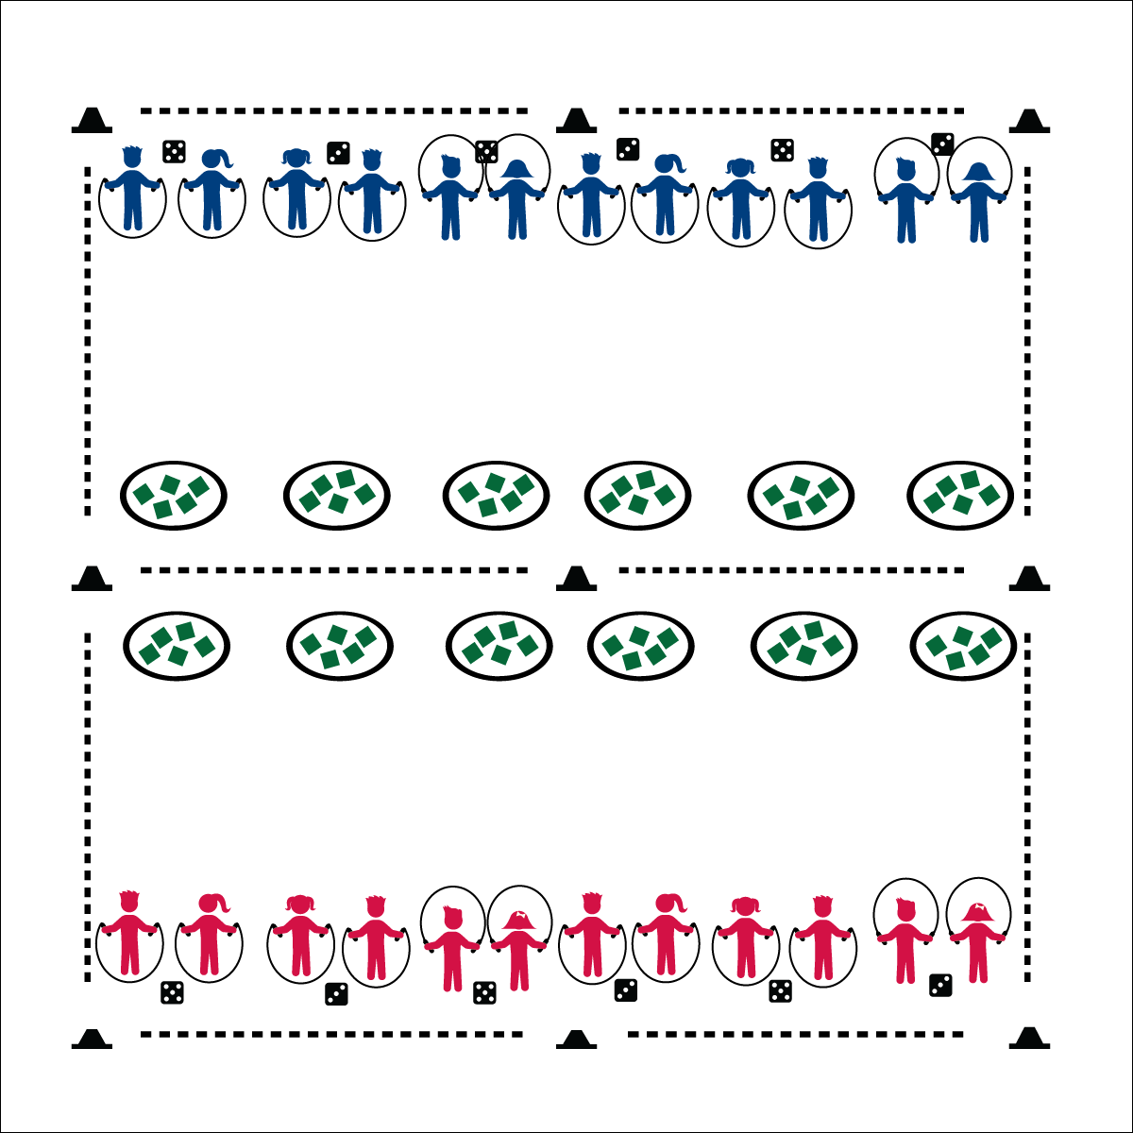

**Activity Procedures:**

1. The game of Jump Rope Battle Bags is a challenge between two teams. Team A is on 1 side of the activity area, and Team B is on the other side.
2. The objective is for you to get rid of your team’s beanbags and be the team with the fewest remaining bags when the game is over.
3. You’ll work in pairs. You and your partner will roll a set of dice to determine the number of jumps to complete before you can collect and toss a beanbag. Both partners must complete a number of jumps equal to the total of the dice.
4. After both partners have completed jumps, you’ll both run to 1 of your team’s hoops, take 1 bean bag each, and toss it into 1 of the other team’s hoops. Then, quickly run back to the dice and roll again. (If you miss the hoop, quickly pick the beanbag up and place it in a hoop.)
5. Continue until you hear the stop signal.

**Grade Level Progression:**

**3rd**: Play the game as described.

**4th & 5th**: Increase intensity with a star jump (or other exercise) in between jumps and running to collect a bean bag.

* **Skill: I** will do the correct number of consecutive jumps in a row using a self-turned rope.
* **Cognitive:** I will identify the fitness components that this activity enhances.
* **Fitness:** I will explain why this activity can enhance my fitness.
* **Personal & Social Responsibility:** I will work cooperatively with my partner.
* Elbows In
* Wrist Circles
* Two Feet Together
* Jump to a Rhythm

**Equipment:**

* 9 low profile cones for boundary and mid line
* Jump rope for each student
* 12 hula hoops
* 12 dice
* Bean bags (about 5 bags per hoop)

**Set-Up:**

1. Use the cones to create a large activity area and divide it in half
2. 6 hula hoops on each side near the mid line
3. About 5 bean bags inside each hoop
4. 6 dice on each side of the activity area
5. Divide the class into 2 groups and send 1 group to each side of the activity area

**JUMP ROPE BATTLE BAGS**



Consecutive, Cooperate, Health-Related Fitness, Vertical, Praise, Accept, Actively Involve



* **DOK 1:** What are the components of health-related fitness?
* **DOK 2:** How did this activity help to enhance your health-related fitness?
* **DOK 3:** How could we adapt this activity to focus on other aspects of health-related fitness?
* **DOK 1:** What does it mean to actively involve someone?
* **DOK 2:** How is our class environment affected when you work to actively involve others?



* Allow students to use an “invisible” jump rope when playing this activity.
* Utilize a spot marker. Students make consecutive jumps on and off the spot marker.
* Students focus on turning a shortened rope beside them, without jumping.
* Pair students with limited mobility with students with full mobility. One student turns a rope, the other jumps.



* **Standard 1** **[E4.3]** Jumps and lands in the vertical plane using a mature pattern (3).
* **Standard 3 [E3.3-5]** Describes the concept of fitness and provides examples of physical activity to enhance fitness (3); Identifies the components of health-related fitness (4); Differentiates between skill-related and health-related fitness (5).
* **Standard 4 [E4.3-5]** Works cooperatively with others (3a); Praises others for their success in movement performance (3b); Praises the movement performance of others both more- and less-skilled (4a); Accepts “players” of all skill levels into the physical activity (4b); Accepts, recognizes, and actively involves others with both higher and lower skill abilities into physical activities and group projects (5).



**Help students practice skills:** Jump Rope Battle Bags adds variety to jump rope lessons while providing ample opportunity for students to practice basic jumping skills. This unique, game-based practice environment provides challenge and interest while helping students development skill competency and confidence.

**MATCH ME IF YOU CAN**

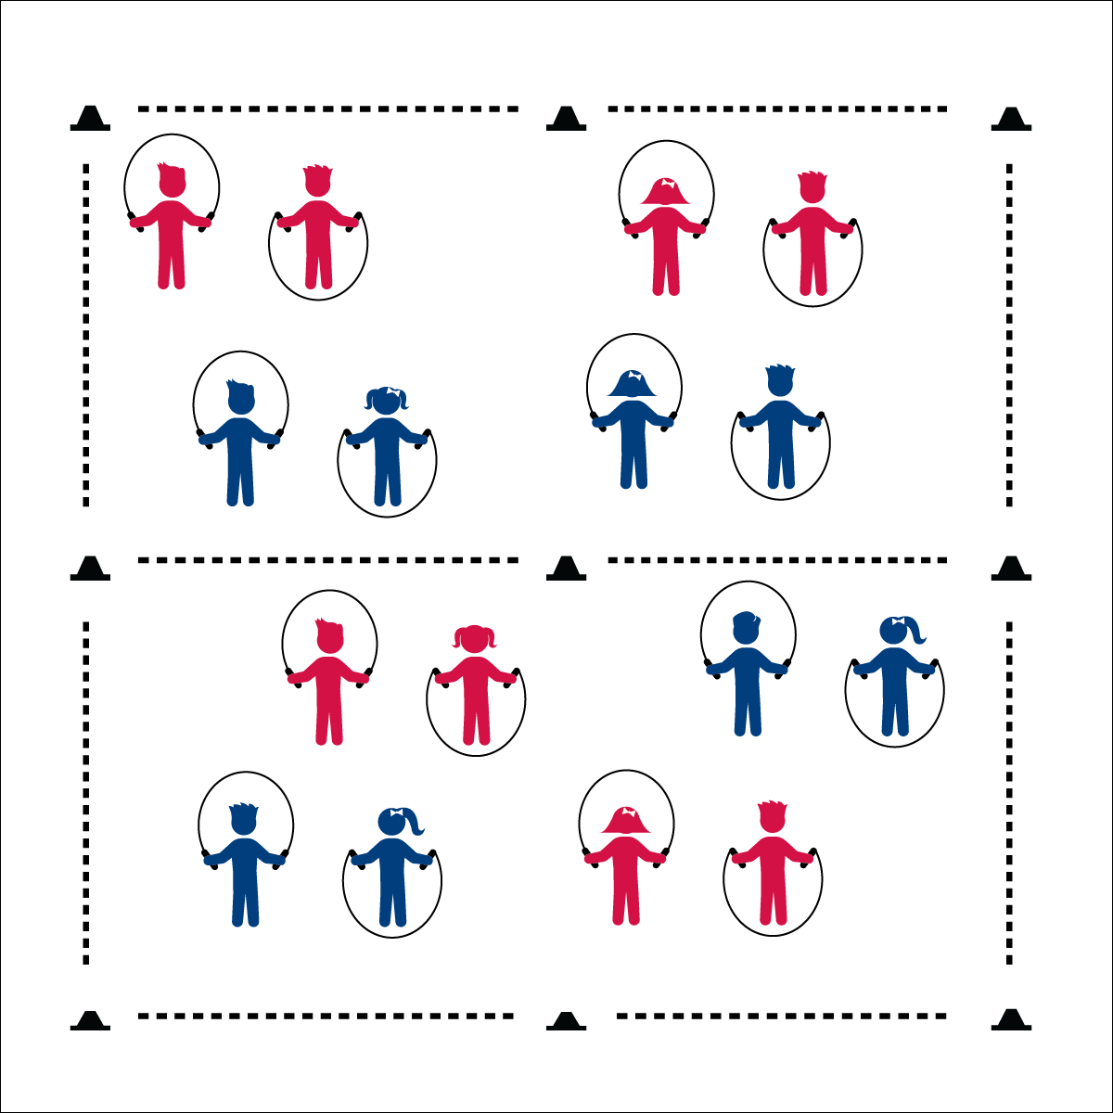

**Activity Procedures:**

1. Match Me If You Can is a head-to-head jump rope challenge game. The object is for you to make more consecutive jumps than your partner, and then move to the Major League side of the gym where you’ll compete with another player for Major League points.
2. The gym is divided in half. We’re starting on the Minor League side, and the other is the Major League side. Play Rock, Paper, Scissors (RPS) to determine who will be Partner 1 and who will be Partner 2.
3. When I say, “GO!” Partner 1 will go first and attempt to do 15 jumps in a row. When Partner 1 is done, Partner 2 will attempt to do 15 jumps in a row. If both reach 15 jumps, play RPS again to see who wins.
4. The partner with the most consecutive jumps will move to the Major League side and look for a new partner. The other will stay on the Minor League side and look for a new partner.
5. When 2 partners compete on the Major League side, the winner stays (and earns one Major League point), and the other partner moves back to the minor league side to try again.

**Grade Level Progression:**

**3rd:** Play the game as described above.

**4th**: When students compete on the major league side, require at least 1 jump rope trick in the 15 jumps.

**5th**: Students play in pairs and perform 16 count jump rope routines to be matched by a competing pair. Provide time prior to the activity for routine development.

* **Skill**: I will do as many consecutive jumps in a row as I can using a self-turned rope.
* **Cognitive**: I will identify the components of fitness that jumping rope can enhance.
* **Fitness**: I will explain why jumping rope can enhance fitness.
* **Personal & Social Responsibility**: I will work safely with my classmates and equipment.
* Elbows In
* Wrist Circles
* Two Feet Together
* Jump to a Rhythm

**Equipment:**

* 1 jump rope per student
* 9 half cones for boundaries and mid-line

**Set-Up:**

1. Create a large activity space using 6 cones.
2. Divide the area in half using 3 other cones. One side is Minor League, the other is Major League.
3. Scatter students with ropes on the Minor League side.
4. Students face one another with enough distance to safely turn a jump rope.

**MATCH ME IF YOU CAN**



* Allow students to use an “invisible” jump rope when playing this activity.
* Utilize a spot marker. Students make consecutive jumps on and off the spot marker.
* Remove the two zones and have the students play in one large zone. This allows students with limited mobility to stay in place, with challengers moving to work with them.
* Allow students to clap or tap to a rhythm as a substitute for jumping. They must stay on the beat of a drum or music in order to complete the correct number of consecutive “jumps.”



Consecutive, Two-Foot Take Off, Routine, Health-Related Fitness, Skill-Related Fitness



* **Standard 1 [E27.3-5]** Performs intermediate jump-rope skills (e.g., a variety of tricks, running in/out of long rope) for both long and short ropes (3); Creates a jump-rope routine with either a short or long rope (4); Creates a jump rope routine with a partner, using either a short or long rope (5).
* **Standard 3 [E3.3-5]** Describes the concept of fitness and provides examples of physical activity to enhance fitness (3); Identifies the components of heath-related fitness (4); Differentiates between skill-related and health-related fitness (5).
* **Standard 4 [E6.3-5]** Works independently and safely in physical activity settings (3); Works safely with peers and equipment in physical activity settings (4); Applies safety principles with age-appropriate physical activities (5).



* **DOK 2**: How does jumping rope affect your body systems?
* **DOK 3**: How is jumping rope connected to skill-related fitness?
* **DOK 4**: With a partner, create a 16-count jump rope routine that you can perform and challenge other pairs to replicate.



**Review content**: This activity provides an opportunity for teachers and students to review basic jump rope cues and concepts before moving on to work with long ropes. Use this opportunity to ensure that students are competent jumpers and understand the importance of jump rope cues and jumping rhythm.

**LONG ROPE BASICS**

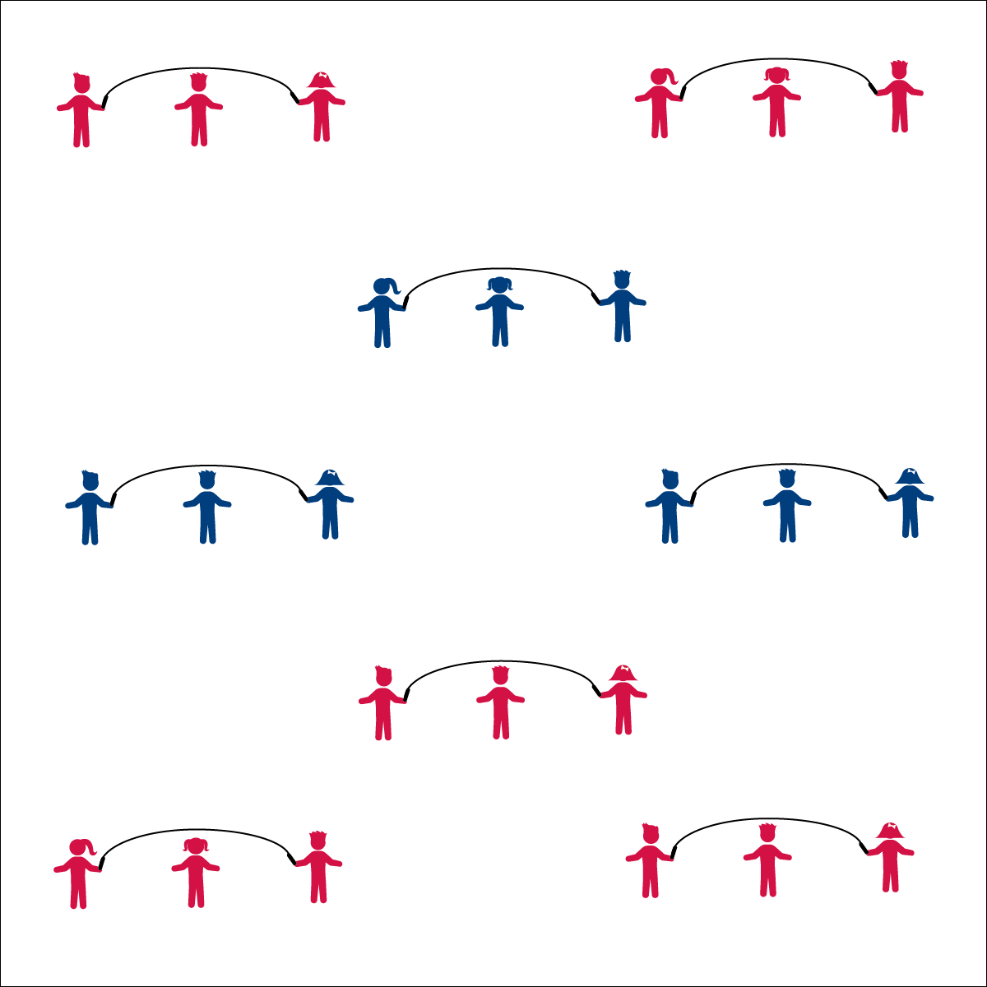

* **Skill:** I will successfully turn and jump a long rope.
* **Cognitive:** I will identify the components of skill-related fitness required for jumping and turning a long rope.
* **Fitness:** I will give an example of how I can improve my skill-related fitness at home.
* **Personal & Social Responsibility:** I will work cooperatively with another rope turner in order to turn a rope for a jumper to jump.
* Face Turner
* Watch Rope
* Small Jumps
* Keep the Rhythm
* Turn with Arms
* Watch Jumper’s Feet
* Keep the Rhythm

**Equipment:**

* 1 long jump rope per 3 students
* 1 Long Rope Progression Card per 3 students

**Set-Up:**

1. Divide students into groups of 3, each group with a long jump rope.
2. Scatter groups in general space with enough room to turn the rope safely.
3. Provide each group with a Long Rope Progression Card.

**Activity Procedures:**

1. Today we are going to work on skills using long jump ropes. In groups of 3 you will practice turning and jumping the rope by following the skill instructions on the Long Rope Progression Card.
2. When I see that a group has mastered one of the skills on the card, I’ll stop the class so we can watch a demonstration.
3. When you hear the music, begin. When you hear the music stop, freeze and listen for instructions.

**Grade Level Progression:**

**3rd:** Complete the activity as described above.

**4th:** Allow advanced students to perform basic tricks during their turn as jumpers.

**5th:** Allow groups of 3 or 4 to create basic long rope routines.

**LONG ROPE BASICS**



Success, Long Rope, Turn, Rhythm, Improve, Skill-Related Fitness



* Designate students as all-time turners.
* Provide a teaching assistant or peer coach to help students turn the rope.
* Turn the rope very slowly with students stepping over the rope.



* **Standard** **1 [E27.3-5]** Performs intermediate jump-rope skills (e.g., a variety of tricks, running in/out of long rope) for both long and short ropes (3); Creates a jump-rope routine with either a short or long rope (4); Creates a jump rope routine with a partner, using either a short or long rope (5).
* **Standard 3 [E3.3-5]** Describes the concept of fitness and provides examples of physical activity to enhance fitness (3); Identifies the components of health-related fitness (4); Differentiates between skill-related and health-related fitness (5).
* **Standard 4 [E4.3-5]** Works cooperatively with others (3a); Praises others for their success in movement performance (3b); Praises the movement performance of others both more- and less-skilled (4a); Accepts “players” of all skill levels into the physical activity (4b); Accepts, recognizes, and actively involves others with both higher and lower skill abilities into physical activities and group projects (5).



* **DOK 1:** What is skill-related fitness?
* **DOK 1:** What are the components of skill-related fitness?
* **DOK 2:** Which components of skill-related fitness are used when turning and jumping a long jump rope?
* **DOK 1:** What does the word rhythm mean?
* **DOK 2:** How does rhythm apply to jumping rope?
* **DOK 3:** What happens if the turners and jumpers are not in the same rhythm? Why?



**Help students examine similarities and differences:** Students new to long rope jumping may be intimidated by the lack of control over the long rope turning. Taking time to explore the similarities to short rope jumping (e.g., rhythm, timing, basic jump technique) will help students connect prior success to this new task. Likewise, examining the difference between the two skills will help them understand the new cues and cooperative requirements of long rope jumping.

**LONG ROPE RHYMES**



* Face Turner
* Watch Rope
* Small Jumps
* Keep the Rhythm
* Turn with Arms
* Watch Jumper’s Feet
* Keep the Rhythm
* **Skill:** I will successfully turn and jump a long rope.
* **Cognitive:** I will recite jump rope rhymes, in rhythm with my partners.
* **Fitness:** I will identify the component of health-related fitness required when jumping and reciting rhymes.
* **Personal & Social Responsibility:** I will work cooperatively with my group to complete each rhyme.

**Equipment:**

* 1 long jump ropes per 3 students
* Rhyme Cards

**Set-Up:**

1. Divide the class into groups of 3 or 4, each group with a long jump rope.
2. Have the students spread out in general space with enough space to turn the rope safely.

**Activity Procedures:**

1. Today we’ll be combining our long jump rope skills with some classic jump rope rhymes.
2. When I say, “GO!” follow the Rhyme Cards with your partners when you jump.
3. After you master each rhyme, work to try all of the different tricks that you’ve learned with your group.

**Grade Level Progression:**

**3rd:** Complete the activity as described above.

**4th:** Allow advanced students to perform basic tricks while completing jump rope rhymes.

**5th:** Challenge students to create their own rhymes.

**LONG ROPE RHYMES**



Success, Long Rope, Turn, Rhythm, Rhyme, Improve, Cooperate



* Use Velcro on gloves and rope handles to help students hold and turn.
* Allow students to jump next to the turning rope, in rhythm with the turning.
* Swing the rope slowly and allow students to step over the rope.
* Designate a student(s) as the rhyme caller.



* **Standard** **1 [E27.3-5]** Performs intermediate jump-rope skills (e.g., a variety of tricks, running in/out of long rope) for both long and short ropes (3); Creates a jump-rope routine with either a short or long rope (4); Creates a jump rope routine with a partner, using either a short or long rope (5).
* **Standard 3 [E3.3-5]** Describes the concept of fitness and provides examples of physical activity to enhance fitness (3); Identifies the components of health-related fitness (4); Differentiates between skill-related and health-related fitness (5).
* **Standard 4 [E4.3-5]** Works cooperatively with others (3a); Praises others for their success in movement performance (3b); Praises the movement performance of others both more- and less-skilled (4a); Accepts “players” of all skill levels into the physical activity (4b); Accepts, recognizes, and actively involves others with both higher and lower skill abilities into physical activities and group projects (5).



* **DOK 1:** How can you recognize groups that are cooperating?
* **DOK 2:** How does cooperation affect a group’s performance?
* **DOK 2:** What are ways that you can cooperate with others in this activity?
* **DOK 1:** How can you recognize a successful Jump Rope Rhyme Routine?
* **DOK 2:** How would you summarize your group’s participation performance today in relation to cooperation? In relation to fitness?



**Help students engage in cognitively complex tasks:** The process of memorizing and reciting rhymes while also focusing on successful rope turning and jumping adds additional complexity to the already dynamic tasks of turning or jumping a long rope. This allows students to practice a level of complexity that can then be applied to the creation, memorization, and successful completion of jump rope routines. In both tasks, students must take their focus off of jumping/turning skills in order to execute a rhyme or routine. This helps to build students’ capacity for increasingly complex skill combinations.

**SURVIVAL MODE STATIONS**

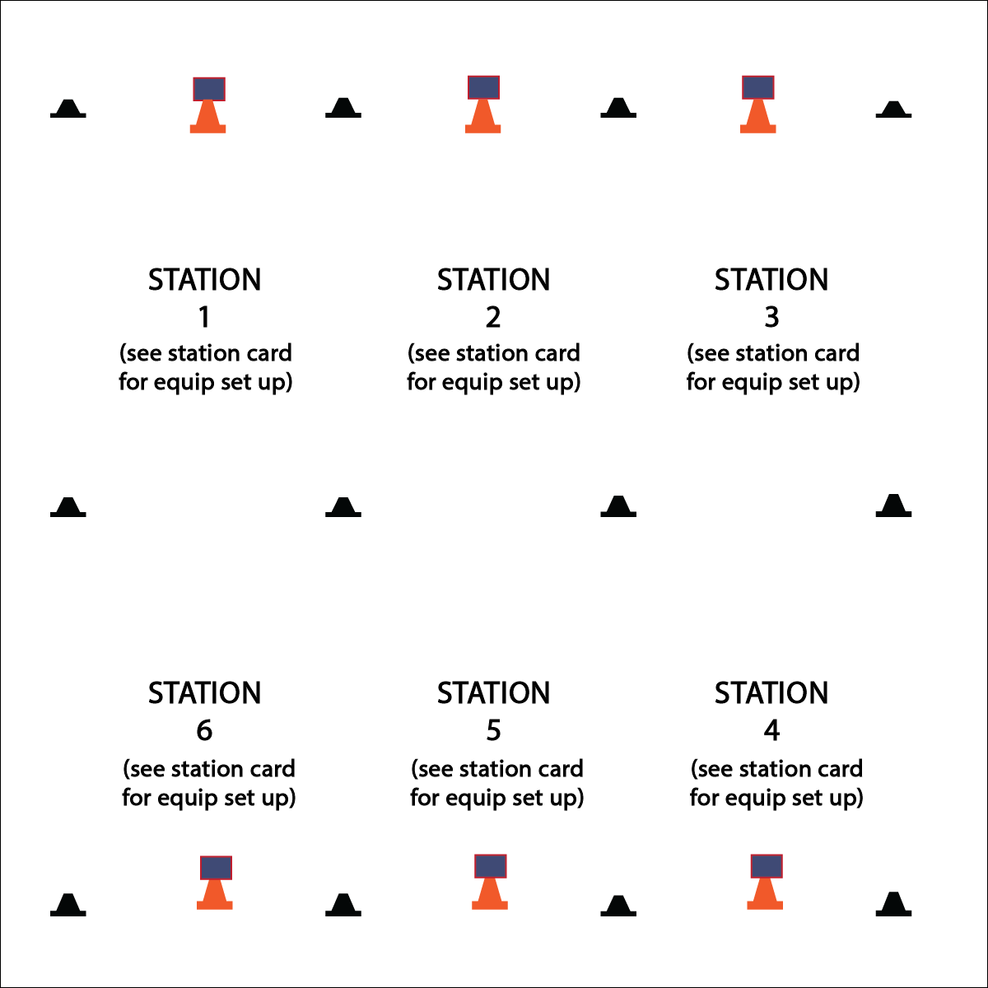

* **Skill:** I will perform the jump rope skills necessary to complete each challenge.
* **Cognitive:** I will answer challenge questions related to jump rope and fitness.
* **Fitness:** I will answer challenge questions related to nutrition and food choices.
* **Personal & Social Responsibility:** I will work cooperatively and provide praise and encouragement to my group.
* Work Safely by Respecting Self-Space
* Work Responsibly and Independently at Each Station
* Clean Station Equipment Before Rotating

**Equipment:**

* See station cards for equipment needs
* 12 low profile cones
* 6 large cones
* 6 Task Tents
* Survival Mode Station Cards

**Set-Up:**

1. Use low profile cones to create 6 stations. Each station should have a large cone, task tent, and station card.
2. Divide class into 6 groups. (Create more stations to accommodate large class sizes.)

**Activity Procedures:**

1. Today’s station day activity is called Survival Mode! This is the day when you’ll put the jump rope skills and tricks that you’ve learned to the test.
2. At each station there will be a Survival Mode Challenge Card that will give you challenge options with 3 levels of difficulty. Your group will have 2 (or 3) minutes to select and complete one of the challenges.
3. When the music starts, begin working at your station. When it stops, you’ll have 1 minute to clean up the station equipment and rotate to the next station. Wait until the music begins again before starting the next activity.

**Grade Level Progression:**

**3rd:** Complete the activity as described above.

**4th & 5th:** Add an element of competition by completing the stations in adventure race format. Each team starts at a different station. Groups complete each challenge as quickly as possible in order be the first group back to their original station.

**SURVIVAL MODE STATIONS**



* **DOK 1:** What does hydration mean?
* **DOK 2:** How does hydration relate to physical activity?
* **DOK 3:** What foods help you prepare for physical activity? Why?
* **DOK 3:** How are your food choices related to your personal health?



* Provide a variety of equipment for students to jump over and on (i.e., a variety of ropes, spot markers, low profile cones, rhythm bands, etc.).
* Provide different challenge areas with tasks that match various skills and abilities, allowing students to choose their levels of participation.
* Provide one-to-one instruction utilizing teaching assistants and/or peer coaches.



Challenge, Nutrition, Food Choice, Hydration, Speed, Endurance, Pace



* **Standard** **1 [E27.3-5]** Performs intermediate jump-rope skills (e.g., a variety of tricks, running in/out of long rope) for both long and short ropes (3); Creates a jump-rope routine with either a short or long rope (4); Creates a jump rope routine with a partner, using either a short or long rope (5).
* **Standard 2 [E3.3-5c]** Combines movement concepts (direction, levels, force, time) with skills as directed by the teacher (3); Applies the movement concepts of speed, endurance and pacing for running (4a). Analyzes movement situations and applies movement concepts (e.g., force, direction, speed, pathways, extensions) in small-sided practice task/game environments, dance and gymnastics (5c).
* **Standard 3 [E3.3-5]** Describes the concept of fitness and provides examples of physical activity to enhance fitness (3); Identifies the components of health-related fitness (4); Differentiates between skill-related and health-related fitness (5).
* **Standard 3 [E6.3-5]** Identifies foods that are beneficial for pre- and post-physical activity (3); Discusses the importance of hydration and hydration choices relative to physical activities (4); Analyzes the impact of food choices relative to physical activity, youth sports & personal health (5).
* **Standard 4 [E4.3-5]** Works cooperatively with others (3a); Praises others for their success in movement performance (3b); Praises the movement performance of others both more- and less-skilled (4a); Accepts “players” of all skill levels into the physical activity (4b); Accepts, recognizes, and actively involves others with both higher and lower skill abilities into physical activities and group projects (5).
* **Standard 5** **[E1.3-5]** Discusses the relationship between physical activity and good health (3); Examines the health benefits of participating in physical activity (4); Compares the health benefits of participating in selected physical activities (5a).



**Help students process content:** Survival Mode Stations shifts the focus from direct instruction to guided discovery as students use the skills previously learned to complete both cognitive and performance challenges. Students work in cooperative groups to read, comprehend, and process tasks/challenges in order to demonstrate content comprehension, skill competence, and cooperative abilities.

**JUMP ROUTINES**

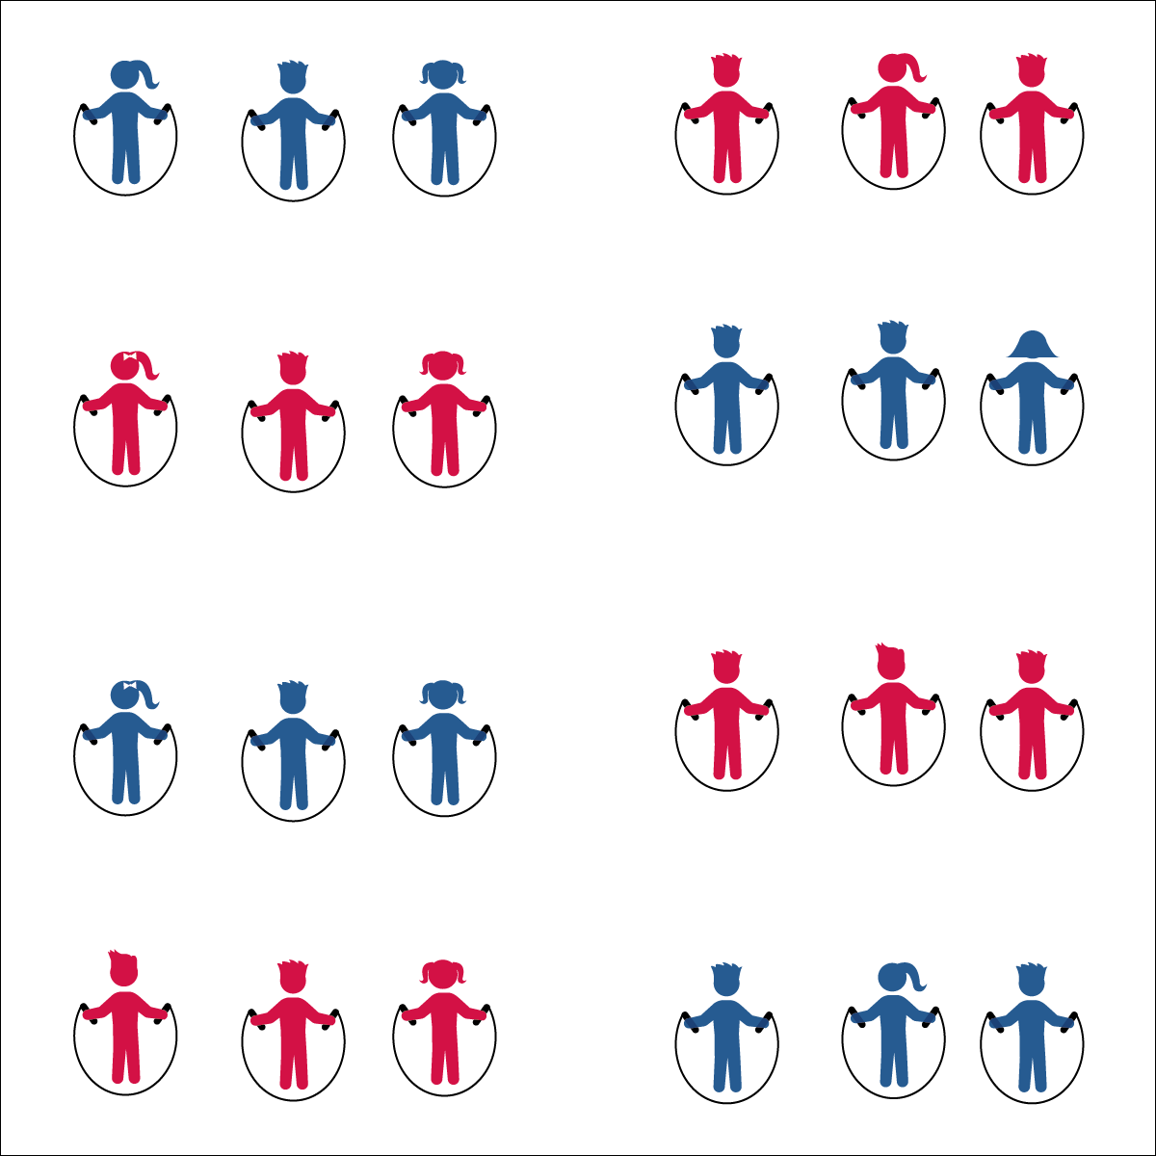

* **Skill:** I will perform a jump rope routine.
* **Cognitive:** I will complete a practice chart to track my jump rope activity outside of physical education class.
* **Fitness:** I will list 3 ways to improve my health-related fitness outside of physical education class.
* **Personal & Social Responsibility:** I will accept, recognize, and actively involve others in my group regardless of skill level.
* Accept Everyone
* Cooperate and Contribute
* Praise Others

**Equipment:**

* 1 jump rope per student
* 1 long rope per 3 students (as needed)
* 1 Jump Rope Routine Task Card per group
* Music

**Set-Up:**

1. Divide students into groups of 3 (or 4), each student with a jump rope.
2. Scatter groups in general space with enough room to turn ropes safely.
3. Provide each group with a Routine Task Card.

**Activity Procedures:**

1. Today you’ll work in groups of 3 (or 4) to complete musical jump rope routines that you can perform for an audience.
2. Each Jump Rope Routine Task Card gives your group a guideline for completing (or creating) a routine. If you create a routine, you can use skills and tricks that you’ve learned in class, tricks that you’ve learned at home, or tricks that you’ve invented.
3. The next time our class meets, you’ll have a few minutes to practice your routine and then will perform it for your classmates. If at all possible, practice your routines before and after school, as well as at recess.

**Grade Level Progression:**

**3rd:** Students perform teacher-assigned routines.

**4th:** Students perform short rope routines that they create individually.

**5th:** Students perform either short or long rope routines that they create cooperatively with group members.

**JUMP ROUTINES**



* **Standard** **1 [E27.3-5]** Performs intermediate jump-rope skills (e.g., a variety of tricks, running in/out of long rope) for both long and short ropes (3); Creates a jump-rope routine with either a short or long rope (4); Creates a jump rope routine with a partner, using either a short or long rope (5).
* **Standard 2 [E3.3-5c]** Combines movement concepts (direction, levels, force, time) with skills as directed by the teacher (3); Applies the movement concepts of speed, endurance and pacing for running (4a). Analyzes movement situations and applies movement concepts (e.g., force, direction, speed, pathways, extensions) in small-sided practice task/game environments, dance and gymnastics (5c).
* **Standard 3 [E1. 3-5]** Charts participation in physical activities outside physical education class (3a); Identifies physical activity benefits as a way to become healthier (3b); Analyzes opportunities for participating in physical activity outside physical education class (4); Charts and analyzes physical activity outside physical education class for fitness benefits of activities (5).
* **Standard 4 [E4.3-5]** Works cooperatively with others (3a); Praises others for their success in movement performance (3b); Praises the movement performance of others both more- and less-skilled (4a); Accepts “players” of all skill levels into the physical activity (4b); Accepts, recognizes, and actively involves others with both higher and lower skill abilities into physical activities and group projects (5).



* **DOK 1:** Let’s list all of the benefits of being physically active
* **DOK 2:** How can charting our physical activity outside of physical education help us understand and improve our personal health?
* **DOK 3:** How can we use the information from an activity chart to improve our fitness?



Cooperate, Practice, Track, Analyze, Accept, Recognize, Actively Involve, Routine



* Allow students to create jumping routines without a rope.
* Allow students to create Hand Jive Routines.
* Allow students to choose the tempo of their routine music.
* Provide a teaching assistant for groups needing help/support.



**Engage students in cognitively complex tasks**: Working with peers to create a short jump rope routine can be both cognitively and socially complex. This exercise provides students with a practice task that combines personal fitness, rope jumping skills, cooperative skills, and the ability to count (“feel”) music. This task can be used as either a formative or summative assessment opportunity.

**STATION DAY**

## 

**Equipment:**

* 24 low profile cones
* Station music and music player
* See station cards for equipment needs

**Set-Up:**

1. Using low profile cones, create 6-10 grids (depending on size of class and activity area).
2. Set station cards up on tall cones in each grid.
3. Set up each station according to its station card.
4. Designate 1 station as an assessment station.
5. Create groups of 2-4 students, each group at a different station.

* **Skill:** I will perform skill assessments to the best of my ability, following as many skills cues as I can.
* **Cognitive**: I will follow the instructions on each station card in order to stay actively engaged with my team.
* **Fitness**: I will find my pulse/heart rate after each station in order to see if it is beating faster than when I’m sitting or resting.
* **Personal & Social Responsibility**: I will follow the

rules and parameters of the Station Day learning environment.

* Start Activity with Music
* When Music Stops: Clean the Area and Rotate

**Activity Procedures:**

1. Today is a Station Assessment Day. We’ll complete each station for 2 (or 3) minutes. One station is an assessment station where you’ll be given feedback based on your skill performance.
2. *Teacher: Talk through and/or demonstrate each station. Emphasize expectations at the assessment station.*
3. When the music starts, begin working at your station. When it stops, you’ll have 1 minute to clean up the station equipment and rotate to the next station. Wait until the music begins again before you start the activity at the new station.
4. While we’re learning this station format, I’ll pause the music for a longer period of time so that every team is able to clean up their area and rotate.



* Some students may need step-by-step assistance during clean-up and rotation.
* Pause the music and don’t restart until every group has safely transitioned.
* Provide visual cues and graphics to enhance station instructions.

**STATION DAY**



*Select words from the module that you’re teaching*



* **Standard 1, 2, 3, 5** [*Select outcomes from the module you’re teaching.*]
* **Standard 4 [E2.3-5]** Works independently for extended periods of time (3); Reflects on personal social behavior in physical activity (4); Participates with responsible personal behavior in a variety of physical activity contexts, environments and facilities (5a); Exhibits respect for self with appropriate behavior while engaging in physical activity (5b).



*Select questions from the module you’re teaching or the assessment you’re using.*



**Organizing students to interact with content:** The use of grids to organize students into learning stations is an effective way to manage activity, assessment, and cooperative learning opportunities. Practice using this format several times, especially with young children, before attempting to facilitate an assessment experience. Students need time to master the management aspects of station work. However, once this routine is learned, it often becomes an essential management tool in physical education.