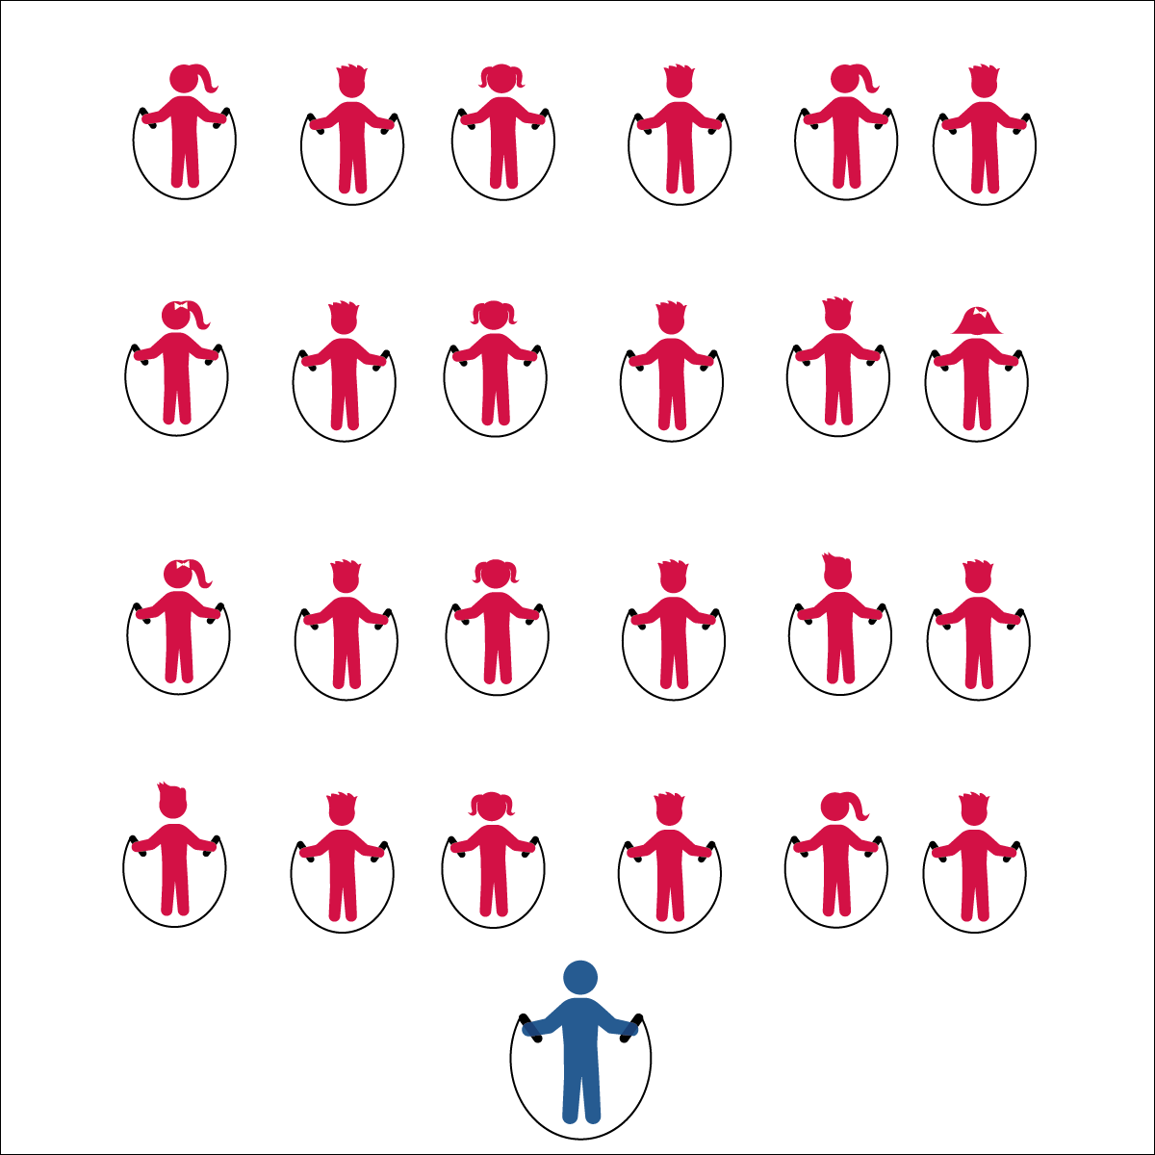­

* Work Safely by Respecting Self-Space
* See *Jump Rope Progression Card* for Basic Jump Rope Skill Cues
* **Skill:** I will practice a variety of jump rope skills using the cues my teacher gives me in class.
* **Cognitive:** I will give examples of physical activities that enhance fitness.
* **Fitness:** I will work to stay actively engaged during all of the jump rope activities.
* **Personal & Social Responsibility**: I will demonstrate safe behaviors without being reminded by a teacher.

**Activity Procedures:**

1. Today, we are going to review the progression for jumping rope.
2. It’s important that everyone has a jump rope that is the proper length. The Rope Selection Rule posted near the jump ropes will help you make the correct choice.
3. Now that everyone has a jump rope, follow along and repeat the skills that I demonstrate. For safety, remember to stay within your own personal space.
4. *Teachers, follow the Jump Rope Progression Cards and lead the class through the progressions for jumping rope.*

**Grade Level Progression:**

**3rd:** Complete the activity as described above.

**4th:** Students work in small groups, each with a progression card, to review basic jump rope technique.

**5th:** Combine this activity with Creative Mode Station Cards. Work through the progression card with students who need assistance. Allow more advanced students to complete Creative Mode Stations.

**Equipment:**

* 1 jump rope per student
* Rope Selection Rule Poster
* Jump Rope Progression Cards

**Set-Up:**

1. Students spread out in general space facing the teacher, each with a jump rope.
2. Jump Rope Progression Cards ready on clipboard or tablet.

**BACK TO BASICS**

**BACK TO BASICS**



Jump, Land, Two-Foot Take Off, Vertical, Turn, Enhance, Fitness, Safe, Health-Related Fitness, Skill-Related Fitness



* **Standard 1 [S1.E4.3]** Jumps and lands in the vertical plane using a mature pattern (3).
* **Standard 3 [E3.3-5]** Describes the concept of fitness and provides examples of physical activity to enhance fitness (3); Identifies the components of health-related fitness (4); Differentiates between skill-related and health-related fitness (5).
* **Standard 4 [E6.3-5]** Works independently and safely in physical activity settings (3); Works safely with peers and equipment in physical activity settings (4); Applies safety principles with age-appropriate physical activities (5).



* **DOK 1:** How can you recognize activities that enhance fitness?
* **DOK 1:** What are some examples of activities that enhance fitness?
* **DOK 2:** How does jumping rope enhance health-related fitness?
* **DOK 3:** Which components of fitness would be most impacted if you jumped rope every day? Why?



**Identify Critical Content:** Jump rope success depends on students’ ability to understand and perform the basic jump. At each grade level, students will benefit from a review of jump rope cues and content. Likewise, there will most likely be students at each grade level who haven’t mastered the basic jump and will require remediation. Take time to assess where students are starting and then identify the critical content needed for progression.



* Allow students to use ropes in a variety of styles and lengths.
* Jump an invisible rope to music with a slow and steady beat. Increase the tempo of the music selection to increase the intensity of the activity.
* Provide ongoing verbal cues with individualized instruction and/or peer tutoring.