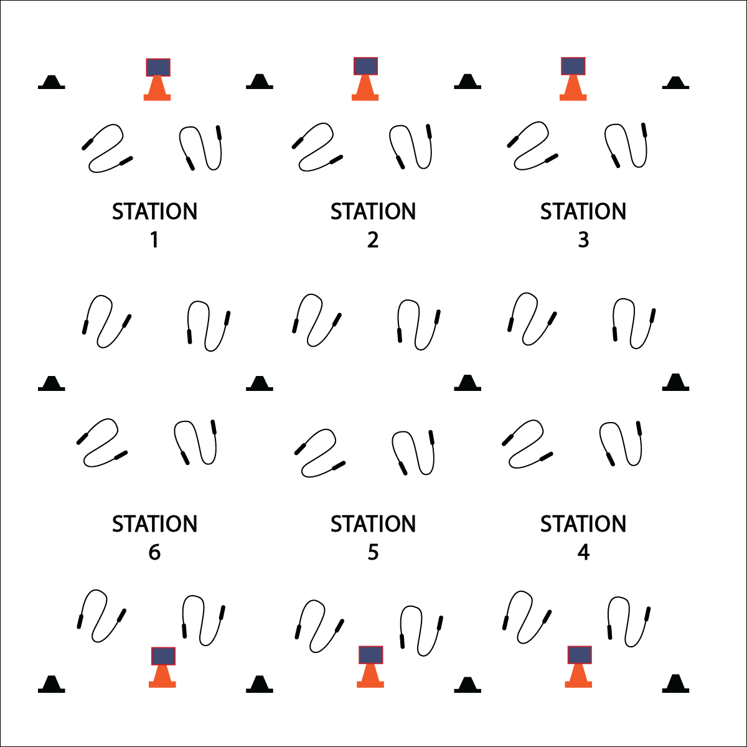­

**Activity Procedures:**

1. Today’s station activity is called Creative Mode! This is the day when you’ll work at stations to learn basic jump rope tricks that will eventually make up a jump rope routine.
2. At each station, there will be a Creative Mode Station Card that will give you instructions on what to do. You’ll complete that station task for 2 (or 3) minutes.
3. *Teachers: if necessary, demonstrate and explain all station tasks.*
4. When the music starts, begin working at your station. When it stops, you’ll have 1 minute to clean up the station equipment and rotate to the next station. Wait until the music begins again before starting the next activity.

**Grade Level Progression:**

**3rd:** Complete this activity with basic skills at each station.

**4th & 5th:** Provide basic and intermediate skills at each station.

**Equipment:**

* 1 jump rope per student
* 12 low profile cones
* 6 large cones
* 6 Task Tents
* Creative Mode Station Cards
* Music

**Set-Up:**

1. Create 6 stations, each with a cone and station card.
2. Evenly distribute jump ropes at each station (e.g., 4 ropes per station).

* Work Safely by Respecting Self-Space
* Work Responsibly and Independently at Each Station
* Clean Station Equipment Before Rotating
* **Skill:** I will perform a variety of jump rope tricks.
* **Cognitive:** I will discuss the health benefits of jumping rope.
* **Fitness:** I will actively participate at all jump rope stations in order to increase my heart rate.
* **Personal & Social Responsibility:** I will work independently and safely at each station.

**CREATIVE MODE STATIONS**

**CREATIVE MODE STATIONS**



Skill, Trick, Benefit, Heart Rate, Short Rope, Long Rope, Quick, Slow, Pace, Health Benefits

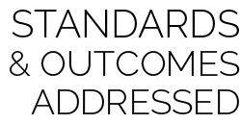

* **Standard 1 [E27.3-5]** Performs intermediate jump-rope skills (e.g., a variety of tricks, running in/out of long rope) for both long and short ropes (3).
* **Standard 2 [E3.3-5c]** Combines movement concepts (direction, levels, force, time) with skills as directed by the teacher (3); Applies the movement concepts of speed, endurance and pacing for running (4a).
* **Standard 4[E6.3-5]** Works independently and safely in physical activity settings (3); Works safely with peers and equipment in physical activity settings (4); Applies safety principles with age-appropriate physical activities (5).
* **Standard 5** **[E1.3-5]** Discusses the relationship between physical activity and good health (3); Examines the health benefits of participating in physical activity (4); Compares the health benefits of participating in selected physical activities (5a).



* **DOK 1:** What are the health benefits of jumping rope?
* **DOK 2:** How do the benefits of jumping rope compare to the benefits of other physical activities (e.g., push-ups, jogging, yoga, etc.)?
* **DOK 3:** How is physical activity related to good health (physical, mental, emotional)?



**Organize students to interact with content:** Creative Mode Stations allows students to interact with a variety of jump rope tasks in small groups. This organizational format has several advantages. First, students are active in a social environment that promotes shared experience and positive interaction. Second, educators can provide focused instructional attention in a small group setting. Third, students’ interest and energy levels are kept high because of the variety of tasks with appropriate practice time. Adding music can also promote engagement while providing tempo and rhythm to jumping tasks.



* Provide a variety of equipment for students to jump over and on (i.e., a variety of ropes, spot markers, low profile cones, rhythm bands, etc.).
* Provide different challenge areas with tasks that match various skills and abilities, allowing students to choose their levels of participation.
* Provide one-to-one instruction utilizing teaching assistants and/or peer coaches.