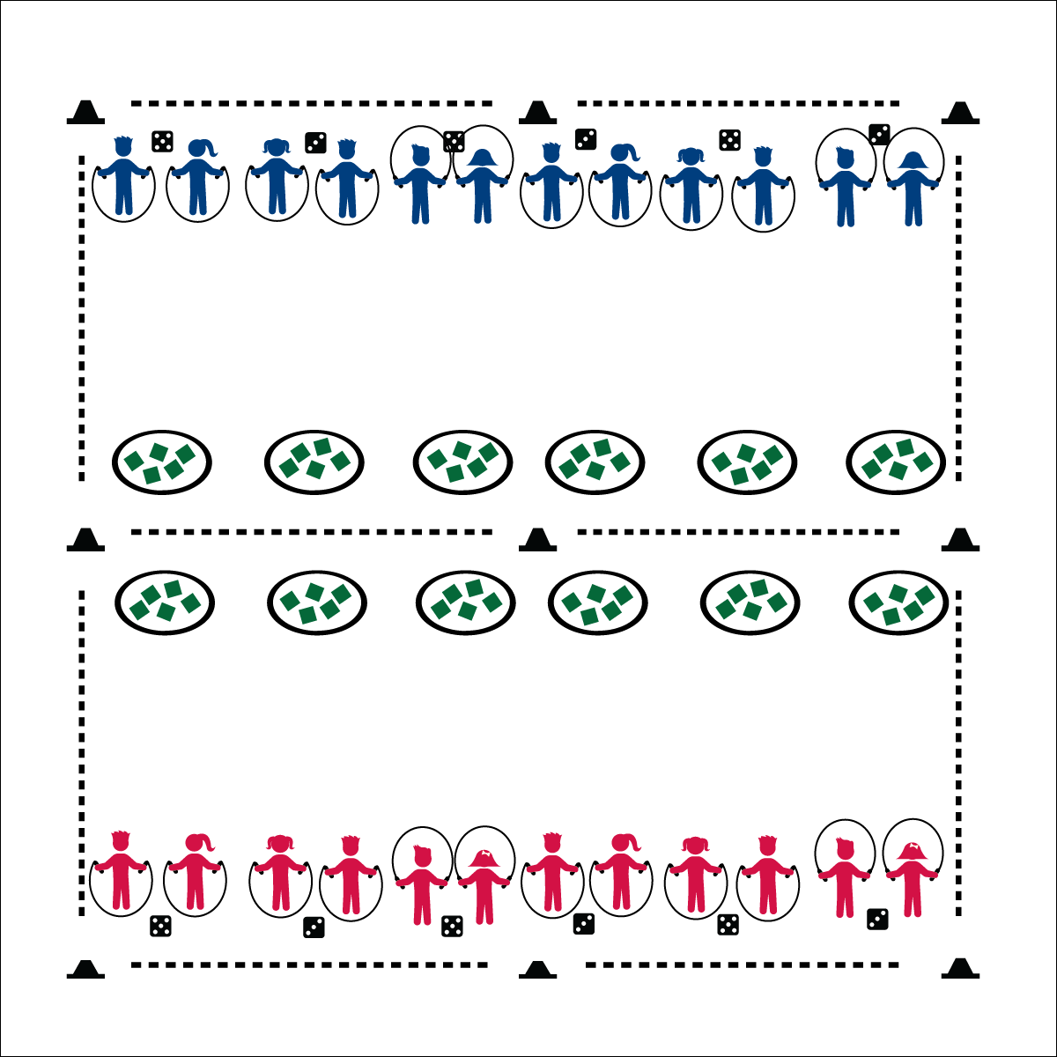

**Activity Procedures:**

1. The game of Jump Rope Battle Bags is a challenge between two teams. Team A is on 1 side of the activity area, and Team B is on the other side.
2. The objective is for you to get rid of your team’s beanbags and be the team with the fewest remaining bags when the game is over.
3. You’ll work in pairs. You and your partner will roll a set of dice to determine the number of jumps to complete before you can collect and toss a beanbag. Both partners must complete a number of jumps equal to the total of the dice.
4. After both partners have completed jumps, you’ll both run to 1 of your team’s hoops, take 1 bean bag each, and toss it into 1 of the other team’s hoops. Then, quickly run back to the dice and roll again. (If you miss the hoop, quickly pick the beanbag up and place it in a hoop.)
5. Continue until you hear the stop signal.

**Grade Level Progression:**

**3rd**: Play the game as described.

**4th & 5th**: Increase intensity with a star jump (or other exercise) in between jumps and running to collect a bean bag.

**Equipment:**

* 9 low profile cones for boundary and mid line
* Jump rope for each student
* 12 hula hoops
* 12 dice
* Bean bags (about 5 bags per hoop)

**Set-Up:**

1. Use the cones to create a large activity area and divide it in half
2. 6 hula hoops on each side near the mid line
3. About 5 bean bags inside each hoop
4. 6 dice on each side of the activity area
5. Divide the class into 2 groups and send 1 group to each side of the activity area

* Elbows In
* Wrist Circles
* Two Feet Together
* Jump to a Rhythm
* **Skill: I** will do the correct number of consecutive jumps in a row using a self-turned rope.
* **Cognitive:** I will identify the fitness components that this activity enhances.
* **Fitness:** I will explain why this activity can enhance my fitness.
* **Personal & Social Responsibility:** I will work cooperatively with my partner.

**JUMP ROPE BATTLE BAGS**

**JUMP ROPE BATTLE BAGS**



Consecutive, Cooperate, Health-Related Fitness, Vertical, Praise, Accept, Actively Involve



* **Standard 1** **[E4.3]** Jumps and lands in the vertical plane using a mature pattern (3).
* **Standard 3 [E3.3-5]** Describes the concept of fitness and provides examples of physical activity to enhance fitness (3); Identifies the components of health-related fitness (4); Differentiates between skill-related and health-related fitness (5).
* **Standard 4 [E4.3-5]** Works cooperatively with others (3a); Praises others for their success in movement performance (3b); Praises the movement performance of others both more- and less-skilled (4a); Accepts “players” of all skill levels into the physical activity (4b); Accepts, recognizes, and actively involves others with both higher and lower skill abilities into physical activities and group projects (5).



* **DOK 1:** What are the components of health-related fitness?
* **DOK 2:** How did this activity help to enhance your health-related fitness?
* **DOK 3:** How could we adapt this activity to focus on other aspects of health-related fitness?
* **DOK 1:** What does it mean to actively involve someone?
* **DOK 2:** How is our class environment affected when you work to actively involve others?

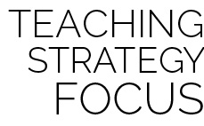

**Help students practice skills:** Jump Rope Battle Bags adds variety to jump rope lessons while providing ample opportunity for students to practice basic jumping skills. This unique, game-based practice environment provides challenge and interest while helping students development skill competency and confidence.



* Allow students to use an “invisible” jump rope when playing this activity.
* Utilize a spot marker. Students make consecutive jumps on and off the spot marker.
* Students focus on turning a shortened rope beside them, without jumping.
* Pair students with limited mobility with students with full mobility. One student turns a rope, the other jumps.