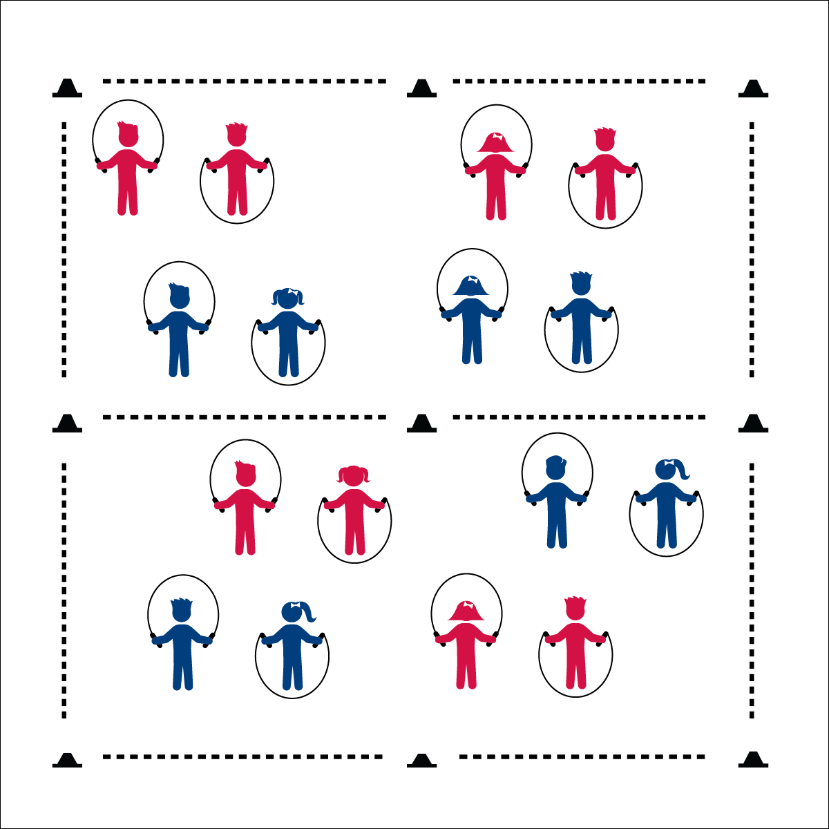

**MATCH ME IF YOU CAN**

**Activity Procedures:**

1. Match Me If You Can is a head-to-head jump rope challenge game. The object is for you to make more consecutive jumps than your partner, and then move to the Major League side of the gym where you’ll compete with another player for Major League points.
2. The gym is divided in half. We’re starting on the Minor League side, and the other is the Major League side. Play Rock, Paper, Scissors (RPS) to determine who will be Partner 1 and who will be Partner 2.
3. When I say, “GO!” Partner 1 will go first and attempt to do 15 jumps in a row. When Partner 1 is done, Partner 2 will attempt to do 15 jumps in a row. If both reach 15 jumps, play RPS again to see who wins.
4. The partner with the most consecutive jumps will move to the Major League side and look for a new partner. The other will stay on the Minor League side and look for a new partner.
5. When 2 partners compete on the Major League side, the winner stays (and earns one Major League point), and the other partner moves back to the minor league side to try again.

**Grade Level Progression:**

**3rd:** Play the game as described above.

**4th**: When students compete on the major league side, require at least 1 jump rope trick in the 15 jumps.

**5th**: Students play in pairs and perform 16 count jump rope routines to be matched by a competing pair. Provide time prior to the activity for routine development.

* **Skill**: I will do as many consecutive jumps in a row as I can using a self-turned rope.
* **Cognitive**: I will identify the components of fitness that jumping rope can enhance.
* **Fitness**: I will explain why jumping rope can enhance fitness.
* **Personal & Social Responsibility**: I will work safely with my classmates and equipment.
* Elbows In
* Wrist Circles
* Two Feet Together
* Jump to a Rhythm

**Equipment:**

* 1 jump rope per student
* 9 half cones for boundaries and mid-line

**Set-Up:**

1. Create a large activity space using 6 cones.
2. Divide the area in half using 3 other cones. One side is Minor League, the other is Major League.
3. Scatter students with ropes on the Minor League side.
4. Students face one another with enough distance to safely turn a jump rope.

**MATCH ME IF YOU CAN**



Consecutive, Two-Foot Take Off, Routine, Health-Related Fitness, Skill-Related Fitness



* **Standard 1 [E27.3-5]** Performs intermediate jump-rope skills (e.g., a variety of tricks, running in/out of long rope) for both long and short ropes (3); Creates a jump-rope routine with either a short or long rope (4); Creates a jump rope routine with a partner, using either a short or long rope (5).
* **Standard 3 [E3.3-5]** Describes the concept of fitness and provides examples of physical activity to enhance fitness (3); Identifies the components of heath-related fitness (4); Differentiates between skill-related and health-related fitness (5).
* **Standard 4 [E6.3-5]** Works independently and safely in physical activity settings (3); Works safely with peers and equipment in physical activity settings (4); Applies safety principles with age-appropriate physical activities (5).



* **DOK 2**: How does jumping rope affect your body systems?
* **DOK 3**: How is jumping rope connected to skill-related fitness?
* **DOK 4**: With a partner, create a 16-count jump rope routine that you can perform and challenge other pairs to replicate.



**Review content**: This activity provides an opportunity for teachers and students to review basic jump rope cues and concepts before moving on to work with long ropes. Use this opportunity to ensure that students are competent jumpers and understand the importance of jump rope cues and jumping rhythm.



* Allow students to use an “invisible” jump rope when playing this activity.
* Utilize a spot marker. Students make consecutive jumps on and off the spot marker.
* Remove the two zones and have the students play in one large zone. This allows students with limited mobility to stay in place, with challengers moving to work with them.
* Allow students to clap or tap to a rhythm as a substitute for jumping. They must stay on the beat of a drum or music in order to complete the correct number of consecutive “jumps.”