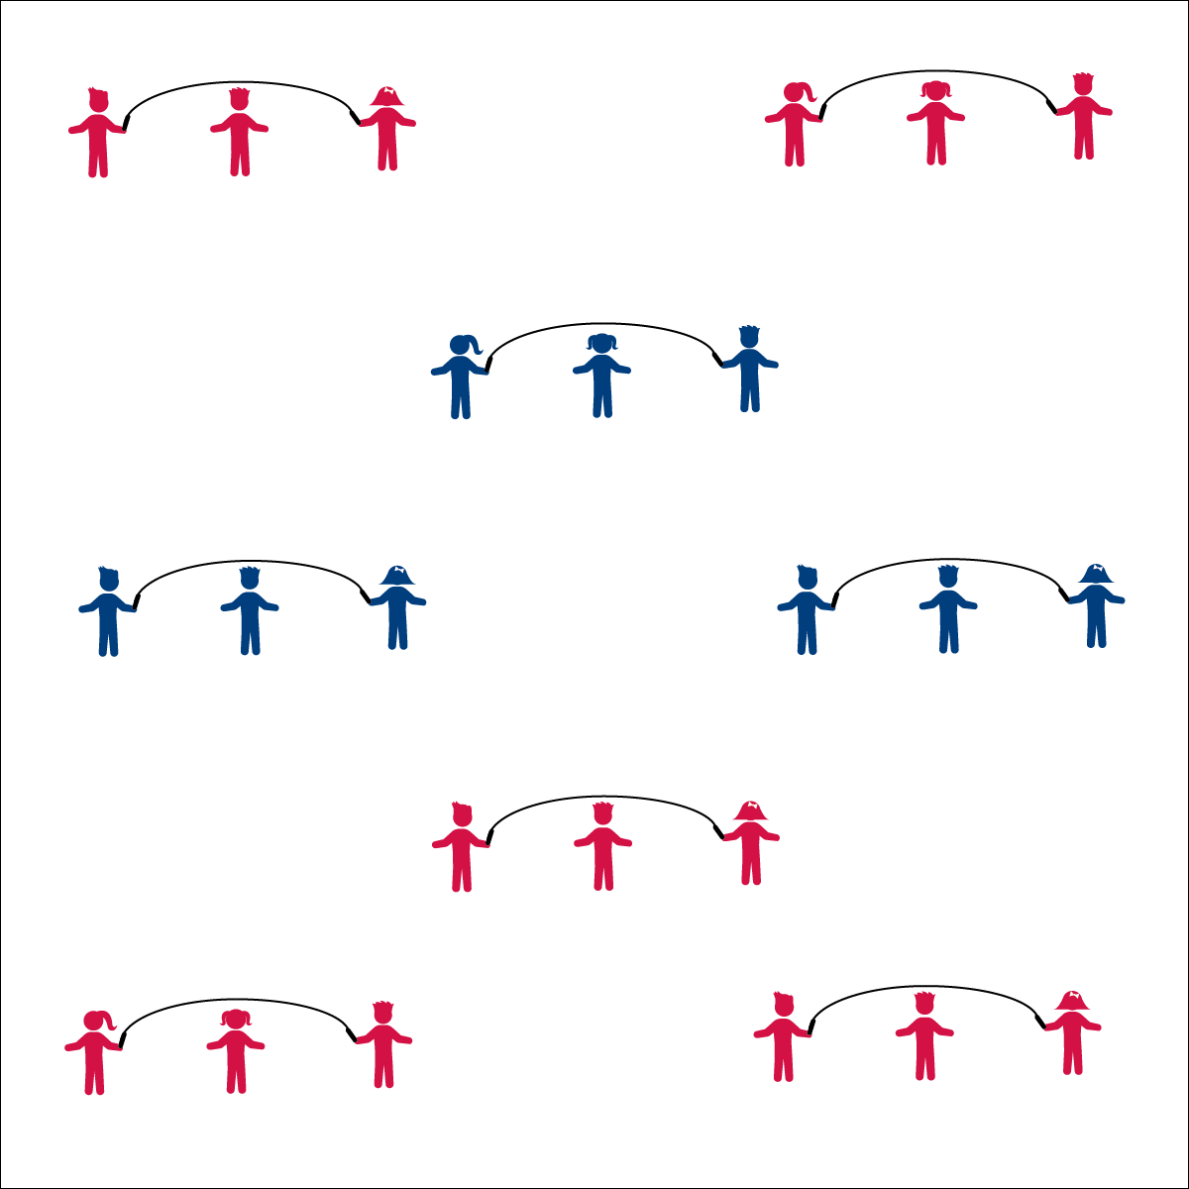

**LONG ROPE BASICS**

* **Skill:** I will successfully turn and jump a long rope.
* **Cognitive:** I will identify the components of skill-related fitness required for jumping and turning a long rope.
* **Fitness:** I will give an example of how I can improve my skill-related fitness at home.
* **Personal & Social Responsibility:** I will work cooperatively with another rope turner in order to turn a rope for a jumper to jump.
* Face Turner
* Watch Rope
* Small Jumps
* Keep the Rhythm
* Turn with Arms
* Watch Jumper’s Feet
* Keep the Rhythm

**Equipment:**

* 1 long jump rope per 3 students
* 1 Long Rope Progression Card per 3 students

**Set-Up:**

1. Divide students into groups of 3, each group with a long jump rope.
2. Scatter groups in general space with enough room to turn the rope safely.
3. Provide each group with a Long Rope Progression Card.

**Activity Procedures:**

1. Today we are going to work on skills using long jump ropes. In groups of 3 you will practice turning and jumping the rope by following the skill instructions on the Long Rope Progression Card.
2. When I see that a group has mastered one of the skills on the card, I’ll stop the class so we can watch a demonstration.
3. When you hear the music, begin. When you hear the music stop, freeze and listen for instructions.

**Grade Level Progression:**

**3rd:** Complete the activity as described above.

**4th:** Allow advanced students to perform basic tricks during their turn as jumpers.

**5th:** Allow groups of 3 or 4 to create basic long rope routines.

**LONG ROPE BASICS**



Success, Long Rope, Turn, Rhythm, Improve, Skill-Related Fitness



* Designate students as all-time turners.
* Provide a teaching assistant or peer coach to help students turn the rope.
* Turn the rope very slowly with students stepping over the rope.



**Help students examine similarities and differences:** Students new to long rope jumping may be intimidated by the lack of control over the long rope turning. Taking time to explore the similarities to short rope jumping (e.g., rhythm, timing, basic jump technique) will help students connect prior success to this new task. Likewise, examining the difference between the two skills will help them understand the new cues and cooperative requirements of long rope jumping.



* **DOK 1:** What is skill-related fitness?
* **DOK 1:** What are the components of skill-related fitness?
* **DOK 2:** Which components of skill-related fitness are used when turning and jumping a long jump rope?
* **DOK 1:** What does the word rhythm mean?
* **DOK 2:** How does rhythm apply to jumping rope?
* **DOK 3:** What happens if the turners and jumpers are not in the same rhythm? Why?



* **Standard** **1 [E27.3-5]** Performs intermediate jump-rope skills (e.g., a variety of tricks, running in/out of long rope) for both long and short ropes (3); Creates a jump-rope routine with either a short or long rope (4); Creates a jump rope routine with a partner, using either a short or long rope (5).
* **Standard 3 [E3.3-5]** Describes the concept of fitness and provides examples of physical activity to enhance fitness (3); Identifies the components of health-related fitness (4); Differentiates between skill-related and health-related fitness (5).
* **Standard 4 [E4.3-5]** Works cooperatively with others (3a); Praises others for their success in movement performance (3b); Praises the movement performance of others both more- and less-skilled (4a); Accepts “players” of all skill levels into the physical activity (4b); Accepts, recognizes, and actively involves others with both higher and lower skill abilities into physical activities and group projects (5).