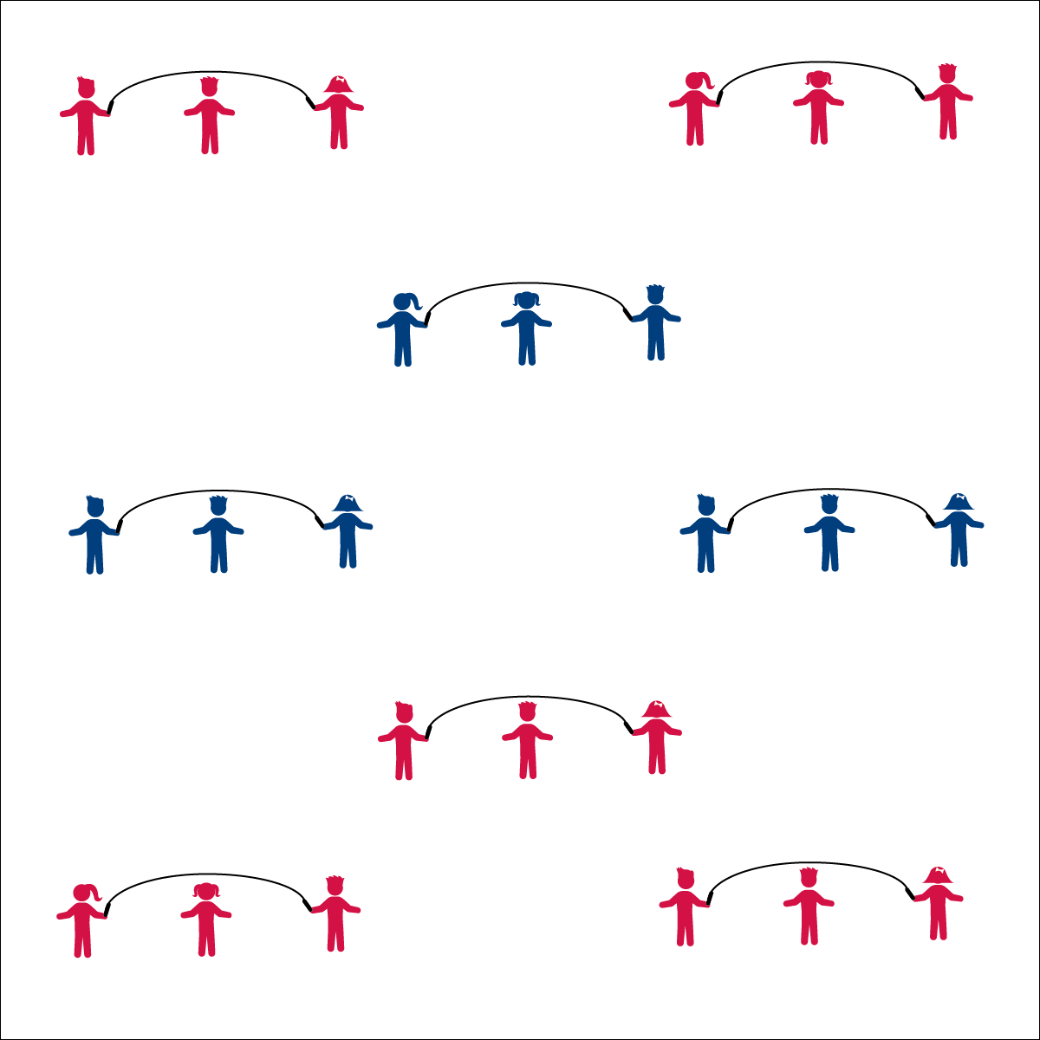

**LONG ROPE RHYMES**

* **Skill:** I will successfully turn and jump a long rope.
* **Cognitive:** I will recite jump rope rhymes, in rhythm with my partners.
* **Fitness:** I will identify the component of health-related fitness required when jumping and reciting rhymes.
* **Personal & Social Responsibility:** I will work cooperatively with my group to complete each rhyme.
* Face Turner
* Watch Rope
* Small Jumps
* Keep the Rhythm
* Turn with Arms
* Watch Jumper’s Feet
* Keep the Rhythm

**Equipment:**

* 1 long jump ropes per 3 students
* Rhyme Cards

**Set-Up:**

1. Divide the class into groups of 3 or 4, each group with a long jump rope.
2. Have the students spread out in general space with enough space to turn the rope safely.

**Activity Procedures:**

1. Today we’ll be combining our long jump rope skills with some classic jump rope rhymes.
2. When I say, “GO!” follow the Rhyme Cards with your partners when you jump.
3. After you master each rhyme, work to try all of the different tricks that you’ve learned with your group.

**Grade Level Progression:**

**3rd:** Complete the activity as described above.

**4th:** Allow advanced students to perform basic tricks while completing jump rope rhymes.

**5th:** Challenge students to create their own rhymes.



* Use Velcro on gloves and rope handles to help students hold and turn.
* Allow students to jump next to the turning rope, in rhythm with the turning.
* Swing the rope slowly and allow students to step over the rope.
* Designate a student(s) as the rhyme caller.



**Help students engage in cognitively complex tasks:** The process of memorizing and reciting rhymes while also focusing on successful rope turning and jumping adds additional complexity to the already dynamic tasks of turning or jumping a long rope. This allows students to practice a level of complexity that can then be applied to the creation, memorization, and successful completion of jump rope routines. In both tasks, students must take their focus off of jumping/turning skills in order to execute a rhyme or routine. This helps to build students’ capacity for increasingly complex skill combinations.



* **DOK 1:** How can you recognize groups that are cooperating?
* **DOK 2:** How does cooperation affect a group’s performance?
* **DOK 2:** What are ways that you can cooperate with others in this activity?
* **DOK 1:** How can you recognize a successful Jump Rope Rhyme Routine?
* **DOK 2:** How would you summarize your group’s participation performance today in relation to cooperation? In relation to fitness?



* **Standard** **1 [E27.3-5]** Performs intermediate jump-rope skills (e.g., a variety of tricks, running in/out of long rope) for both long and short ropes (3); Creates a jump-rope routine with either a short or long rope (4); Creates a jump rope routine with a partner, using either a short or long rope (5).
* **Standard 3 [E3.3-5]** Describes the concept of fitness and provides examples of physical activity to enhance fitness (3); Identifies the components of health-related fitness (4); Differentiates between skill-related and health-related fitness (5).
* **Standard 4 [E4.3-5]** Works cooperatively with others (3a); Praises others for their success in movement performance (3b); Praises the movement performance of others both more- and less-skilled (4a); Accepts “players” of all skill levels into the physical activity (4b); Accepts, recognizes, and actively involves others with both higher and lower skill abilities into physical activities and group projects (5).



Success, Long Rope, Turn, Rhythm, Rhyme, Improve, Cooperate

**LONG ROPE RHYMES**