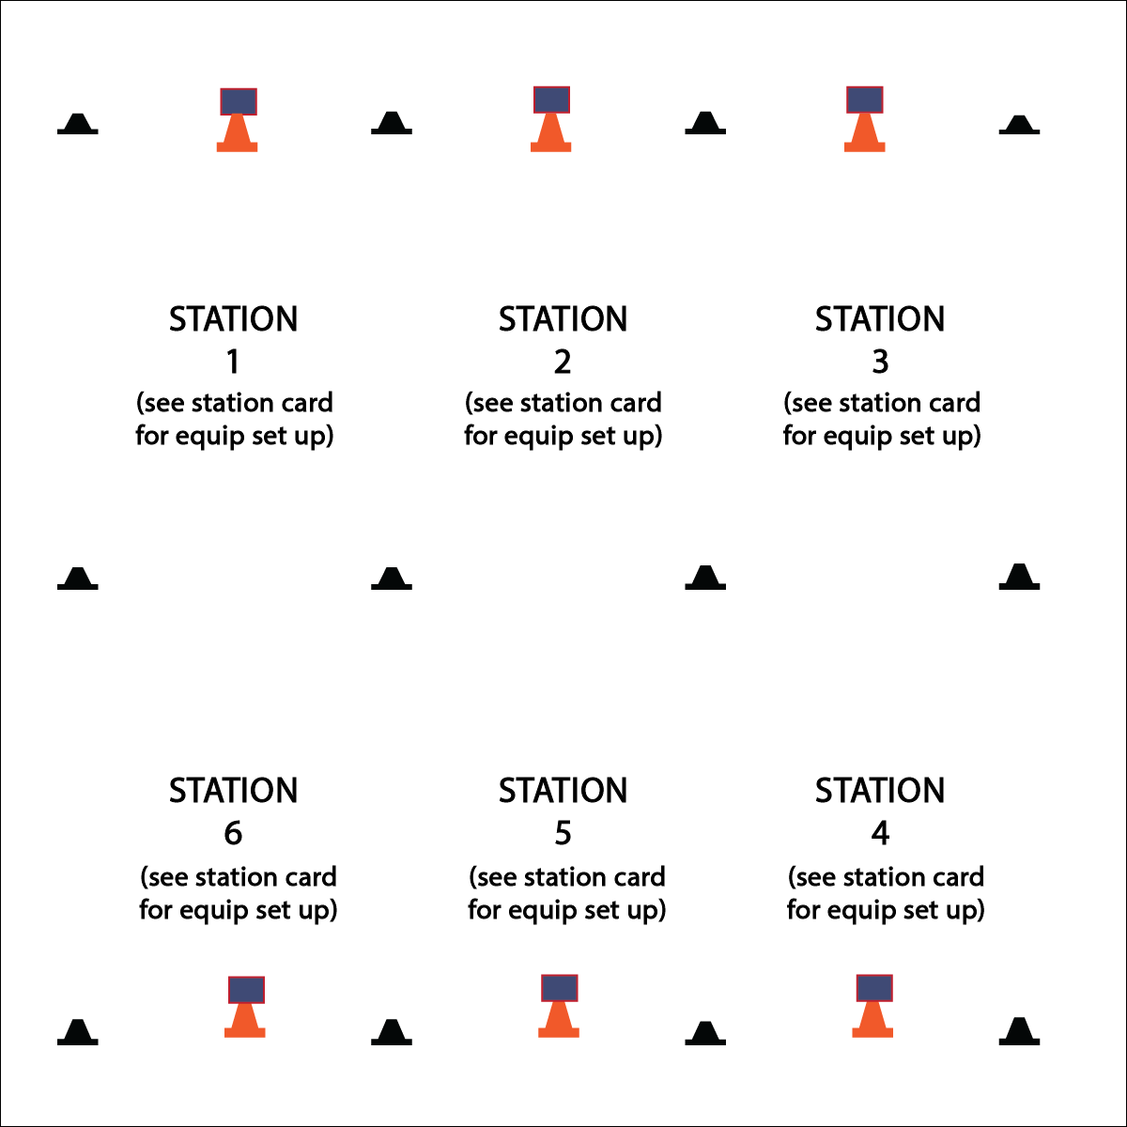

* Work Safely by Respecting Self-Space
* Work Responsibly and Independently at Each Station
* Clean Station Equipment Before Rotating

**Activity Procedures:**

1. Today’s station day activity is called Survival Mode! This is the day when you’ll put the jump rope skills and tricks that you’ve learned to the test.
2. At each station there will be a Survival Mode Challenge Card that will give you challenge options with 3 levels of difficulty. Your group will have 2 (or 3) minutes to select and complete one of the challenges.
3. When the music starts, begin working at your station. When it stops, you’ll have 1 minute to clean up the station equipment and rotate to the next station. Wait until the music begins again before starting the next activity.

**Grade Level Progression:**

**3rd:** Complete the activity as described above.

**4th & 5th:** Add an element of competition by completing the stations in adventure race format. Each team starts at a different station. Groups complete each challenge as quickly as possible in order be the first group back to their original station.

**Equipment:**

* See station cards for equipment needs
* 12 low profile cones
* 6 large cones
* 6 Task Tents
* Survival Mode Station Cards

**Set-Up:**

1. Use low profile cones to create 6 stations. Each station should have a large cone, task tent, and station card.
2. Divide class into 6 groups. (Create more stations to accommodate large class sizes.)

* **Skill:** I will perform the jump rope skills necessary to complete each challenge.
* **Cognitive:** I will answer challenge questions related to jump rope and fitness.
* **Fitness:** I will answer challenge questions related to nutrition and food choices.
* **Personal & Social Responsibility:** I will work cooperatively and provide praise and encouragement to my group.

**SURVIVAL MODE STATIONS**

**SURVIVAL MODE STATIONS**



Challenge, Nutrition, Food Choice, Hydration, Speed, Endurance, Pace



* **Standard** **1 [E27.3-5]** Performs intermediate jump-rope skills (e.g., a variety of tricks, running in/out of long rope) for both long and short ropes (3); Creates a jump-rope routine with either a short or long rope (4); Creates a jump rope routine with a partner, using either a short or long rope (5).
* **Standard 2 [E3.3-5c]** Combines movement concepts (direction, levels, force, time) with skills as directed by the teacher (3); Applies the movement concepts of speed, endurance and pacing for running (4a). Analyzes movement situations and applies movement concepts (e.g., force, direction, speed, pathways, extensions) in small-sided practice task/game environments, dance and gymnastics (5c).
* **Standard 3 [E3.3-5]** Describes the concept of fitness and provides examples of physical activity to enhance fitness (3); Identifies the components of health-related fitness (4); Differentiates between skill-related and health-related fitness (5).
* **Standard 3 [E6.3-5]** Identifies foods that are beneficial for pre- and post-physical activity (3); Discusses the importance of hydration and hydration choices relative to physical activities (4); Analyzes the impact of food choices relative to physical activity, youth sports & personal health (5).
* **Standard 4 [E4.3-5]** Works cooperatively with others (3a); Praises others for their success in movement performance (3b); Praises the movement performance of others both more- and less-skilled (4a); Accepts “players” of all skill levels into the physical activity (4b); Accepts, recognizes, and actively involves others with both higher and lower skill abilities into physical activities and group projects (5).
* **Standard 5** **[E1.3-5]** Discusses the relationship between physical activity and good health (3); Examines the health benefits of participating in physical activity (4); Compares the health benefits of participating in selected physical activities (5a).



* **DOK 1:** What does hydration mean?
* **DOK 2:** How does hydration relate to physical activity?
* **DOK 3:** What foods help you prepare for physical activity? Why?
* **DOK 3:** How are your food choices related to your personal health?

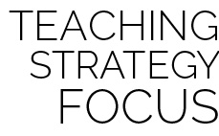

**Help students process content:** Survival Mode Stations shifts the focus from direct instruction to guided discovery as students use the skills previously learned to complete both cognitive and performance challenges. Students work in cooperative groups to read, comprehend, and process tasks/challenges in order to demonstrate content comprehension, skill competence, and cooperative abilities.



* Provide a variety of equipment for students to jump over and on (i.e., a variety of ropes, spot markers, low profile cones, rhythm bands, etc.).
* Provide different challenge areas with tasks that match various skills and abilities, allowing students to choose their levels of participation.
* Provide one-to-one instruction utilizing teaching assistants and/or peer coaches.