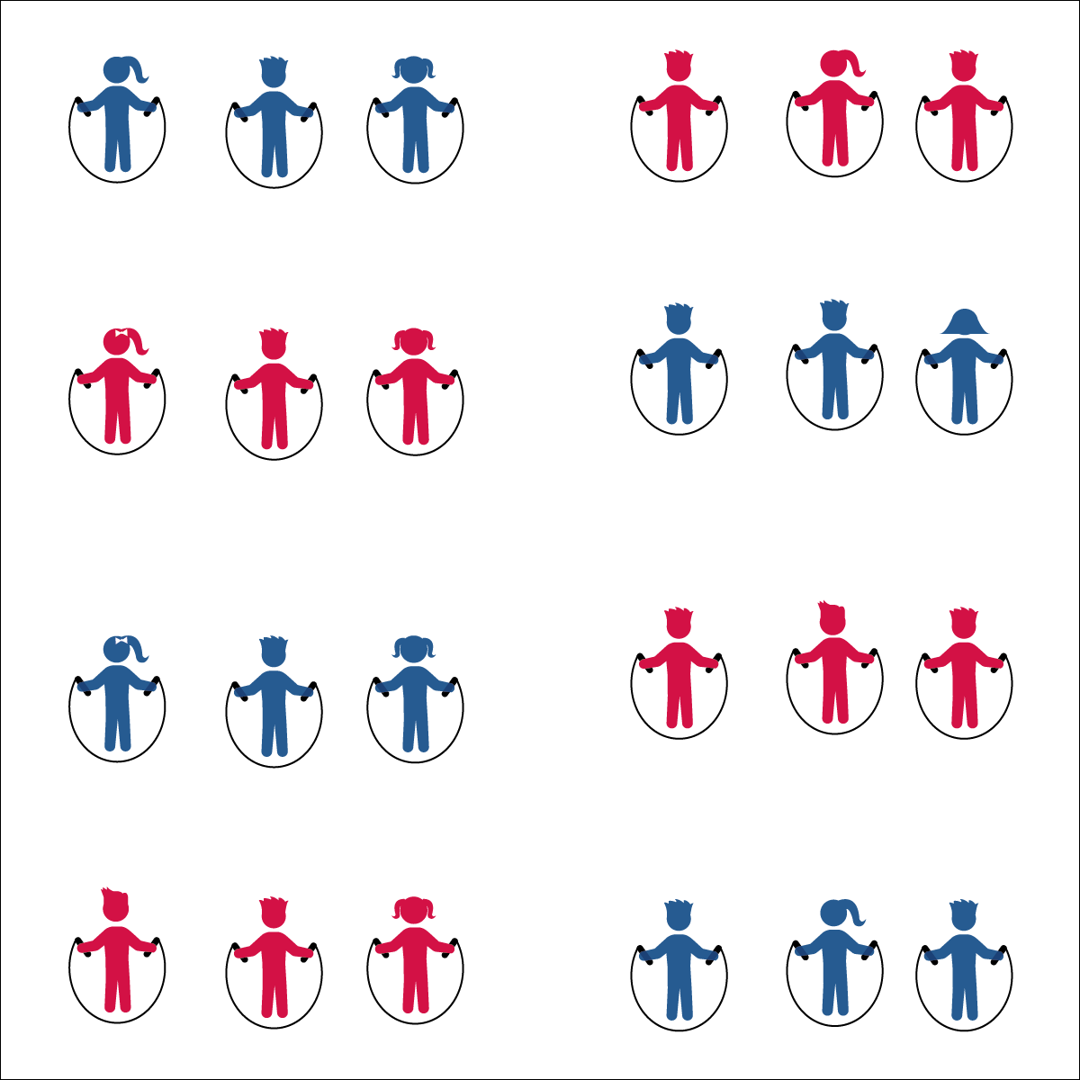

**JUMP ROUTINES**

* **Skill:** I will perform a jump rope routine.
* **Cognitive:** I will complete a practice chart to track my jump rope activity outside of physical education class.
* **Fitness:** I will list 3 ways to improve my health-related fitness outside of physical education class.
* **Personal & Social Responsibility:** I will accept, recognize, and actively involve others in my group regardless of skill level.
* Accept Everyone
* Cooperate and Contribute
* Praise Others

**Equipment:**

* 1 jump rope per student
* 1 long rope per 3 students (as needed)
* 1 Jump Rope Routine Task Card per group
* Music

**Set-Up:**

1. Divide students into groups of 3 (or 4), each student with a jump rope.
2. Scatter groups in general space with enough room to turn ropes safely.
3. Provide each group with a Routine Task Card.

**Activity Procedures:**

1. Today you’ll work in groups of 3 (or 4) to complete musical jump rope routines that you can perform for an audience.
2. Each Jump Rope Routine Task Card gives your group a guideline for completing (or creating) a routine. If you create a routine, you can use skills and tricks that you’ve learned in class, tricks that you’ve learned at home, or tricks that you’ve invented.
3. The next time our class meets, you’ll have a few minutes to practice your routine and then will perform it for your classmates. If at all possible, practice your routines before and after school, as well as at recess.

**Grade Level Progression:**

**3rd:** Students perform teacher-assigned routines.

**4th:** Students perform short rope routines that they create individually.

**5th:** Students perform either short or long rope routines that they create cooperatively with group members.

**JUMP ROUTINES**



Cooperate, Practice, Track, Analyze, Accept, Recognize, Actively Involve, Routine



* **Standard** **1 [E27.3-5]** Performs intermediate jump-rope skills (e.g., a variety of tricks, running in/out of long rope) for both long and short ropes (3); Creates a jump-rope routine with either a short or long rope (4); Creates a jump rope routine with a partner, using either a short or long rope (5).
* **Standard 2 [E3.3-5c]** Combines movement concepts (direction, levels, force, time) with skills as directed by the teacher (3); Applies the movement concepts of speed, endurance and pacing for running (4a). Analyzes movement situations and applies movement concepts (e.g., force, direction, speed, pathways, extensions) in small-sided practice task/game environments, dance and gymnastics (5c).
* **Standard 3 [E1. 3-5]** Charts participation in physical activities outside physical education class (3a); Identifies physical activity benefits as a way to become healthier (3b); Analyzes opportunities for participating in physical activity outside physical education class (4); Charts and analyzes physical activity outside physical education class for fitness benefits of activities (5).
* **Standard 4 [E4.3-5]** Works cooperatively with others (3a); Praises others for their success in movement performance (3b); Praises the movement performance of others both more- and less-skilled (4a); Accepts “players” of all skill levels into the physical activity (4b); Accepts, recognizes, and actively involves others with both higher and lower skill abilities into physical activities and group projects (5).



* **DOK 1:** Let’s list all of the benefits of being physically active
* **DOK 2:** How can charting our physical activity outside of physical education help us understand and improve our personal health?
* **DOK 3:** How can we use the information from an activity chart to improve our fitness?



**Engage students in cognitively complex tasks**: Working with peers to create a short jump rope routine can be both cognitively and socially complex. This exercise provides students with a practice task that combines personal fitness, rope jumping skills, cooperative skills, and the ability to count (“feel”) music. This task can be used as either a formative or summative assessment opportunity.



* Allow students to create jumping routines without a rope.
* Allow students to create Hand Jive Routines.
* Allow students to choose the tempo of their routine music.
* Provide a teaching assistant for groups needing help/support.