­­­

* Jump
* Two-Foot Take Off
* Vertical
* Enhance
* Fitness

­

* Self Assessment (Jumping a Short Rope)
* **Skill:** I will practice a variety of jump rope skills using the cues my teacher gives me in class.
* **Cognitive:** I will give examples of physical activities that enhance fitness.
* **Fitness:** I will work to stay actively engaged during all of the jump rope activities.
* **Personal & Social Responsibility**: I will demonstrate safe behaviors without being reminded by a teacher.
* **Standard 1 [S1.E4.3]** Jumps and lands in the vertical plane using a mature pattern (3).
* **Standard 1 [E27.3-5]** Performs intermediate jump-rope skills (e.g., a variety of tricks, running in/out of long rope) for both long and short ropes (3).
* **Standard 3 [E3.3-5]** Describes the concept of fitness and provides examples of physical activity to enhance fitness (3); Identifies the components of health-related fitness (4); Differentiates between skill-related and health-related fitness (5).

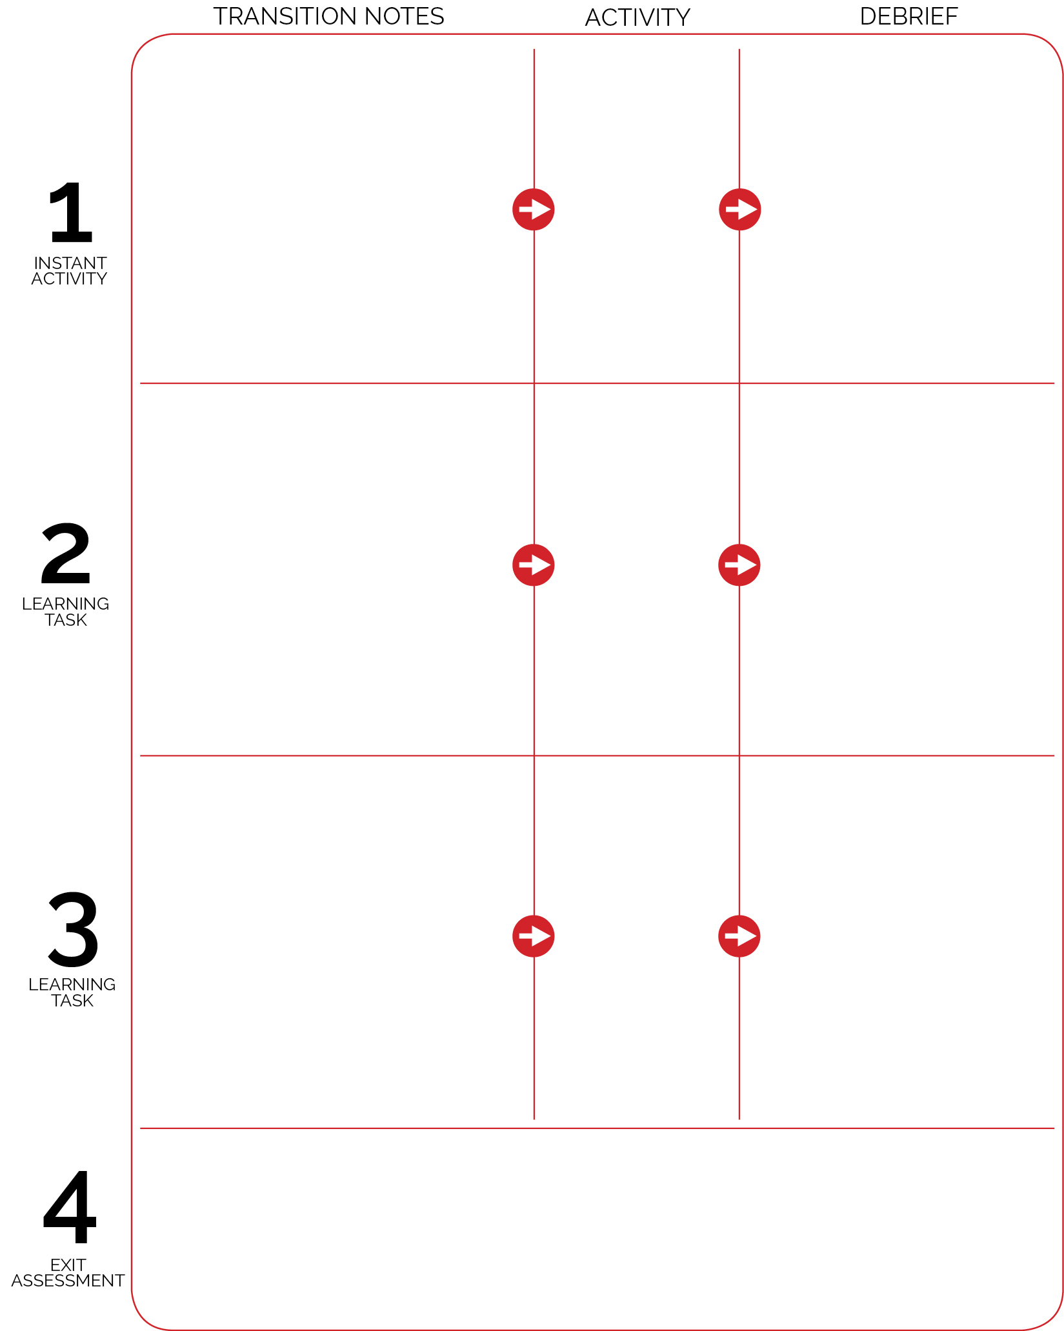

As students enter the activity area, the class will be playing Pick a Card. The Pick a Card Challenge Posters will be modified to include Invisible Jump Rope as the physical activity to perform.

Jump rope stations are set up around the perimeter of the area with enough room in the center for activity.

**DOK 1:** What are the health benefits of jumping rope?

**DOK 2:** How do the benefits of jumping rope compare to the benefits of other physical activities (e.g., push-ups, jogging, yoga, etc.)?

**DOK 3:** How is physical activity related to good health (physical, mental, emotional)?

Creative Mode Stations

Self Assessment (Jumping a Short Rope)

Discuss the self-assessment, providing guidance to the class as a whole on how to honestly complete the assessment. Prompt students to think about their own personal assessment, which will be completed at the start of next class.

**DOK 1:** What are some examples of activities that enhance fitness?

**DOK 2:** How does jumping rope enhance health-related fitness?

**DOK 3:** Which components of fitness would be most impacted if you jumped rope every day? Why?

**DOK 1:** What are the 5 food groups?  
**DOK 2:** Who can tell the class why it’s important to eat foods from the different food groups throughout the day?

Back to Basics

Pick A Card

Gather students to view video highlights of world jump rope championships (YouTube). Briefly speak about the history of jumping rope.

Students then collect a rope from the equipment areas on the perimeter of the activity area and find open space with enough room to safely jump rope. Review cues and progression.

With students in the center of the area, briefly explain and demonstrate each Creative Mode Station. Explain that the skills at each station will be used later in the module to complete challenges.

Create 6 groups and send each group to a station. Allow those who would like more help with the basic cues to remain in the center of the area of additional help.