**BASIC ROPE JUMPING**



Perform basic jumps while staying on a spot marker.

**CREATIVE MODE 1**



**Choose 1 of 2 jump rope tricks to perform at this station.**

1. Bell Front and Back
2. Ski Jump

**MATCH ME IF YOU CAN**



1. Challenge a partner to a game of Match Me If You Can.
2. The object is to make more consecutive jumps than your partner makes.
3. If both partners reach 15 jumps in a row, play Rock, Paper, Scissors to see who wins.
4. Score a Match Point to win a round. How many Match Points can you collect before you hear the stop signal?
5. As an optional challenge, add a different trick into each round.

**LONG ROPE BASICS**



1. Take turns jumping the long rope for 5 to 10 consecutive jumps.
2. Change places when the jumper has made at least 5 jumps (10 jumps maximum).
3. As an optional challenge, perform a moving entrance and exit.

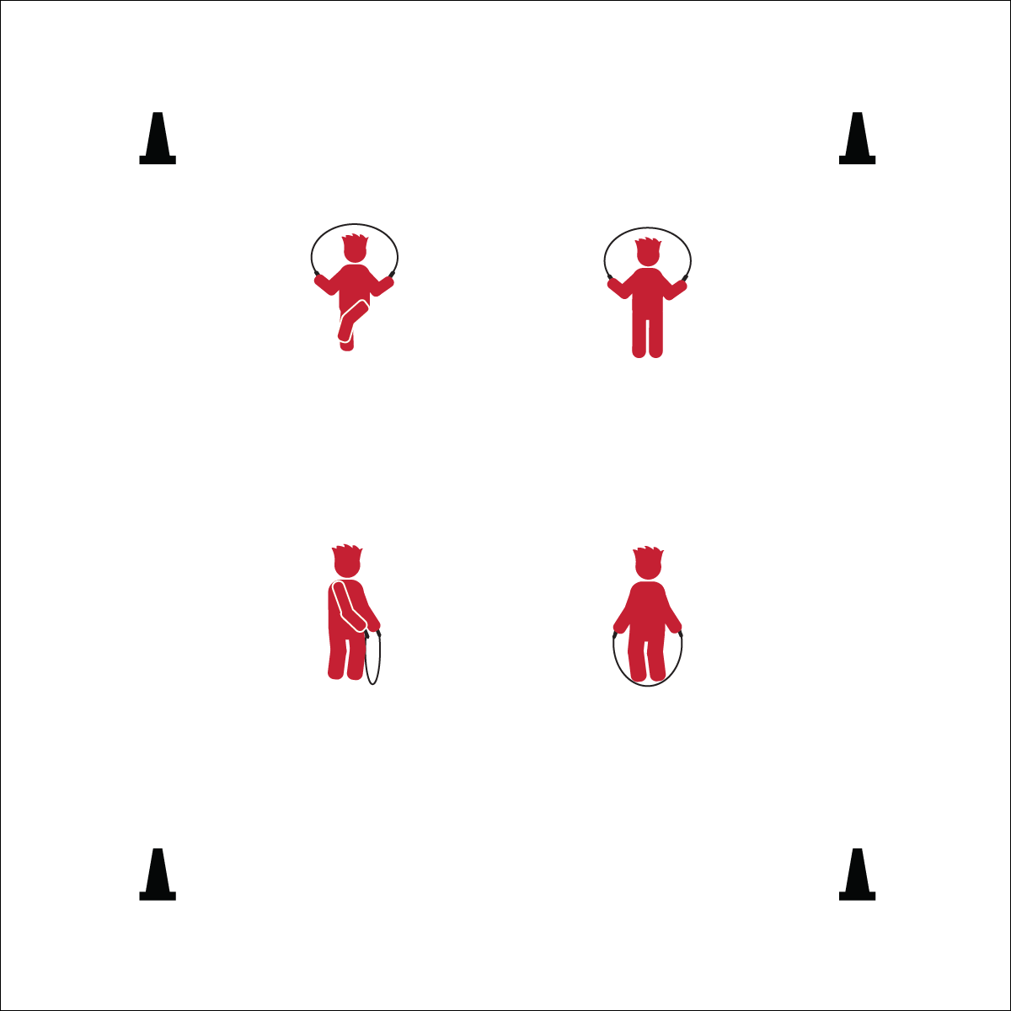

**Choose 1 of 2 jump rope tricks to perform at this station.**

1. Kick Bounce
2. Side Turn Bounce

**CREATIVE MODE 2**



1. Complete the Assessment for Jump Rope Skills
2. When you’re finished, perform jump rope rhymes while jumping a short rope.
3. As an optional challenge, create and perform a new rhyme.

**SELF-ASSESSMENT**