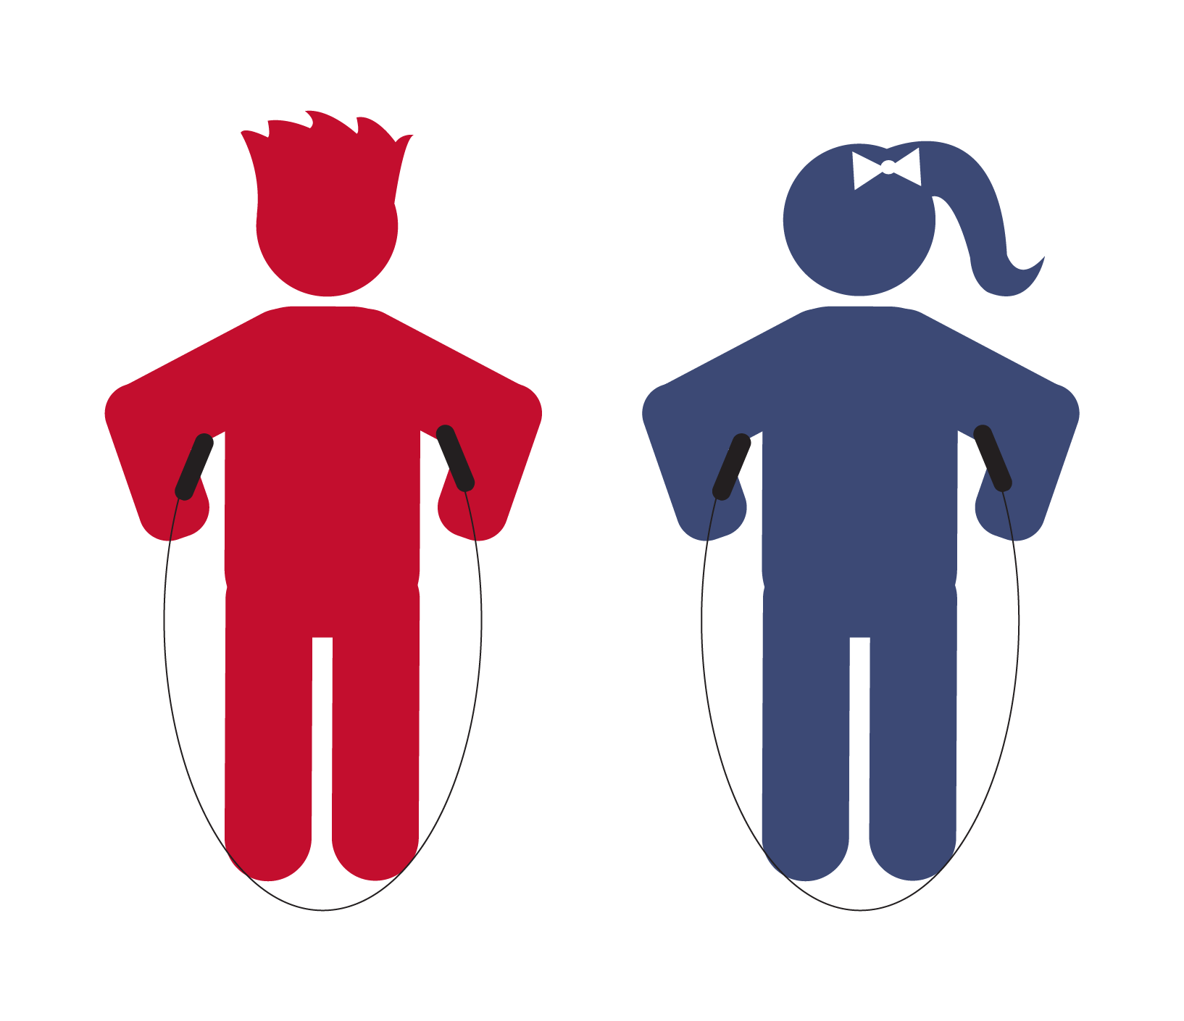

**Step 1:**

Hold the ends of the jump rope in each hand.

**Step 2:**

Step on the middle of the rope with both feet.

**Step 3:**

Bring the ends of the rope straight up by your side.

**Step 4:**

See if it’s the right length. The ends of the rope should come near your armpits.