Level 1  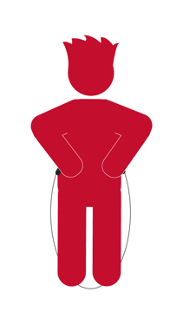  Knuckle Bump + Turn Rope | Level 2  Knuckle Bump + Turn Rope + Trap with Feet
Level 3  Knuckle Bump + Turn Rope + Trap with Feet + Jump Over Once | Level 4  Knuckle Bump + Turn Rope + Jump Over Once
Level 5
Knuckle Bump + Turn Rope + Jump + Keep Jumping

