**Basic Jump (2 Feet)**

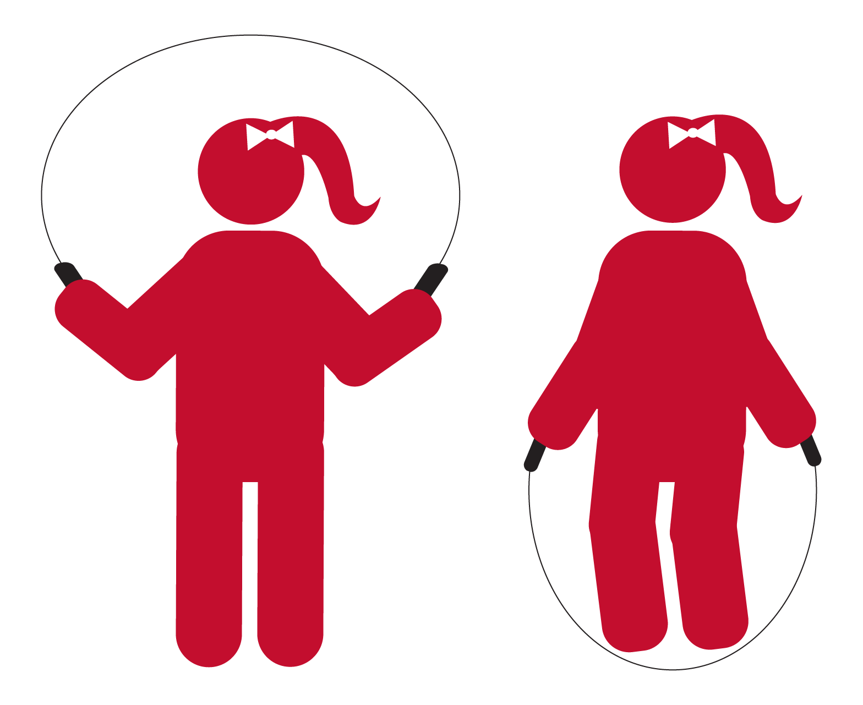

* Feet and knees together
* Two-foot take off and landing
* Stay on balls of feet
* JUMP, JUMP, JUMP

**Side Turns**

* Both handles swing right
* Both handles swing left
* Repeat side to side
* Right, Left, Right, Left

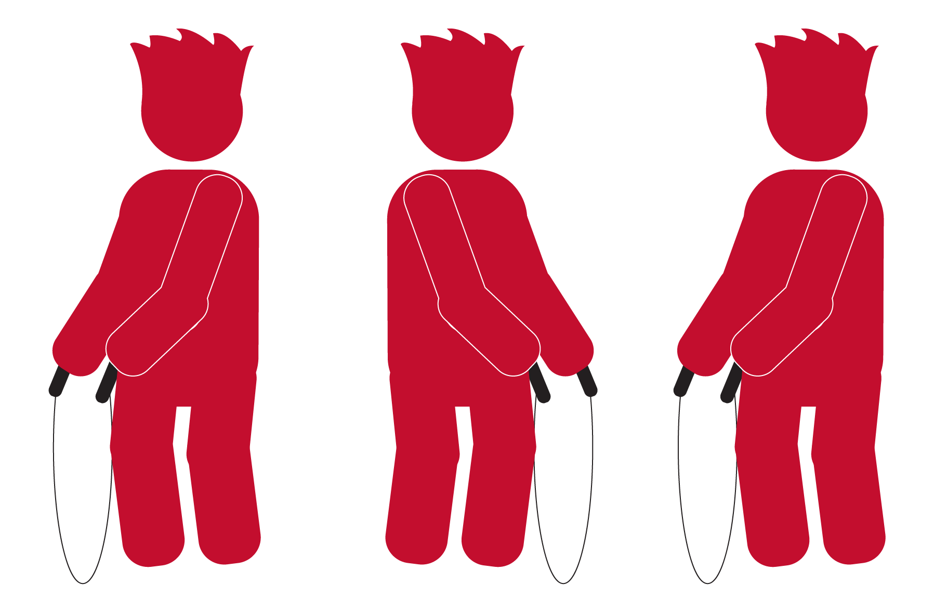

**Side Turn Jump**

* Both handles swing right
* Both handles swing left
* Jump to center
* Right, Left, Jump

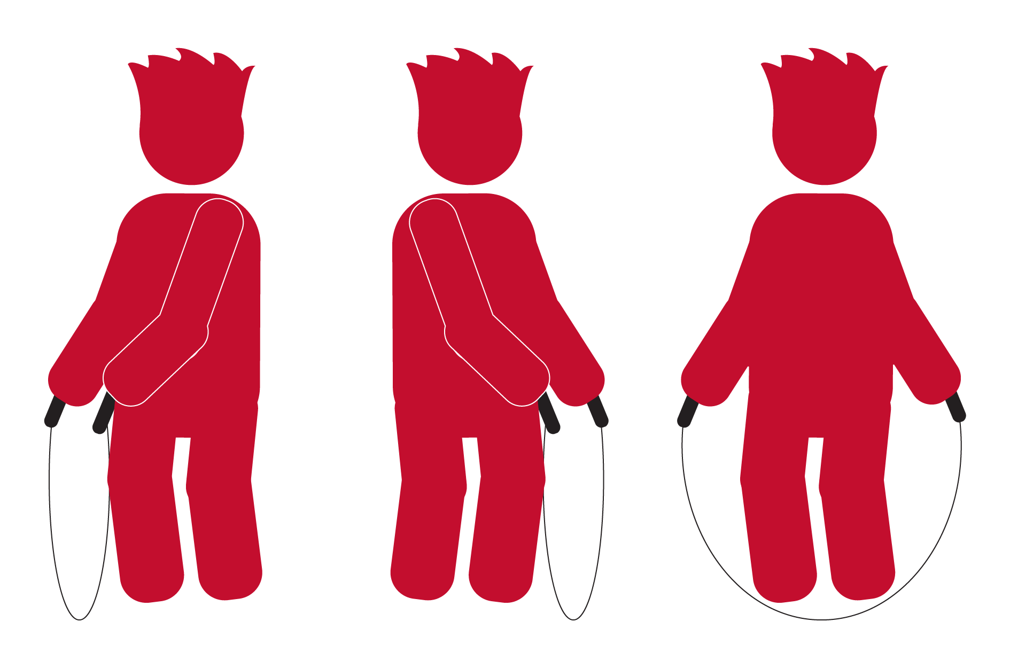

**Bell Jump (Front and Back)**

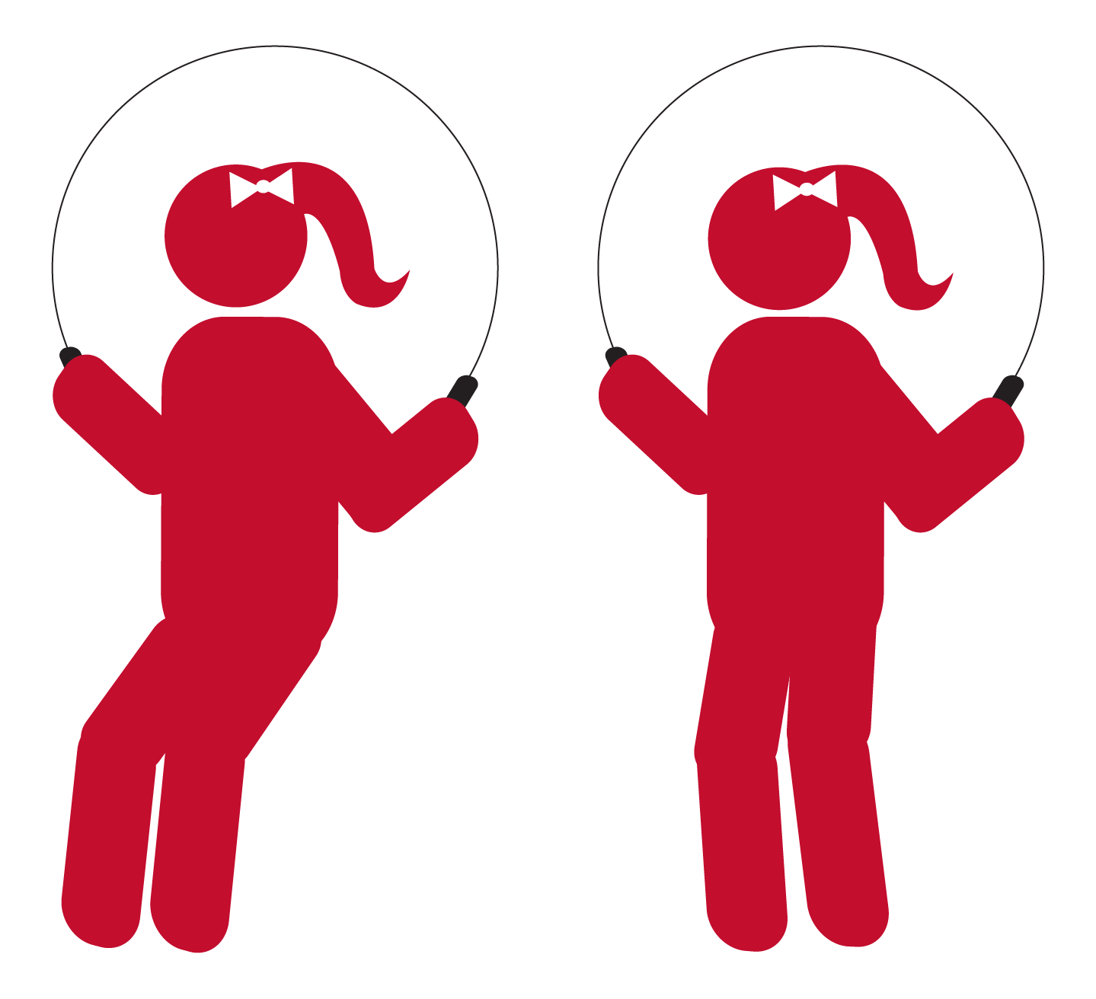

* Jump over forward
* Jump over backward
* Forward, Back, Forward, Back

**Forward Straddle Jump**

* Jump & straddle right to front
* Jump & straddle left to front
* Right, Left, Right, Left

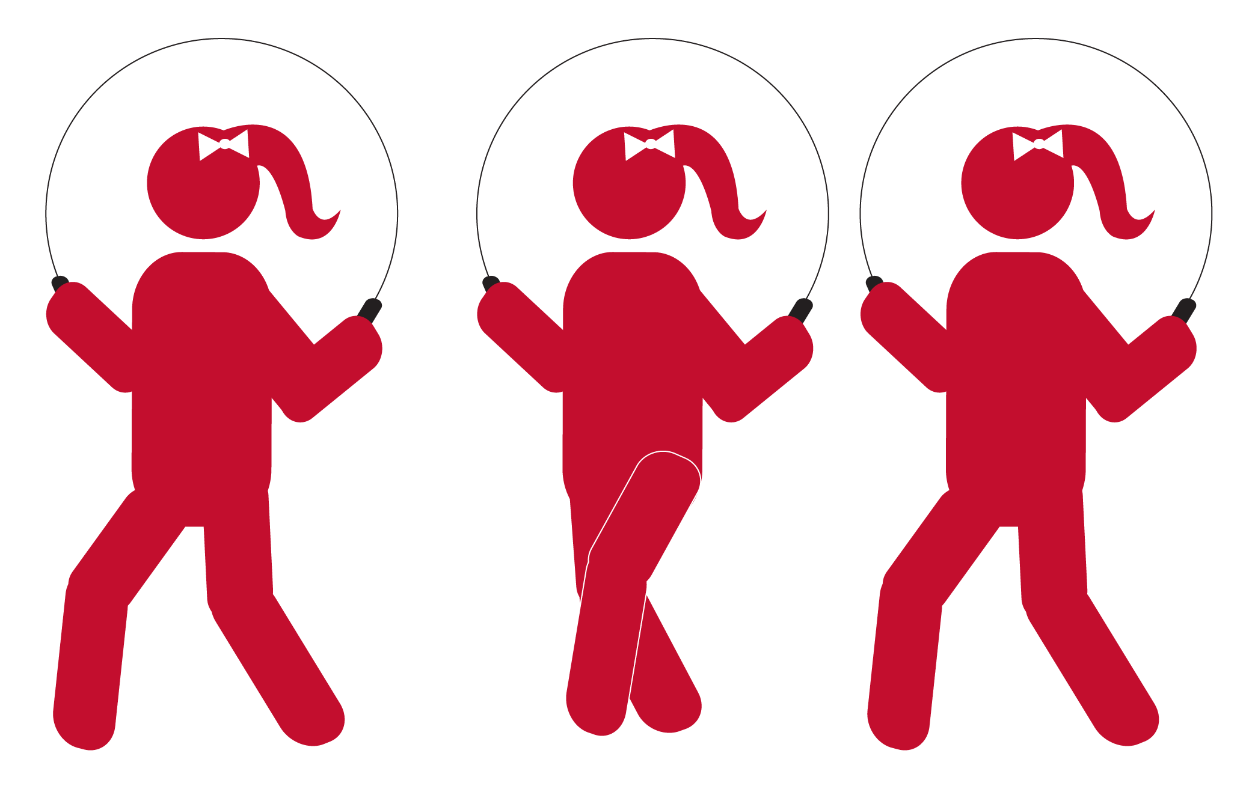

**Side Straddle**

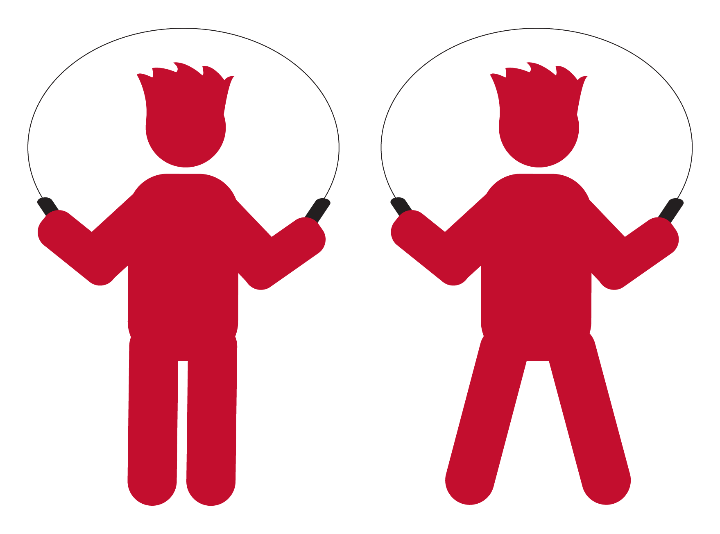

* Basic jump
* Jump to straddle
* Basic, Straddle, Basic, Straddle

**Heel to Heel**

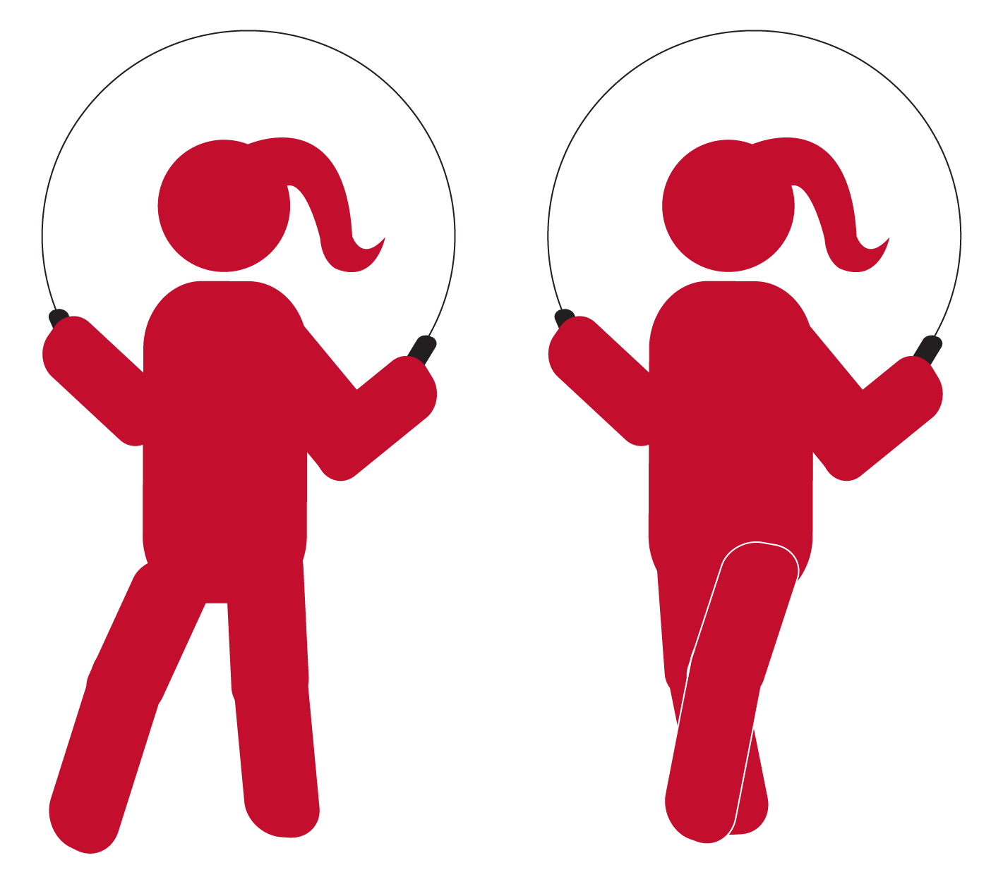

* Jump, right heel front
* Jump, left heel front
* Right, Left, Right, Left

**Toe to Toe**

* Jump, right toe back
* Jump, left toe back
* Right, Left, Right, Left

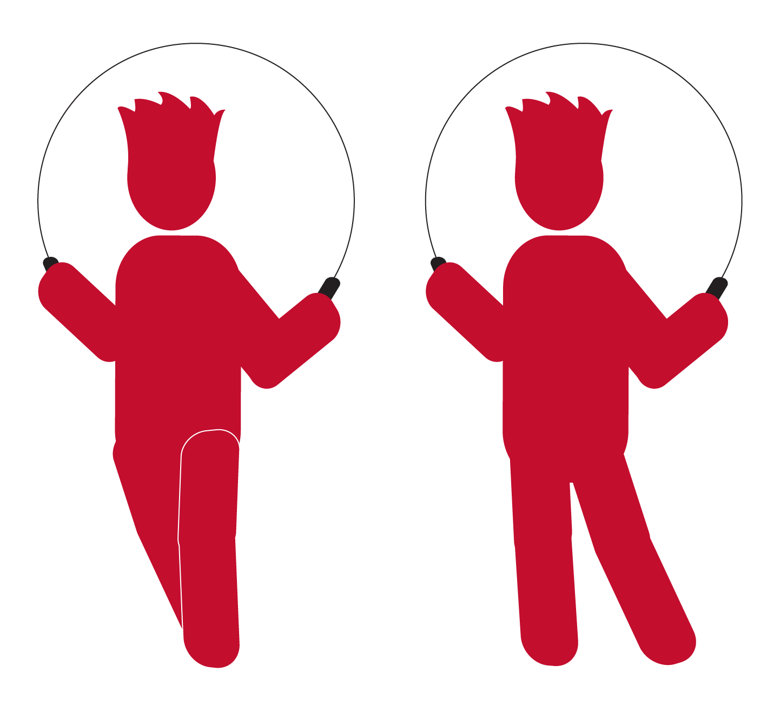

**Heel Toe Bounce**

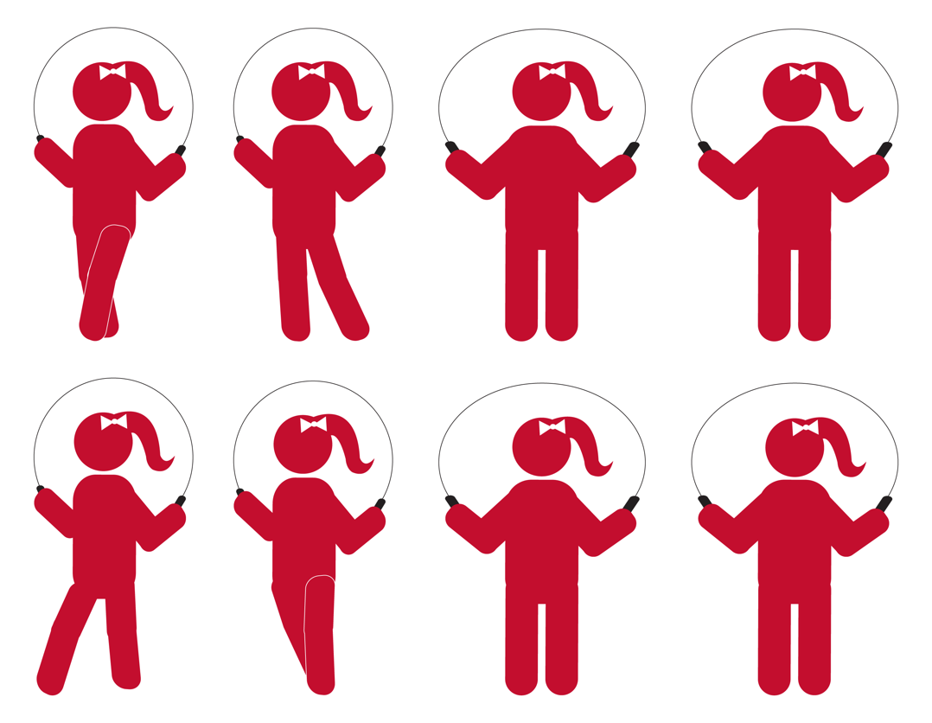

* Jump, heel front
* Jump, toe back
* Bounce
* Bounce
* Heel, Toe, Bounce, Bounce

**Kick Bounce**

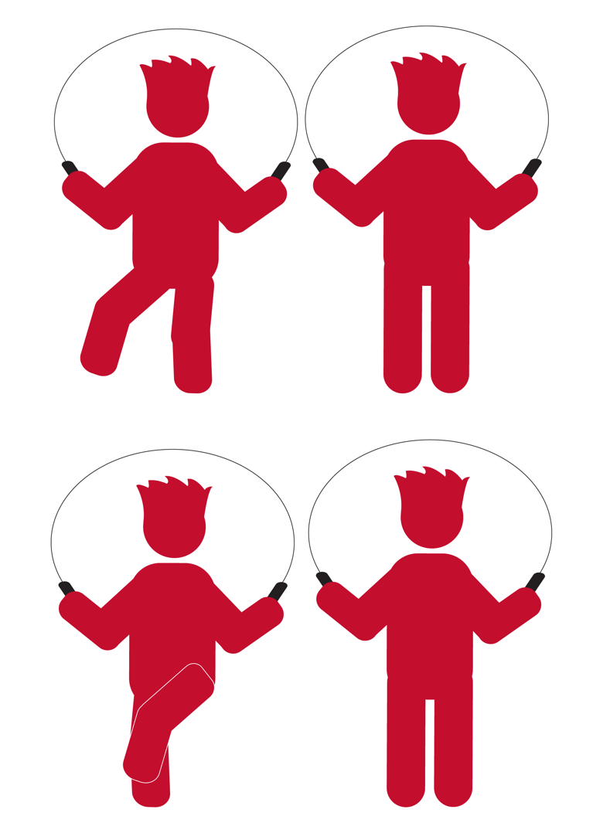

* Jump, right kick
* Basic jump
* Jump, left kick
* Basic jump
* Kick, Bounce, Kick, Bounce

**Ski Jump Side to Side**

* Jump Left
* Jump Right
* Left, Right, Left, Right

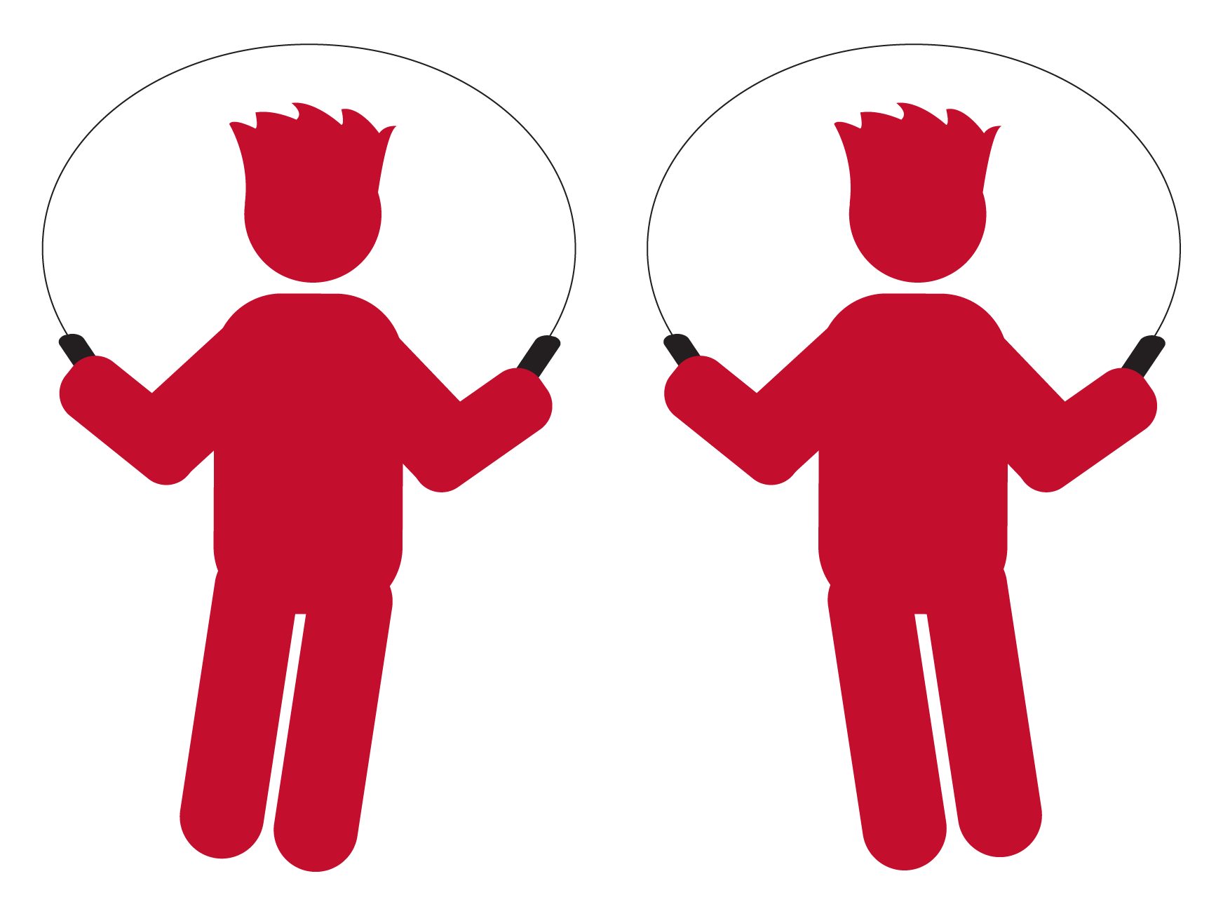

**Double Under**



* Jump for rhythm
* Jump high and double under
* Jump, Two, Three, Double