Level 1 – Cooperative Turning  1, 2, 3 and Over  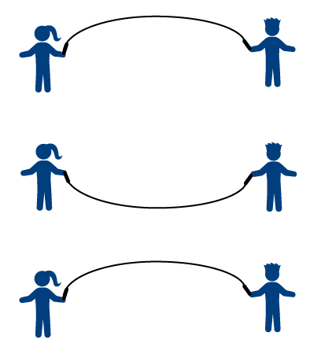 | Level 2 – Center Jump  Stand in Center, Face 1 Turner,  Turn and Jump  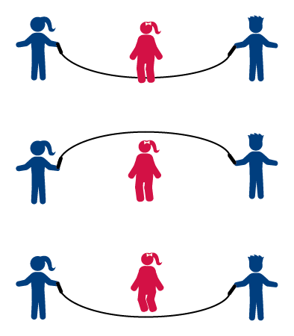 | Level 3 – Continuous Jumping  Face 1 Turner, Turn, Jump, Turn, Jump  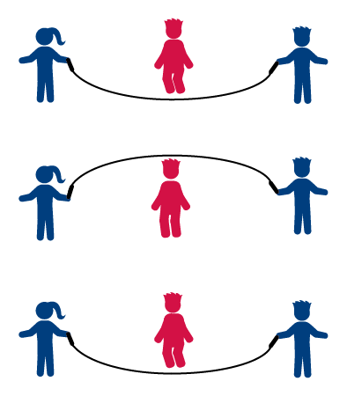
Level 4 – Enter and Exit  Enter Quick, Jump 1 Time, Exit Quick  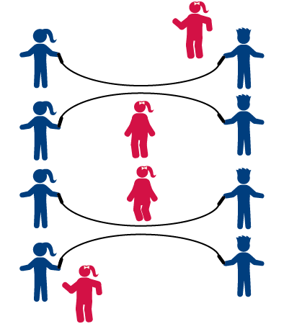 | Level 5 – Enter and Stay  Enter Quick, Jump, Turn, Jump | Level 6 – Add a Jumper  Stand in Center, Face 1 Turner,  Turn and Jump  