­­

AIR BALL

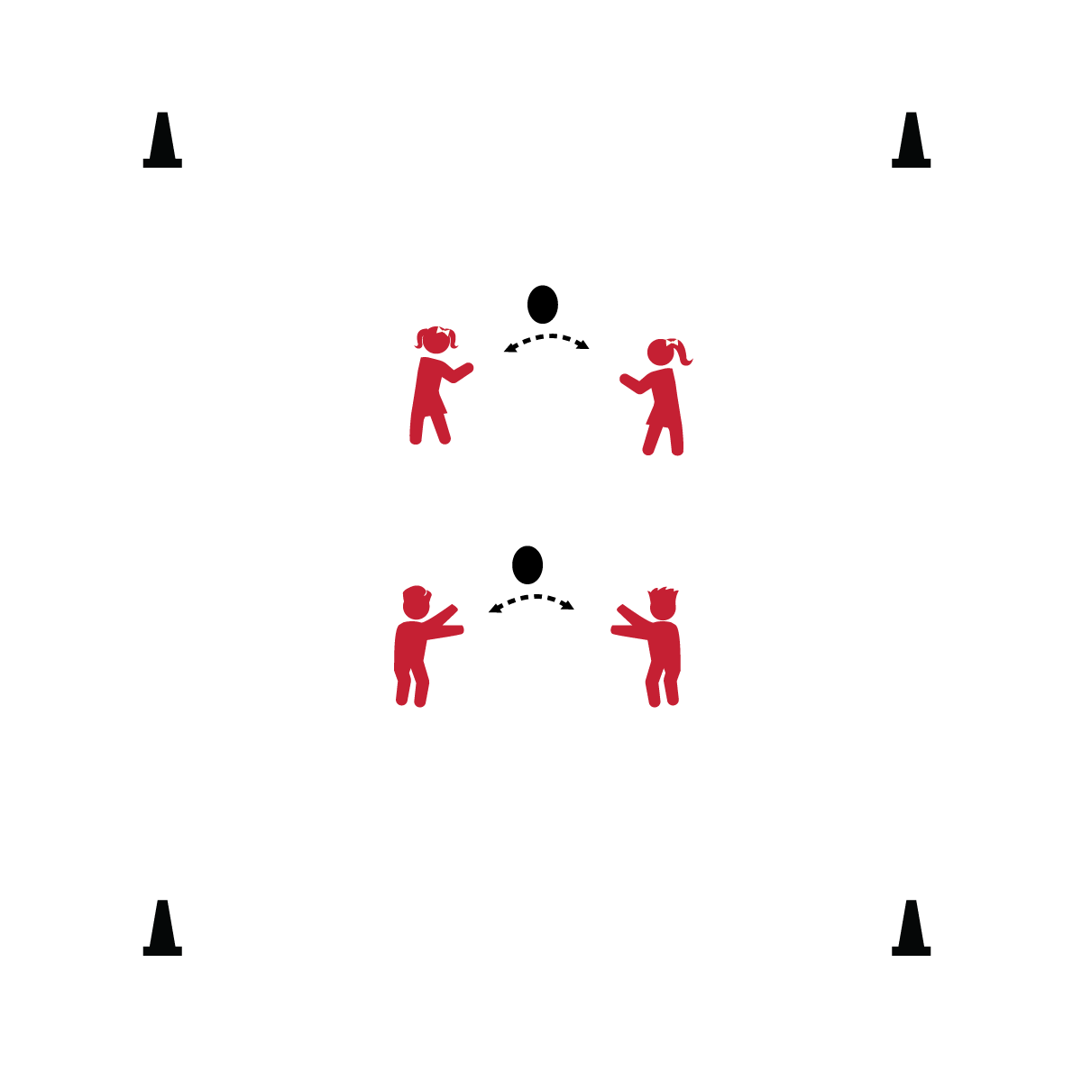

* **Whole Grain Happiness:** Whole grains help keep you happy. Yep! Fiber in whole grains keep your digestive track on schedule. That keeps you happy! Try this for digestive smooth sailing – homemade chili with whole-wheat pasta. Your digestive train will be running right on time!

**Equipment:**

* 1 lightweight ball or large balloon per pair or group of 3

**Set-Up:**

1. Group students and send them into open space with 1 ball per group.

**Activity Procedures:**

1. This game is called Air Ball. The object of the game is to work with your partners to keep the ball in the air as long as you can.
2. Count how many hits in a row your group can make. When the ball hits the floor, pick it up and try again.
3. When I say, “GO!” we’ll begin. When I say, “FREEZE!” stop, and turn toward me with your hand on your knees.

**Universal Design:**

* Allow students to toss and catch balls/balloons with their partners.
* Use a variety of ball types (e.g., size, shape, texture, and color).
* Today we will work together to have fun, be successful, and get some exercise!
* **Get’em going:** The procedures on this page are 76 words long. Don’t use more than that when you’re talking. Say, “GO” and then look for kids who need a little help.