­­

NEWCOMB

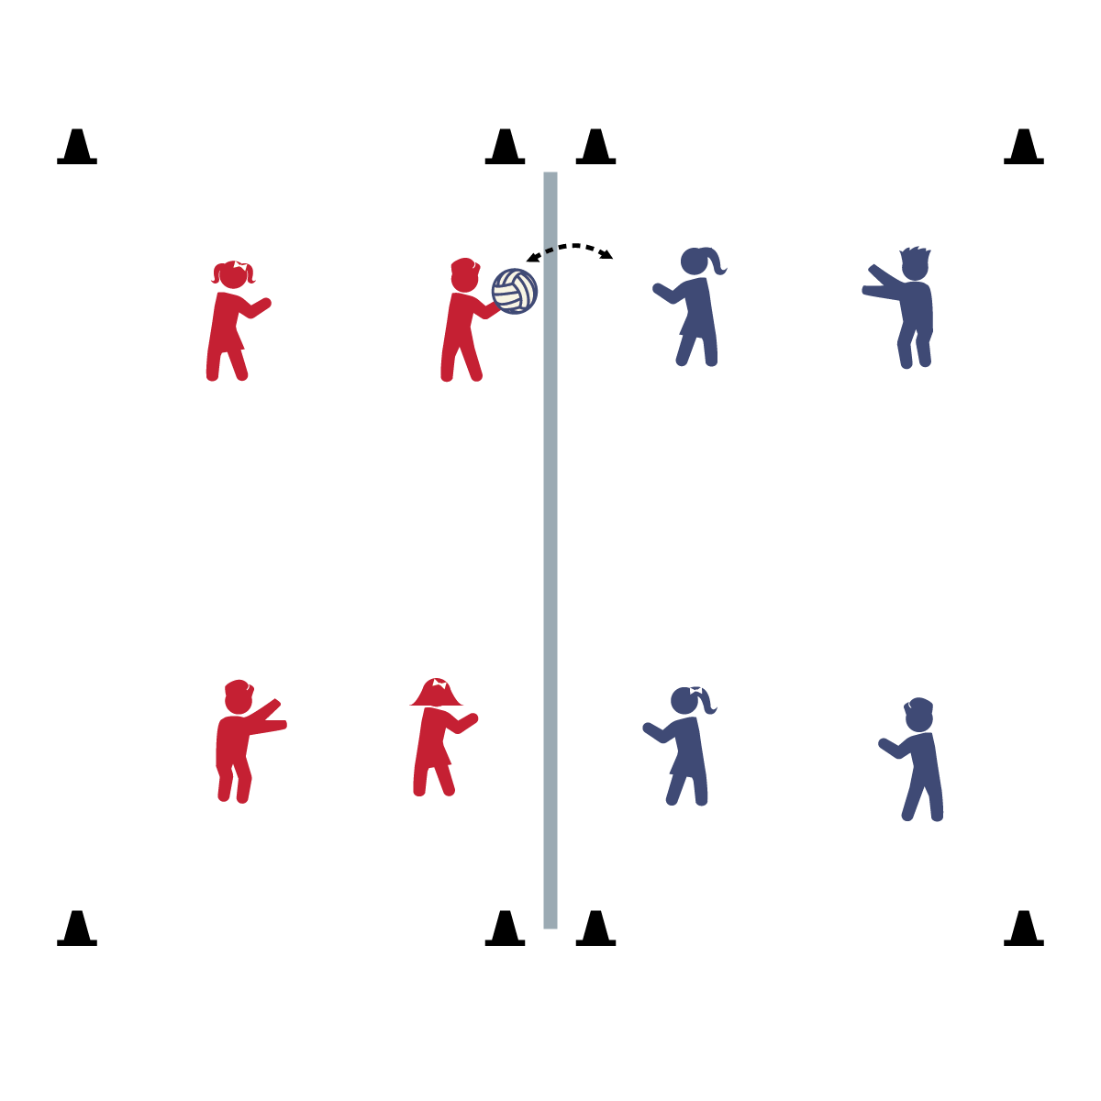

* **Proximity:** Do you have a goof-ball group finding it hard to stay on task? Go stand near them, watch and smile. No need to scream and yell, your presence will help remind them to stay on target.

**Activity Procedures:**

1. Today’s Cooperative Game is called Newcomb. It’s very similar to volleyball, except players catch and toss the ball, instead of hitting it over the net. The object is to toss the ball over the net so that the opposite team cannot catch it. All tosses must travel up, before they go down. No “spikes.”
2. Play starts with a player on the back line throwing the ball over the net (a serve). The receiving team must catch the ball, make 2 passes to teammates, and then toss the ball back over the net. (As students become more skilled, make passing to a teammate optional, and ball movement more strategic.)
3. Games are played to 7.

**Universal Design:**

* Allow students to hand off passes to teammates before tossing the ball over the net.
* Use a floor line instead of a net.

**Equipment:**

* 1 ball per court
* 1 low net (e.g., adjustable volleyball net). *A long jump rope across 2 large cones will also work.*
* 8 cones to create court boundaries

**Set-Up:**

1. Create 1 activity court per 8 students. Divide courts into 2 halves with a low net across the center and 8 cones marking the boundaries.
2. Divide group in to teams of 4 students.

* **Milk Mustaches:** When you’re eating a meal, don’t forget your mustache! Milk mustache that is. Milk and other dairy products help you build strong bones, strong teeth, and strong muscles. That’s a lot of strong stuff that you need!
* Today we will follow all rules of the game, work together with our teammates, and have fun with our friends!