­­

JUMP ROPE RHYMES

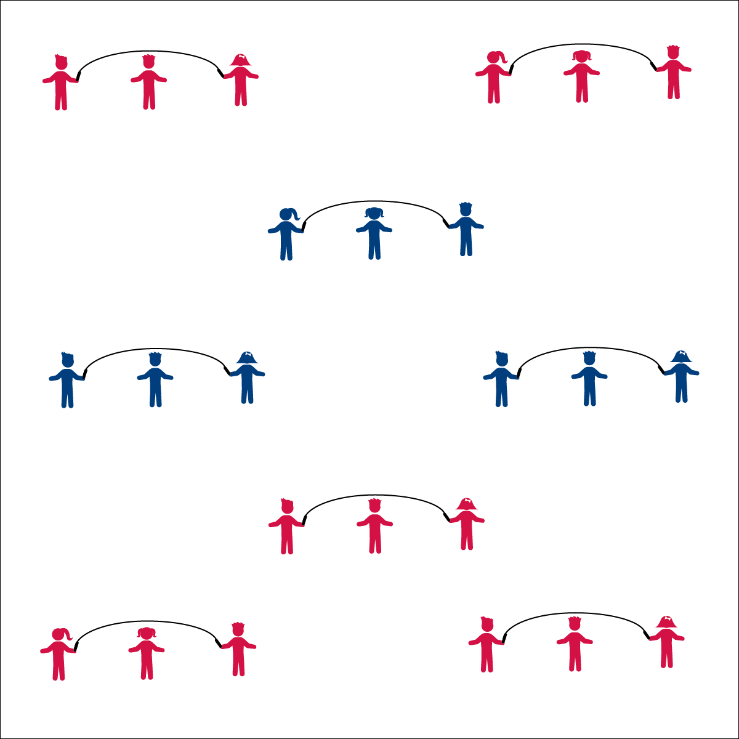

* **Catch’em Being Good!** Need to get some kids back on task? Find another group that is doing the right thing and praise their behavior. Chances are the other students will start to copy the desired behavior.
* **Focus on Fruit:** Eating a fresh apple, including the skin, is one of the best things you can do with your teeth on any given day. Eating the skin with the rest of the apple gives you twice as much fiber when compared to peeled apple slices. Not to mention all of the other essential nutrients that are found mostly in the skin. Eat up!

**Equipment:**

* 16 long jump ropes per 3 students
* OR, 1 short jump rope per student
* Rhyme Cards

**Set-Up:**

1. Divide the class into groups of 3 or 4, each group with a long jump rope. (Or, each student with a short rope.)
2. Have the students spread out in general space with enough space to turn the rope safely.

**Activity Procedures:**

1. Today you’re going to get the chance to work in groups to combine rope skills with jump rope rhymes.
2. When I say, “GO!” follow the Rhyme Cards with your partners when you jump.
3. After you master each rhyme, work to try and add all of the different jump rope tricks that you know.

**Universal Design:**

* Use Velcro on gloves and rope handles to help students hold and turn.
* Allow students to jump next to the turning rope, in rhythm with the turning.
* Swing the rope slowly and allow students to step over the rope.
* Designate a student(s) as the rhyme caller.
* We will work together to learn and perform jump rope rhymes.