­­

MATRIX TAG

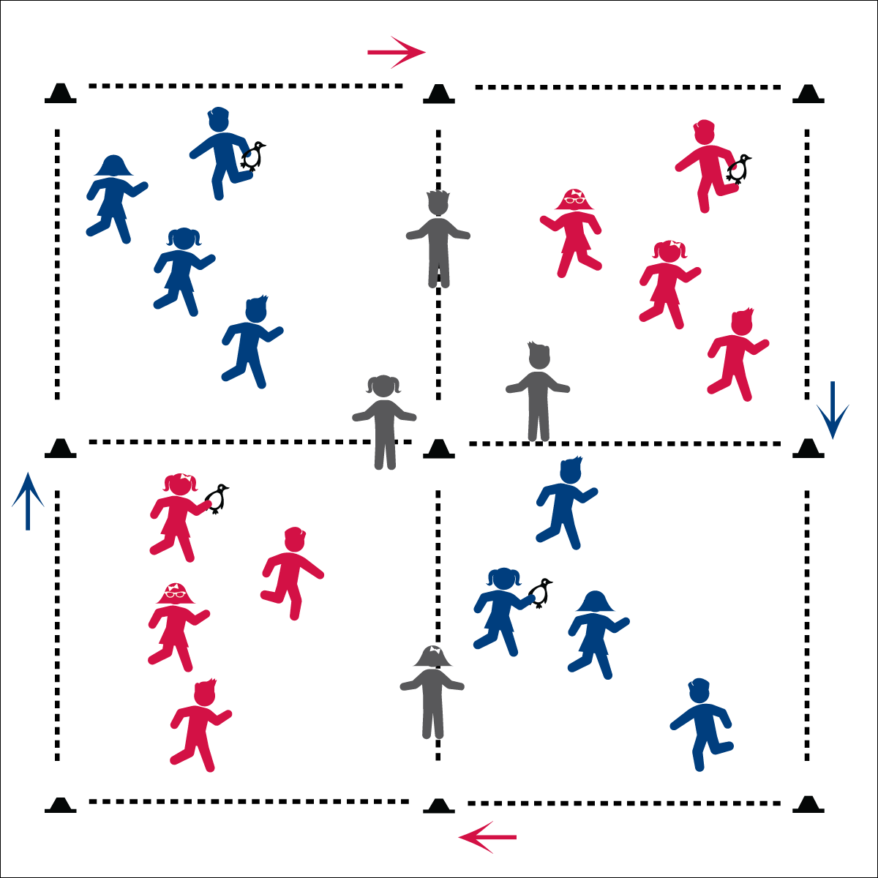

* **Veggies are Awesome:** For most of human history food was grown on a farm or found freely in nature. Within the last 100 years, food has started to come from processing factories. What?! Yuck! Keep it real, for real! Eat food from farms not factories. There’s no substitute for the real thing. Really.

**Activity Procedures:**

1. It’s time to play Matrix Tag. This is a speed walking tag game.
2. The object of the game is to stay inside each quadrant for as long as you can without getting tagged. If you are tagged, move clockwise to the center border between two quadrants and do 5 jumping jacks. When you’re done with your jumping jacks, speed walk into the next quadrant and try not to get tagged.
3. When I say, “GO!” taggers will count to 10 before trying to tag people in their quadrant. Taggers cannot move into other quadrants.
4. When you hear, “FREEZE!” face me with hands on knees.

**Universal Design:**

* Allow taggers to use a foam noodle for tagging.
* Use mats to cover potentially hazardous part of the activity area.
* As the group plays the tag game, give individualized instruction to student that need more assistance.
* **Keep’em Safe!** Stop the activity immediately if it doesn’t seem to be going quite right. Don’t freak out. Just say, “Freeze!” Explain the directions again and re-start the activity.

**Equipment:**

* 16 cones
* 8 beanbags or rubber critters  
  (to identify taggers)
* Matrix Arrow Posters

**Set-Up:**

1. Use cones to create a large activity area split into 4 quadrants.
2. Post Matrix Arrow Posters on cones to show a clockwise rotation from one quadrant to the next.
3. Scatter students evenly throughout the entire area. Identify 2 taggers in each quadrant.

* We will watch where we’re going, play safely, and make our hearts beat quickly.