­­

MUSCLE MAGIC TAG

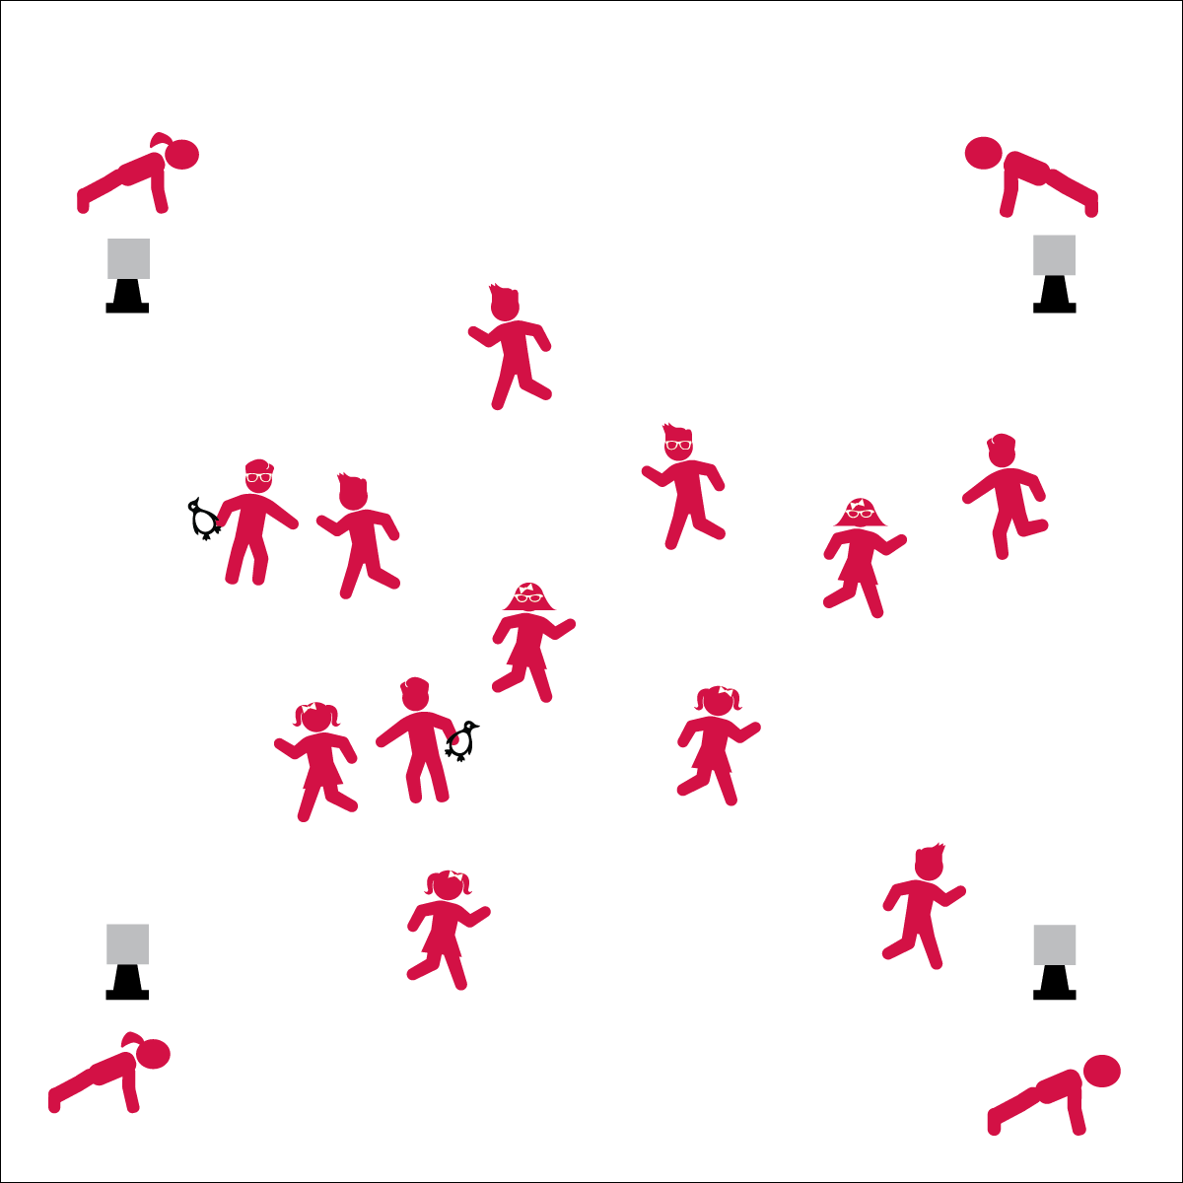

**Activity Procedures:**

1. It’s time to play Muscle Magic Tag. This is a speed walking tag game.
2. The object of the game is to move throughout the activity area without getting tagged. If you are tagged, move to a Muscle Magic Re-Entry Station and hold a 10-second plank pose. When you’re done with your plank pose, speed walk back into the game and try not to get tagged.
3. When I say, “GO!” taggers will count to 10 before trying to tag people.
4. When you hear, “FREEZE!” face me with hands on knees.
5. Planks are magic for your muscles. Here’s why…

* Planks engage all major core muscle groups. You need core muscle strength and tone (trust us).
* You’ll have better posture (trust us).
* You’ll improve balance and flexibility (again…trust us).

**Universal Design:**

* Allow taggers to use a foam noodle for tagging.
* Use mats to cover potentially hazardous part of the activity area.
* As the group plays the tag game, give individualized instruction to student that need more assistance.
* Modify planks (e.g., hold position on hands and knees, plank upright against the wall, etc.).
* **Keep’em Safe!** Stop the activity immediately if it doesn’t seem to be going quite right. Don’t freak out. Just say, “Freeze!” Explain the directions again and re-start the activity.

**Equipment:**

* 4 cones
* 2 or 3 beanbags or rubber critters  
  (to identify taggers)
* Muscle Magic Re-Entry Posters

**Set-Up:**

1. Use cones to create a large activity area.
2. Post Muscle Magic Re-Entry Posters on cones to create re-entry stations.
3. Scatter students evenly throughout the entire area. Identify 2 or 3 taggers.

* **Protein Power:** Did you know that peas pack protein?! Well, they do. They taste good, they’re fun to eat, and they provide building blocks for strong muscles.   
  Power to the Peas!
* We will watch where we’re going, play safely, and make our muscles stronger.