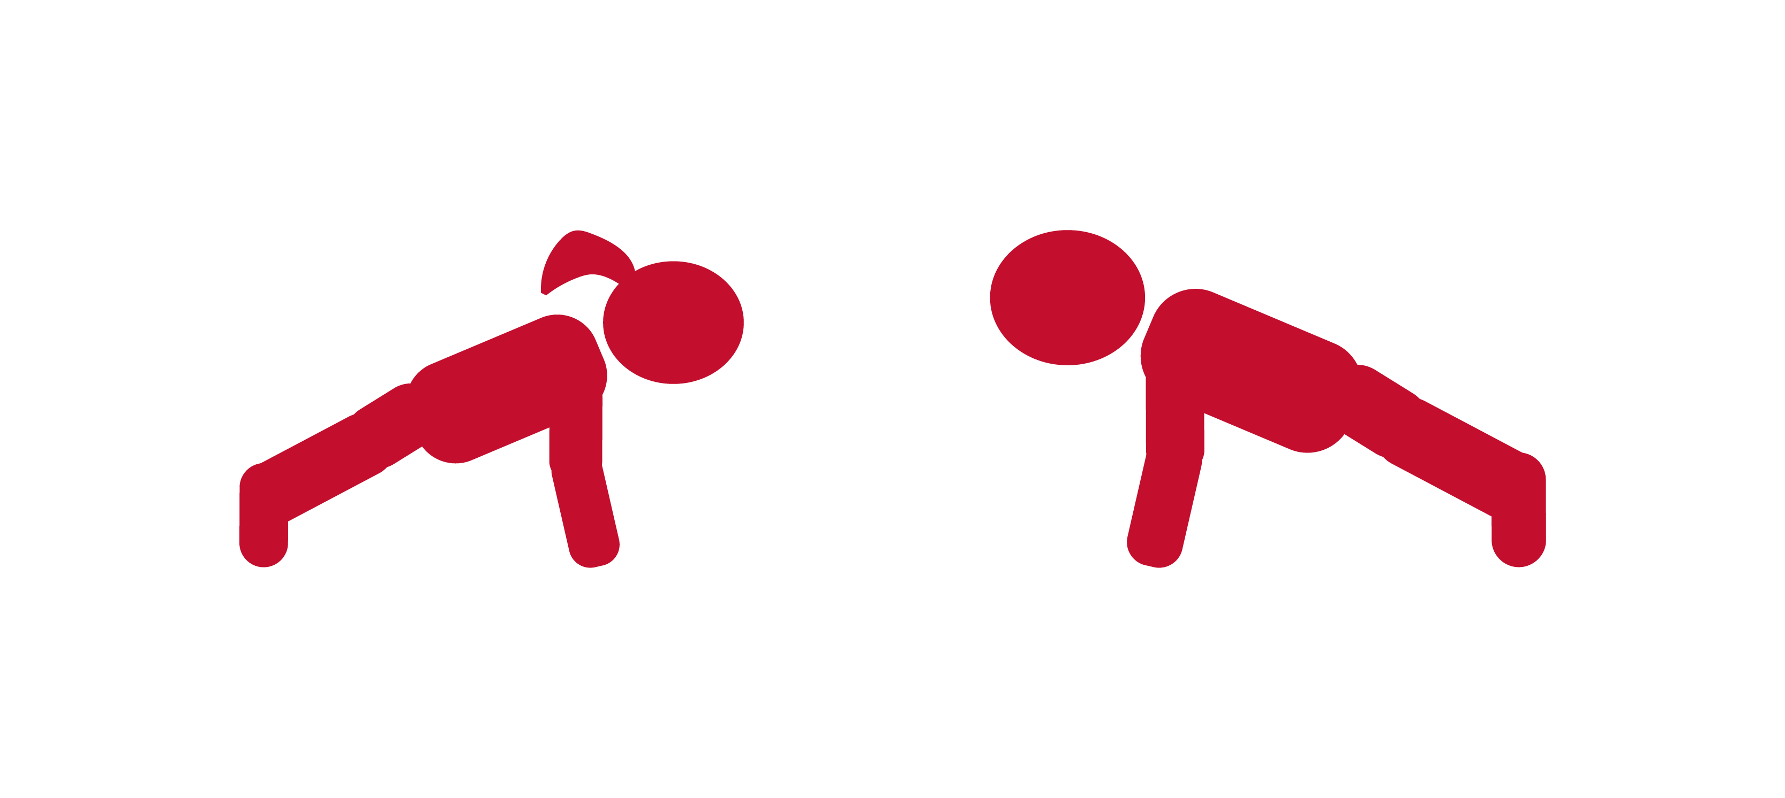

**Hold PLANK for 10 seconds, then get back in the game.**

**PLANK POSE IS MUSCLE MAGIC**

**RE-ENTRY POSTER**