­­

TWO SQUARE

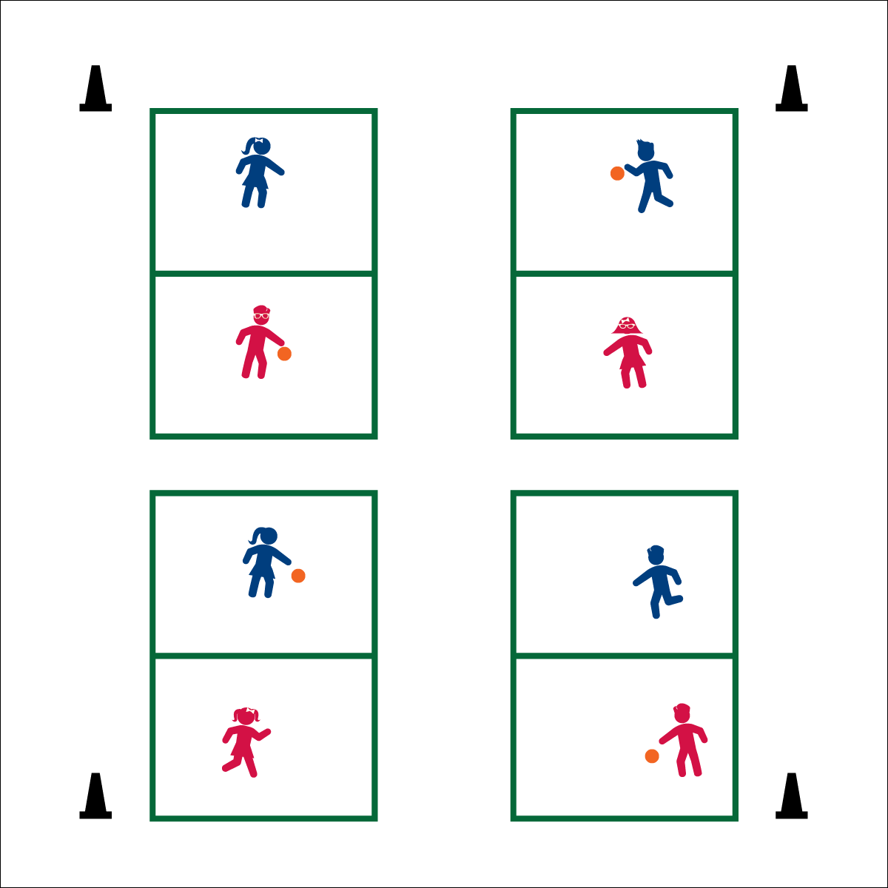

**Activity Procedures:**

1. Today’s friendly competition is called Two Square. The object is to score points by hitting the ball fairly in play, and forcing your opponent to fault (i.e., miss the return, or hit the ball out of bounds).
2. Points are scored on each volley. The player who forces the fault wins both the point and the right to serve.
3. The sever drops the ball and serves off a bounce. Serves must bounce 1X in the receiving square. The receiving player must return the ball back over the centerline after 1 bounce.
4. The server gets 1 fault in order to put the ball in play. On the second fault, the receiver gets a point and the right to serve.
5. Outside lines are in-bounds; the centerline is out-of-bounds. If a player hit the centerline, she/he losses the point and the serve.
6. Games can be played to a set point (e.g., 11), or for a set amount of time (e.g., 5 minutes).

**Universal Design:**

* Allow students to catch and toss balls into play.
* Allow the ball to bounce twice.
* Remove scoring. How many volleys can a team complete?

**Equipment:**

* 1 playground ball per court
* Courts marked with paint, floor tape, or cones
* Two Square Rules Poster

**Set-Up:**

1. Create 8’X16’ courts divide into 2 squares measuring 8’X8’. (Note: The size of the court can vary based on space available.)
2. Send 2 students to each court, 1 ball per court.

* **Fruit Fact:** Choosing from a variety of fruits at meal time makes your plate more colorful, which means you’re eating more of the vitamins and minerals you need to grow and play!
* We will stay active, encourage others, and keep a positive attitude.
* **Get’em going!**  
  Set Two Square courts up before students arrive so that the can get moving quickly and safely.