­­

FOUR SQUARE

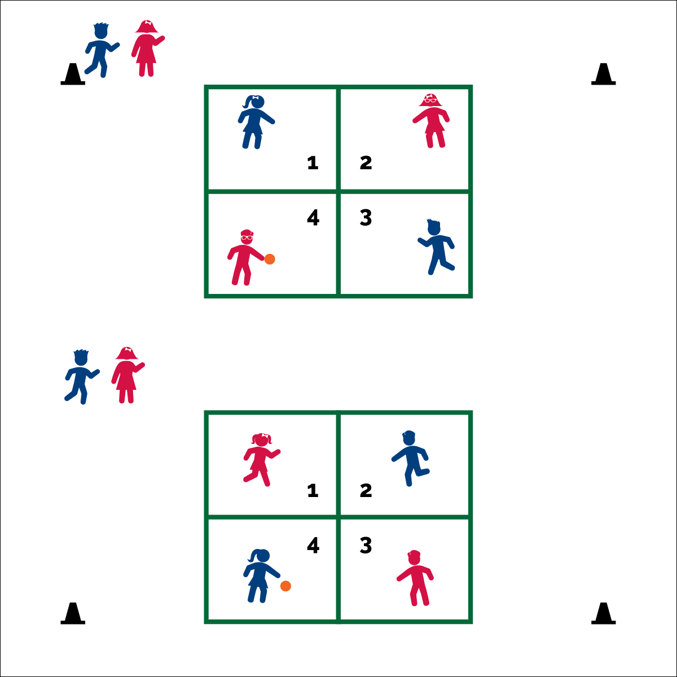

**Activity Procedures:**

1. Today’s friendly competition is Four Square. The object is to eliminate players in higher squares so you can advance up to 4 Square. If you are eliminated, move to the end of the line behind 1 Square.
2. Begin play with a diagonal serve from 4 Square to 2 Square. Sever drops the ball and serves off a bounce. Serves must bounce 1X in the receiving square, then the player in 2 Square must hit the ball into another square of her/his choice. Now the ball is in play. Server and receiver each get one fault in order to put the ball in play. On the second fault, the player making the error is out.
3. When a ball bounces in a square, the owner of the square must hit it fairly into another square. If the player does not hit the ball before a second bounce, or she/he hits it out of bounce, the player is out and returns to the line behind 1 Square. The ball must be hit, not caught or carried into play.
4. Outside lines are in-bounds; inside lines are out-of-bounds. If a ball hits an inside line, the player who hit the ball is eliminated.
5. Play continues until time runs out. The player in 4 Square at that time is the winner. (Advance players may decide to create custom rules.)

**Universal Design:**

* Allow students to catch and toss balls into play.

**Equipment:**

* 1 playground ball per court
* Courts marked with paint, floor tape, or cones

**Set-Up:**

1. Create 16’X16’ courts with 4 quadrants (squares) measuring 8’X8’. (Note: The size of the court can vary based on space available.)
2. Number squares 1 thru 4, moving clockwise around the court.
3. Send 4 to 8 students to each court. Four students take their place in a square. The others line up at least 5’ behind 1 Square. The ball begins in the 4 Square.

* **Skip the Sugar:** Added sugars are called “empty Calories” because they add Calories without adding important nutrients. Limit foods and drinks with added sugar. Soda, fruit drinks, candy, and many cereals can have a lot of added sugar.
* We will stay active, play fair, and enjoy time with our friends.
* **Think About Safety!**  
  Create a safe zone around each court 5’ to 8’ wide. Be sure that this zone is free of clutter, other equipment, and other players.