­­

HORSE

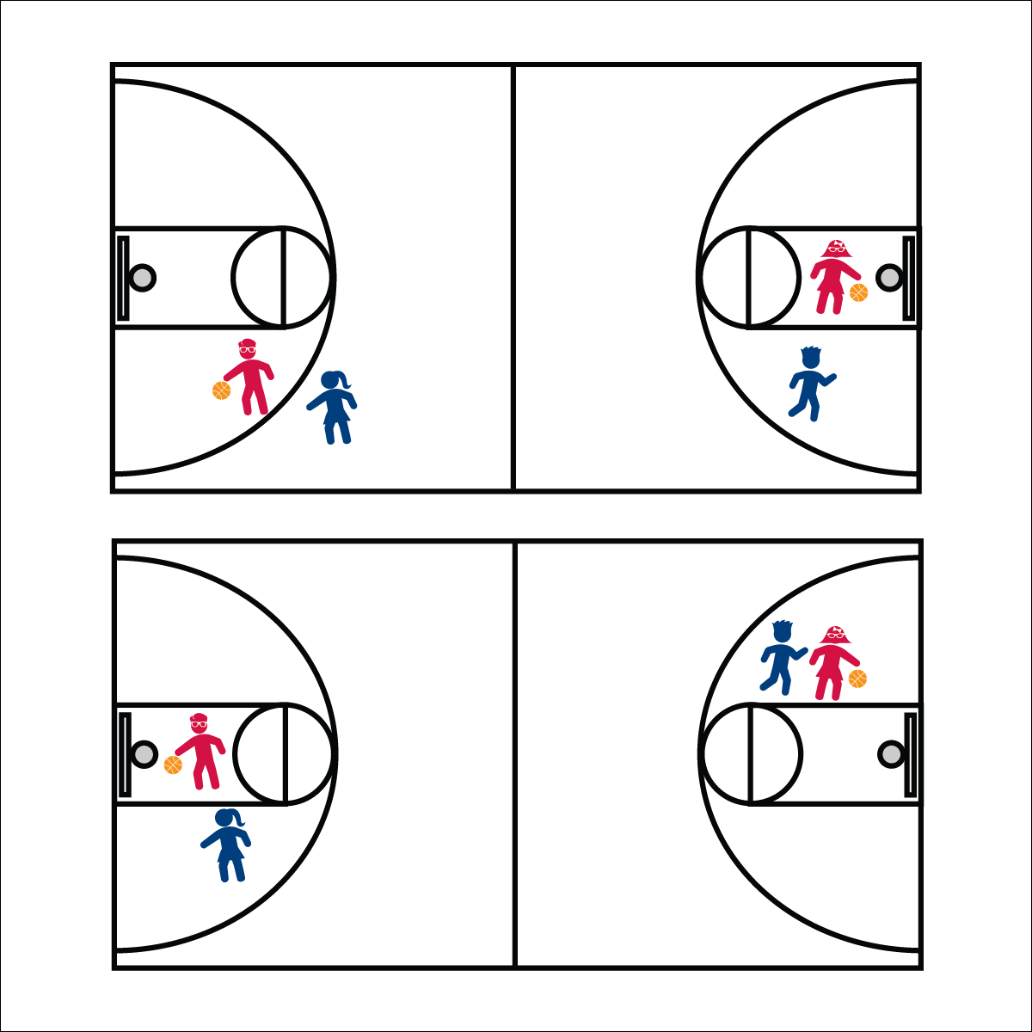

**Activity Procedures:**

1. Today’s friendly competition is a game of HORSE. The object is for players to invent and score shots that other players cannot make. Each time a scored shot is followed by a missed shot, the player that misses adds a letter to the word HORSE (e.g., that player has an H after the first miss). When the complete word HORSE is spelled (5 misses), that player is eliminated from the game.
2. First, decide an order of play. If you can’t decide, start the game youngest to oldest. The first player invents and takes a shot from anywhere on the court. Shots can include special rules (e.g., you must shoot backward, or with your eyes closed).
3. If the first player makes a basket, the next player must copy and make the shot exactly as the first player did. If the first player misses, the second player gets to invent a shot.
4. Any time the player before you makes a basket, you must copy their shot. If everyone makes a shot and play goes back to the inventor, that player gets to invent a new shot. (Note: You don’t get a letter if you miss the shot you’re trying to invent.) Play continues until there’s only 1 player left.

**Universal Design:**

* Play the game with a hula hoop on the floor, rather than a basketball hoop.
* Eliminate special rules.
* Play shorter (or longer) words. PIG is a common example.

**Equipment:**

* 1 basketball hoop per 2 or more players
* 1 basketball per hoop

**Set-Up:**

1. Send a group of 2 or more players to a hoop.
2. Be sure that the activity area is free of clutter and safe for play.

* **Fruit Fact:** A cup of fruit juice everyday can be a part of a healthy diet. BUT! Fruit juice doesn’t give you the fiber or other good stuff that whole fruit does. So, limit the juice and grab the real thing!
* We will play fairly while keeping control of our bodies and our equipment. This will keep everyone safe.
* **Group’em:** Four players per game is a good max group size. This allows play to continue quickly and keeps students active.