­­

AROUND THE WORLD

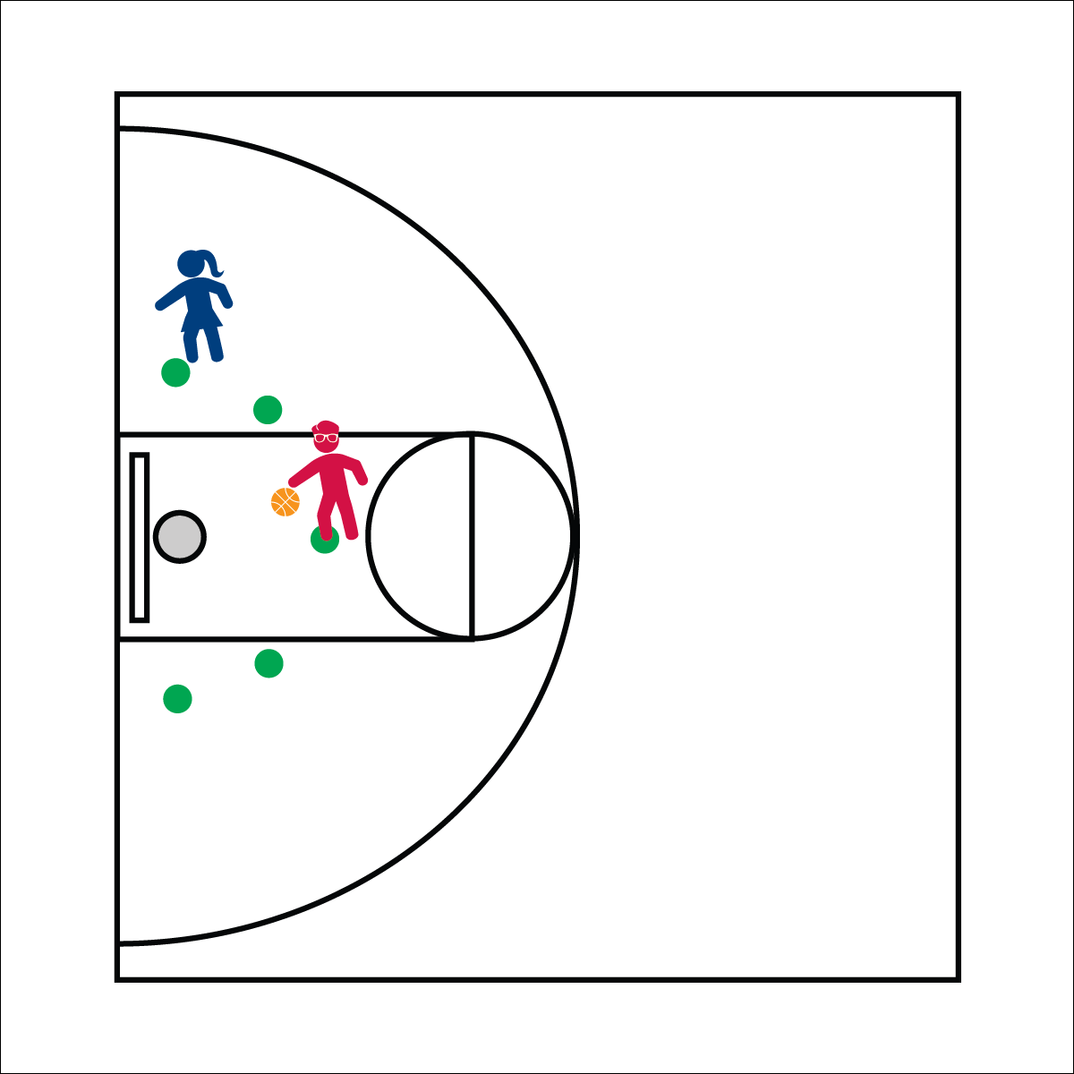

**Equipment:**

* 1 basketball hoop per 2 or more players
* 1 basketball per hoop
* 5 to 7 spot markers (or painted floor spots)

**Set-Up:**

1. Send a group of 2 or more players to each hoop.
2. Set 5 or more spots in an arc around the basket. Be sure spots are at a distance that promotes success.
3. Be sure that the activity area is free of clutter and safe for play.

* **Give’em Instruction:** Give clear cues using as few words as possible. Start with the object of the activity. This helps kids visualize the instructions you give from that point on.

**Activity Procedures:**

1. Today’s friendly competition is a game of Around the World. The object of the game is to to be the first player to make a shot from every spot marker around the world.
2. First, decide an order of play. If you can’t decide, start the game youngest to oldest. Each player gets 2 shots at each spot. If you make a shot, move to the next spot and continue. If you miss your first shot, you can give up your second shot and stay where you are. If you take and miss the second shot, you have to move back to the first spot and start from scratch.
3. Players keep shooting until they miss twice or skip a turn. Everyone gets an equal number of turns to win. For example, if player 1 makes it all the way around the world, players 2 and 3 get to take their turns in order to match player 1. If there’s a tie, play another round. The player who gets the furthest without missing wins.
4. Games can be played one time through the arc (half-way around the world), or through the arc and back (all the way around the world).

**Universal Design:**

* Play the game with a hula hoop on the floor rather than a basketball hoop.
* Use a smaller/lighter ball.
* **Water Works:** When you’re thirsty, water is the best drink choice that you can make. It helps keep you hydrated and healthy. It also helps rinse food from your teeth and keeps your smile healthy and strong!
* We will stay active, try our best, and play fairly.