­­

ULTIMATE ANYTHING

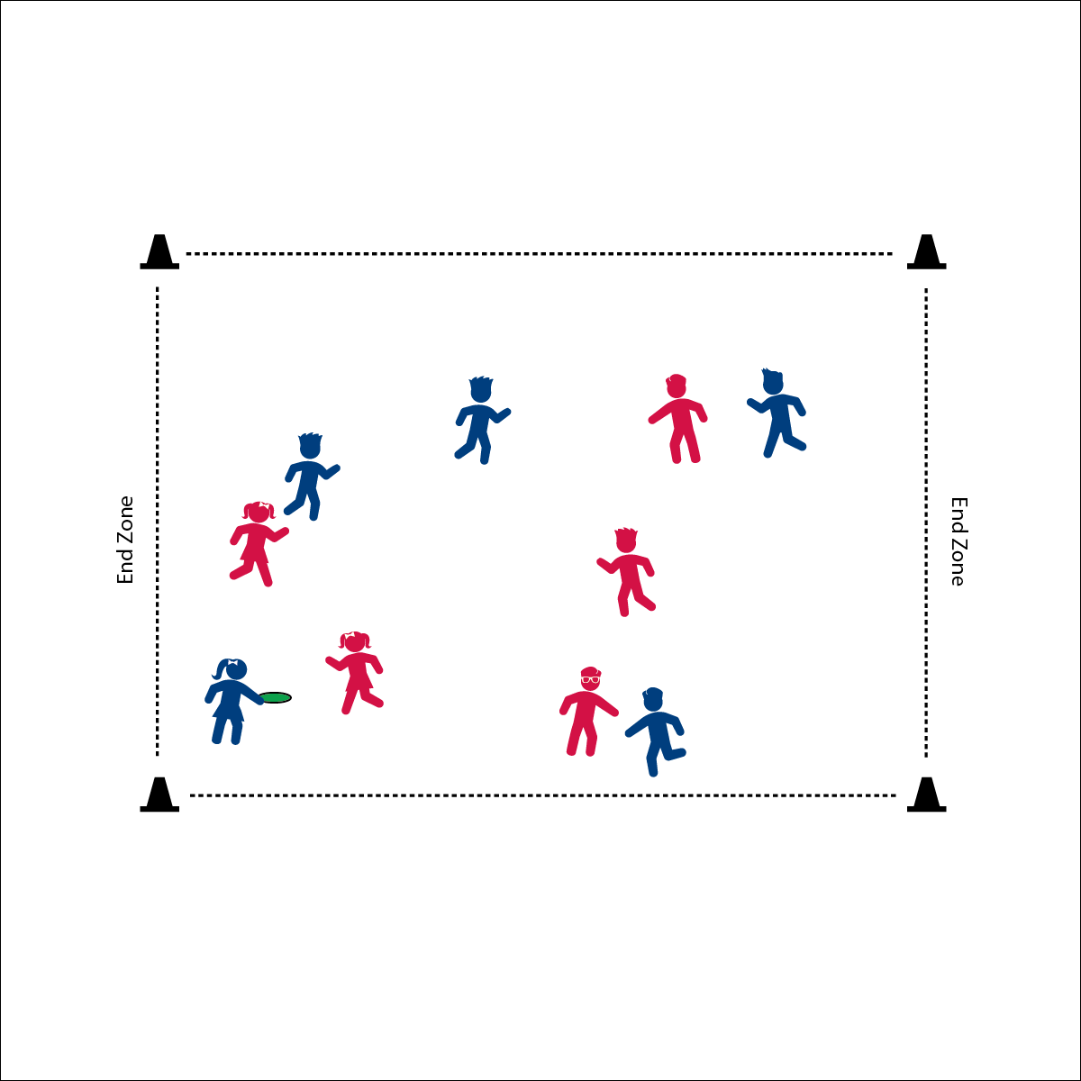

**Activity Procedures:**

1. Today’s friendly competition is called Ultimate Anything. It’s a game of Ultimate using any safe tossable that we have available.
2. The object of the game is to score points by moving the tossable object down the field and across the end line.
3. The player holding the object cannot move, and can hold the object for no more than 10 seconds. Teammates will move to get open for a pass.
4. If a pass is dropped, goes out of bounds, or is intercepted, possession changes at the spot of the ball.
5. A point is scored when a pass is completed in your opponent’s end zone (past the end line).
6. Defense must stay more than an arms-length from the offense and cannot make contact with an offensive player. Defense cannot hit the object away from the offensive player’s hands. If contact is made, offense gets 1 free pass.
7. The defender covering the player with the object is responsible for counting 10-mississippi out loud.
8. Continue play to a set score (e.g., 11), or for a set amount of time.

**Universal Design:**

* Play the game with offense only. Start at one end, making passes down field and across the end line.
* Allow students to choose the tossable object used from a variety of shapes, colors, sizes, and textures.
* **You Are My Sunshine:** You’re so bright you have to wear shades! Better bring a pair. When giving instructions outside, position students with their backs to the sun. This means you are facing the sun.

**Equipment:**

* 4 large cones to make activity area
* 1 safe tossable per area (Frisbee, foam ball, rubber chicken, etc.)
* 1 pinnie per 2 players

**Set-Up:**

1. Create a large playing area (minimum size = basketball court) marked with large cones at each corner.
2. Create two equal teams, between 5 and 7 players per team.
3. One team wears a pinnie. Pinnies begin on offense.

* **Water Works:** Activity Leaders, be sure to have cold water available for kids – especially if they’re playing outdoors where it’s hot. If water is the only choice for thirsty kids, then they’ll be sure to choose the healthiest drink on the planet.
* We will honor all rules and the safety of our opponents in the spirt of the game.