­­

STATION DAY SET UP

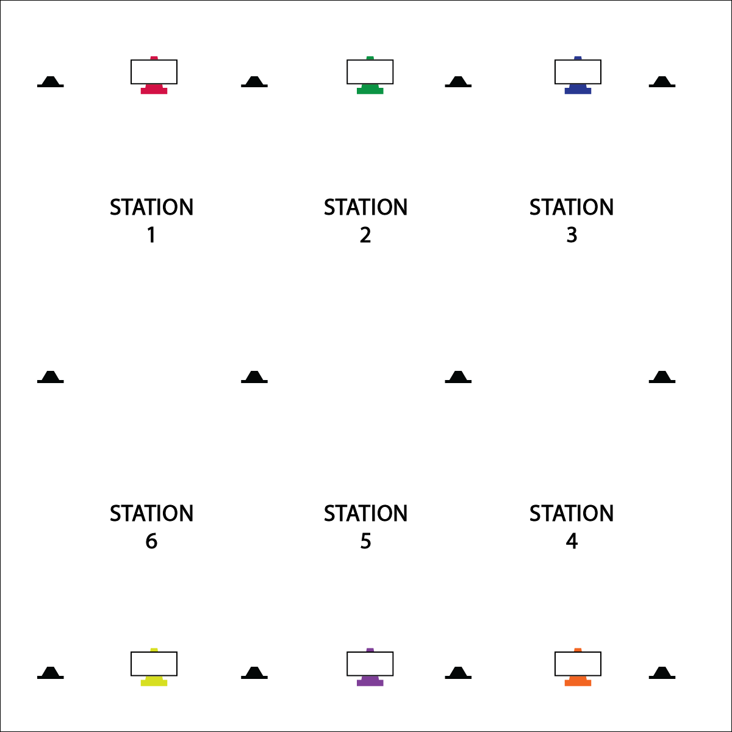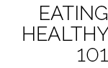

* **Watch the Added Sugar!** Speaking of FroYo, did you know that Frozen Yogurt is not regulated by the USFDA and often times contains a lot of added sugar with not a lot of nutritional value? To get the true benefits of Yogurt, it’s best to eat the unfrozen stuff.

**Activity Procedures:**

1. Today is a Station Day. We’ll complete each station for 2 (or 3) minutes.
2. *(Note to Activity Leaders: Talk through and/or demonstrate each station. Emphasize safety expectations. There are 2 types of stations: 1) Creative Mode with skill practice activities; 2) Survival Mode with skill challenges to test new skills.)*
3. When the music starts, begin working at your station. When it stops, you’ll have 1 minute to clean up the station equipment and rotate to the next station. Wait until the music begins again before you start the activity at a new station.
4. While we’re learning this station format, I’ll pause the music for a longer period of time so that every team is able to clean up their area and rotate.

**Universal Design:**

* Some students may need step-by-step assistance during cleaning-up and rotation.
* Pause the music and don’t restart until every group has safely transitioned.
* Provide a visual signal to prompt station rotation.

**Equipment:**

* 6 or more cones
* 6 or more task tents
* 6 or more stations cards
* 12 or more low profile cones
* Equipment to match selected station cards
* Music player and music

**Set-Up:**

1. Using low profile cones, create 6-10 grids (depending on group size and activity area).
2. Set station cards up on tall cones in each grid.
3. Set up stations according to station cards.
4. Create groups of 2-4 students. Send each group to a different station.

* We will practice our skills at Creative Mode Stations.
* We will complete skill challenges at Survival Mode Stations.
* **Hustle, Hustle!** Just before you restart the station music, slowly start counting, “10, 9, 8, 7, 6…” The kids will hustle like you just offered them free FroYo!