Complete this challenge with your group and answer the nutrition challenge question before moving to the next station.
Skill Challenge

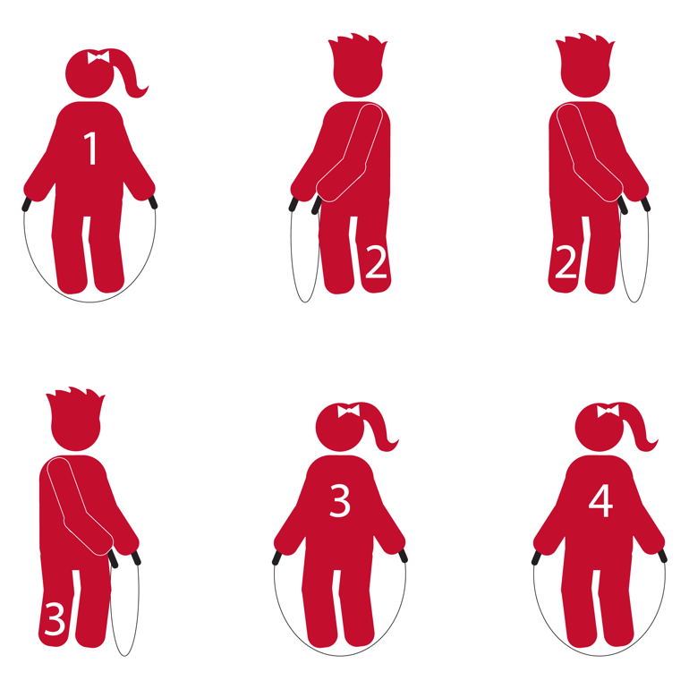 | - Basic Jump (4 Jumps)  - Side Turns (4 Jumps)  - Side Turn, Side Turn, Jump, Jump (4 Jumps)  - Basic Jump (4 Jumps)

Nutrition Challenge

Q: Which is a better snack to eat BEFORE jumping rope: an apple or a candy bar?
A: An apple of course!

Complete this challenge with your group and answer the nutrition challenge question before moving to the next station.
Skill Challenge
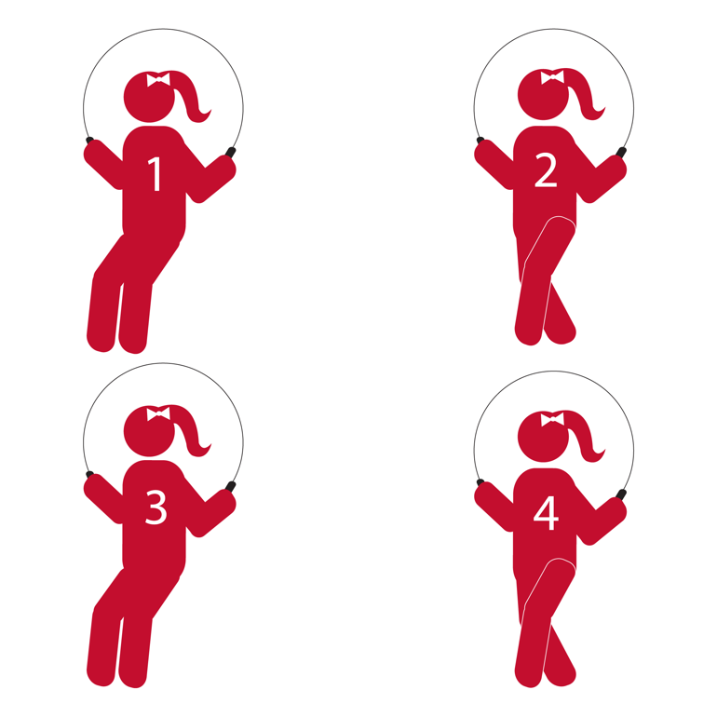
- Bell Jump (4 Jumps)
- Forward Straddle (4 Jumps)
- Bell Jump (4 Jumps)
- Forward Straddle (4 Jumps)

Nutrition Challenge

Q: Why are fruits and veggies good snacks to eat before and after exercise?
A: Because they give you quick energy, are easy to digest, and are juicy (which helps hydrate you).

Complete this challenge with your group and answer the nutrition challenge question before moving to the next station.
Skill Challenge

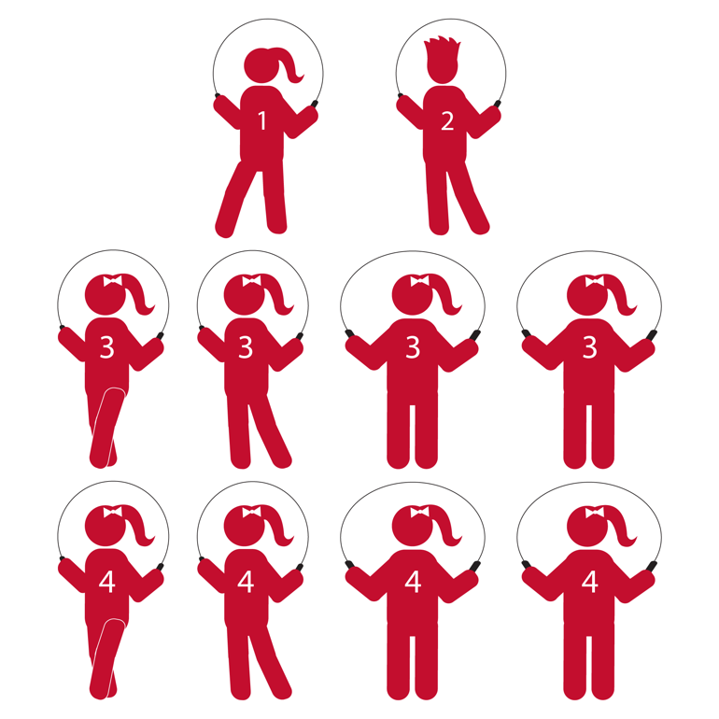 | - Heel to Heel (4 Jumps)  - Toe to Toe (4 Jumps)  - Heel, Toe, Bounce, Bounce (4 Jumps)  - Heel, Toe, Bounce, Bounce (4 Jumps)

Nutrition Challenge

Q: What is the best drink for hydrating the body during exercise?
A: Water.

Complete this challenge with your group and answer the nutrition challenge question before moving to the next station.
Skill Challenge

- Long Rope Jumping while reciting 1 jump rope rhyme (of your choice)

Nutrition Challenge

eQ: More hydration is needed when it is…? (choose all the correct answers)
A) Hot Outside; B) Cold Outside; C) Just Right; D) You Sweat a Lot

A: A & D – Hot Outside and You Sweat a Lot

Complete this challenge with your group and answer the nutrition challenge question before moving to the next station.
Skill Challenge

- Each member of your group complete 5 Long Rope Jumps. It’s okay to jump 2 people at a time.

Nutrition Challenge

Q: Name 3 different fruits.
A: Apple, Pear, Grapes, Orange, and many, many more!

Complete this challenge with your group and answer the nutrition challenge question before moving to the next station.
Skill Challenge
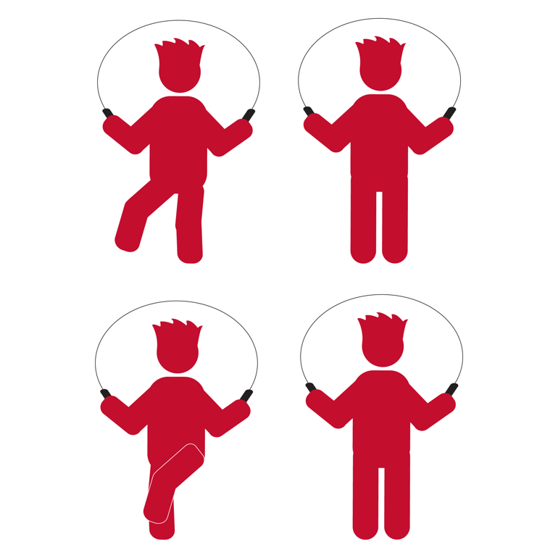
- Kick Bounce for 16 Jumps

Nutrition Challenge

Q: Name 3 different vegetables.

A: Carrots, Lettuce, Peas, Broccoli, and many, many more!

Complete this challenge with your group and answer the nutrition challenge question before moving to the next station.
Skill Challenge
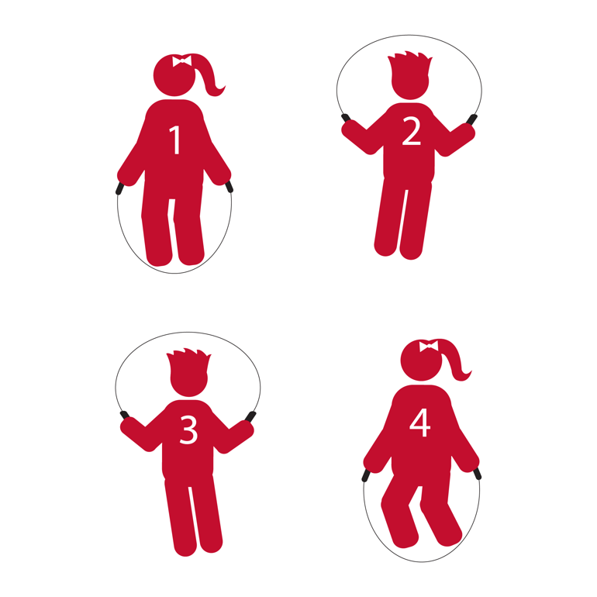
- Basic Jump (4 Jumps)
- Ski Jumps (4 Jumps)
- Ski Jumps (4 Jumps)
- Double Under (4 Jumps)

Nutrition Challenge

Q: Name 3 protein foods.
A: Beans, Soy/Tofu, Grilled Chicken, Fish, and many, many more!

Complete this challenge with your group and answer the nutrition challenge question before moving to the next station.
Skill Challenge
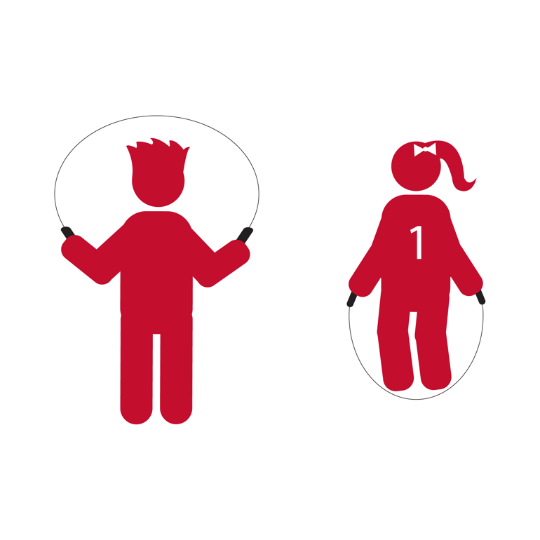

- Create a new Endurance Rhyme that includes a fruit or vegetable.
- Then perform the rhyme while jumping a short rope.

Nutrition Challenge

Q: Foods of different color provide important micronutrients that help your body work the right way.
Name 3 foods that are each a different color.
A: Carrot (orange), Grape (blue or green), Corn (yellow)

Complete this challenge with your group and answer the nutrition challenge question before moving to the next station.
Skill Challenge

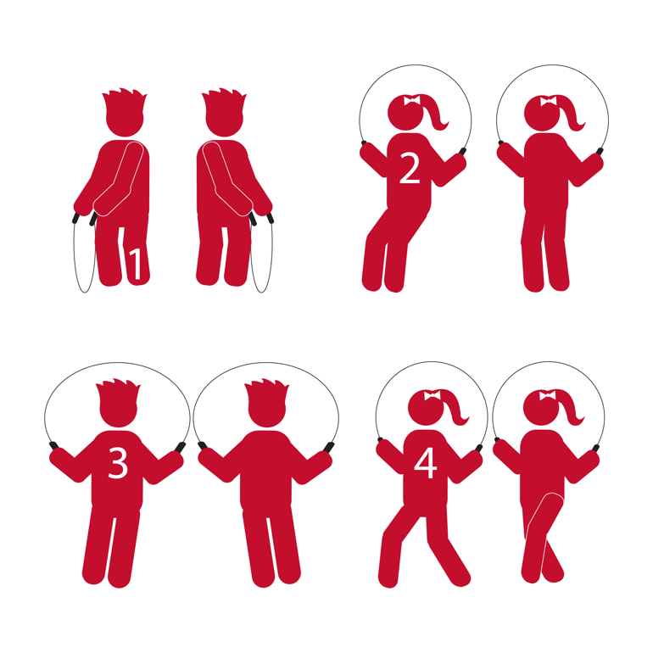

Recite:
I love carrots. I love Peas.
Grab your rope and follow me.
- Side turns, 2, 3, 4
- Bell Jump, 2, 3, 4
- Ski Jumps, 2, 3, 4
- Straddle, 2, 3, 4

Nutrition Challenge

Q: Why is it important to choose healthy foods and correct portion sizes?
A: To maintain a healthy weight, to grow strong and lean, to have enough energy to be active, and to fight off disease.

Complete this challenge with your group and answer the nutrition challenge question before moving to the next station.
Skill Challenge

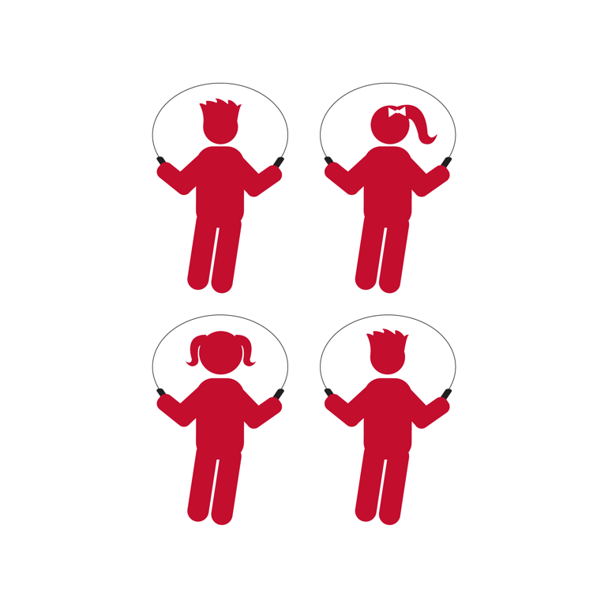

- Create a mini jump rope routine and perform it in unison as a group. The routine must have 2 tricks and 8 jumps.

Nutrition Challenge

Q: Name the 5 food groups.
A: Fruits, Vegetables, Protein, Grain, Calcium/Dairy

Complete this challenge with your group and answer the nutrition challenge question before moving to the next station.
Skill Challenge

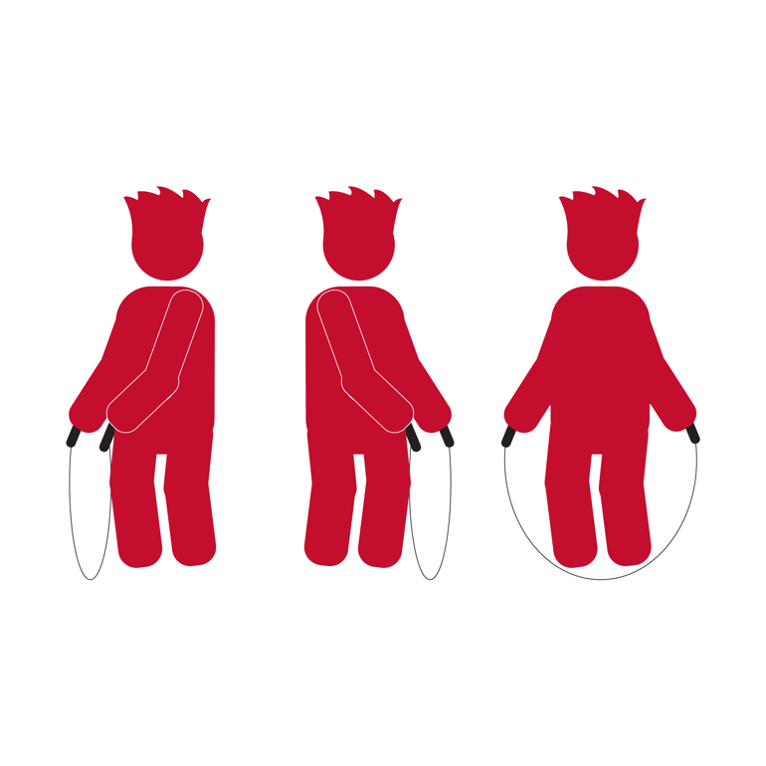

N

- Side Turn Jump (16 Jumps)

Nutrition Challenge

Q: What foods provide calcium?
A: Cheese, Yogurt, Milk, Spinach, Enriched Orange Juice, and more!

Complete this challenge with your group and answer the nutrition challenge question before moving to the next station.
Skill Challenge

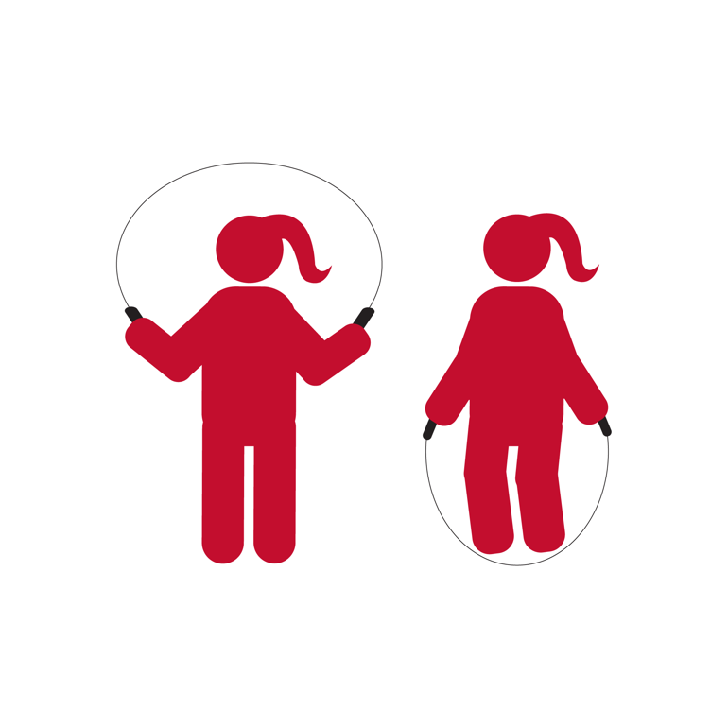

- Speed Jump using a Basic Jump (32 Jumps)

Nutrition Challenge

Q: If your group could make a healthy, whole-grain pizza,
what ingredient would you choose to top it with?
A: There are a lot of answers to this question. For example, peppers, onions, pineapple, spinach

