­­

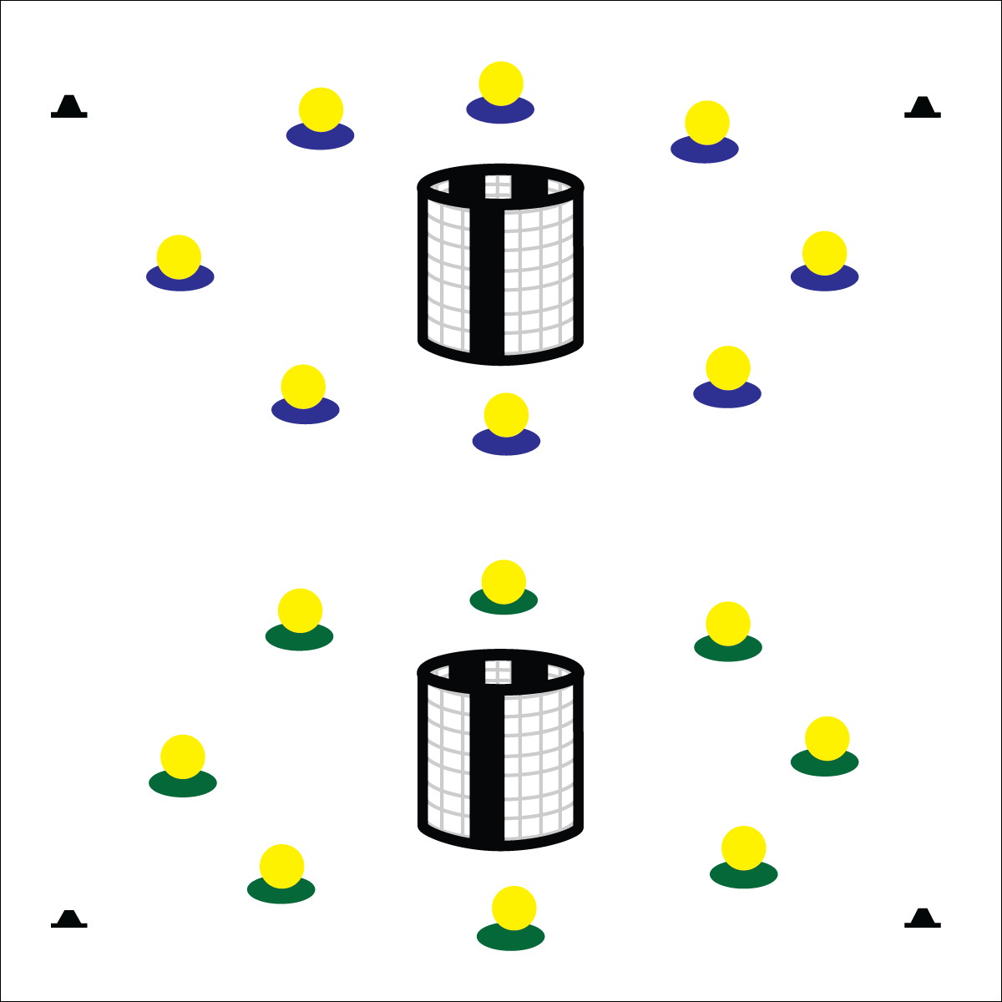

**Equipment:**

* 2 goals
* 1 foam ball per group of 4 students
* 1 spot marker per group of 4 students
* Fitness Relay Challenge Card

**Set-Up:**

1. Set the goals on opposite sides of the playing area.
2. Space spot markers in a circle evenly around each of the goals, approximately 10 to 15 yards from the center of the goal.
3. Set 1 foam ball on each spot marker.
4. Create groups of 4 students, each group at a spot marker. Students lay in a line on their back, head-to-toe with feet toward the spot marker.

* Cooperate
* Move Quickly
* Show Control
* **Skill:** I will control my actions and movements in order to work safely.
* **Cognitive:** I will provide examples of activities that can enhance my fitness.
* **Fitness:** I will remain actively engaged in order to increase my heart rate.
* **Personal & Social Responsibility:** I will identify and discuss safety principles.

**FITNESS RELAY**

**Activity Procedures:**

1. Today’s activity is called Fitness Relay. Your team will complete a series of fitness challenges in order to get our muscles warmed up and ready to play.
2. The object of each relay is to move your team’s ball from the spot marker to the goal, working cooperatively to follow the rules of each challenge.
3. When the player closest to the goal gets the ball, she/he will tap the ball into the goal and then quickly move to the spot marker. Everyone in your group will rotate 1 place toward the goal with the new line leader at the spot marker. How many times can you tap into the goal in 1 minute?
4. On the stop signal, freeze, return the ball to the spot marker, and listen for the next challenge.
5. Challenge: Pass the ball using only the feet. (For more challenges see Challenge Card.)

**Grade Level Progression:**

**3rd:** Play the activity as described above.

**4th:** Create fitness challenges for the different components of health-related fitness. Students must identify the component focus after each round of play.

**5th:** Allow students to create fitness challenges to enhance both health- and skill-related fitness.

**FITNESS RELAY**



* Use passable objects of various sizes, shapes, color, and texture.
* Use balls that provide auditory signals.
* Line students up on mats for support and protection.



* **DOK** **1:** What activities can you name that enhance fitness?
* **DOK 2:** How would you compare and contrast activities that enhance aerobic strength with activities that enhance muscular strength?
* **DOK 3:** How is physical activity related to good personal health?



* **Standard** **3 [E2.3-5]** Engages in the activities of physical education class without teacher prompting (3); Actively engages in the activities of physical education class, both teacher-directed and independent (4); Actively engages in all the activities of physical education (5).
* **Standard 3 [E3.3-5]** Describes the concept of fitness and provides examples of physical activity to enhance fitness (3); Identifies the components of health-related fitness (4); Differentiates between skill-related and health-related fitness (5).
* **Standard 4[E6.3-5]** Works independently and safely in physical activity settings (3); Works safely with peers and equipment in physical activity settings (4); Applies safety principles with age-appropriate physical activities (5).
* **Standard 5 [E1.3-5]** Discusses the relationship between physical activity and good health (3); Examines the health benefits of participating in physical activity (4); Compares the health benefits of participating in selected physical activities (5).



Enhance, Fitness, Health-Related Fitness, Skill-Related Fitness, Safety Principles

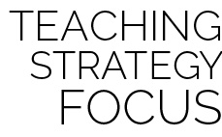

**Help students process content:** Fitness Relay challenges provide an environment for students to work with and experience fitness-enhancing physical activity. Extending student processing and critical thought requires meaningful debrief discussions that focus on the relationship between physical activity, good health, and fitness development.

**OVER THERE**

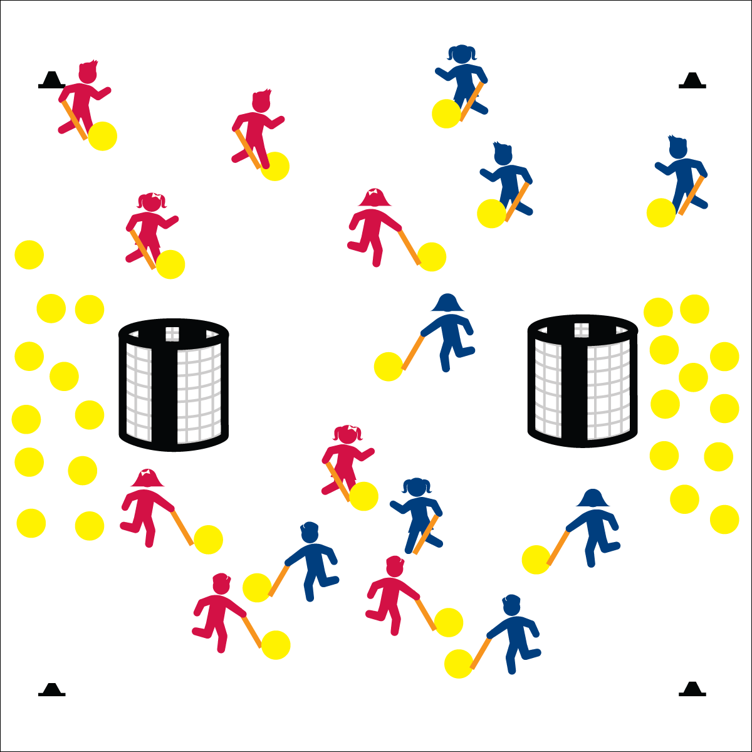

**Equipment:**

* 2 goals per group of 16 students
* 3 (or more) foam balls per student
* 1 long foam noodle per student
* 4 cones per group of 16 students
* Pinnies for half of all the students
* Long-Handled Striking Cue Chart

**Set-Up:**

1. Using cones, create 1 court (activity area) for each group of 16 students.
2. Set goals at the ends of each court, approximately 5 yards from the court’s end line.
3. Scatter 24 foam balls at one end of each court and 24 at the other. (If you have more than 3 foam balls per student, adjust accordingly.)
4. Create teams of 8 students, each with a noodle.
5. Send 2 teams to each court, 1 team at each court wearing pinnies.

**Activity Procedures:**

1. Today’s activity is called Over There. Your team’s goal is to get all of your foam balls into the other team’s goal as quickly as you can.
2. You’ll use your foam noodle and safe striking rules to move the ball from your side of the area to the goal. After shooting your ball into the goal, hustle back to get another ball from inside your goal.
3. Freeze when you hear the stop signal and listen for instructions.
4. Extensions: Move the ball soccer-style with the feet. Move the ball by rolling it with the hands. Add goalies and/or defensive players.

**Grade Level Progression:**

**3rd:** Play the activity as described above.

**4th:** Add scattered cones throughout the activity area as mock defenders.

**5th:** Add 1 or 2 roaming defenders attempting to knock the balls away from both teams.

* Grip: Dominant hand to the bottom, non-dominant on top.
* Non-dominant side/shoulder toward the target.
* Load back waist high. Swing square.
* Follow through waist high, point at target.
* **Skill:** I will use proper grip for striking with a long-handled implement.
* **Cognitive:** I will recite the cues for striking an object with a long-handled implement.
* **Fitness:** I will remain actively engaged in order to accumulate physical activity minutes.
* **Personal & Social Responsibility:** I will work safely while striking foam balls.

**OVER THERE**



* Use long-handled implements of various lengths, weights, shapes, and colors.
* Allow students to roll foam balls with their hands.
* Provide an auditory cue at each goal.



* **Standard** **1 [E25.3-5]** Strikes a ball with a long-handled implement, sending it forward, while using proper grip for the implement (e.g., hockey sticks) (3); Strikes an object with a long-handled implement (e.g., hockey sticks), while demonstrating three of the five critical elements of a mature pattern for the implement (grip, stance, body orientation, swing plane, and follow-through) (4); Combines striking with a long-handled implement with receiving and traveling skills in a small-sided game (5b).
* **Standard 2 [E3.3-5]** Combines movement concepts (direction, levels, force, time) with skills as directed by the teacher (3); Applies movement concepts to strategy in game situations (5a); Applies the concepts of direction and force to strike an object with a long-handled implement (5b); Analyzes movement situations and applies movement concepts (e.g., force, direction, speed, pathways, extensions) in small-sided practice task/game environments, dance, and gymnastics (5c).
* **Standard 3 [E2.3-5]** Engages in the activities of physical education class without teacher prompting (3); Actively engages in the activities of physical education class, both teacher-directed and independent (4); Actively engages in all the activities of physical education (5).
* **Standard 4 [E6.3-5]** Works independently and safely in physical activity settings (3); Works safely with peers and equipment in physical activity settings (4); Applies safety principles with age-appropriate physical activities (5).



* **DOK1:** What are the skill cues for striking an object with a long-handled implement?
* **DOK 2:** How do the concepts of direction and force affect the result of your striking performance?
* **DOK 3:** How would you describe a strike intended to go a far distance? How would you describe a strike intended to accurately go to a teammate only a few feet away?



**Help students practice skills:** Developing student competence and confidence with respect to long-handled striking will require a series of practice and experimentation sessions that celebrate progress while emphasizing proper technique. Allow students to practice for short periods of time, and then stop the activity to highlight student examples and skill cues. Restart the activity, allowing students to refocus and work toward greater skill fluency.



Invasion Games, Strike, Long-Handled Implement, Skill Cues, Grip, Stance, Body Orientation, Swing Plane, Follow-Through

**THE GROUCH**

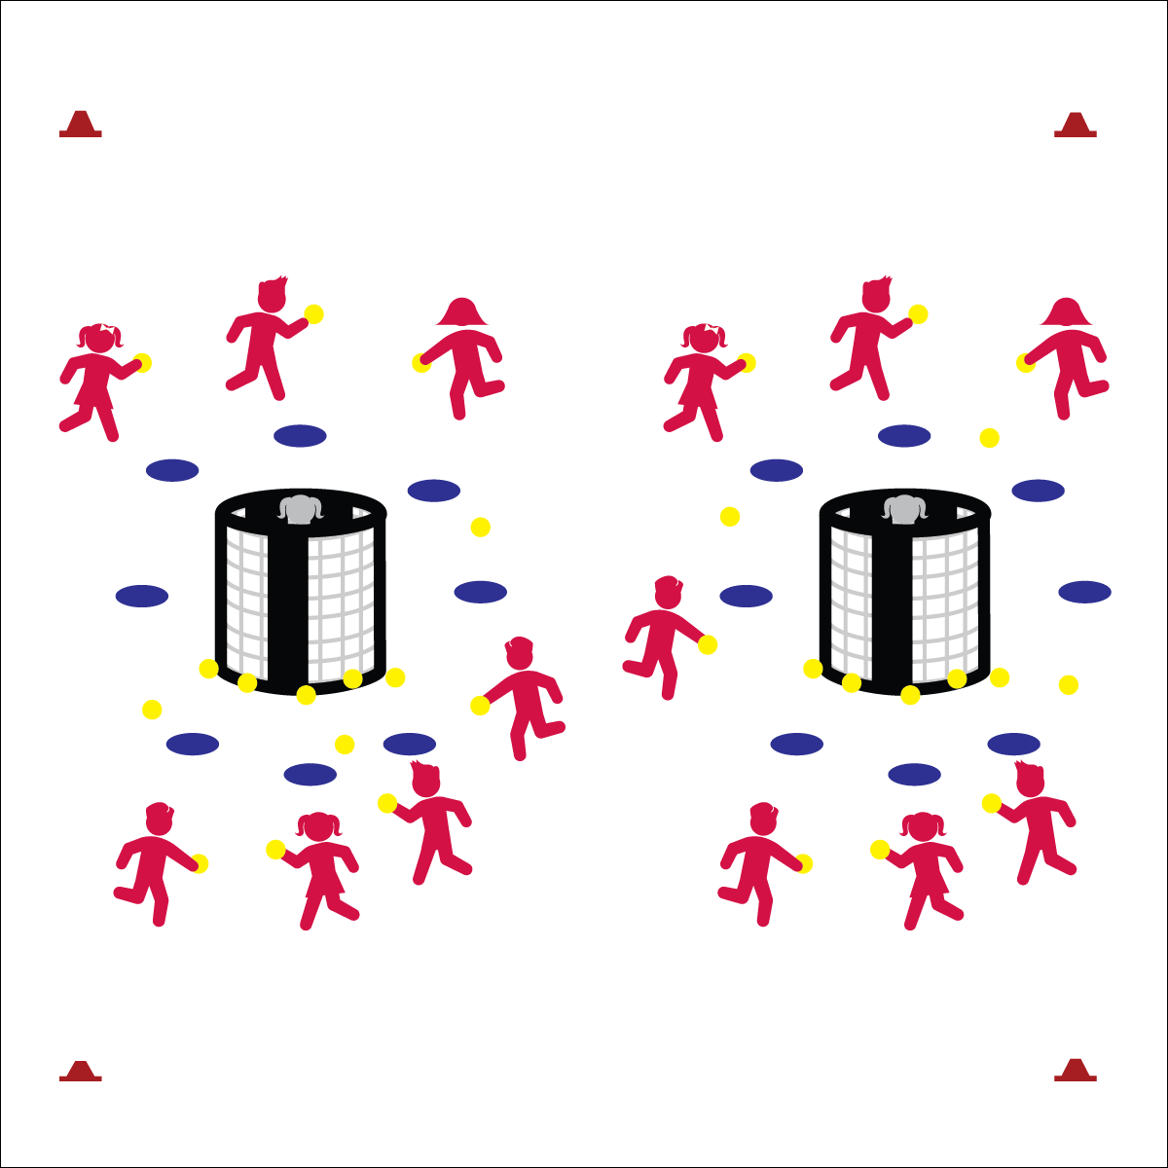

**Equipment:**

* 2 goals
* 1 (or more) yarn balls per student
* 16 spot markers
* 4 large cones
* Throwing and Catching Skill Cue Chart

**Set-Up:**

1. Create a large rectangular activity with the 4 large cones.
2. Set 2 goals up 5 to 10 paces from each end line.
3. Place 8 spot markers in a circle around each goal, approximately 5 paces from the goal.
4. Choose 2 students to be “Grouches,” each standing inside one of the goals.
5. All other students scattered throughout the activity area with a yarn ball.

**Activity Procedures:**

1. Today’s activity is called The Grouch. The object is for you to shoot the foam balls into the goal while the Grouch tosses them back out.
2. On the start signal, players with a yarn ball can shoot at either goal from behind the spot markers. If a ball goes inside the goal, it’s the Grouch’s job to toss it back out as quickly as she/he can. If the ball doesn’t go inside the goal, players can move to pick up any ball that’s on the floor.
3. On the stop signal, stop and listen for instructions.

**Grade Level Progression:**

**3rd:** Play the activity as described above.

**4th & 5th:** Divide the class into 2 teams. Each team will shoot on 1 goal only. The grouch will “defend” their team’s goal by tossing yarn balls back out of the goal as quickly as they can. Grouches will work to toss the balls into open space, away from the opposing team.

* **Skill:** I will use all of the skill cues for throwing to a target.
* **Cognitive:** I will discuss the reasons why I enjoy different physical activities.
* **Fitness:** I will remain actively engaged in order to accumulate physical activity minutes.
* **Personal & Social Responsibility:** I will maintain control of my actions and throws in order to keep myself and my classmates safe.
* Throwing: Shoulder to Target, Load Back, Opposite Foot to Target, Throw Across
* Catching: Eye/Hands Ready, Reach, Soft Hands

**THE GROUCH**



* Pairs work together with one partner gathering the ball and the other shooting.
* Provide an auditory cue at each goal.
* Use safe passable objects of various sizes, shapes, colors, and textures.



* **DOK** **1:** What is an activity that you enjoy?
* **DOK 2:** Can you summarize the reasons why you enjoy a particular activity?
* **DOK 3:** Based on the answers you’ve heard in class, what are the top reasons why people choose different physical activities?



* **Standard** **1 [E13&14.3-5b)** Throws underhand to a partner or target with reasonable accuracy (3). Throws overarm to a partner or at a target with accuracy at a reasonable distance (4b). Throws (underhand and overarm) using a mature pattern in non-dynamic environments, with different sizes and types of objects (5a). Throws (both underhand and overarm) to a large target with accuracy (5b).
* **Standard 3 [E2.3-5]** Engages in the activities of physical education class without teacher prompting (3); Actively engages in the activities of physical education class, both teacher-directed and independent (4); Actively engages in all the activities of physical education (5).
* **Standard 4 [E6.3-5]** Works independently and safely in physical activity settings (3); Works safely with peers and equipment in physical activity settings (4); Applies safety principles with age-appropriate physical activities (5).
* **Standard 5 [E3.3-5]** Reflects on the reasons for enjoying selected physical activities (S5.E3.3); Ranks the enjoyment of participating in different physical activities (S5.E3.4); Analyzes different physical activities for enjoyment and challenge, identifying reasons for a positive or negative response (S5.E3.5).



Accuracy, Target, Independent, Safe, Control, Enjoyment, Challenge



**Review content:** The Grouch is a perfect activity for reviewing underhand and overarm throwing cues while also focusing on the connection between self-control and safety. Passing, catching, and shooting are all important skills required for successful participation in invasion games. Highlight proper form, the importance of skill cues, and the need for safe, controlled play.

**GOLDEN GOALIE**

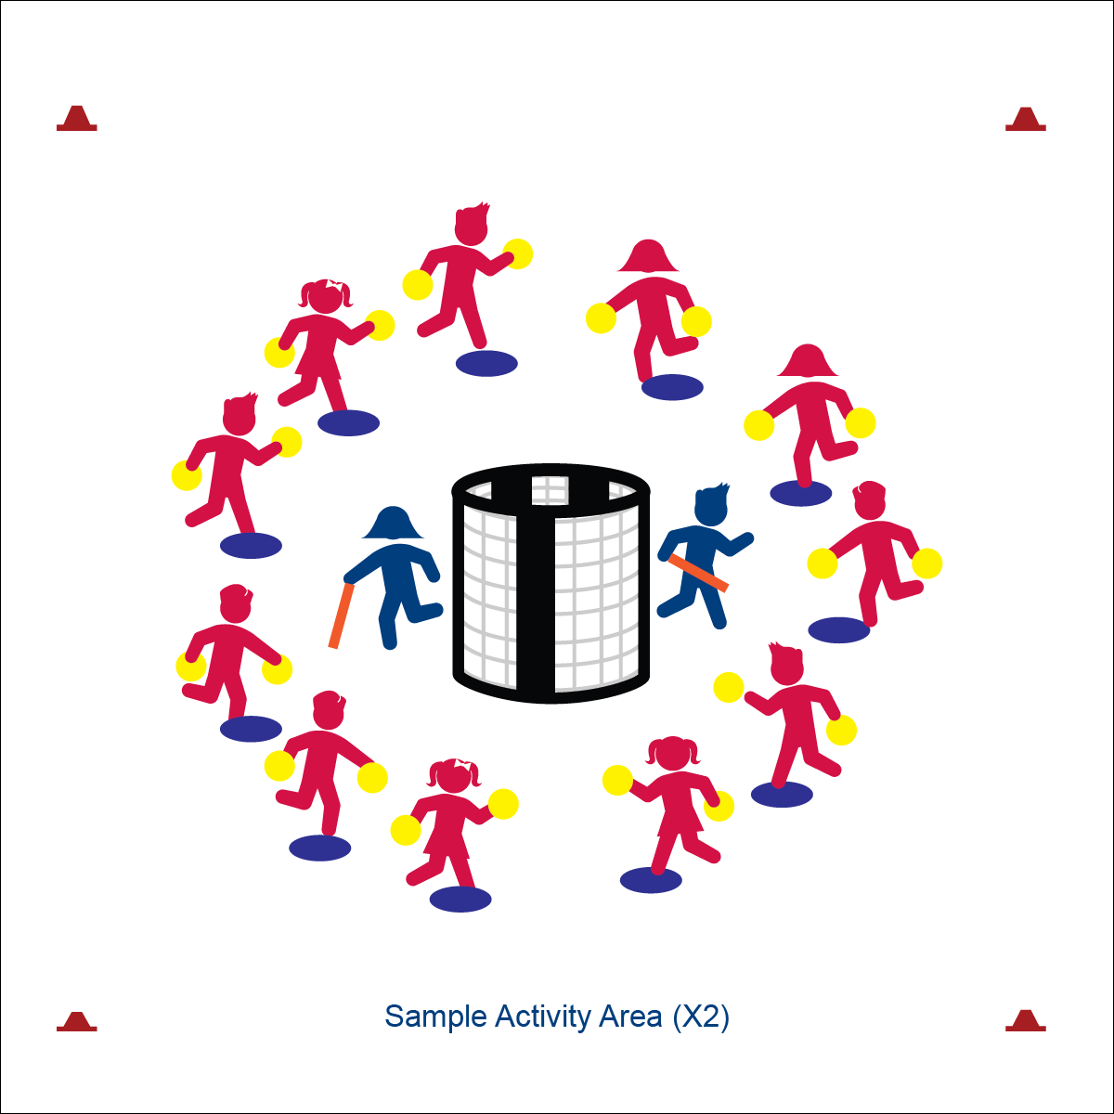

* Relationship: Goal, Ball, Players
* Space Awareness: Open/Closed, Levels, Pathways
* Effort: Move Fast/Slow, Pressure Strong/Light

**Activity Procedures:**

1. Today’s activity is called Golden Goalie. We’ll take turns practicing our goalie skills. The object of the game is for the goalie to block as many rolling shots as they can using the foam noodle.
2. On the start signal, player number 1 at each goal will roll 1 of their balls and attempt to make a goal. The goalie will attempt to strike it away with the noodle.
3. As soon as the ball is hit by the goalie (or goes into the net), the next player will roll a ball at the goal. We’ll continue in order until everyone has rolled both of their foam balls.
4. Offensive players must keep at least 1 foot on their spot at all times. After both foam balls are rolled, get in plank position and hold until the round is over.
5. After each round, we’ll choose a new goalie and reset the game.

**Grade Level Progression:**

**3rd:** Play the activity as described above.

**4th:** Offensive players may bounce shots in addition to rolling.

**5th:** Stagger spot markers to create a variety of shooting distances.

**Equipment:**

* 2 goals
* 11 spot markers
* 2 foam noodles
* 2 (or more) foam balls per student
* Defensive Movement Concept Chart

**Set-Up:**

1. Create 2 separate activity areas, each with a goal in the center.
2. Place 11 spot markers in a circle around each goal, approximately 5 paces from the goal.
3. Choose 2 students to be goalies. Give each goalie a foam noodle and send them to defend separate goals.
4. All other students on a spot marker with 2 foam balls. At each goal, number each student consecutively from 1 to 11.

* **Skill:** I will move thoughtfully in order to position my body to gain an advantage as a goalie.
* **Cognitive:** I will identify movement concepts important to positioning as goalie.
* **Fitness:** I will remain actively engaged in order to accumulate physical activity minutes.
* **Personal & Social Responsibility:** I will recognize and follow all activity rules.

**GOLDEN GOALIE**



* Help the goalie hold the foam noodle using Velcro or other safe fastener.
* Provide 1-on-1 assistance to students needing hand-over-hand support.
* Use equipment that provides auditory cues/signals.



* **DOK** **1:** Can you make a list of movement concepts that impact invasion games?
* **DOK 2:** Which concepts are important to positioning as a goalie?
* **DOK 3:** How does the concept of levels relate to defensive positioning as a goalie?



* **Standard** **1 [E25.3-4]** Strikes a ball with a long-handled implement, sending it forward, while using proper grip for the implement (e.g., hockey stick) (3); Strikes an object with a long-handled implement (e.g., hockey stick), while demonstrating three of the five critical elements of a mature pattern for the implement (grip, stance, body orientation, swing plane and follow-through) (4).
* **Standard 2 [E3.3&5b]** Combines movement concepts (direction, levels, force, time) with skills as directed by the teacher (3); Applies the concepts of direction and force to strike an object with a long-handled implement. (5b).
* **Standard 4 [E5.3-5]** Recognizes the role of rules and etiquette in physical activity with peers (3); Exhibits etiquette and adherence to rules in a variety of physical activities (4); Critiques the etiquette involved in rules of various game activities (5).



Goalie, Mature Pattern, Rule, Etiquette, Accumulate, Movement Concept, Positioning



**Help students process content:** While the application of movement concepts may seem instinctual for some students, others will struggle at a very basic level. Students working to defend a goal must also overcome natural apprehension. All of this requires a gentle and observant teacher who is constantly looking for teachable moments within the activity and provides feedback in a positive and meaningful way.

**FOUR CORNERS**

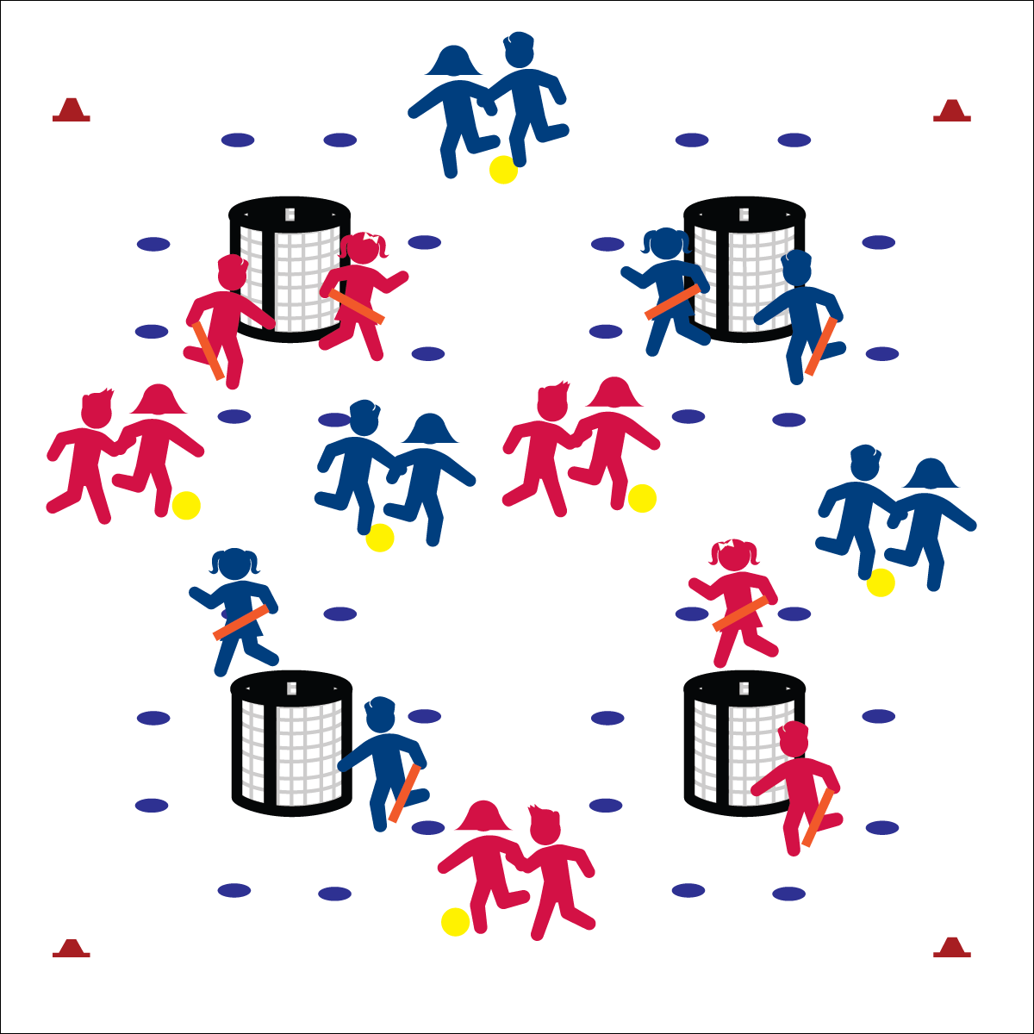

* **Skill:** I will combine locomotor skills (walk/jog) with foot dribbling/passing.
* **Cognitive:** I will identify and apply basic offensive and defensive strategies.
* **Fitness:** I will discuss the health benefits of participating in today’s activity.
* **Personal & Social Responsibility:** I will work safely with my partner and classmates.
* Offense: Space, Movement, Pass, Shoot
* Defense: Ball/Opponent, Angles, Space, Force Outside

**Equipment:**

* 4 goals (for up to 24 players)
* 1 ball per pair
* 24 spot markers
* Offense/Defense Strategy Chart

**Set-Up:**

1. Create a large activity area and place a goal in each of the 4 corners of the area.
2. Place 8 spot markers in a circle around each goal, approximately 5 paces from the goal.
3. Pair students. Send 1 pair to each of the 4 goals as goalies. All other pairs scattered in area with locked elbows and a ball at their feet.

**Activity Procedures:**

1. It’s time to play Four Corners. The object is for you and your partner to work cooperatively to score a goal at any of the 4 goals.
2. The first round of play will be soccer style. You’ll dribble and pass the ball soccer style between you and your partner toward a goal, and then shoot the ball from behind the spot markers.
3. If you score a goal, switch places with the goalies. They’ll lock arms and dribble your ball to a new goal while you and your partner defend the goal you just scored on. Goalies do not have to lock elbows.
4. If goalies block a shot, the shooting team must then go get their ball and dribble to a different goal before taking another shot.
5. We’ll begin on the start signal. When you hear the stop signal, freeze and listen for instructions.

**Grade Level Progression:**

**3rd & 4th:** Play the activity as described above.

**5th:** Offensive players unlock elbows and travel together while staying approximately 6 to 10 feet apart.

**FOUR CORNERS**



* Utilize brightly colored boundaries and equipment.
* Use auditory signals in goals.
* Play the game without goalies, focusing on traveling with the ball and shooting.



* **Standard** **1 [E1.4 & 5c]** Uses various locomotor skills in a variety of small-sided practice tasks, dance, and educational gymnastics experiences (4); Combines traveling with manipulative skills for execution to a target (e.g., scoring in soccer, hockey, and basketball) (5c).
* **Standard 1[E20.4-5]** Dribbles with hand/feet in combination with other skills (e.g., passing, receiving, shooting) (4). Hand/foot-dribbles with mature patterns in a variety of small-sided game forms (5).
* **Standard 2 [E5.4c-5a]** Recognizes the type of kicks needed for different games/sports situations (4c); Applies basic offensive and defensive strategies/ tactics in invasion small-sided practice tasks (5a).
* **Standard 4 [E6.3-5]** Works independently and safely in physical activity settings (3); Works safely with peers and equipment in physical activity settings (4); Applies safety principles with age-appropriate physical activities (5).
* **Standard 5 [E1.3-5]** Discusses the relationship between physical activity and good health (3); Examines the health benefits of participating in physical activity (4); Compares the health benefits of participating in selected physical activities (5).



Combine, Offense, Defense, Strategy, Health Benefits



* **DOK** **1:** What does offense mean? What does defense mean?
* **DOK 2:** What do you know about playing offense? About playing defense?
* **DOK 3:** How would you apply what you know in order to perform well during Four Corners?



**Organize students to interact with content:** Four Corners organizes students as well as the activity environment to promote purposeful practice with a developmentally appropriate level of challenge for a wide range of skill and ability levels. Students combine locomotor and manipulative skills in an open offensive environment, with defensive pressure increasing as pairs work to execute directly toward a goal.

**SWITCH**

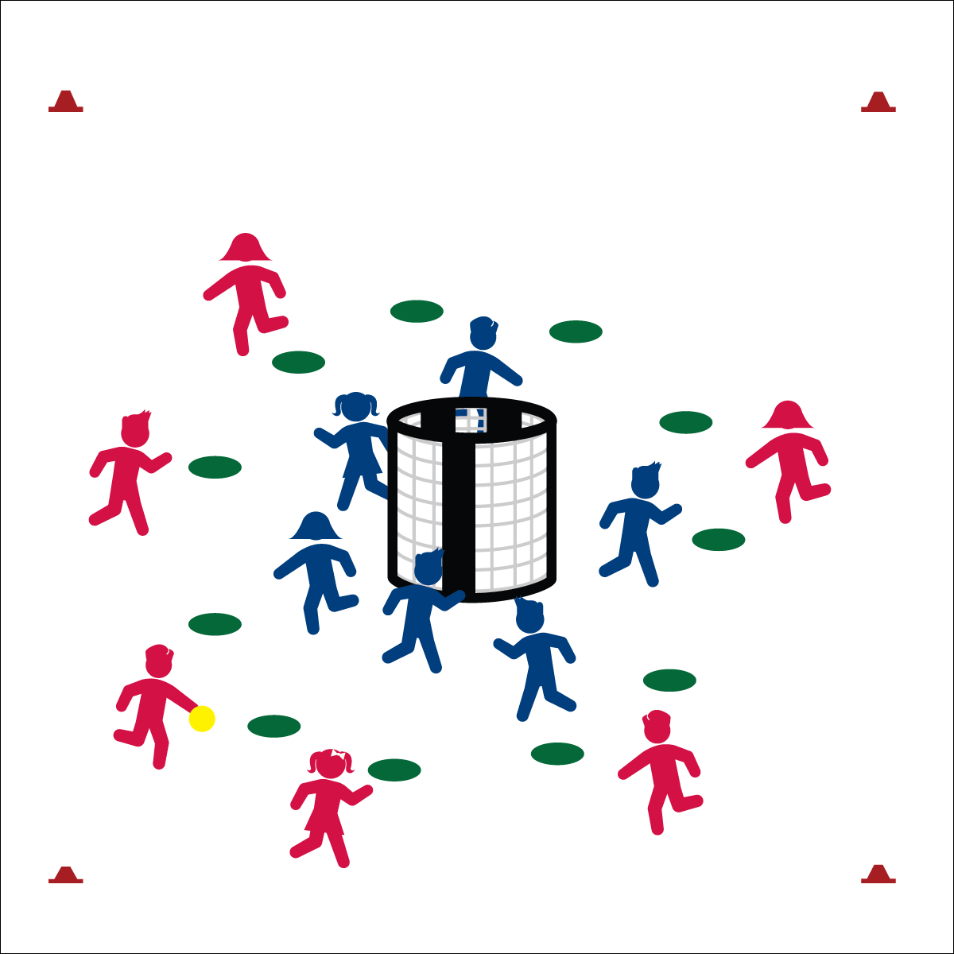

**Activity Procedures:**

1. Today’s activity is called Switch. The object of the game is for the offense to score a goal (teacher’s choice: soccer, handball, or basketball style). Three passes must be made before a shot is taken.
2. When a goal is scored or an interception is made (defense gains possession), players yell, “SWITCH!” On this signal, teams switch; offense becomes defense and defense becomes offense.
3. The new offensive team must complete 10 jumping jacks before the next round begins.
4. Defensive teams must stay inside the cones but may move throughout the defensive area. Offense must stay outside cones but may move throughout the offensive area. If a player breaks this rule 3 times, she/he must sit out for 1 minute while the other team has a Power Play.
5. Continue play until you hear the stop signal.

**Grade Level Progression:**

**3rd:** Play the activity as described above.

**4th & 5th:** Add a second ball to the activity. This could be a different type of ball (e.g., a football).

**Equipment:**

* 1 or 2 goals per 12 students
* 1 ball per 12 students
* 12 spot markers per group of 12 students
* 1 pinnie per 2 students.
* Offense/Defense Strategy Chart
* Throwing and Catching Skill Cue Chart

**Set-Up:**

1. Create 1 activity area per 12 students with 2 stacked goals in the center of each area.
2. Create a shooting circle 8 to 10 paces from the goal using 12 spot markers. This creates a defensive area inside the spots and an offensive area outside the spots.
3. Create teams of 6 students with 1 team inside the circle area (defense) and 1 team outside the circle area (offense). The team starting on offense wears pinnies.

* **Skill:** I will demonstrate throwing and catching cues in order to pass and shoot accurately.
* **Cognitive:** I will identify and discuss basic skills and strategies need to gain an offensive advantage.
* **Fitness:** I will remain actively engaged in order to enhance my fitness.
* **Personal & Social Responsibility:** I will work safely while staying active.
* Offense: Space, Movement, Pass, Shoot
* Defense: Ball/Opponent, Angles, Space, Force Outside

**SWITCH**



* Allow teams to continue as offense/defense for a set time, followed by an auditory cue to switch roles.
* Teammates must hand the ball off to teammates rather than passing/tossing.
* Vary the number of players on offense and defense to give one an advantage.



* **Standard** **1 [E13&14.3-5b)** Throws underhand to a partner or target with reasonable accuracy (3); Throws overarm to a partner or at a target with accuracy at a reasonable distance (4b); Throws (underhand and overarm) using a mature pattern in non-dynamic environments, with different sizes and types of objects (5a); Throws (both underhand and overarm) to a large target with accuracy (5b).
* **Standard 1 [E15.4-5b]** Throws to a moving partner with reasonable accuracy in a non-dynamic environment (4). Throws with accuracy, both partners moving (5a). Throws with reasonable accuracy in dynamic, small-sided practice tasks.
* **Standard 1 [E16.4-5c]** Catches a thrown ball above the head, at chest/waist level, and below the waist using a mature pattern in a non-dynamic environment (4); Catches with accuracy, both partners moving (5b); Catches with reasonable accuracy in dynamic, small-sided practice tasks (5c).
* **Standard 2 [E5.3-5]** Applies basic offensive and defensive strategies/ tactics in invasion small-sided practice tasks (5a); Recognizes the type of throw, volley or striking action needed for different games/sports situations (5c).
* **Standard 4 [E6.3-5]** Works independently and safely in physical activity settings (3); Works safely with peers and equipment in physical activity settings (4); Applies safety principles with age-appropriate physical activities (5).



* **DOK1:** What does it mean to have an offensive advantage?
* **DOK 2:** What skills and strategies help you gain an offensive advantage?
* **DOK 3:** How is ball movement (passing) related to offensive advantage?



**Help students engage in cognitively complex tasks:** Execution of locomotor and manipulative skill combinations within a dynamic activity environment is both physically and cognitively complex for intermediate school students. Further increasing the complexity of the task is the transition from offense to defense and vice versa. Switch is a perfect game for introducing this level of complexity: play remains focused on 1 goal, there are auditory and visual cues to announce the transitions, and possession changes can be buffered by adjusting the number of exercises the offense must complete before play resumes.



Skill Cue, Pass, Shoot, Advantage, Accurately

**TEAM HANDBALL**

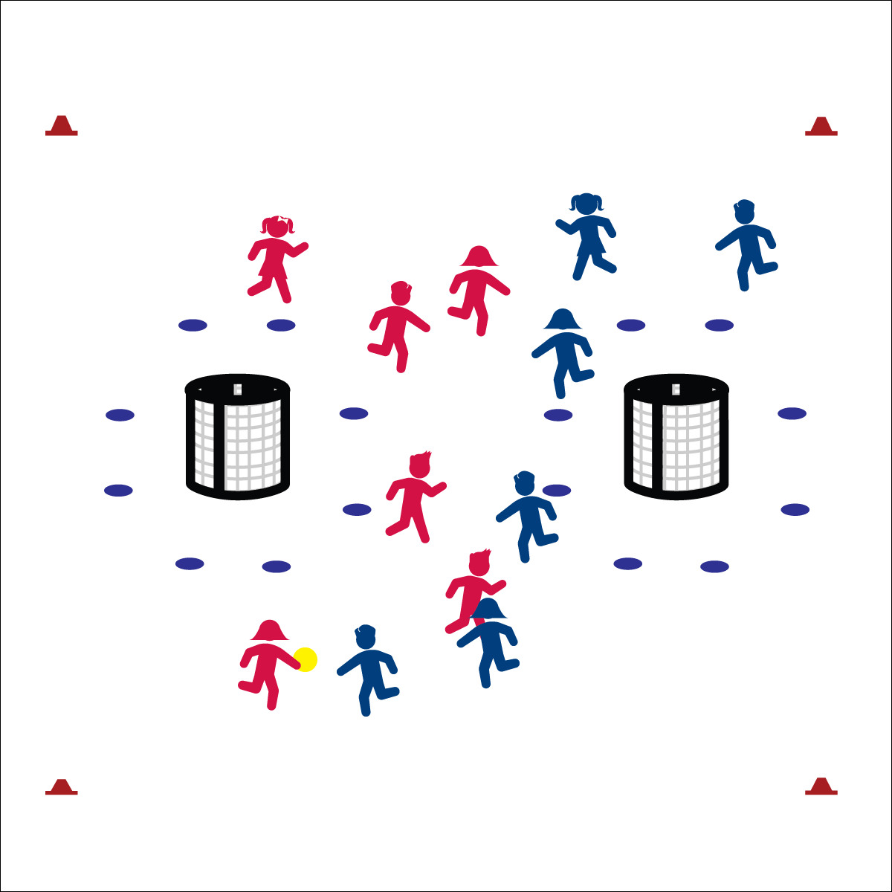

**Activity Procedures:**

1. Today we’re going to play Team Handball. The object of the games is for your team to score more points than your opponent scores before the stop signal. You’ll use the skills and strategies we’ve learned in previous activities to work as a team on both offense and defense.
2. There are a few important rules:

* Play begins with a throw-off from midfield: the starting player stands at midfield and passes to a teammate. This starts the game and is the way players should restart play after each goal.
* If the ball goes out of bounds, restart with a throw-in: a player standing on the side line or end line throws to a teammate who is in bounds.
* Defense must be 5 paces away from the player performing every throw-off and throw-in.
* No contact between players is allowed. Defense must stay an arms-length from the player with the ball.
* Defense cannot touch the ball when an offensive player has control.
* Passes and shots can be intercepted/knocked down with hands and arms.
* Offense can take 3 steps with the ball and/or hold the ball for no more than 3 seconds.
* Challenge: Change possession if the ball hits the ground after a pass. Shots are not considered passes. Offense may get a rebound from a shot.

**Equipment:**

* 2 goals per 12 students
* 1 ball per 12 students
* 12 spot markers per goal
* 4 large cones per court/field
* Offense/Defense Strategy Chart

**Set-Up:**

1. Create a large activity area (the size of a basketball court) using large cones.
2. Set up goals 5 to 10 paces from each end line.
3. Create a shooting circle (i.e., crease) 6 paces from the goal using spot markers.
4. Create two teams per activity area (6 per team is ideal). One team per area wearing pinnies. Pinnies begin with the ball.

* **Skill:** I will use a combination of skills and movement concepts.
* **Cognitive:** I will apply my understanding of open space.
* **Fitness:** I will remain actively engaged in order to enhance my fitness.
* **Personal & Social Responsibility:** I will work safely while staying active.
* Offense: Space, Movement, Pass, Shoot
* Defense: Ball/Opponent, Angles, Space, Force Outside

**TEAM HANDBALL**



* Use larger, stacked goals to increase opportunities for shooting success.
* Play without goalies. Place auditory signals in goals.
* Use passable objects of various sizes, shapes, colors, and textures.
* Implement a 5-, or 3-second rule for players holding the ball.
* Require a minimum number of passes prior to shooting.



* **Standard** **1 [E1.4 & 5c]** Uses various locomotor skills in a variety of small-sided practice tasks, dance, and educational gymnastics experiences (4); Combines traveling with manipulative skills for execution to a target (e.g., scoring in soccer, hockey and basketball) (5c).
* **Standard 1 [E15.4-5b]** Throws to a moving partner with reasonable accuracy in a non-dynamic environment (4). Throws with accuracy, both partners moving (5a). Throws with reasonable accuracy in dynamic, small-sided practice tasks.
* **Standard 1 [E16.4-5c]** Catches a thrown ball above the head, at chest/waist level, and below the waist using a mature pattern in a non-dynamic environment (4); Catches with accuracy, both partners moving (5b); Catches with reasonable accuracy in dynamic, small-sided practice tasks (5c).
* **Standard 2 [E1.3-5]** Recognizes the concept of open spaces in a movement context (3); Applies the concept of open spaces to combination skills involving traveling, (e.g., dribbling and traveling) (4a); Applies the concept of closing spaces in small-sided practice tasks (4b); Combines spatial concepts with locomotor and non-locomotor movements for small groups in gymnastics, dance, and games environments (5).
* **Standard 2 [E5.3-5]** Applies basic offensive and defensive strategies/tactics in invasion small-sided practice tasks (5a); Applies basic offensive and defensive strategies/tactics in net/wall small-sided practice tasks (5b); Recognizes the type of throw, volley or striking action needed for different games/sports situations (5c).



* **DOK1:** What is an open space?
* **DOK 2:** How does open space affect offense? How does it affect defense?
* **DOK 3:** What does the defense have to do to closed space?



**Help students examine similarities and differences:** Students may not be familiar with Team Handball as a specific invasion sport. However, many students will recognize invasion strategies from prior experience in sports such as basketball, soccer, lacrosse, etc. Examine similarities as well as differences in order to help students connect with prior learning as well as extend learning into future participation in all invasion games. Skill and knowledge transfer will work to enhance both competence and confidence as we encourage students to try a variety of activity options.



Apply, Skill, Movement Concept, Combination, Open Space

**INVASION TRIATHLON**

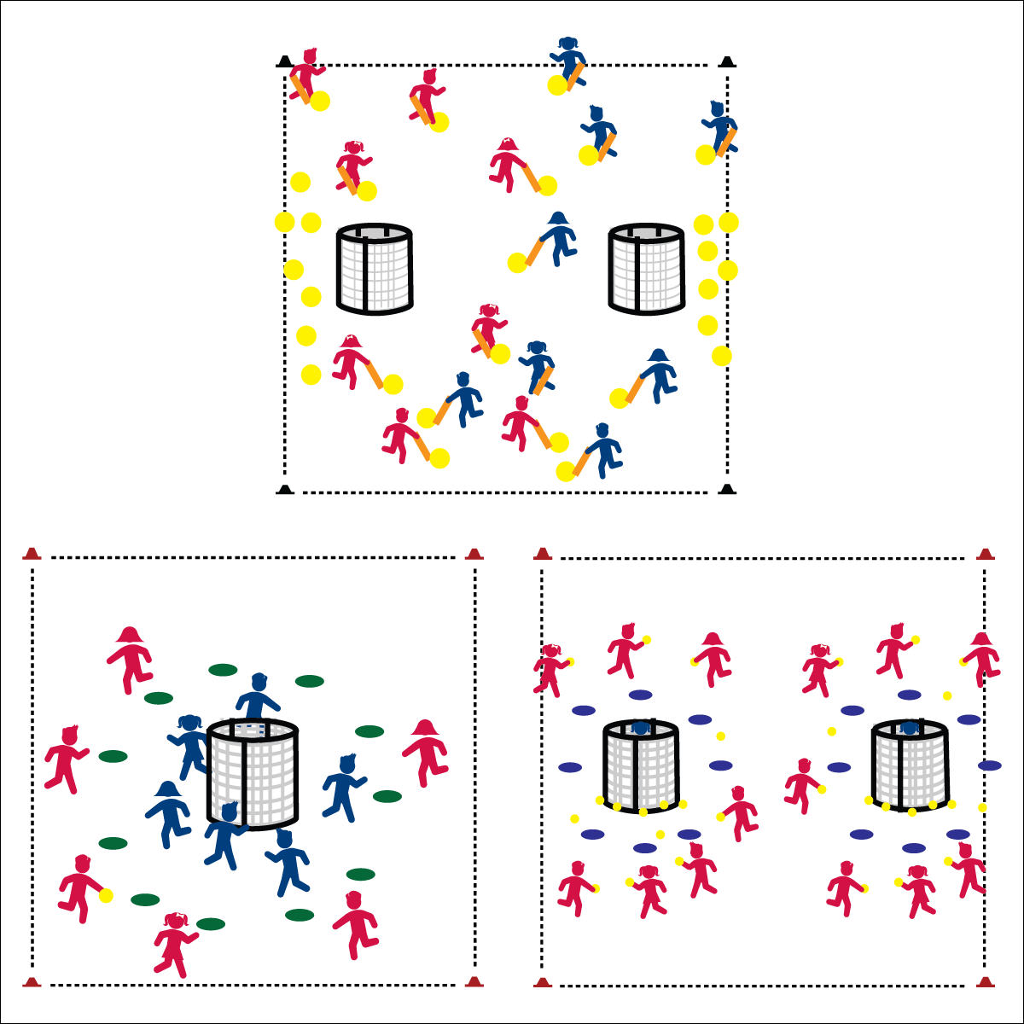

* **Skill:** I will use a combination of skills to execute offensive and defensive strategies and tactics.
* **Cognitive:** I will discuss the health benefits of participating in invasion games/sports.
* **Fitness:** I will compare the health benefits of invasion games with other activities that I enjoy.
* **Personal & Social Responsibility:** I will identify the reasons why I enjoy being physically active in a variety of activity choices.
* Offense: Space, Movement, Pass, Shoot
* Defense: Ball/Opponent, Angles, Space, Force Outside

**Equipment:**

* E See equipment needed for selected activities.

**Set-Up:**

1. Set up 3 activity areas according to the set-up instructions for selected activities.
2. Create even teams and number teams as Team 1, Team 2, Team 3, Team 4, etc.
3. Rotate teams through each of the selected activities.
4. Even teams rotate clockwise, odd teams rotate counter-clockwise.

**Activity Procedures:**

1. It’s time for the Invasion Triathlon. Today you’ll work independently with your team, rotate through each activity area, and participate in 3 different invasion activities.
2. While you’re participating in each activity, I’ll be using a rubric to assess your skill level. We’ll review your assessment together when you compete the Invasion Basics Self-Assessment.
3. Teachers, choose 3 activities from this module in order to assess student performance.
4. Suggested Activities:

* Over There
* The Grouch
* Switch (Team Handball for highly skilled groups)

**Grade Level Progression:**

**3rd – 5th:** See grade level progressions for selected activities.

**INVASION TRIATHLON**



* **Standard** **1 & 2 [Multiple Outcomes:** Select outcomes from the activities chosen for this event.
* **Standard 3 [E3.3-5]** Describes the concept of fitness and provides examples of physical activity to enhance fitness (3); Identifies the components of health-related fitness (4); Differentiates between skill-related and health-related fitness (5).
* **Standard 4 [E5.3-5]** Recognizes the role of rules and etiquette in physical activity with peers (3); Exhibits etiquette and adherence to rules in a variety of physical activities (4); Critiques the etiquette involved in rules of various game activities (5).
* **Standard 5 [E1.3-5]** Discusses the relationship between physical activity and good health (3); Examines the health benefits of participating in physical activity (4); Compares the health benefits of participating in selected physical activities (5).
* **Standard 5 [E3.3-5]** Reflects on the reasons for enjoying selected physical activities (S5.E3.3); Ranks the enjoyment of participating in different physical activities (S5.E3.4); Analyzes different physical activities for enjoyment and challenge, identifying reasons for a positive or negative response (S5.E3.5).



Choose words from selected activities.



* **DOK1:** How can you recognize an invasion game?
* **DOK 2:** How do invasion games affect personal health?
* **DOK 2:** How would you compare the health benefits of invasion games with other activities that you enjoy?



**Review content:** Take an opportunity to review critical skill cues and movement concepts from earlier lessons and activities in order to highlight the cumulative nature of skill and knowledge acquisition. Highlight progress made from the start of the module through the final lessons. This helps to underscore the importance of purposeful practice.



* Choose UDA’s from selected activities.