­­

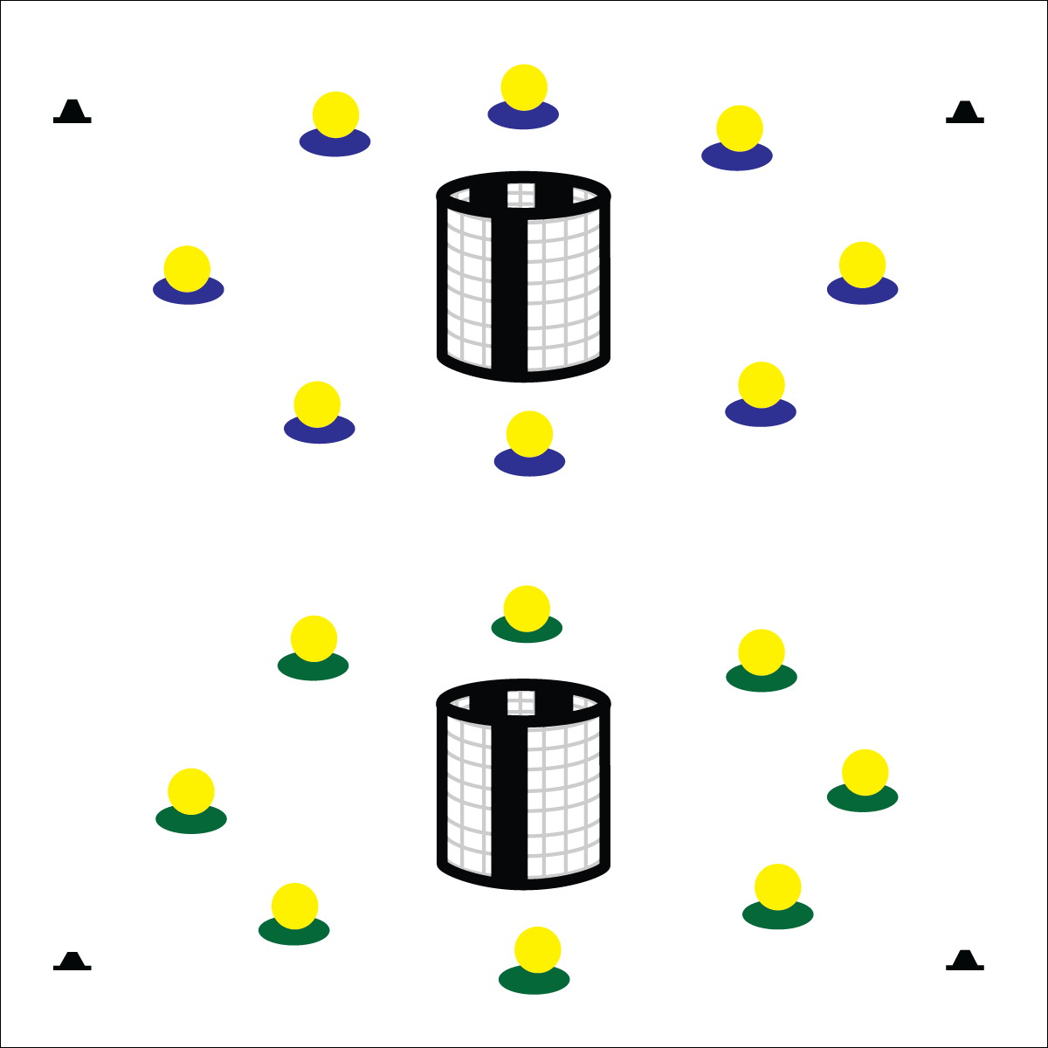

**FITNESS RELAY**

* **Skill:** I will control my actions and movements in order to work safely.
* **Cognitive:** I will provide examples of activities that can enhance my fitness.
* **Fitness:** I will remain actively engaged in order to increase my heart rate.
* **Personal & Social Responsibility:** I will identify and discuss safety principles.
* Cooperate
* Move Quickly
* Show Control

**Equipment:**

* 2 goals
* 1 foam ball per group of 4 students
* 1 spot marker per group of 4 students
* Fitness Relay Challenge Card

**Set-Up:**

* Set the goals on opposite sides of the playing area.
* Space spot markers in a circle evenly around each of the goals, approximately 10 to 15 yards from the center of the goal.
* Set 1 foam ball on each spot marker.
* Create groups of 4 students, each group at a spot marker. Students lay in a line on their back, head-to-toe with feet toward the spot marker.

**Activity Procedures:**

1. Today’s activity is called Fitness Relay. Your team will complete a series of fitness challenges in order to get our muscles warmed up and ready to play.
2. The object of each relay is to move your team’s ball from the spot marker to the goal, working cooperatively to follow the rules of each challenge.
3. When the player closest to the goal gets the ball, she/he will tap the ball into the goal and then quickly move to the spot marker. Everyone in your group will rotate 1 place toward the goal with the new line leader at the spot marker. How many times can you tap into the goal in 1 minute?
4. On the stop signal, freeze, return the ball to the spot marker, and listen for the next challenge.
5. Challenge: Pass the ball using only the feet. (For more challenges see Challenge Card.)

**Grade Level Progression:**

**3rd:** Play the activity as described above.

**4th:** Create fitness challenges for the different components of health-related fitness. Students must identify the component focus after each round of play.

**5th:** Allow students to create fitness challenges to enhance both health- and skill-related fitness.

**FITNESS RELAY**



* **DOK** **1:** What activities can you name that enhance fitness?
* **DOK 2:** How would you compare and contrast activities that enhance aerobic strength with activities that enhance muscular strength?
* **DOK 3:** How is physical activity related to good personal health?



* **Standard** **3 [E2.3-5]** Engages in the activities of physical education class without teacher prompting (3); Actively engages in the activities of physical education class, both teacher-directed and independent (4); Actively engages in all the activities of physical education (5).
* **Standard 3 [E3.3-5]** Describes the concept of fitness and provides examples of physical activity to enhance fitness (3); Identifies the components of health-related fitness (4); Differentiates between skill-related and health-related fitness (5).
* **Standard 4[E6.3-5]** Works independently and safely in physical activity settings (3); Works safely with peers and equipment in physical activity settings (4); Applies safety principles with age-appropriate physical activities (5).
* **Standard 5 [E1.3-5]** Discusses the relationship between physical activity and good health (3); Examines the health benefits of participating in physical activity (4); Compares the health benefits of participating in selected physical activities (5).



* Use passable objects of various sizes, shapes, color, and texture.
* Use balls that provide auditory signals.
* Line students up on mats for support and protection.



Enhance, Fitness, Health-Related Fitness, Skill-Related Fitness, Safety Principles



**Help students process content:** Fitness Relay challenges provide an environment for students to work with and experience fitness-enhancing physical activity. Extending student processing and critical thought requires meaningful debrief discussions that focus on the relationship between physical activity, good health, and fitness development.