­­

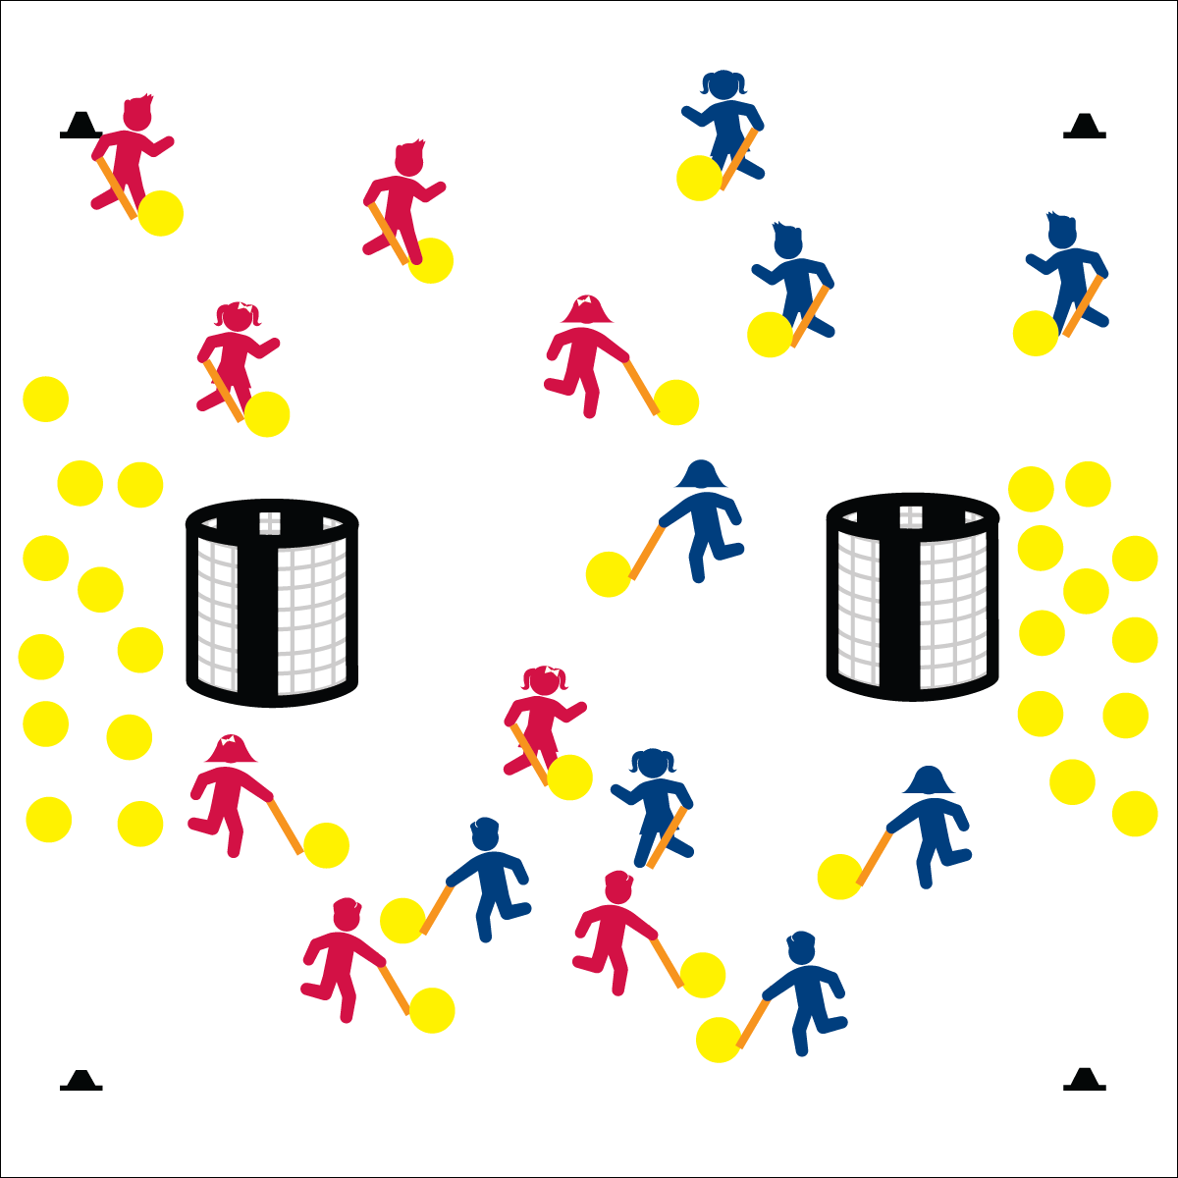

**OVER THERE**

* **Skill:** I will use proper grip for striking with a long-handled implement.
* **Cognitive:** I will recite the cues for striking an object with a long-handled implement.
* **Fitness:** I will remain actively engaged in order to accumulate physical activity minutes.
* **Personal & Social Responsibility:** I will work safely while striking foam balls.
* Grip: Dominant hand to the bottom, non-dominant on top.
* Non-dominant side/shoulder toward the target.
* Load back waist high. Swing square.
* Follow through waist high, point at target.

**Equipment:**

* 2 goals per group of 16 students
* 3 (or more) foam balls per student
* 1 long foam noodle per student
* 4 cones per group of 16 students
* Pinnies for half of all the students
* Long-Handled Striking Cue Chart

**Set-Up:**

* Using cones, create 1 court (activity area) for each group of 16 students.
* Set goals at the ends of each court, approximately 5 yards from the court’s end line.
* Scatter 24 foam balls at one end of each court and 24 at the other. (If you have more than 3 foam balls per student, adjust accordingly.)
* Create teams of 8 students, each with a noodle.
* Send 2 teams to each court, 1 team at each court wearing pinnies.

**Activity Procedures:**

1. Today’s activity is called Over There. Your team’s goal is to get all of your foam balls into the other team’s goal as quickly as you can.
2. You’ll use your foam noodle and safe striking rules to move the ball from your side of the area to the goal. After shooting your ball into the goal, hustle back to get another ball from inside your goal.
3. Freeze when you hear the stop signal and listen for instructions.
4. Extensions: Move the ball soccer-style with the feet. Move the ball by rolling it with the hands. Add goalies and/or defensive players.

**Grade Level Progression:**

**3rd:** Play the activity as described above.

**4th:** Add scattered cones throughout the activity area as mock defenders.

**5th:** Add 1 or 2 roaming defenders attempting to knock the balls away from both teams.

**OVER THERE**



* Use long-handled implements of various lengths, weights, shapes, and colors.
* Allow students to roll foam balls with their hands.
* Provide an auditory cue at each goal.



Invasion Games, Strike, Long-Handled Implement, Skill Cues, Grip, Stance, Body Orientation, Swing Plane, Follow-Through

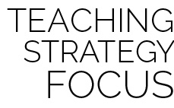

**Help students practice skills:** Developing student competence and confidence with respect to long-handled striking will require a series of practice and experimentation sessions that celebrate progress while emphasizing proper technique. Allow students to practice for short periods of time, and then stop the activity to highlight student examples and skill cues. Restart the activity, allowing students to refocus and work toward greater skill fluency.



* **DOK1:** What are the skill cues for striking an object with a long-handled implement?
* **DOK 2:** How do the concepts of direction and force affect the result of your striking performance?
* **DOK 3:** How would you describe a strike intended to go a far distance? How would you describe a strike intended to accurately go to a teammate only a few feet away?



* **Standard** **1 [E25.3-5]** Strikes a ball with a long-handled implement, sending it forward, while using proper grip for the implement (e.g., hockey sticks) (3); Strikes an object with a long-handled implement (e.g., hockey sticks), while demonstrating three of the five critical elements of a mature pattern for the implement (grip, stance, body orientation, swing plane, and follow-through) (4); Combines striking with a long-handled implement with receiving and traveling skills in a small-sided game (5b).
* **Standard 2 [E3.3-5]** Combines movement concepts (direction, levels, force, time) with skills as directed by the teacher (3); Applies movement concepts to strategy in game situations (5a); Applies the concepts of direction and force to strike an object with a long-handled implement (5b); Analyzes movement situations and applies movement concepts (e.g., force, direction, speed, pathways, extensions) in small-sided practice task/game environments, dance, and gymnastics (5c).
* **Standard 3 [E2.3-5]** Engages in the activities of physical education class without teacher prompting (3); Actively engages in the activities of physical education class, both teacher-directed and independent (4); Actively engages in all the activities of physical education (5).
* **Standard 4 [E6.3-5]** Works independently and safely in physical activity settings (3); Works safely with peers and equipment in physical activity settings (4); Applies safety principles with age-appropriate physical activities (5).